Jose Perea, Keith Haizlett, Zach Anderson

Group 1

Dr. Shankar

Lab Assignment 4

Google maps was incorporated in two different screens as a Map Fragment. The initial menu screen looks like:

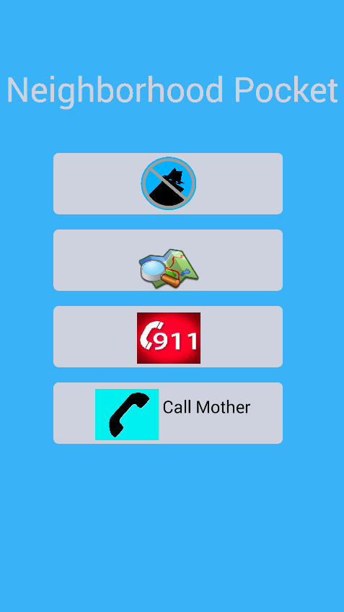

Button used to view a Map containing suspicious activity

Button used to Report a Suspicious Activity

Clicking  will display a map with the most current suspicious activity that has been reported:

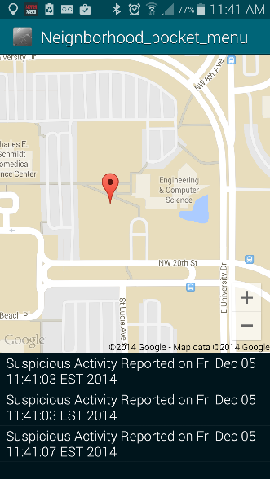

Clicking  icon will display a map that has all the suspicious activities that have ever been reported:

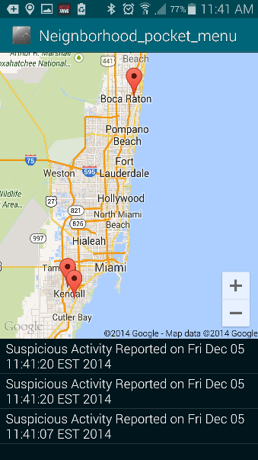

The user can click on this marker, and the appropriate Suspicious Activity in the listView.

Thus, Google Maps is being used in our project to visually display suspicious activity that is reported by users. It will also allow for a user to quickly find suspicious activity by tapping on a marker on the map.