Abhinav Komaravelli

Oluwapelumi Omole

Alec Handal

David Hernandez

Dr. Shankar

Home Quiz 3: Sudoku

This project involved working with Sudoku and eclipse. We were given 5 versions of a Sudoku app, each progressive version better than the previous. We analyzed each one and their difference and improvements as we go from one version to another.

# V0:

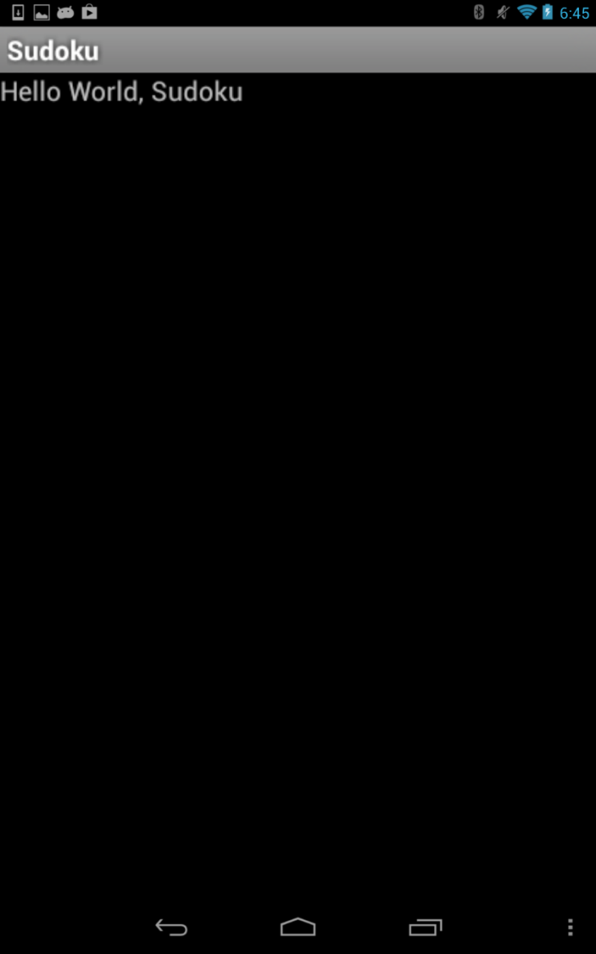

Basically, all this version does is print “Hello World, Sudoku”, and it only contains one activity as shown above.

# V1:

# 

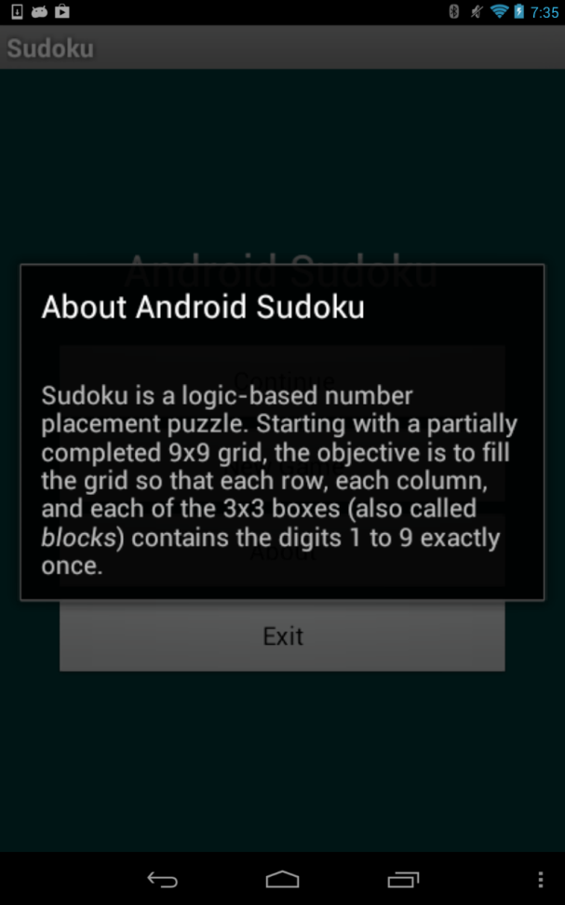

This version introduces the menu screen along with three new activities. The “continue” button won’t function yet, but you can click the “new game” button. If pressed, it displays a screen where the player is allowed to choose a level to play at, but this part will not work (cannot proceed further). In this version, you can also click the new “about” button on the menu screen and it gives a little introduction information on Sudoku.

# V2:

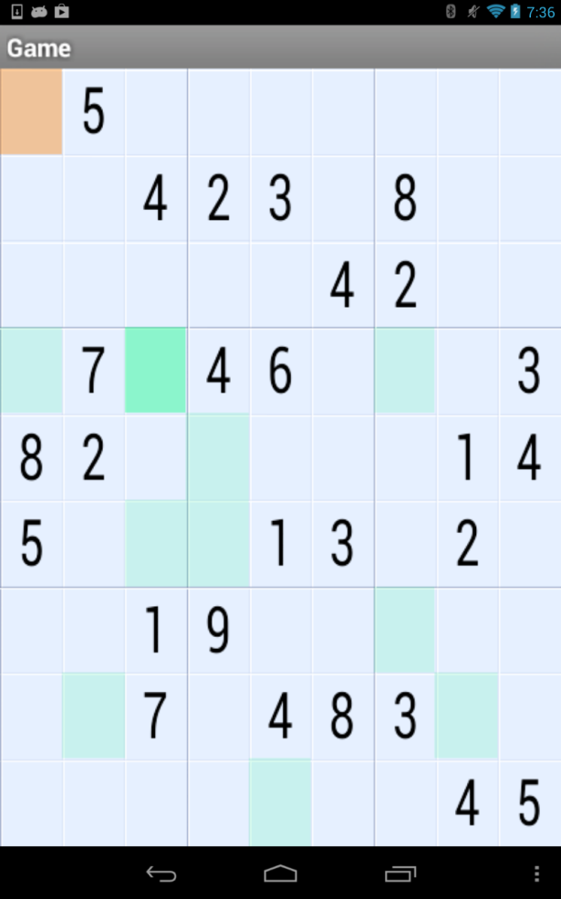 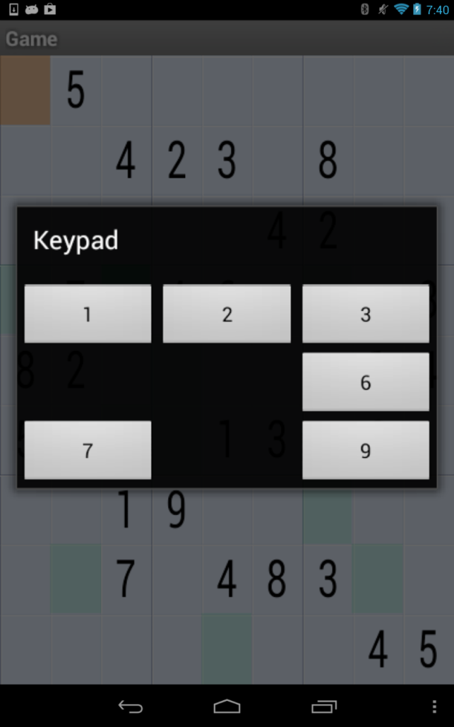

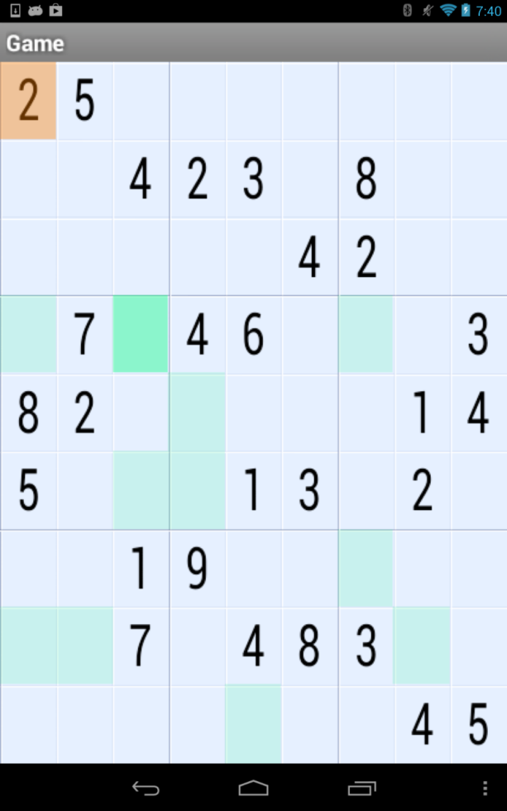

This version only adds in two more features. It enables the user to select their difficulty level and even start playing. For example, if I clicked on an empty square, I get a list of options and whichever number I select, it will then be displayed in the square. I can do this until I complete the game.

# V3:

Actually, this version does not add anything besides the sound. When the app is started, a tune is played repeatedly as background music during the game.

# V4:

# 

This version simply adds another activity by enabling the user to use the “Continue” button. If the app is exited in the middle of a game, then this feature will allow the user to resume. This is available on the menu screen and the only extra feature added from the previous version.