Rebecca Russell, Tiago Baptiste, and Daniel Feldan

Home Quiz 4

Group 2

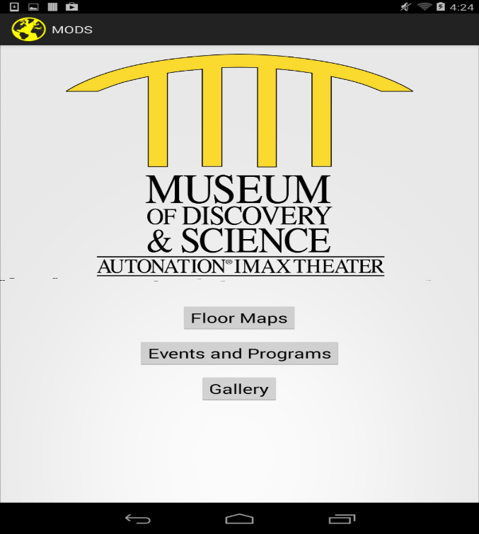

On this page, the home screen, the user can select from three options: “Floor Maps,” “Events and Programs,” and “Gallery.”

When the user selects “Floor Maps,” the following screen appears.

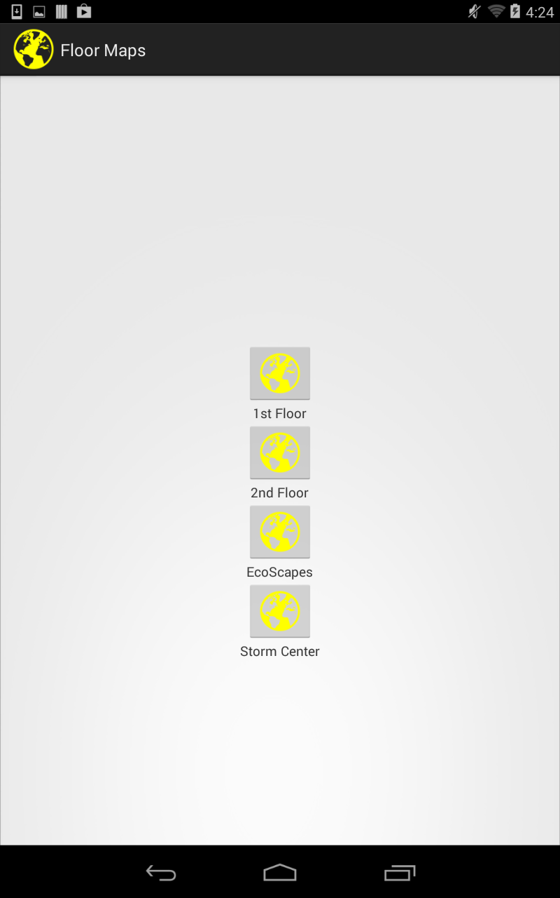

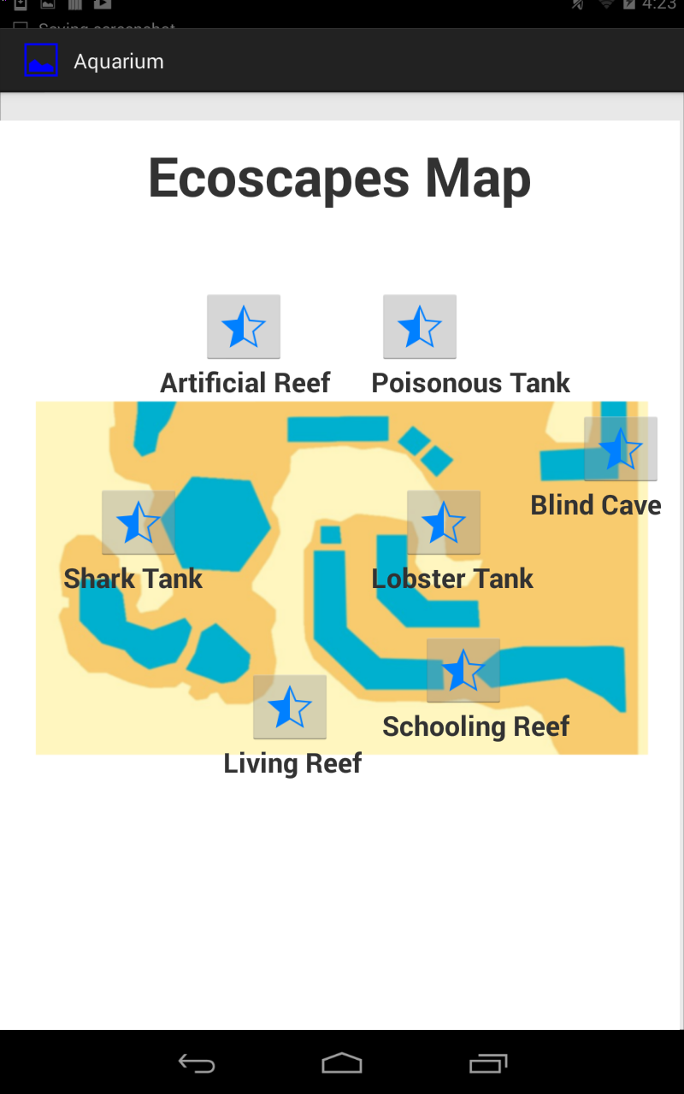

The “Floor Maps” screen displays a selection of the “1st Floor,” “2nd Floor,” “EcoScapes,” and the “Storm Center.”

When the user clicks on the “1st Floor” icon, the map of the first floor is displayed. The same set occurs when the user clicks on the “EcoScapes” icon.

The EcoScapes screen shows an interactive map of the EcoDiscovery Center in the Museum of Discovery and Science. The blue sections in the screen represent areas of water in the exhibit. The EcoScapes screen is essentially the home screen of the Aquarium App.

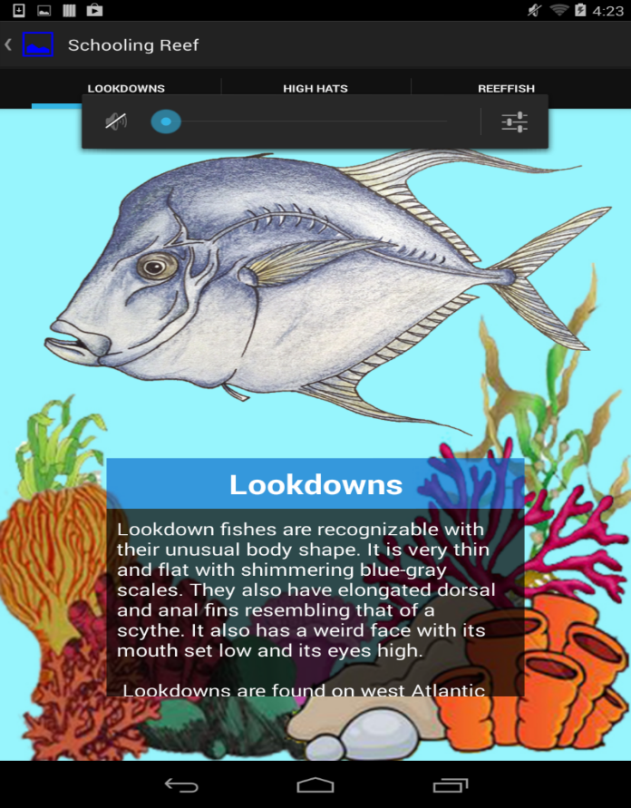

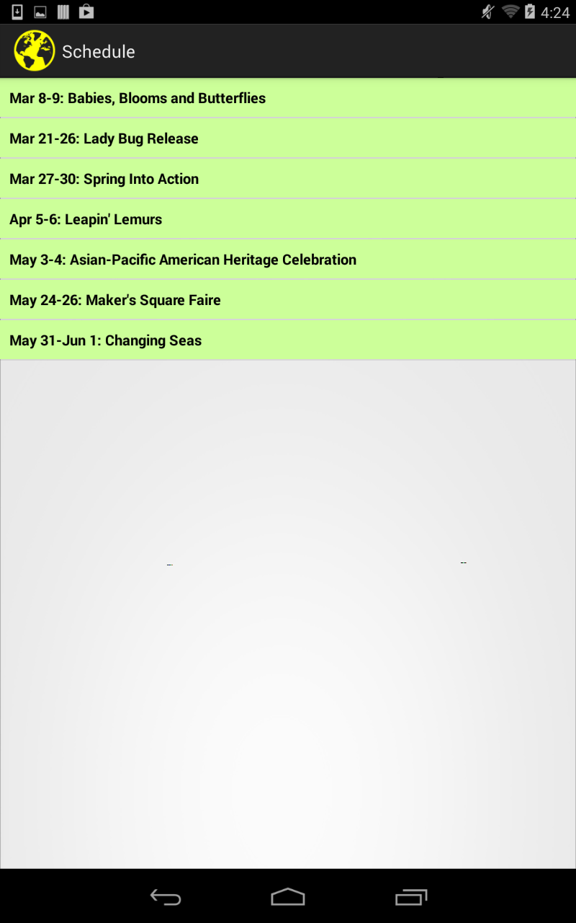

This screen is pulled up when the icon for the Schooling Reef is tapped on the EcoScapes Map. Each section of the EcoScapes Map (e.g. Lobster Tank, Blind Cave, Living Reef) pull up its respective diagrams of the living organisms within that part of the exhibit. For example, in this screen of the Schooling Reef, the Lookdown Fish are displayed. The user can tap and drag the text down to see the rest of the text. The user can also swipe left and right to see the other organisms within the exhibits.

This screen is displayed when the “Events and Programs” button is tapped on the MODS app home screen. It shows the schedule of the events that are upcoming so the user can plan his/her trip to tailor to their specific desires.

This screen is displayed when the “Events and Programs” button is tapped on the MODS app home screen. It shows the schedule of the events that are upcoming so the user can plan his/her trip to tailor to their specific desires.