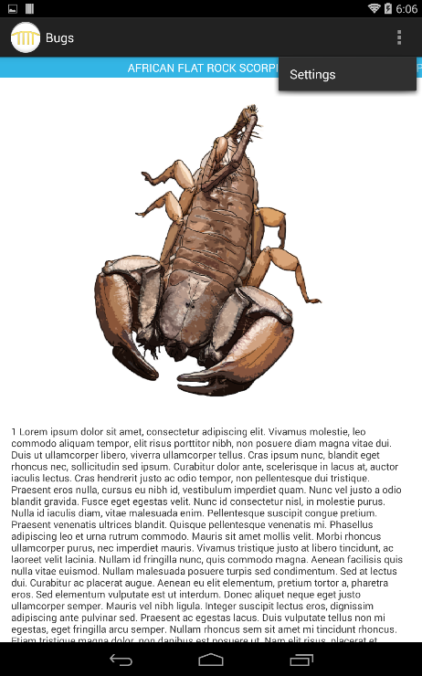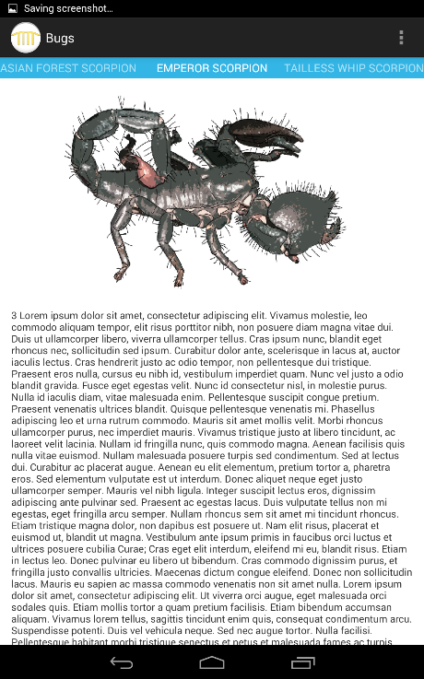The Bugs MODSApp features a simple UI in which the user can swipe left or right to access different pictures of the bugs and information about them. Pictures of the bugs are placed at the top and their descriptions are at the bottom. The users can scroll down to continue reading the descriptions as they see fits. There is no special interaction when the user press on the pictures nor is there any interaction when the user press on the Bugs logo at the top left. The three buttons at the top right prompts the user to a setting button that has no functionality.

The pictures are located under “drawable-hpdi” in the “res” folder. Under “drawable-mpdi”, the path name of the logo located at the upper left is shown.

DetectRobot

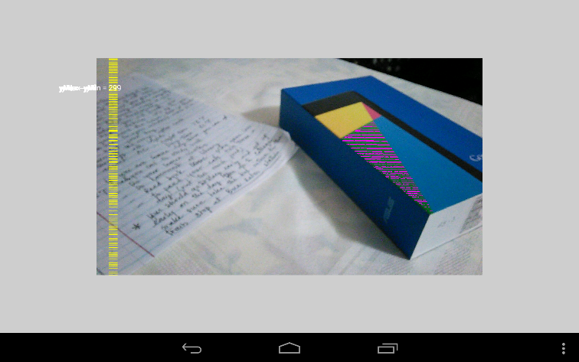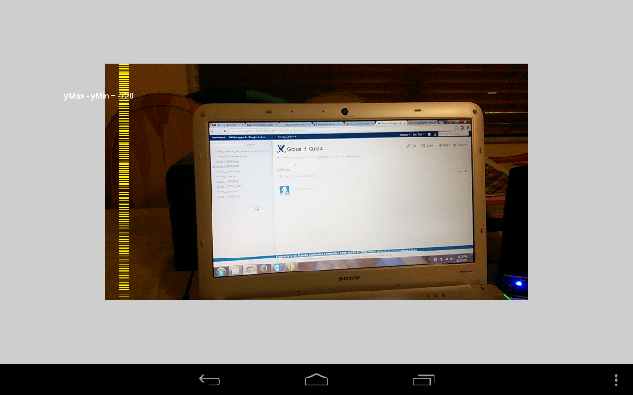­The app first launch in a blank screen. With a press on the screen, the camera shows up at 10 frames per second as indicated by the code. When the screen is tapped again, a picture is taken by the camera. Then the camera begin analyzing the picture for green pixels. It would shade in any region where green pixels where indicated via RGB color mode. A pixel with green being the most as compared to red and blue will be flagged as green.

The green pixels are marked on the picture by the purple dashes.

**Distance Measurement**

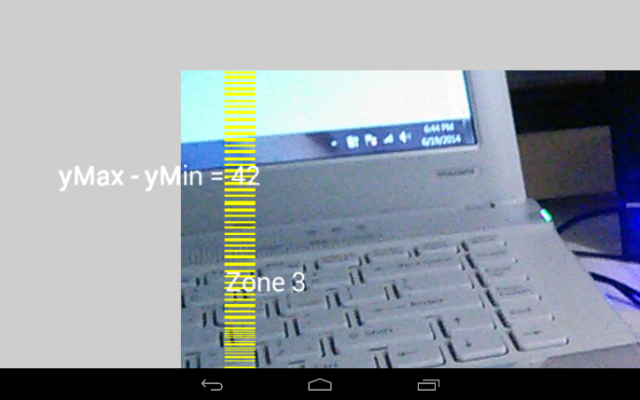DetectRobot also measures the distance. To the left of the vertical yellow collum, ymax-ymin represents the distance from the longest green object to the camera. In the photo below, the distance between the camera and the furthest green object is 42cm.