**Kareem Hunte**

**Loc Tran**

**Vincenzo D’Auria**

**Group #5**

**Sudoku0 - Version 1**

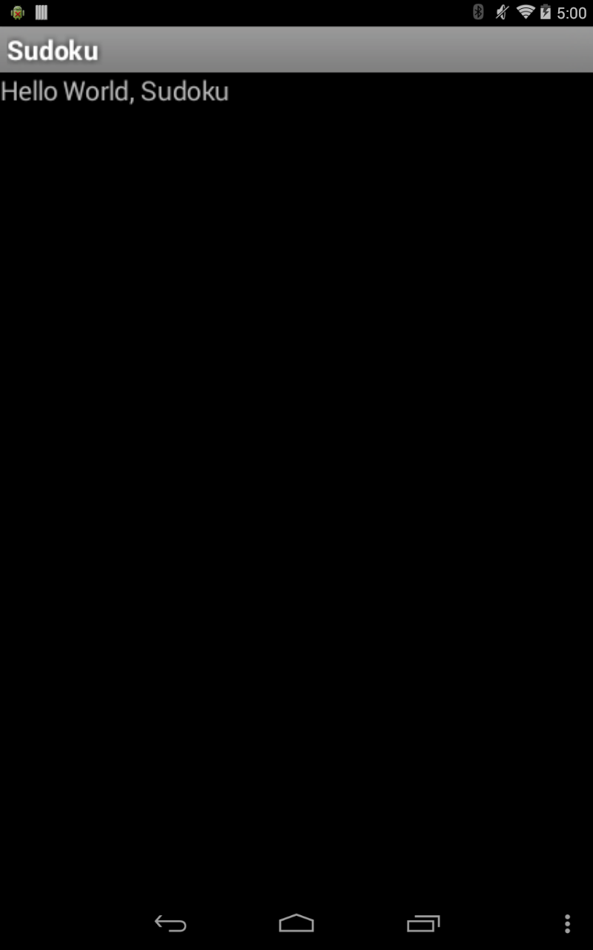

This is the first version of the Sudoku application. The main layout of the game is created. The title of the game is displayed on the title bar. Nothing is on the main layout except plain text that says “Hello World, Sudoku.”

**Sudoku1 - Version 2**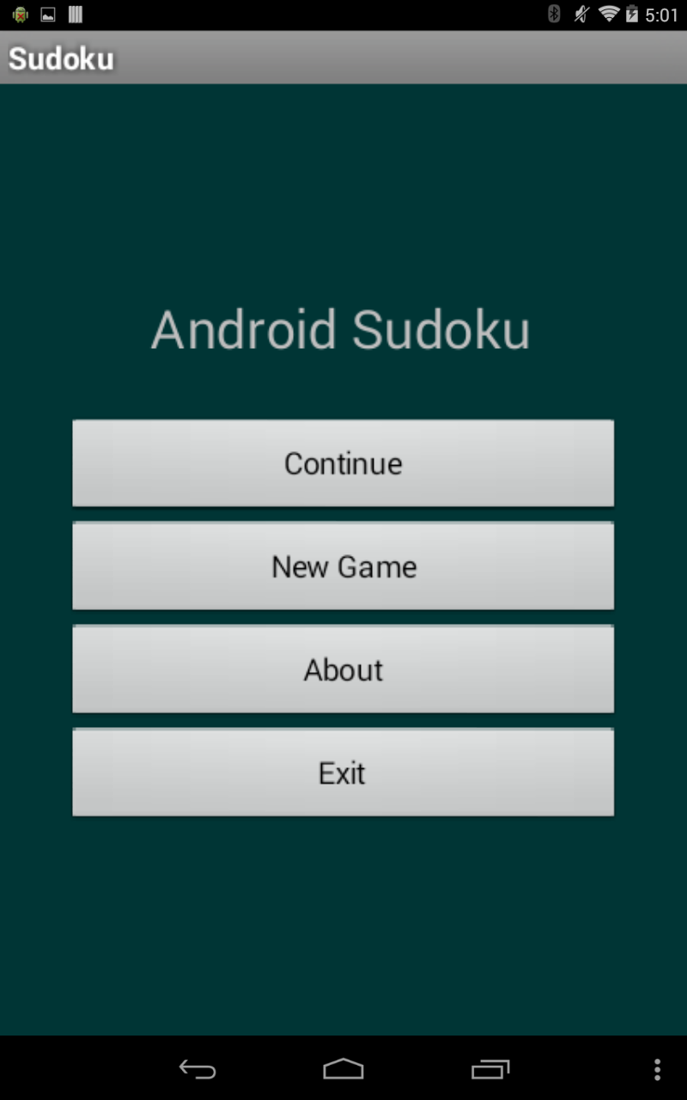

This is the second version of the Sudoku application. The main layout was changed with the addition of buttons. The continue button doesn’t do anything. However, each of the other buttons function differently.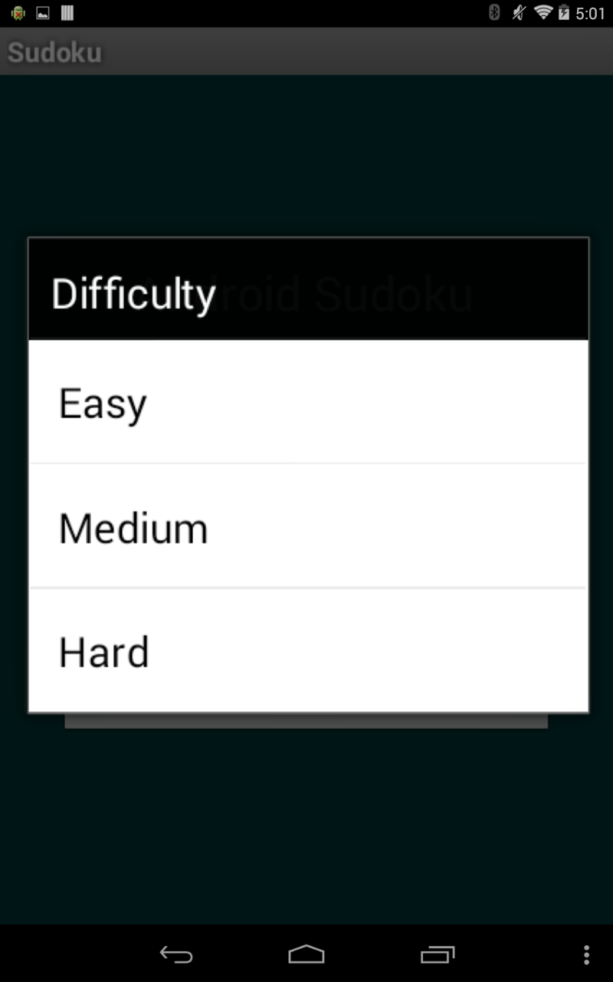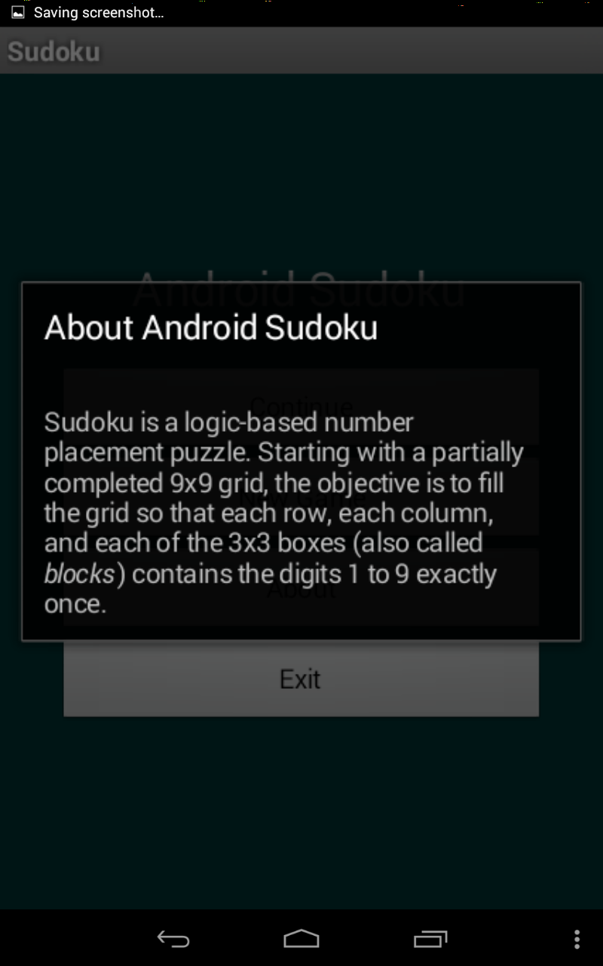

The New Game button brings up the difficulty options for an Easy, Medium, or Hard Sudoku playing board. However, each of these selections does nothing so far.

The About button brings up a small screen titled “About Android Sudoku” that gives a short description of the the application and how to play. Lastly, the Exit button simply exits out of the application.

**Sudoku2 - Version 3**

**EASY MEDIUM HARD**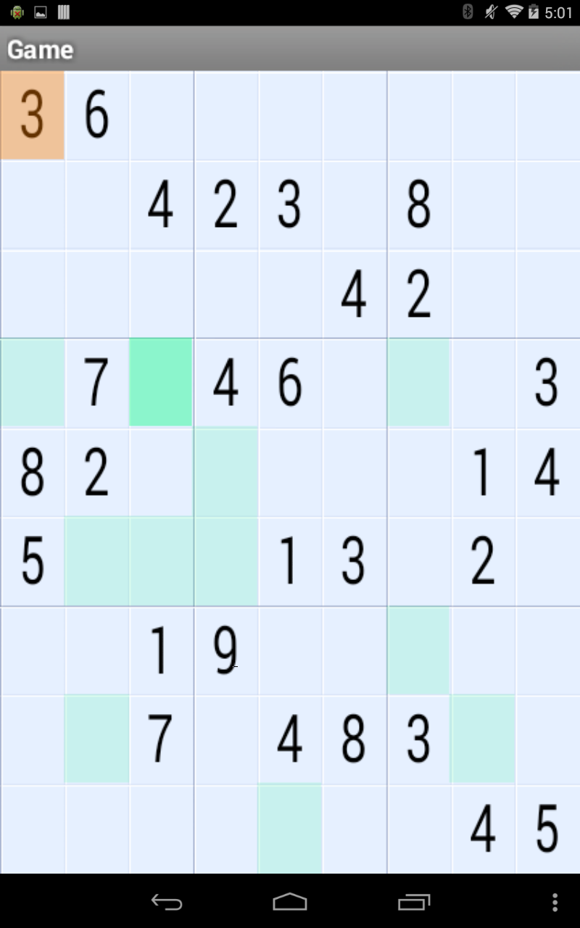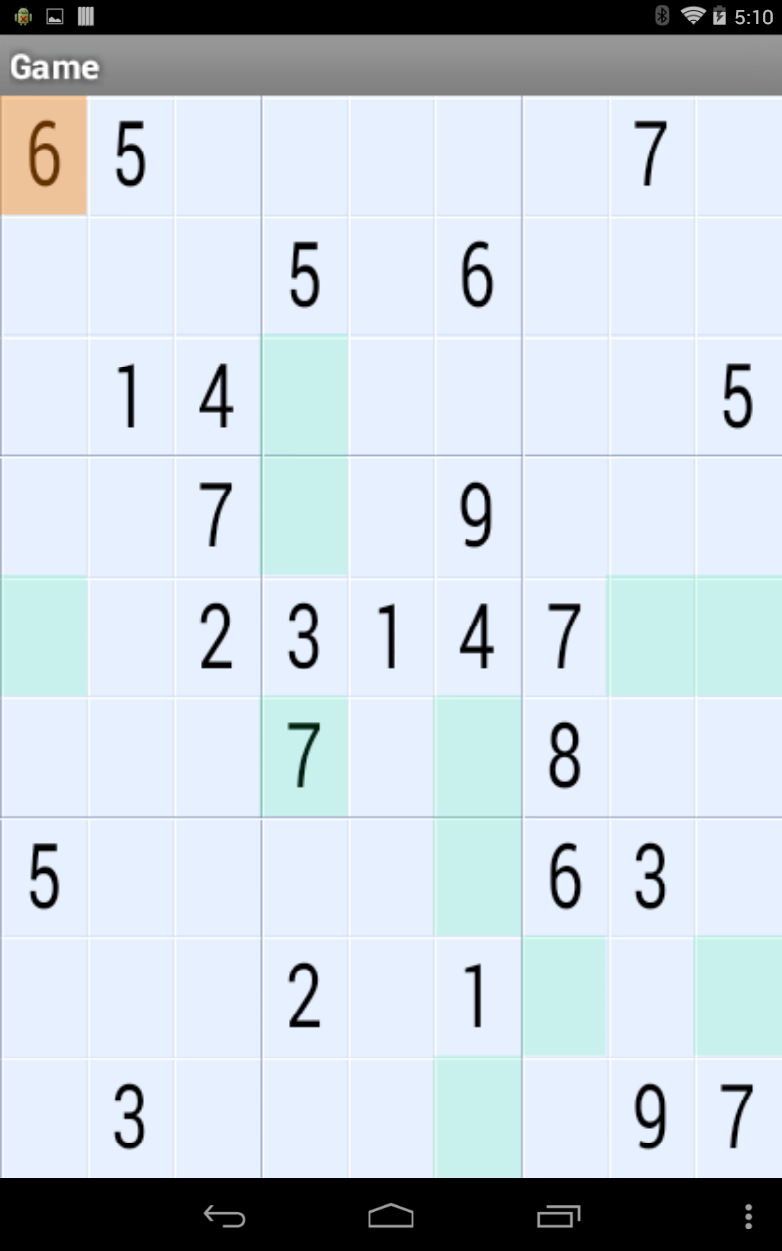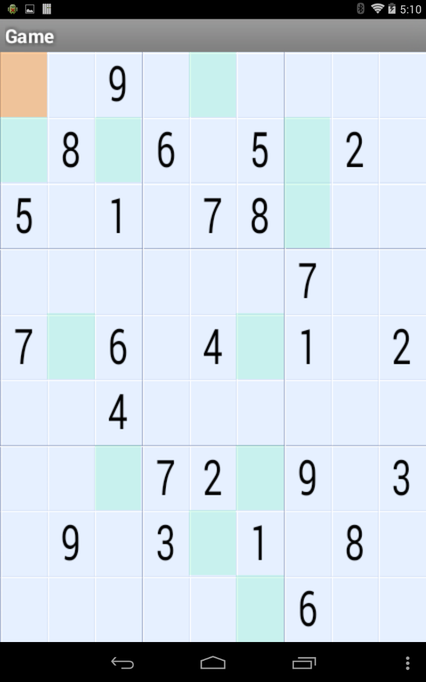

This is the third version of the Sudoku application. Game difficulties now brings up the EASY, MEDIUM, and HARD boards when either is selected.

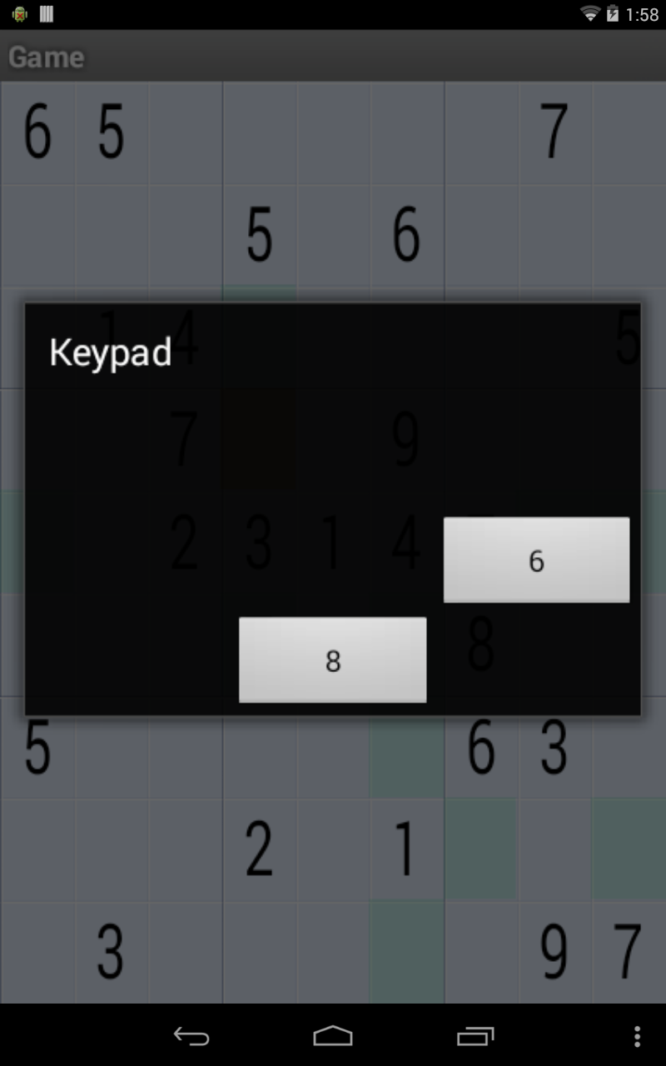

When one of the tiles is clicked, a mini-screen appears giving the available options for a number to be placed on the selected tile.

**Sudoku3 - Version 4**

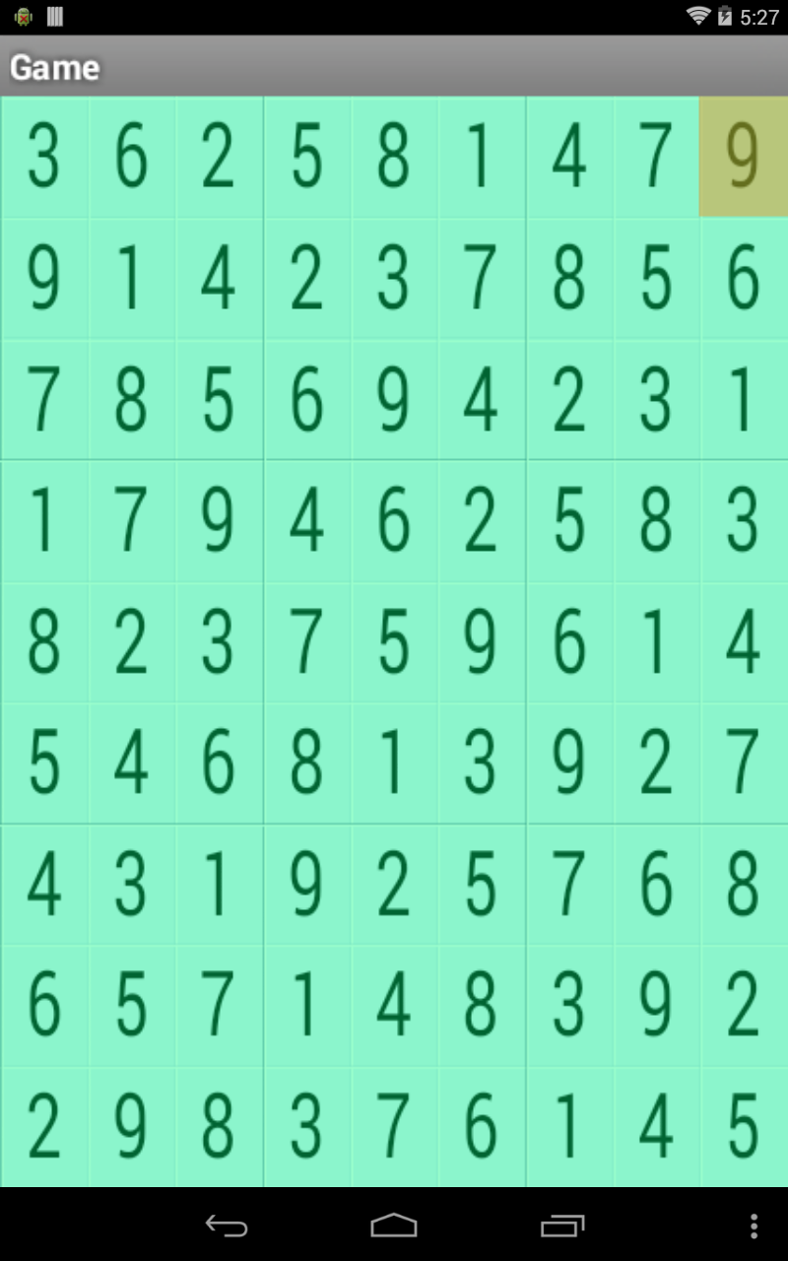

This is the fourth version of the Sudoku application. What was added-on to this version cannot be seen. Music is played when the main menu is displayed. However, when you select a game difficulty, the music changes.

**Sudoku4 - Version 5**

This is the fifth version (last version) of the Sudoku application. The Continue button has a function now. Whenever a user backs out of the game board, hitting the Continue button will resume their previous playing session. 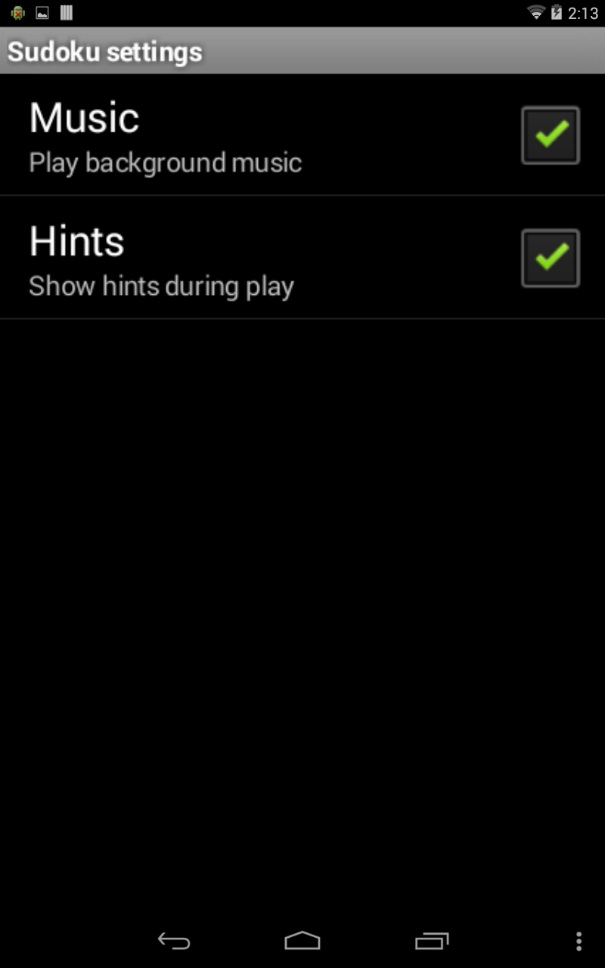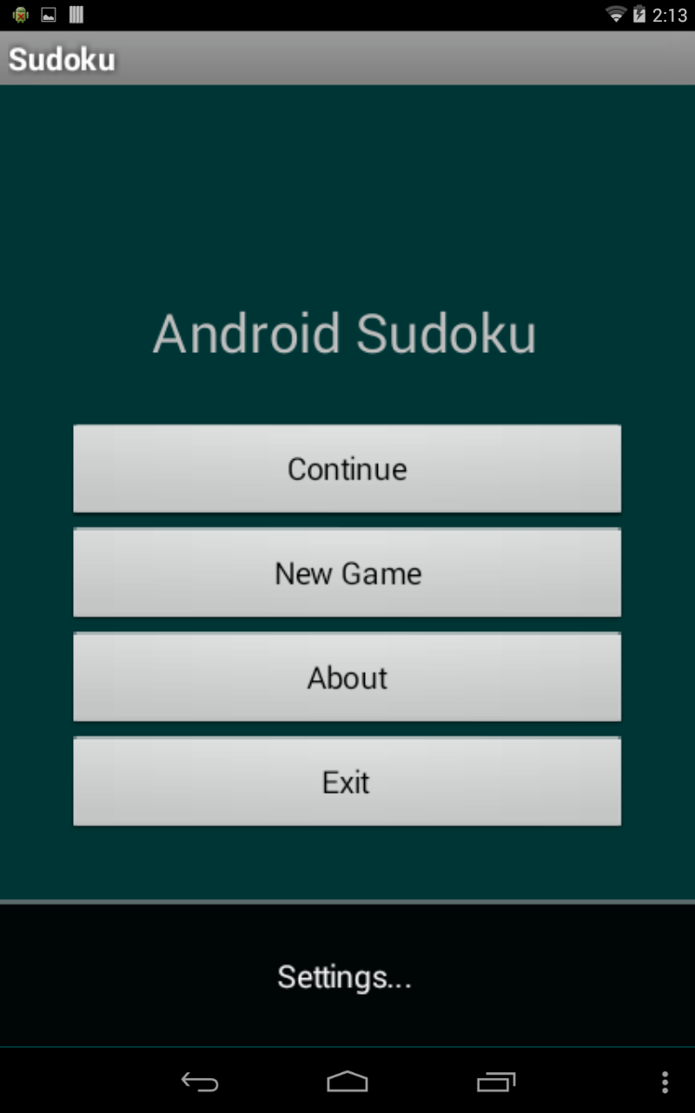

Settings were added to the application. The Settings gives options to enable/disable background music and in-game hints. In-game hints are displayed when a tile on the game board turns orange. It will turn orange at certain intervals throughout your game.