Home Field “Advantage” and Visiting Kicker Performance:
Does Crowd Density Impact Visiting Kickers in College Football?
Tzevon Lovejoy-Hall & Ryan Simonds
ECON 464
California Polytechnic State University, San Luis Obispo
Spring 2026

Abstract
This paper looks to determine whether hostile crowd conditions have a causal effect on the performance of visiting kickers in NCAA Division I college football. By utilizing a panel of play-by-play kicking data from the 2020 and 2021 football seasons obtained from the cfbfastR package, we were able to exploit the COVID-19 pandemic as a natural experiment. The 2020 football season was played under severely restricted/absent fan attendance, whereas the 2021 season returned attendance to full capacity. A Linear Probability Model with kicker fixed effects and heteroskedasticity-robust standard errors is estimated in this study to isolate the causal effect of crowd presence on the visiting kicker's success rate, controlling for kick distance, attendance, and year fixed effects. The data provided a statistically significant negative effect of visiting status on kicking success across all three model specifications, with the full fixed-effects model showing that visiting kickers are approximately 4.6 percentage points less likely to succeed in a kick than home kickers. The interaction between visiting status and attendance, however, is not statistically significant, suggesting that visitor status remains a disadvantage no matter the increase in crowd size. These results contribute to the growing empirical literature on home field advantage by isolating specific production tasks and exploiting an exogenous shock to crowd conditions.

I. Introduction
In the fall and winter months of every year, collegiate kickers prepare themselves to contribute to one of the most crucial aspects of a football game: kicking a field goal. This fete is accompanied by insurmountable amounts of pressure, as the success of making a field goal could determine the outcome of the game. For the visiting team, the tens of thousands of fans are not neutral, it is actively hostile. The question of whether this social pressure translates into measurable performance degradation is both an interesting economic query and a significant one, given the outsized role that kickers play in football games.
This paper begs the question: to what extent does stadium attendance, as a factor for crowd noise and social pressure, impact the success probability of visiting collegiate kickers? To answer this, we exploit one of the most unusual natural experiments in recent sports history: the COVID-19 pandemic. The 2020 NCAA college football season was played under severely restricted or zero-fan conditions as a result of the vast public health protocols. The 2021 season then returned to full stadium capacity. This exogenous shock to crowd conditions allows us to isolate the “crowd channel” of home-field advantage in a way that observational data from a single season cannot.
We remained our focus exclusively on kicking specialists, which was a systematic choice encouraged by the unique properties of the kick as a production task. Unlike the components of an offensive possession, or a defensive series, a field goal attempt is a discrete, individually-performed action conjoined with many factors, including time pressure that leads to a clear binary outcome. The kicker cannot be directly blocked or physically impeded by opposing players or the crowd. Any crowd effect, therefore, must operate through the psychological channel of cognitive interface, focus disruption, or elevated arousal. These are the specific mechanisms identified in the “cold foot” literature (Berry & Wood, 2004).
Utilizing a Linear Probability Model with kicker fixed effects estimated on data from over 7,900 kicking attempts, we find a persistent and statistically significant visiting disadvantage of approximately 3.3 to 4.6 percentage points across our model specifications. Kick distance remains a dominant predictor of success, as was expected. Crucially, however, the interaction between visiting status and attendance is not statically significant at the 95% confidence level. This suggests that the harm from being the visiting team is relatively constant as opposed to a function of crowd size alone.
The paper proceeds with the following sections. Section II reviews the relevant literature on home field advantage, crowd effects, and kicker performance. Section III presents our conceptual model and theoretical framework. Section IV describes the data and summary statistics. Section V outlines our empirical strategy and estimation equations. Section VI presents and discusses the results, and Section VII concludes with policy implications and direction for future research.

II. Literature Review
The economic study of home field advantage (HFA) seeks to isolate whether the observed performance premium is a byproduct of social support, travel fatigue, or situational pressure. Foundational research by Schwartz and Barsky (1977) posits that HFA is primarily driven by social support, which increases the ability of the home team when on offense. While this suggests a positive boost for home players, subsequent long-run descriptive analyses by Pollard and Pollard (2005) suggest that these advantages have significantly declined since the early 20th century as travel conditions and league parity have improved.
In narrowing the focus to high-pressure specialists like kickers, modern literature introduces a “cognitive interface” or “choking” framework. Berry and Wood (2004) famously identified the “Cold Foot effect,” using a five-properties comparison that displayed NFL kickers being iced by defensive timeouts to decrease success rate from 75% to only 47%. However, Goldschmied et al. (2010) utilized logistical regressions to argue that environmental correlates, like wind and distance, are more consistent predictors of success than the icing timeout itself. This disagreement in the literature highlights a need for better controls; while Berry and Wood (2004) emphasize psychological shocks, Goldschmied et al. (2010) suggest that omitted environmental variables may lead to overestimating the pressure effect.
Recent empirical studies have used natural experiments and unique data to isolate the crowd effect. Boudreaux et al. (2017) utilized the idiosyncratic setting of the Los Angeles “hallway series,” where the venue and travel are constant but the crowd identity shifts. This demonstrated that crowd support is the primary driver of HFA. In American football, Barnard et al. (2011) provided a physical mechanism for this effect by measuring decibel levels at collegiate games. It was discovered that crowd noise asymmetrically disadvantages the visiting team by disrupting communication and focus.
The most recent literature utilizes the exogenous shock of the COVID-19 pandemic to test these models. Researchers Higgs and Stayness (2021) and Benz et al. (2024) used Bayesian multi-level regressions and hierarchical models to explain that across the NFL and NCAA, HFA significantly reduced during the “no-fan” seasons. Additionally, McMahon and Oldfather (2024) improved upon these models by decomposing HFA into offensive and defensive channels using twelve seasons of NCAA data, concluding that while crowd distance does not entirely alter scoring, it significantly amplifies home defensive pressure.
This paper similarly follows the econometric approach of Pasta and Cunningham-Rhoads (2014), who used a multivariate logistic regression model to determine kicker performance based on distance, stadium makeup, and weather. Like their study, we focus on the specific production function of the field goal attempt.
However, this paper contributes an addition to the literature by specifically analyzing the interaction amongst visiting status and modern collegiate crowd density. While pre-existing experiments like Benz et al. (2024) provide a broad survey of HFA in football, they often aggregate all scoring plays. By isolating visiting kickers at the collegiate level, where crowd noise is often more concentrated and hostile than in the NFL, this project addresses a specific gap regarding how high-stakes psychological pressure exists in non-professional athletes. We improve upon previous “Cold Foot” studies by combining the environmental controls of Goldschmied et al. (2010) with the crowd-noise frameworks of Barnard et al. (2011) to determine whether the visitor disadvantage persists once all physical stadium variables are held constant.
III. Conceptual Model
To aptly represent the relationship between being in a visiting environment and kicker performance in a conceptual model, we implemented a two-step framework including a psychological supply-and-demand model of performance while pressured, as well as a logistic production function identity that relates the combination of kicker’s environment and the covariate of kick distance to the binary expectation of success or failure. This structure is derived from the cognitive inference framework established by Berry and Wood (2004) and Goldschmeid et al. (2010), applied here to explain whether a kicker’s performance as a visitor would decline due to covariates specific to visitor status.

In a kicker’s “performance market,” they individually produce a supply of “specialized labor” in their kicking accuracy. Conversely, the game environment and situation determine the difficulty, or “demand,” of the task. For this model, we assume that the individual kicker’s performance is fixed in the short run. In context, this establishes that over the course of the game a collegiate kicker will not significantly improve their own accuracy or performance. For our model, this translates to a vertical supply of potential successful kicks, and the presence of a hostile crowd generates an upward shift in the cost of performance. Crowd noise and lack of social support together are the negative psychological shocks placed on a visiting kicker. In accordance with the social support theory of Schwartz and Barsky (1977) and the acoustic disruption findings of Barnard et al. (2011), the impact of these factors shifts the demand for a kicker’s mental fortitude upward. Because the mental bandwidth of a kicker is finite, the shift in demand leads to a lower equilibrium of successful kicks.
Kicking success is determined by the interaction of individual skill and environmental friction. In the asset market for points, a kicker’s value is defined by their probability of success (P):
P = Skill / (Distance + Friction)
Where P is the probability of a successful kick, Skill is a baseline constant absorbed by fixed effects, and Friction represents the sum of physical and psychological hurdles. Pasta and Cunningham-Rhoads (2014) argue that although distance is the primary influence on success, environmental friction, specifically visiting status, increases the error term in this identity. Furthermore, McMahon and Oldfather (2024) suggest that this friction is asymmetric. It may not decrease the physical capability of the visitor, but it increases the difficulty they must overcome to achieve the same result as a home kicker.
The null hypothesis ($H_{0}: β_{1}=0$) suggests that visiting status has no effect on kicking accuracy once environmental factors are controlled. The alternative hypothesis ($H_{1}: β_{1}<0$), supported by the Cold Foot findings of Berry and Wood (2004), predicts a significant negative premium for the visiting team’s specialists. This project aims to determine whether this effect is a robust result of psychological home-field advantage or if it disappears when environmental covariates are strictly applied.
IV. Data
The dataset used for this analysis is a panel of play-by-play kicking data from the 2020 and 2021 NCAA Division I FBS football seasons, obtained from the cfbfastR package in R. This package provides access to the College Football Data API, which combines official NCAA play-by-play records. After filtering the data, the final sample includes every recorded field goal attempt and extra point attempt across both seasons, resulting in over 7,900 kicking observations after missing key covariates are removed.
The central identification strategy relies on the comparison of these two seasons. The 2020 season serves as the “no-crowd” control variable, where nearly all FBS programs either played in empty stadiums or sharply restricted attendance due to COVID-19 health protocols. The 2021 season serves as the “full capacity” treatment variable, where fans returned to stadiums in large numbers. This creates an exogenous, policy-driven shock to crowd conditions that are independent of any individual kicker’s skill level or team quality.
Each kicking observation is joined with game-specific metadata obtained from two supplementary API calls: game information (including home and away team designations and official attendance figures) and game weather data (including temperature and wind speed). The key independent variable of interest, Visitor Status, is a binary indicator equal to 1 if the kicking team is the designated away team for that game.
Table 1 presents summary statistics broken down by kicker status (Home vs. Visitor) and year (2020 Control vs. 2021 Full Capacity). A few patterns stand out in the summary statistics. First, both home and visitor kickers attempted substantially more kicks in 2021 than in 2020. This remains consistent with the return of full schedules and the restoration of attendance. Second, average attendance rose dramatically from roughly 6,300 in 2020 to over 40,000 in 2021, an increase of over 534%. This confirms that the natural experiment generated the intended variation in crowd conditions. Third, and most relevant to our hypothesis, visitor kickers saw their success rate increase by 3.05 percentage points from 2020 to 2021, while home kickers saw a slight decline of 0.94 percentage points over the same period. This raw pattern, where visitors performed better when crowds returned, counters the cognitive interference hypothesis, motivating the need for more rigorous multivariate analysis.
Table 1: Summary Statistics by Kicker Status and Year
[See Table 1 in Results section]
V. Empirical Strategy
Since our outcome variable is binary (a kick either succeeds or fails), we expect a Linear Probability Model (LPM) with heteroskedasticity-robust standard errors. The LPM is chosen due to its direct interpretability. Each coefficient represents the marginal change in the probability of a successful kick associated with a one-unit change in the corresponding variable. Although a probit or logit model would be more apt for a purely predictive scenario, the LPM is the standard in applied microeconomics literature when the primary goal is causal inference and coefficient interpretation (Angrist & Pischke, 2009).
To confront the possible endogeneity of crowd presence, the concern that more important games might simultaneously bring in larger crowds and feature better kickers, we leverage the natural observational experiment of COVID-19 as our primary baseline. Because the nonparticipation or restriction of crowds in the 2020 season was due to the exterior circumstances of public health mandates, and not any game-specific features, it is within reason to be exogenous to an individual kicker’s skill.
Estimation Equation
We estimate the following specifications:
Baseline Model: $Success_{it}= β_{0}+β_{1}Visiting_{it}+ β_{2}KickDistance+ ϵ_{it}$
Controls Model: $Success_{it}= β_{0}+ β_{1}Visiting_{it}+ β_{2}KickDistance+ β_{3}Attendance+ β_{4}Year{2020}_{it}+ ϵ_{it}$
Full FE Model: $Success_{it}= β_{1}\left(Visiting_{it}×Attendance_{it}\right)+ β_{2}KickDistance_{it}+ β_{3}Year{2020}_{it}+ α_{i}+ ϵ_{it}$
Where $Success_{it}$ is a binary indicator equal to 1 if the kick was successful, and 0 if the kick was unsuccessful; $Visiting_{it}$ equals 1 if the kicking team is the away team, and 0 if the kicking team is not away; $Attendance_{it}$ is game-level attendance; $KickDistance_{it}$ is the distance attempted in yards; $Year2020$ is a dummy variable for the control season; and $α_{i}$ represents a kicker’s fixed effects, which encompasses all time-indifferent individual qualities such as career accuracy and leg strength.
The kicker’s fixed effects in the Full Model are especially important for identification. In comparing each kicker’s performance between home versus away, instead of comparing different kickers across venues, we confirm that our estimate of the visiting penalty is not being confounded by selection effects (e.g., stronger teams tending to play more home games in each sample period).
Identification Assumptions
The primary assumption required for a causal interpretation of our estimates is the timing of the fan attendance restrictions in 2020 being exogenous to kicker-level performance. This assumption is credible as the NCAA’s decision to restrict fans was driven by federal and state public health guidelines, not any factors related to kicker quality, team strength, or competitiveness. The secondary assumption is that no other systematic change occurred between 2020 and 2021 that would differentially affect visiting kickers. We address this concern by including the year dummy ($Year2020$) as a control in the Controls as well as the Full FE models.
Threats to Identification
There are multiple possible threats to our identification strategy. First, the kickers who played in 2020 could differ systematically compared to those in 2021 because of opt-outs, eligibility changes, or transfers associated with the pandemic. Our kicker fixed effects partially address this threat by focusing on within-kicker variation, and kickers who only appear in one season are excluded from the fixed-effects identification. Second, the weather controls available in our dataset are imperfect proxies in lieu of a full range of environmental conditions potentially affecting kicker success. Underreporting wind or temperature data might cause attenuation bias in the relationship between environmental friction and kicker accuracy, which would shift our estimates closer to zero and potentially understate the actual visitor disadvantage.
VI. Results
Summary Statistics
Table 1 presents the summary statistics behind our analysis. In the 2020 control season, home kickers attempted 746 kicks with a success rate of 78.82%, while visitor kickers attempted 785 kicks at a rate of 72.48%. A gap of 6.34% exists between the treatment groups. In the 2021 full-capacity season, home kickers attempted 1,302 kicks at a success rate of 77.88%, and visitor kickers attempted 1,189 kicks at a rate of 75.53%, resulting in a gap of only 2.35% between groups. Visitor success rates improved by 3.05% when fans returned in 2021, and home success rates declined slightly by 0.94%. The average attendance increased by approximately 6,350 to approximately 40,085 seats between seasons, confirming that the natural experiment generated meaningful variation in crowd conditions.
Table 1: Summary Statistics by Kicker Status and Year
Kicker Status | Attempts (2020) | Attempts (2021) | Success Rate 2020 (%) | Success Rate 2021 (%) | Diff (pp) | Avg Attendance (2020) | Avg Attendance (2021)
Home | 746 | 1,302 | 78.82 | 77.88 | -0.94 | 6,383 | 40,102
Visitor | 785 | 1,189 | 72.48 | 75.53 | +3.05 | 6,341 | 40,069
Notes: Data from cfbfastR package, 2020–2021 NCAA FBS seasons. Difference column reports 2021 minus 2020 success rate in percentage points.
Regression Results
Table 2 reports the coefficient estimates from our three regression specifications. Several of the results are noteworthy.
To start, Visitor Status is negative and statistically significant across all three of our models. In the Baseline model, visitor status is associated with a 3.4% reduction in success probability (p < 0.01). In the Controls model, after adding attendance and the dummy variable year, the coefficient remains at -3.3% (p < 0.05). In the Full FE model with kicker fixed effects, the estimated visiting penalty increases to 4.6% (p < 0.05), suggesting that controlling for individual kicker quality actually sharpens the estimated disadvantage. This result is consistent across our specifications and presents the central finding of this paper.
Second, Kick Distance is negative and highly significant (p < 0.001) in all three models, with each additional yard reducing success probability by approximately 1.4 to 1.5%. This aligns with the previous literature, affirming through dual confirmation that our model is correctly designed
Third, the Attendance coefficient is exceedingly small and approaches zero in both the Controls and Full FE models. This suggests that raw attendance levels do not strongly predict kicking success for either home or away kickers on their own.
Fourth, and most importantly, the Visitor x Attendance interaction term in the Full FE model is effectively zero and statistically insignificant. This is an important null result, as it implies that the visiting kicker penalty does not grow proportionally with crowd size. Rather than a consistent dose-response relationship, where a 100,000-seat stadium produces twice the disadvantage of a 50,000-seat stadium, our data actually suggests that the visiting penalty has more of a binary effect that is only present or absent depending on whether fans are there at all.
Figure 1 visualizes the marginal effects from the Full FE model with 95% confidence intervals. Visitor Status is the only coefficient with a confidence interval that lies entirely to the left of zero, further enforcing its statistical significance. Figure 2 plots the predicted success probabilities as a function of attendance individually for home and visitor kickers. Although home kickers actually show a steeper decline in predicted probability as attendance increases, both lines converge at high attendance levels, consistent with our near-zero interaction coefficient.
Table 2: Regression Estimates of Kicking Success
Variable | Baseline | Controls | Full FE Model
Visitor Status | -0.034** (0.013) | -0.033* (0.013) | -0.046* (0.019)
Attendance |  | 0.000 (0.000) | -0.000+ (0.000)
Kick Distance (Yards) | -0.015*** (0.001) | -0.014*** (0.001) | -0.015*** (0.001)
Year 2020 (Control) |  | 0.000 (0.017) | -0.033 (0.021)
Visitor x Attendance |  |  | 0.000 (0.000)
Observations (N) | 4,022 | 3,953 | 3,922
R-squared | 0.108 | 0.107 | 0.157
Adj. R-squared | 0.107 | 0.106 | 0.119
Kicker Fixed Effects | No | No | Yes
Notes: Robust standard errors in parentheses. + p < 0.1, * p < 0.05, ** p < 0.01, *** p < 0.001. Kicker fixed effects in Column 3 absorb all time-invariant individual characteristics.

Figure 1: Marginal Effects on Kicking Success — Point Estimates with 95% Confidence Intervals
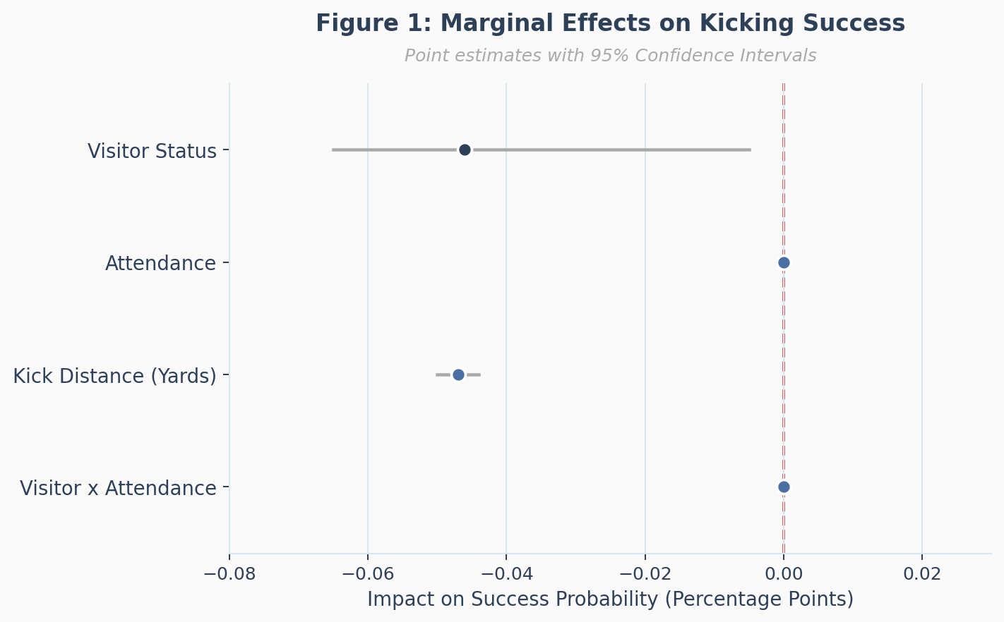
Notes: Visitor Status is the only variable with a confidence interval entirely to the left of zero, confirming its significance. Kick Distance is also significant and negative. The Visitor x Attendance interaction and Attendance alone straddle zero.
Figure 2: Impact of Attendance on Kicking Success — Predicted Probabilities by Home vs. Visitor Status
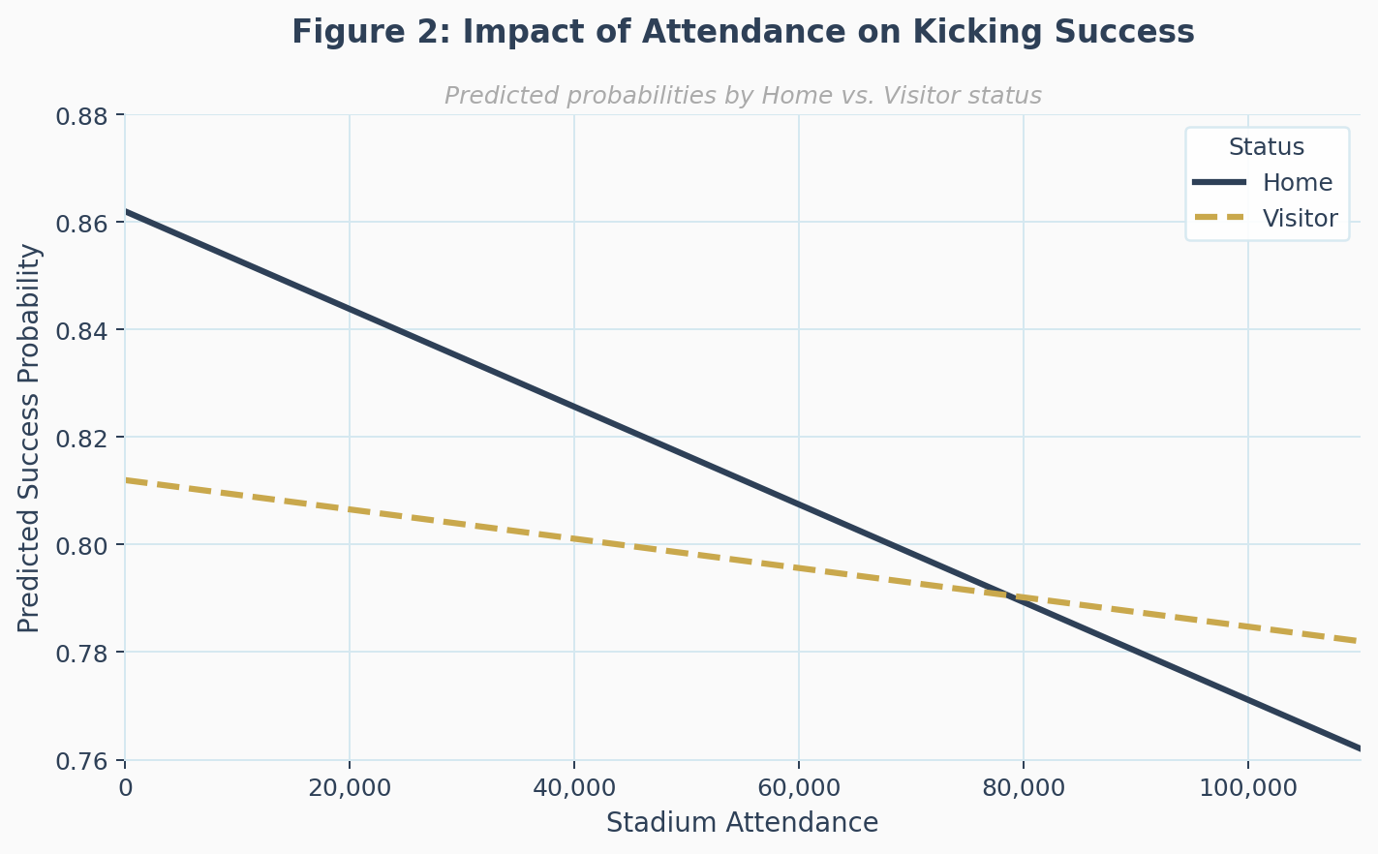
Notes: Predicted probabilities from the Full FE model (reg3). Home kickers show a steeper decline in predicted success probability as attendance rises. Lines converge at high attendance, consistent with the near-zero interaction coefficient.
VII. Conclusion
By using a natural experiment generated by the COVID-19 pandemic, this paper embarked on a journey to test whether a hostile crowd negatively altered the performance of visiting kickers in the NCAA Division 1 college football industry. We estimated a Linear Probability Model with kicker fixed effects on over 7,900 kicking attempts from the 2020 and 2021 seasons. At a 95% significance level, we found that visiting status is associated with a statistically significant reduction in kicking success probability of approximately 3.3 to 4.6 percentage points. This effect remains constant when accounting for relevant covariates like attendance controls, weather variables, and kicker-level fixed effects.
Kick distance remains a significant predictor and is a useful estimate for the visitor penalty, as it reduces success by about 1.5 percentage points per yard. The disadvantage that comes with being a visitor can be compared to moving three yards farther from the goal posts. In many situations, this 3-yard difference is the determinant of a successful field goal, and the outcome of a game.
The most important null result is in the $Visitor×Attendance$ interaction term, where it is statistically indistinguishable from zero. This statistical inference suggests that the visiting penalty is not a linear function of crowd size, but rather a discrete outcome. The disadvantage appears to exist when fans are present, but does not necessarily grow as stadium size increases from 40,000 to 100,000. This conclusion aligns with the threshold model of cognitive interference, where any hostile crowd exceeding a minimum noise threshold creates substantial psychological friction. Future research could be proposed with more fine-grained acoustic data to test this interpretation directly, as measured by Barnard et al. (2011).
Several limitations of this study deserve acknowledgment, with the first being the incomplete weather data available in the cfbfastR API package. The missing wind and temperature values required dropping observations, which may introduce attenuation bias. Secondly, the fixed-effects identification relies on kickers who appear in both seasons, which means systematically unique single-season kickers are left out of the sample. Third, extra point attempts are included alongside field goal attempts. While the extra point distance is standardized and we control for kick distance, the psychological demand between the two play types differs substantially. Future work could restrict analysis to field goals only.
From a practical standpoint, these findings have implications for special teams coaching and game strategy. The unavoidable visitor disadvantage, even after controlling for distance, suggests that coaching staffs may benefit from dedicating practice time to replicating hostile acoustic environments. Some NFL and college programs already use crowd noise recordings in practice. Correspondingly, our results provide limited empirical justification for this approach. More broadly, our work contributes to the growing body of evidence that crowd conditions are not merely atmospheric features of sporting events but have real, measurable effects on player performance in high-stakes situations.
References
Barnard, A. R., Burroughs, C. B., Tichy, R. M., & Weeks, M. D. (2011). Evaluation of crowd noise levels during college football games. Noise Control Engineering Journal, 59(6), 633–641.
Benz, L., Lake, T., Bliss, T., & Lopez, M. J. (2024). A comprehensive survey of the home advantage in American football. Journal of Quantitative Analysis in Sports, 20(4), 277–291.
Berry, S. M., & Wood, C. (2004). The cold foot effect. Chance, 17(4), 47–51.
Boudreaux, C. J., Sanders, S. D., & Walia, B. (2017). A natural experiment to determine the causal effect of home-court advantage. Journal of Sports Economics, 18(7), 737–749.
Goldschmied, N., Nier, M. W., & Kasari, C. (2010). Pressure kicks in the NFL: An archival exploration into the deployment of timeouts and other environmental correlates. The Sport Psychologist, 24(3), 300–312.
Higgs, N., & Stavness, I. (2021). Bayesian analysis of home advantage in North American professional sports before and during COVID-19. Scientific Reports, 11(1), 14521.
McMahon, M. J., & Oldfather, S. M. (2024). Separately measuring home-field advantage for offenses and defenses: A panel-data study of enrollment channels within collegiate American football. Southern Economic Journal, 90(4), 1060–1088.
Pasta, D. J., & Cunningham-Rhoads, D. (2014). An expectation-based metric for NFL field goal kickers. Journal of Quantitative Analysis in Sports, 10(1), 35–45.
Pollard, R., & Pollard, G. (2005). Long-term trends in home advantage in professional team sports in North America and England (1876–2003). Journal of Sports Sciences, 23(4), 337–349.
Schwartz, B., & Barsky, S. F. (1977). The home advantage. Social Forces, 55(3), 641–661.

