End Movie Screen

After the player beats Boss Level 3 and closes the score screen. We Load into the End Movie Screen

PART 1
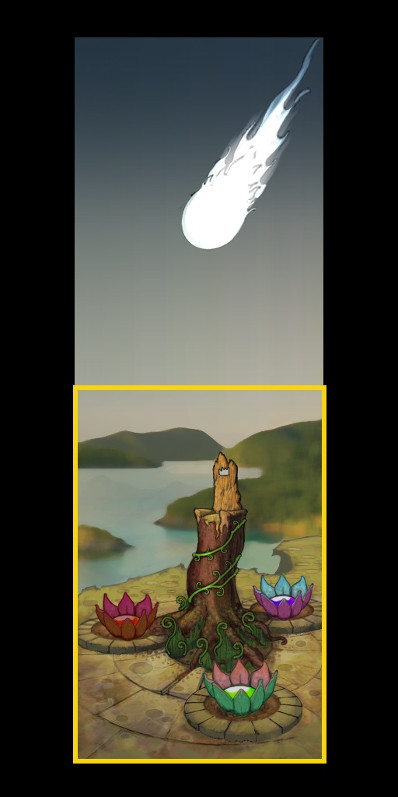
Fade in.

The first Panel shows the Vine king surrounded by
Vinelings lording over his newly revived Kingdom.

There is text at the top of the screen

“All Life has been regrown!”
“The planet belongs to the VineKing!”
“...”
“...But wait!!!!”

This will be on four lines

The player will press the Next button located in the
bottom right hand corner to move through the text
lines.

PART 2

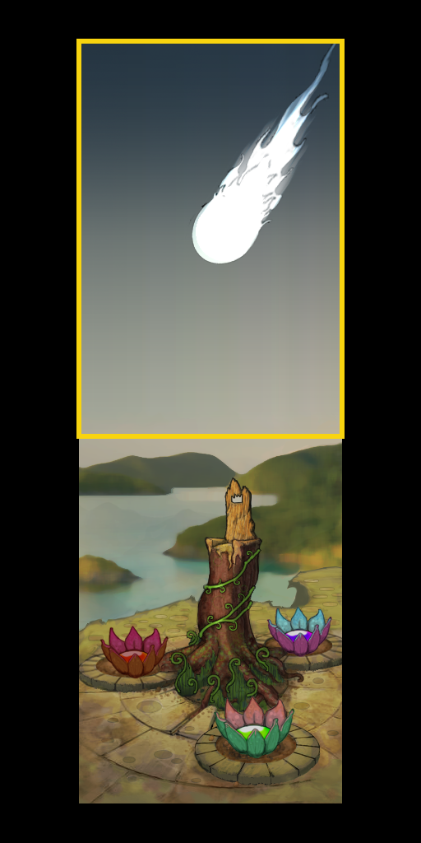
Once the player presses next three times. The text disappears and a timer starts. After 10 seconds the camera starts to pan up.

NOTE:The pan will take 10 seconds

The music fades out and BGM_Eclipse begins to play as soon as the pan starts.

The upper panel shows the sun as the moon eclipses it. (programming animation)

After the full eclipse has taken place start a timer.

After 10 seconds the screen slowly fades to black over 5 seconds as the music fades out. After the music has faded away, load the credits screen.

