In Game Tutorials

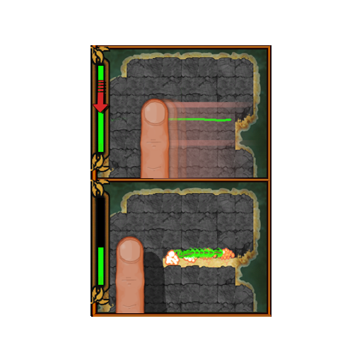
Sequence

Part 1 – The Vineking enters the scene as normal. When the Vineking finishes his entry animation and the associated sounds are done playing, pause the game and display Tutorial 01 – DRAWING A LINE. TAGLINE: “Break all Lava Rock!”

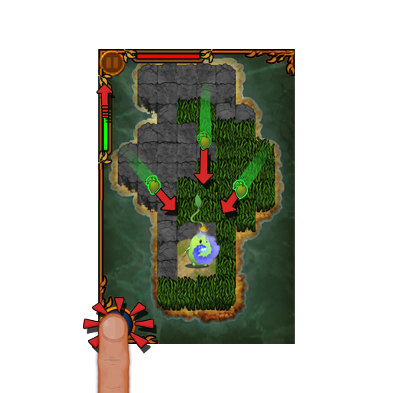
Part 2 – After the player has closed this first tutorial pane the game starts again.

Two sequences can play in the order their conditions are met.

1- Seed Tutorial:
- A Seed will appear when either of these conditions is true:
  - 1 tile has been fully grown.
  - A Monster is destroyed.
- When the Seed is displayed on screen, display Tutorial 02 – SEEDS.

2 – Monster Tutorial:

Monster sequence starts when:
EITHER
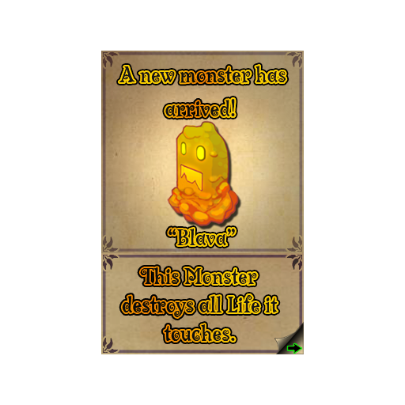
- No line is in the process of drawing
- The player has no mana left
- No seed is on the board.
OR
- No mana left
- No tile destroyed.

When either of these conditions is met, display Tutorial 03 – MONSTER INTRO.

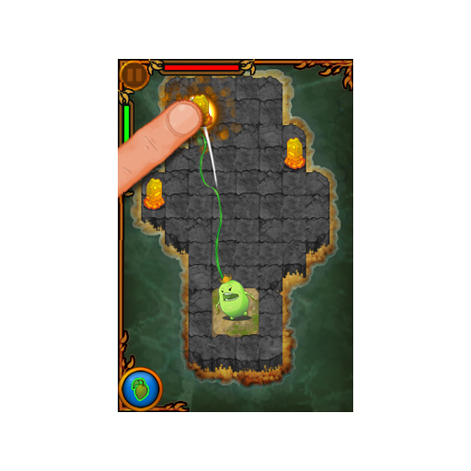

- After closing Tutorial 03 – MONSTER INTRO, immediately play Tutorial 04 – TAPPING MONSTERS.

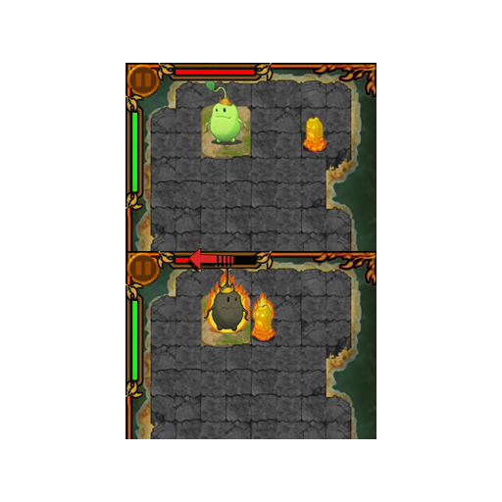
- After closing Tutorial 04 – TAPPING MONSTERS, display Tutorial 05 – HEALTH BAR -TAGLINE: “Protect the Vineking!”

Part 3 – Continue to spawn a Blava Every 3 seconds iterating through spawners b1-b4

