P02 - VineKing - RPG System

The New RPG screen!!
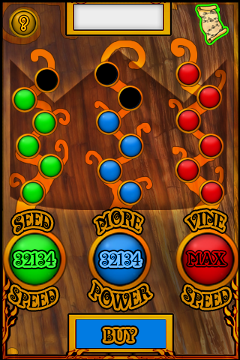

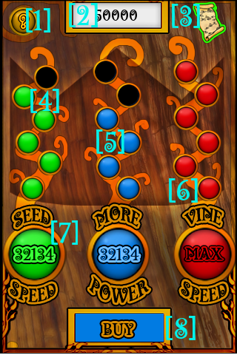
RPG SCREEN LEGEND

[1] – Help Menu
[2] – Player Bank
[3] – Return to Map
[4] – Empty Upgrade Slot
[5] – Filled Upgrade Slot
[6] – Full Tree Upgraded
[7] – Upgrade Tree Selection Button
[8] – Buy Button

HOW THE RPG SYSTEM WORKS

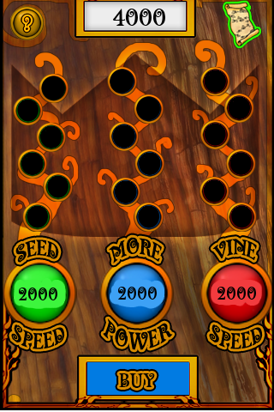
STEP 1 – Entering for the first time

When the player enters the RPG screen for the first time this is what they will see.

All of the Upgrade slots are empty.

The current cost to upgrade a tree will be displayed on each Upgrade Tree Selection Button.

The player Bank will display the players current Coins.

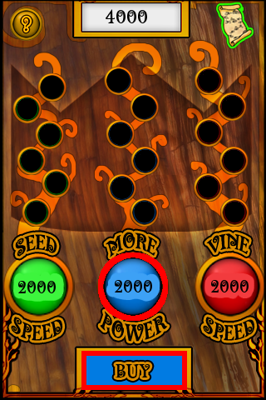
STEP 2 – Selecting an Upgrade Tree

The player selects a Tree by pressing the Upgrade Tree Selection Button.

After pressing the Upgrade Tree Selection Button it becomes highlighted.

If the player has enough Coins in their bank to purchase the upgrade the Buy Button becomes highlighted as well.

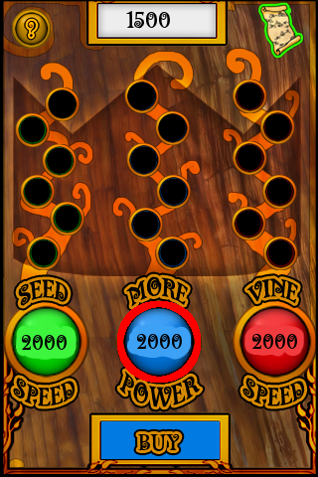

Not having enough Coin
If the player does not have enough Coins in
their bank to purchase the upgrade, the Buy
button will not highlight and will not respond
to button presses.

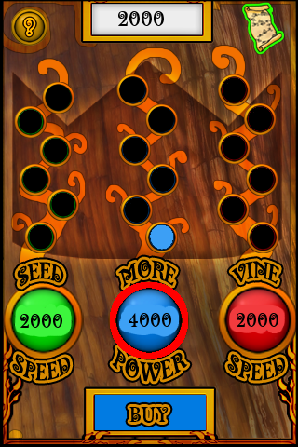
STEP 3 – Making the buy

When the buy button is highlighted the player simply presses it to purchase the selected upgrade. When the buy button is pressed a Cash Register sound is played as Coins are instantly drained from the player bank.

The player is rewarded with the appropriate Upgrade Slot being filled. Prices are adjusted to the next level after upgraded. When all upgrade slots are filled on a specific tree, the cost becomes MAX.

Level 1 – 2000 Coins
Level 2 – 4000 Coins
Level 3 – 6000 Coins
Level 4 – 8000 Coins
Level 5 – 10000 Coins
Level 6 – 15000 Coins

