Score Screen – Timer

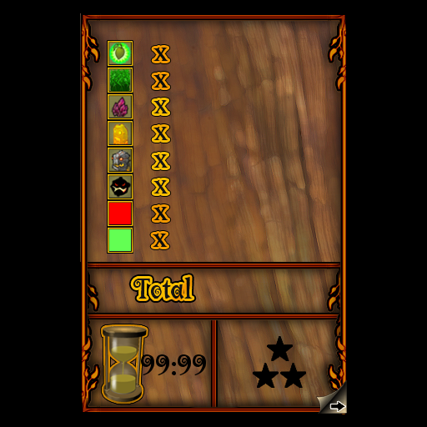
A new addition to the score screen will be the Timer. Players are given a rating based on how much time has it has taken them to complete the level. There are three possible ratings per level.

Examples of how the timer and scoring will work. (These times are arbitrary.)

Rating #1 – 3 stars – Complete the level in 1:00 or less.
Rating #2 – 2 stars – Complete the level from 1:01 to 1:30
Rating #3 – 1 star – Complete the level in 1:31 or more.

Players will be able to replay levels to try and earn a 3 star rating for each one!

Star Rating and the Sub map Menu

The star rating the player has achieved is displayed on the submap menu. These Star ratings also act as buttons to re-enter completed levels. (just like the stars work now.)
