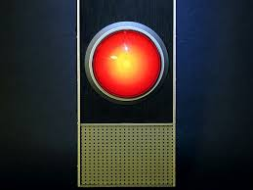Secret: Input

1. Write a program to wait for user response
2. Practice: Try writing the phrase input() into code
   1. What does it do?
   2. What happens if you try to define a variable to the input?
   3. Can you print the input?
3. Print a robot to ask you questions
   1. print What is your name?
   2. Wait for a response
   3. print How old are you?
   4. Wait for a response
   5. print Hello <name>, you are <age> years old
   6. The final print line should depend on what was responded on lines b and c
4. Hint:
   1. This is a secret problem. There are no hints.
5. Bonus (hard):
   1. You can’t be kdfsljjksdkjlsfd years old. Make sure the age is a number.