Bronze: SimpleFile.py!

1. Write a program in your W2 folder called SimpleFile.py
2. When the program runs, it should print:
   1. I am a simple file. I do simple things
3. Hint:
   1. Ask your neighbor.
   2. Ask Mr. Hillard

print(“I am a simple file. I do simple things”)

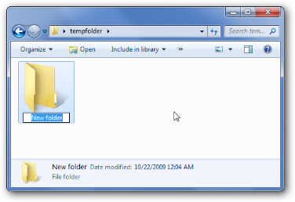Silver: SimpleProgram.py!

1. Write a program in your W2 folder called simpleFile2.py
2. When the program runs it should print
   1. I am a simple program. I do simple things
   2. I am better than my sibling, simple file, because I can write
   3. on more than one line.
   4. I think that’s pretty cool.
3. Hint:
   1. Try typing print on more than one line? Can you do it?
   2. What happens if you include \n in a print statement
   3. Make sure you can run it in the console.

Gold: hiddenFile.py

1. Make a folder inside the W2 folder called hiddenFolder
2. Inside hiddenFolder, make a file called hiddenFile.py
3. When you run hiddenFile.py, print
   1. Congratulations! You Have found the hidden file.
   2. Maybe I should have hidden it better
4. Hint:
   1. How did we run a file in the normal W2 folder? Can you do the same thing for hiddenFolder

Platinum: printInput.py

1. Make a file inside W2 folder called printInput.py
2. On the first line of printInput.py write
   1. print(input())
3. Run the File
4. What does input() do?
5. On the second line of printInput.py write
   1. print(“You just typed “ + input())
6. When you run hiddenFile.py, print
   1. Congratulations! You Have found the hidden file.
7. Hint:
   1. How did we run a file in the normal W2 folder? Can you do the same thing for hiddenFolder