Turtle Advice:

1. At the top of the program: Always have the line of code

from turtle import *

This tells the program that you are going to be using the turtle to draw picture

1. At the bottom of every program, Always have the line of code

done()

This tells the program to show the picture on the screen until you press the exit key

1. Running a turtle program is just like running any other program. Make sure to go into the correct folder inside the command line and type python <<name of File>>
2. Canvas is the blank white box that the turtle uses to draw pictures. When I say “Let’s draw a picture on the canvas” that means drawing something on the white box
3. In order to make the turtle go the line of code

forward(50)

will do that. The number 50 refers to the number of pixels the turtle will go forward

1. In order to make the turtle turn to the left or right use the line of code

left(90) or

right(90)

the number 90 refers to the number of degrees the turtle will turn.

1. If you can’t run your code Try these:
   1. Close the window that displays the Canvas
   2. Make sure you are in the correct folder (type dir and press enter, you should see the file you are trying to run)
   3. make sure the file you are trying to run is spelled correctly
   4. make sure you type python and then the file name in the command line.
   5. Make sure all parenthesis are filled out.
   6. Ask your Neightbor or Mr. Hillard

Bronze: Square.py

Goal: Write a program to draw a simple square. Save the program as square.py in your W3turtle folder.

Hint:

1. If you are having troubles. Look at the turtle advice page
2. How Many Degrees is the corner of a square?

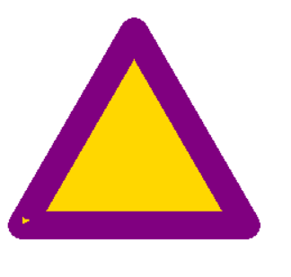Silver: Triangle.py

Goal: Write a program to draw and color in an equilateral triangle on the blank canvas. Make the outside of the triangle purple and the inside of the triangle gold. Save the program as triangle.py in your W3turtle folder.

Hint:

*from turtle import \**

*color(‘red’, ‘green’)*

*begin_fill()*

*Your Program to draw a square*

*end_fill()*

*done()*

What does this Do?

1. If you are having problems filling a shape in. Make sure the shape is closed.
2. What happens if you add the line of code

*pen(pensize = 10)*

What happens to your program?

Gold: star.py

Goal: Write a program to draw and color in a 5-pointed white star on a blue canvas. Save the Program as star.py in your W3turtle folder

Hint:

1. What happens if you type the line of code

*bgcolor(‘red’)*

and then run your program.

1. Try Drawing the 5 pointed star on a piece of paper or looking up how to draw one online. How many straight lines do you have to use? How many times do you have to turn the pen?
2. If you don’t know what angle or what length to use. You have two options:
   1. Guess and Check
   2. Math

Try Using both.

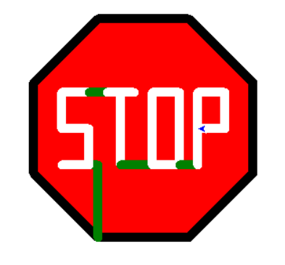Platinum: stop.py

Goal: Make a stop sign on a blank canvas. Save the stop sign as stop.py in your W3turtle folder

Hints:

1. This isn’t easy. But if you keep working, you can get it.
2. Start with a Red Octagon with a Black pen color. Then Try to imagine one letter at a time.
3. In the picture I use green Lines to draw between letters. You can use any color. Maybe Red would make this look more like a real life stop sign.
4. Making each edge 100 Pixels long and a pen size of 10 seems to work really well.