The While Loop

1. The while loop will repeat something as long as the statement is true.
   1. for example: These two Code examples will make the same square

|  |  |
| --- | --- |
| *from turtle import \**  *I = 0*  *while(I <* ***4****):*  ***forward(100)***  ***left(90)***  *I = I +1* | *from turtle import \**  ***forward(100)***  ***left(90)***  *forward(100)*  *left(90)*  *forward(100)*  *left(90)*  *forward(100)* |

Notice the Bold. This is the part that repeats.

***4*** This is how many times the loop repeats: There are 4 sides in a square. So it makes sense to loop 4 times.

I = 0 This creates a variable called I and sets the value to 0. Imagine this creates a hole in the ground and puts 0 things in it.

while(I < 4): This asks the question. Should I go into The loop. If the value of I is less than 4. Then it will not go into the loop.

I = I + 1: This increases the value of I by 1. When combining the while loop and the I = I + 1. Then the loop will only repeat four times.

bonus1: gabon.py

Goal: write a program to draw the flag of Gabon. To precise proportions

Hint:

1. The flag of Gabon has very precise colors. The green represents the forests. the yellow represents the equator. The blue represents the ocean. These can’t be imitated with ‘green’, ‘yellow’, and ‘blue’. Go online and find a website that tells you the exact color of the 3 bands of Gabon.
   1. In colors, the easiest way to name the color is called Hexadecimal. Every color has a hexadecimal code. For example. The color red has a hexadecimal value of #FF000. if I wanted to write with a color red I could use the code

*color(‘#FF000’)*

1. the Flag of Gabon was presented to the world in 1960, shortly after this west African country gained independence from the French. It have very specific dimensions. Go online and find exactly what dimensions it should be flown at.
   1. Often flag proportions will be represented as the ratio between two numbers. For example 2 : 1. This means the for every two pixels on the width, there is one pixel of height.

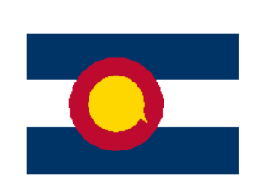bonus2: Colorado.py

Goal: Draw the Colorado State flag

Hint:

1. In order to make the circle try running a command
   1. *circle(100)*
   2. what happens?
2. Online there are official definitions of what the dimensions should be. These can be hard to follow but can also be very helpful. I’ll let you decide if you need them.
3. your code is probably going to get long for this one. If you want to mark your code without running it, just add an # at the beginning of each line

*from turtle import \**

*#this line of code is just a comment*

*done()*

1. Bonus: The cut in the Colorado state flag that makes the iconic C is difficult. See if you can make it work.
   1. Hint: you can draw a white triangle over the red circle then cover the triangle with a gold circle

Gold: star.py

Goal: Write a program to draw and color in a 5-pointed white star on a blue canvas. Save the Program as star.py in your W3turtle folder

Hint:

1. What happens if you type the line of code

*bgcolor(‘red’)*

and then run your program.

1. Try Drawing the 5 pointed star on a piece of paper or looking up how to draw one online. How many straight lines do you have to use? How many times do you have to turn the pen?
2. If you don’t know what angle or what length to use. You have two options:
   1. Guess and Check
   2. Math

Try Using both.

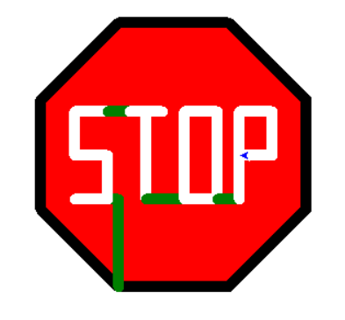Platinum: stop.py

Goal: Make a stop sign on a blank canvas. Save the stop sign as stop.py in your W3turtle folder

Hints:

1. This isn’t easy. But if you keep working, you can get it.
2. Start with a Red Octagon with a Black pen color. Then Try to imagine one letter at a time.
3. In the picture I use green Lines to draw between letters. You can use any color. Maybe Red would make this look more like a real life stop sign.
4. Making each edge 100 Pixels long and a pen size of 10 seems to work really well.