The Loop

1. The loop will repeat something multiple times
   1. for example: These two Code examples will make the same square

|  |  |
| --- | --- |
| *from turtle import \**  *for I in range(****4****):*  ***forward(100)***  ***left(90)*** | *from turtle import \**  ***forward(100)***  ***left(90)***  *forward(100)*  *left(90)*  *forward(100)*  *left(90)*  *forward(100)* |

Notice the Bold. This is the part that repeats.

***4*** This is how many times the loop repeats: There are 4 sides in a square. So it makes sense to loop 4 times.

1. Indent:
   1. The word ‘Indent’ is very important to python. AN indented word begins not at the edge of the document but a little in.

|  |
| --- |
| *for I in range(****4****):*  ***forward(100)***  ***left(90)*** |

* 1. the f*or I in range(4)* is not indented.
  2. The forward and left commands are indented.
  3. An indent is used to find out what is inside the loop.
  4. In order to make an Indent, just press TAB once.

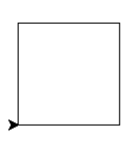Bronze SquareLoop.py

Goal: Write a program that draws a square with a loop.

Hint:

1. Look at the first page for the loop.
2. Make sure to have the colon and the indent below the loop. The indent is needed.

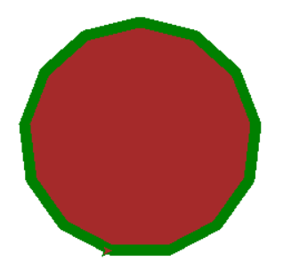Silver triskaidecagon.py

Goal: Draw a triskaidecagon with a loop. Save it as triskaidecagon.py in your week 5 folder

Hint:

1. Triskaidecagon is a shape that has 13 equal sides and 13 equal angles.
2. The same process that works for a square, also works for any sided shape. You just need to change the number of loops and the size of the angle.
3. For the angle of turn. You know that the total angle needs to be 360 degrees. Try to divide 360 by the number of angles.
4. Remember: You can change the width of the lines and if a fill happens.

*color(‘green, ‘brown)*

*pensize(10)*

*start_fill()*

*# Code goes here*

*end_fill()*

1. You can put a loop inside a fill. It just matters when the start_fill and end_fill happen.

Gold: weekFourEverything.py

Goal: Write a program that redoes the gold silver and bronze from week 3/4 in a single file. Save the file as weekFourEverything.py

Hint:

1. Go to instructions from the previous week. Use that if you don’t remember.
2. Feel free to use old code. Old code is very useful. Don’t be afraid to copy and paste
3. Any time there is repeated code. You can replace that repeated code with a while loop.

Platinum: oldGlory.py

Goal: Make the American flag in turtle. Use loops to help speed up the process. Save the file as oldGlory.py

Hints:

1. Anything you draw once, use a while loop to repeat multiple times
2. start with the stripes and then the union (blue section). It might make it easier.
3. USE LOOPS!

BONUS:

Add the stars!

