Turtle/Loop advice:

1. A While loop is a loop that works while something is true. The best way to understand a while loop is looking at example code. Here is the code for a turtle Octogon

from turtle import *

i = 0

while(i < 8):

i = i +1

forward(100)

left(45)

done()

1. If you want to repeat something multiple times. Be sure to have the i = 0 above the while loop. We will go over exactly what this means next time. In simple terms. i = 0 declares a variable called i. The while loop keeps checking if the value of i is less than 8.

Bronze: LoopSquare.py

Goal: Write a program to draw a simple square. But make sure to do it with a loop.

Hint:

1. See the program to draws an octogon on the first page? How might we change that to become a square.

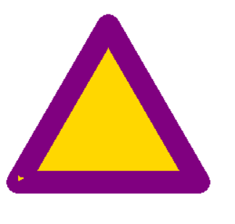Silver: Triangle.py

Goal: Write a program to draw and color in an equilateral triangle on the blank canvas. Make the outside of the triangle purple and the inside of the triangle gold. Save the program as triangle.py in your W3turtle folder.

Hint:

*from turtle import \**

*color(‘red’, ‘green’)*

*begin_fill()*

*Your Program to draw a square*

*end_fill()*

*done()*

What does this Do?

1. If you are having problems filling a shape in. Make sure the shape is closed.
2. What happens if you add the line of code

*pen(pensize = 10)*

What happens to your program?

Gold: star.py

Goal: Write a program to draw and color in a 5-pointed white star on a blue canvas. Save the Program as star.py in your W3turtle folder

Hint:

1. What happens if you type the line of code

*bgcolor(‘red’)*

and then run your program.

1. Try Drawing the 5 pointed star on a piece of paper or looking up how to draw one online. How many straight lines do you have to use? How many times do you have to turn the pen?
2. If you don’t know what angle or what length to use. You have two options:
   1. Guess and Check
   2. Math

Try Using both.

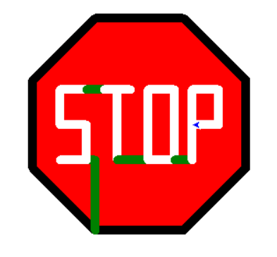Platinum: stop.py

Goal: Make a stop sign on a blank canvas. Save the stop sign as stop.py in your W3turtle folder

Hints:

1. This isn’t easy. But if you keep working, you can get it.
2. Start with a Red Octagon with a Black pen color. Then Try to imagine one letter at a time.
3. In the picture I use green Lines to draw between letters. You can use any color. Maybe Red would make this look more like a real life stop sign.
4. Making each edge 100 Pixels long and a pen size of 10 seems to work really well.