If, else, elif: Hints

1. The word ‘if’ is a conditional question. If the question is true. Then the program will do what is inside

if (5 < 6):

print(“Here”)

else:

print(“5 is greater than 6”)

* 1. This program will print ‘Here’ because 5 is less than 6

if (5 == 6):

print(“here”)

else:

print(‘we missed it’)

* 1. This program will print ‘We missed it’ because 5 is not equal to 6.

1. Boolean operators:
   1. **==** is equal to
   2. < is less than
   3. > is greater than
   4. The Boolean operators are a question. If the question is true. then it will go into the if statement.

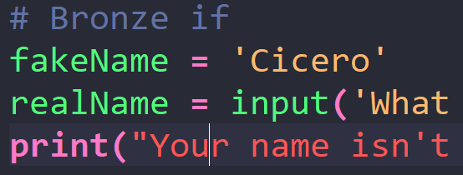Bronze: fakeName.py

Goal: Fill out the class notes questions (see below) . And save it as a fakeName.py.

# Define a variable called fakeName

# Make this variable equal to a string that is not your real name?

# Make a variable called realName

# Ask for a variable with the question, what is your real name?

# print ‘Your name isn't fakeName so I guess it's realName’

Hint:

1. If you are having problems finding variables or doing the input. Try looking at the previous word document
2. When you print use a + to connect two parts, use the plus.

*print(“Hello, My name is “ + myNameIs)*

Silver: tellMeYourName.py

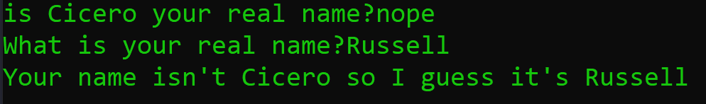Goal: Write a program that asks if <fakename is your real name. If you type yes. Then print “Hello <fakeName>” if you type no, then it should ask you what is you real name. Save it as tellMeYourName.py

**Hint:**

1. If you want to know if the input is a yes or no.

fakeName = “Russell”

nameValue = input(“Is it your real name?”)

if (nameValue == ‘yes’):

print(“hello “ + fakeName)

1. It’s a combination of printing and questions.

Gold: 5passwords.py

Goal: open the file called goldif.py. Run the file and see if you can guess 5 passwords.

Hint:

1. Try opening the file in python. Try running the file in
2. If you don’t know what something does. Try to write it in its own file and see what happens.
3. You won’t be able to run the file inside Mr.Hillard’s folder.

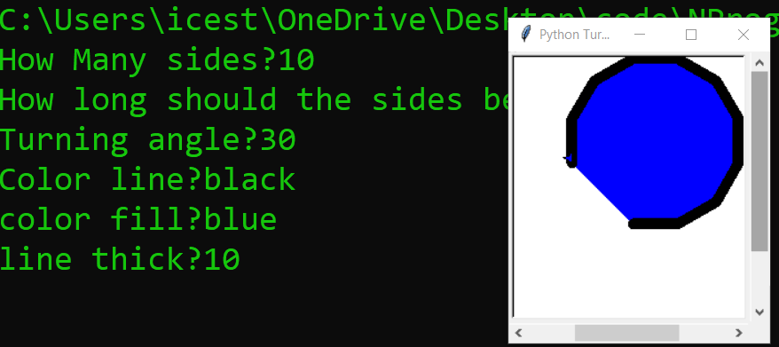Platinum: advTurtleGame.py

Goal: Make a turtle game that creates a custom shape depending on your input

Ask these Questions?

*How many sides in the shape?*

*How long should the sides be?*

*What is the turning angle?*

*What is the color of the line?*

*What is the color of the fill?*

*What is the thickness of the line?*

Hints:

1. You can use variables Just like in the previous examples. Just use more of them
2. It’s good to use a **FOR LOOP** to show how many sides there are. Don’t try to print out every one.