If, else, elif: Hints

1. A Variable is a hole in the ground. You have to name the hole and you have to put things in the hole. For example:

*myNameIs = “Russell”*

The name of the variable is, *myNameIs*

the value of the variable is “Russell”

the line of code *print(myNameIs)*

will print *Russell*

* 1. When naming a variable: Don’t use spaces! keep it one word
  2. When using variables: check the spelling!

1. There are two types of things we’ve learned **Strings** and **Integers**
   1. A **String** is any series of characters with quotation marks around it. A string is anything you could say
      1. examples
      2. “I am a string”
      3. “You’re string can have spaces”
      4. “You can even have longer strings just keep the quotation marks around the beginning and the end”
   2. An **Integer** is any number without quotation marks around it. An Integer have the value of a number
      1. Examples:
      2. 5
      3. 10
2. input(“Question here”)
   1. if you write the line of code *input(“question goes here”)* Then the program will stop and ask you the question.
   2. It’s useful to define a variable based on input.

*myNameIs = input(“What is your name?”)*

*print(myNameIs*

Bronze: myNameIs.py

Goal: Write a program that uses a variable to write the phrase “Hello my name is <<nameHere>>” Save the file as myNameIs.py

Hint:

1. Be sure to define a variable on the first line.

*myNameIs = “Russell”*

1. When you print use a + to connect two parts, use the plus.

*print(“Hello, My name is “ + myNameIs)*

BronzePlus: AskMyNameIs.py

Goal: Write a program that uses a variable to write the phrase. When you run the program is should ask for your name. “Hello my name is <<nameHere>>”

Hint:

1. When you define the variable. Make sure to put the input on the other side

*myNameIs = input(“What is your name?”)*

1. When you print use a + to connect two parts, use the plus. Just like in Bronze

*print(“Hello, My name is “ + myNameIs)*

Silver: biography.py

Goal: Write a program that print a short biography Be sure to use variables for the name, age, and school

*Hello my name Is <nameHere>*

*I am <age> years old*

*I go to <school here>*

Save the file as Biography.py

**Hint:**

1. The First and third lines is identical to the first line of Bronze.
2. Age is tricky: You can only print integers if they are string you need to put a str(…) around the variable that has an integer.

*myAgeIs = 22*

*print(“I am “ +* ***str(age)*** *+ “ years old”)*

Hint 2 is really important. Please Read it carefully.



SilverPlus: askBiography.py

Goal: Write a program to print a short biography. But this time. Make sure the command prompt asks you asks the question

**Hint:**

1. You don’t have to rewrite everything. You can reuse code. From silver

myName = input(“What is your name?”)

myAge = input(“How old are you?”)

mySchool = input(“Where do you go to school?”)

Gold: simpleTurtleGame.py

Goal: Write a program that asks you how far it should draw a line, then draws the turtle that many pixels. Save the file as **simpleTurtleGame.py**

Hint:

1. You can define a variable called distance

*distance = input(“How far should I go?”)*

1. You know how to make the turtle go forward, When using the variable distance to make the turtle go forward, You have to make sure it is an integer.

*forward(****int(distance)****)*

1. Be sure to include all the normal parts of a turtle program. The Import and the done().

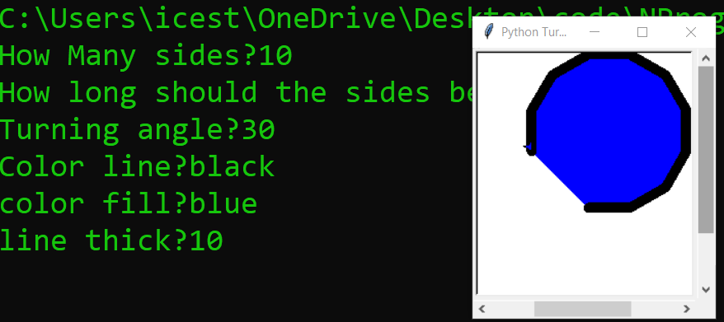

Platinum: advTurtleGame.py

Goal: Make a turtle game that creates a custom shape depending on your input

Ask these Questions?

*How many sides in the shape?*

*How long should the sides be?*

*What is the turning angle?*

*What is the color of the line?*

*What is the color of the fill?*

*What is the thickness of the line?*

Hints:

1. You can use variables Just like in the previous examples. Just use more of them
2. It’s good to use a **FOR LOOP** to show how many sides there are. Don’t try to print out every one.