TURTLE BONUS

bonus1: gabon.py

Goal: write a program to draw the flag of Gabon. To precise proportions

Hint:

1. The flag of Gabon has very precise colors. The green represents the forests. the yellow represents the equator. The blue represents the ocean. These can’t be imitated with ‘green’, ‘yellow’, and ‘blue’. Go online and find a website that tells you the exact color of the 3 bands of Gabon.
   1. In colors, the easiest way to name the color is called Hexadecimal. Every color has a hexadecimal code. For example. The color red has a hexadecimal value of #FF000. if I wanted to write with a color red I could use the code

*color(‘#FF000’)*

1. the Flag of Gabon was presented to the world in 1960, shortly after this west African country gained independence from the French. It has very specific dimensions. Go online and find exactly what dimensions it should be flown at.
   1. Often flag proportions will be represented as the ratio between two numbers. For example 2 : 1. This means the for every two pixels on the width, there is one pixel of height.

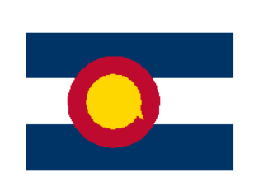bonus2: Colorado.py

Goal: Draw the Colorado State flag

Hint:

1. in order to move the cursor without making lines use the code

*penup()*

*#no ink is used here*

*pendown()*

*#ink is used again*

1. In order to make the circle try running a command
   1. *circle(100)*
   2. what happens?
2. Online there are official definitions of what the dimensions should be. These can be hard to follow but can also be very helpful. I’ll let you decide if you need them.
3. your code is probably going to get long for this one. If you want to mark your code without running it, just add an # at the beginning of each line

*from turtle import \**

*#this line of code is just a comment*

*done()*

1. 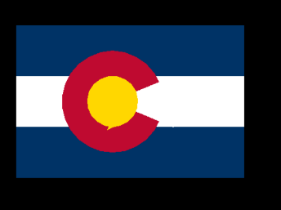Bonus: The cut in the Colorado state flag that makes the iconic C is difficult. See if you can make it work.
   1. Hint: you can draw a white triangle over the red circle then cover the triangle with a gold circle