# Lab: Lists Basics

Problems for in-class lab for the [Python Fundamentals Course @SoftUni](https://softuni.bg/trainings/3368/python-fundamentals-may-2021).   
Submit your solutions in the SoftUni judge system at <https://judge.softuni.bg/Contests/1724/Lists-Basics-Lab>.

## Strange Zoo

You are at the zoo and the **meerkats** look strange**.** You will receive **3 strings**: (tail, body, head). Your task is to **re-arrange** the elements in a list, so that the animal looks normal again: (head, body, tail).

### Example

|  |  |
| --- | --- |
| **Input** | **Output** |
| my tail  my body seems on place  my head is on the wrong end! | ['my head is on the wrong end!','my body seems on place','my tail'] |
| tail  body  head | ['head', 'body', 'tail'] |

### Hints

We start by reading the three parts of the body:

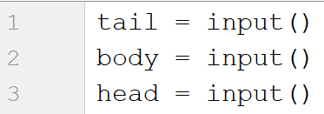

Then, we create a list containing those three elements:



We swap the elements and print the list:



tail = input()  
body = input()  
head = input()  
  
my_list = [head, body, tail]  
print(my_list)

## Courses

You will receive a single number **n**. On the next **n** lines you will receive **names** of courses. You should create a **list of courses and print it**.

### Example

|  |  |
| --- | --- |
| **Input** | **Output** |
| 2  PB Python  PF Python | ['PB Python', 'PF Python'] |
| 4  Front-End  C# Web  JS Core  Programming Fundamentals | ['Front-End', 'C# Web', 'JS Core', 'Programming Fundamentals'] |

### Hints

We read the number **n** from the console and we create an **empty list**:

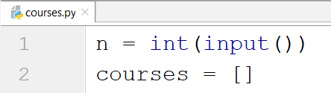

Then, we create a loop which reads each course and adds it to the list:

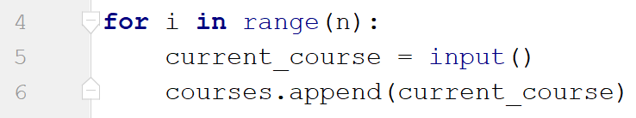

Finally, we print the list:



n = int(input())  
input_data = []  
for i in range(0, n):  
 current_input = input()  
 input_data += [current_input]  
  
print(input_data)

n = int(input())  
input_data_as_list = []  
for i in range(0, n):  
 current_input = input()  
 input_data_as_list.append(current_input)  
  
print(input_data_as_list)

## List Statistics

You will be given a number **n**. On the next **n** lines you will receive integers. You should **create** and **print** two lists:

* One with all the positives (including 0) numbers
* One with all the negatives numbers

Finally, print the following message**: "Count of positives: {count_positives}. Sum of negatives: {sum_of_negatives}"**

### Example

|  |  |
| --- | --- |
| **Input** | **Output** |
| 5  10  3  2  -15  -4 | [10, 3, 2]  [-15, -4]  Count of positives: 3. Sum of negatives: -19 |

n = int(input())  
pos_counter = 0  
neg_sum = 0  
pos_list = []  
neg_list = []  
  
for i in range(0, n):  
 input_int = int(input())  
  
 if input_int >= 0:  
 pos_counter += 1  
 pos_list.append(input_int)  
 elif input_int < 0:  
 neg_sum += input_int  
 neg_list.append(input_int)  
  
print(pos_list)  
print(neg_list)  
print(f"Count of positives: {pos_counter}. Sum of negatives: {neg_sum}")

### Hints

We start by reading the number n:

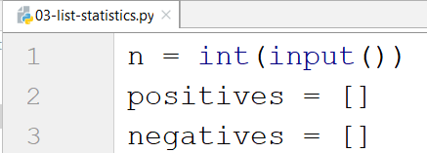

Then, we create **a loop** which reads the **current number** and checks if it **is positive or not**:

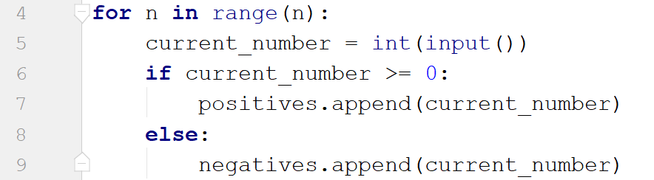

* If it is, we add it to the list of positive numbers.
* If it is not, we add it to the list of negative numbers.

Then we print the three lines:



* To get the count of the positives we can use the **len** function.
* To get the sum of the negatives we can use the **sum** function.

## Search

You will receive a number **n** and a **word**. On the next **n lines** you will be given some **strings**. You should **add** them in a **list and print** them. After that you should **filter out** only the strings that **include** the given **word** and **print** that list too.

### Example

|  |  |
| --- | --- |
| **Input** | **Output** |
| 3  SoftUni  I study at SoftUni  I walk to work  I learn Python at SoftUni | ['I study at SoftUni', 'I walk to work', 'I learn Python at SoftUni']  ['I study at SoftUni', 'I learn Python at SoftUni'] |
| 4  tomatoes  I love tomatoes  I can eat tomatoes forever  I don't like apples  Yesterday I ate two tomatoes | ['I love tomatoes', 'I can eat tomatoes forever', "I don't like apples", 'Yesterday I ate two tomatoes']  ['I love tomatoes', 'I can eat tomatoes forever', 'Yesterday I ate two tomatoes'] |

### Hints

We start by reading the number n and the word we would search for. Then, we create our empty list:

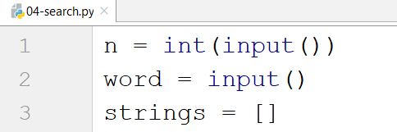

We create a loop which adds all the strings in our list. After that, we print it:

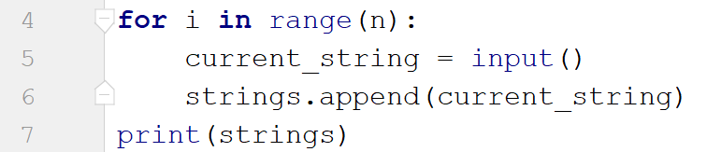

Finally, we create another loop to remove the strings we do not need by iterating through the strings reversed (so we don't skip elements when removing) and print the list again:

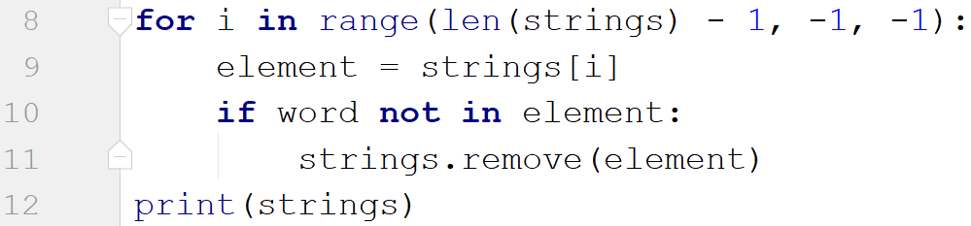

n = int(input())  
search_word = input()  
sentence_list = []  
  
for i in range(0, n):  
 sentence = input()  
 sentence_list.append(sentence)  
print(sentence_list)  
  
for i in range(len(sentence_list)-1, -1, -1):  
 element = sentence_list[i]  
 if search_word not in element:  
 sentence_list.remove(element)  
print(sentence_list)

n = int(input())  
search_word = input()  
my_list = []  
filtered_list = []  
  
for i in range(0, n):  
 input_sentence = input()  
 my_list.append(input_sentence)  
print(my_list)  
  
for element in my_list:  
 if search_word in element:  
 filtered_list.append(element)  
print(filtered_list)

n = int(input())  
search_word = input()  
my_list = []  
  
for i in range(0, n):  
 input_sentence = input()  
 my_list.append(input_sentence)  
print(my_list)  
# below is an example of using a comprehension list  
filtered_list = [i for i in my_list if search_word in i]  
print(filtered_list)

## Numbers Filter

You will receive a single number **n**. On the next **n** lines you will receive integers. After that you will be given one of the following commands:

* even
* odd
* negative
* positive

Filter all the numbers that fit in the category (0 counts as a positive and even). Finally, print the result.

### Example

|  |  |
| --- | --- |
| **Input** | **Output** |
| 5  33  19  -2  18  998  even | [-2, 18, 998] |
| 3  111  -4  0  negative | [-4] |

### Hints

First, we read the number n, then, we create the numbers list and the filtered list:

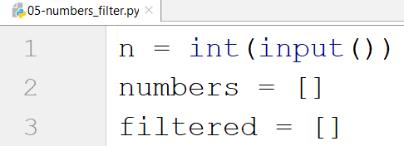

We create a loop which reads all the numbers and adds them to the list:

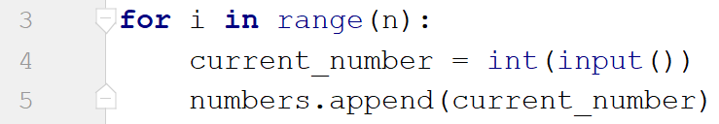

Then, we read the command and check for all the cases:

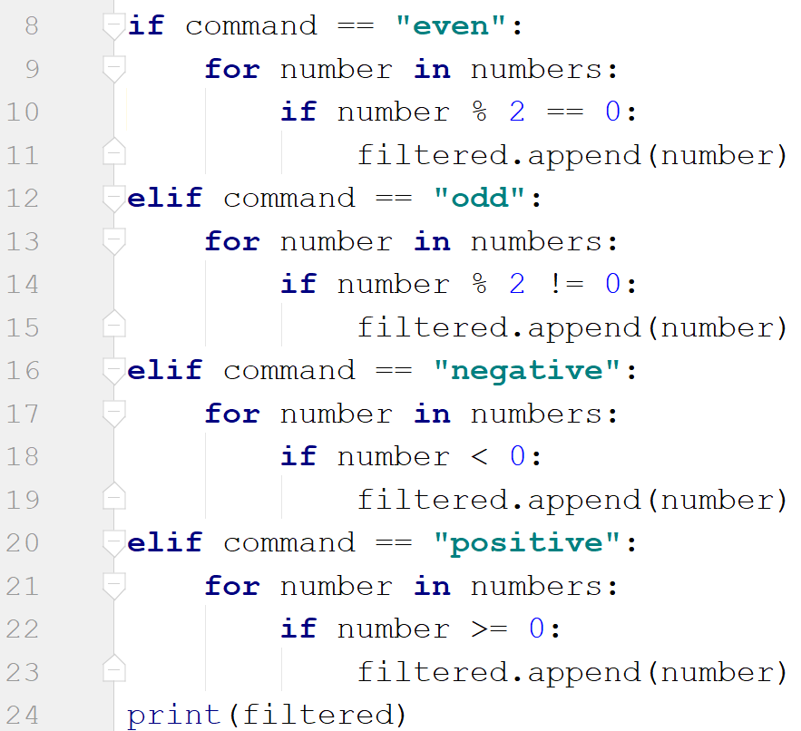

* Finally, we print the filtered list.

n = int(input())  
numbers_list = []  
filtered_list = []  
  
for i in range(n):  
 current_number = int(input())  
 numbers_list.append(current_number)  
  
command = input()  
  
if command == 'even':  
 for number in numbers_list:  
 if number % 2 == 0:  
 filtered_list.append(number)  
elif command == 'odd':  
 for number in numbers_list:  
 if number % 2 != 0:  
 filtered_list.append(number)  
elif command == 'negative':  
 for number in numbers_list:  
 if number < 0:  
 filtered_list.append(number)  
elif command == 'positive':  
 for number in numbers_list:  
 if number >= 0:  
 filtered_list.append(number)  
  
print(filtered_list)

Another solution:

n = int(input())  
  
current_number = 0  
even_nums = []  
odd_nums = []  
positive_nums = []  
negative_nums = []  
  
for i in range(n):  
 current_number = int(input())  
  
 if current_number % 2 == 0:  
 even_nums.append(current_number)  
 if current_number % 2 != 0:  
 odd_nums.append(current_number)  
 if current_number < 0:  
 negative_nums.append(current_number)  
 if current_number >= 0:  
 positive_nums.append(current_number)  
  
command = input()  
  
if command == 'even':  
 print(even_nums)  
elif command == 'odd':  
 print(odd_nums)  
elif command == 'positive':  
 print(positive_nums)  
elif command == 'negative':  
 print(negative_nums)

Additional task -----

