# More Exercises: Data Types and Variables

Additional exercises for the [Python Fundamentals Course @SoftUni](https://softuni.bg/trainings/3368/python-fundamentals-may-2021).

Submit your solutions in the SoftUni judge system at <https://judge.softuni.bg/Contests/1723>.

***Note: All the exercises are excluded from your homework!***

1. **Exchange Integers**

Read two integer numbers and after that **exchange their values**. Print the variable values before and after the exchange, as shown below:

**Examples**

|  |  |
| --- | --- |
| **Input** | **Output** |
| 5  10 | Before:  a = 5  b = 10  After:  a = 10  b = 5 |

**Hints**

You may use a **temporary variable** to remember the old value of **a**, then assign the value of **b** to **a**, then assign the value of the temporary variable to **b**.

a = old_a = input()  
b = old_b = input()  
  
print(f"Before:")  
print(f"a = {a}")  
print(f"b = {b}")  
a = old_b  
b = old_a  
print(f"After:")  
print(f"a = {a}")  
print(f"b = {b}")

## Prime Number Checker

Write a program to check if a number is **prime**. A prime number is a natural number greater than 1 that is not a product of two smaller natural numbers. For example, the only ways of writing 5 as a product, 1 × 5 or 5 × 1, involve 5 itself.The **input** comes as an integer number.

The **output** should be **True** if the number is prime and **False** otherwise.

num = int(input())  
prime = True  
  
if num > 1:  
 for i in range(2, num):  
 if (num % i) == 0:  
 prime = False  
 break

print(prime)

**Examples**

|  |  |  |  |  |  |  |  |
| --- | --- | --- | --- | --- | --- | --- | --- |
| **Input** | **Output** |  | **Input** | **Output** |  | **Input** | **Output** |
| 7 | True |  | 8 | False | 81 | False |

## Decrypting Messages

On the **first line**, you will receive a **key** (**integer**). On the **second line**, you will receive **n** – the number of **lines**, which will **follow**.On the next **n lines** – you will receive a **lower** and an **uppercase** letter per line.

You should **add the key** to **each of the characters** and append them to a **message**. At the end **print the** **decrypted message**.

key_integer = int(input())  
number_of_lines = int(input())  
message = ""  
  
for i in range(0, number_of_lines):  
 encrypted_letter = input()  
 decrypted_letter = ord(encrypted_letter) + key_integer  
 message += chr(decrypted_letter)  
  
print(message)

### Examples

|  |  |  |  |  |
| --- | --- | --- | --- | --- |
| **Input** | **Output** |  | **Input** | **Output** |
| **3**  **7**  P  l  c  q  R  k  f | SoftUni |  | **1**  **7**  C  d  b  q  x  o  s | Decrypt |

## Balanced Brackets

On the **first line**, you will receive **n** – the number of lines, which will follow. On the next **n** lines, you will receive **one** of the following:

* Opening bracket – “(“,
* Closing bracket – “)” or
* **Random string**

Your task is to find out if the **brackets** are **balanced**. That means after every **closing** bracket should follow an **opening** one. Nested parentheses are **not valid**, and if **two** **consecutive opening brackets** exist, the expression should be marked as **unbalanced**. You should print “BALANCED”, if the parentheses are balanced and “UNBALANCED” otherwise.

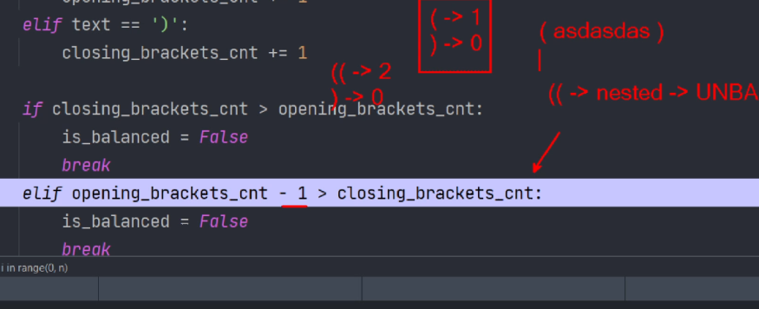

### Examples

|  |  |  |  |  |
| --- | --- | --- | --- | --- |
| **Input** | **Output** |  | **Input** | **Output** |
| **8**  (  5 + 10  (  * 2 +  )  5  )  -12 | BALANCED |  | **6**  12 *  )  10 + 2 -  (  5 + 10  ) | UNBALANCED |

number_of_lines = int(input())  
opening_brackets_count = 0  
closing_brackets_count = 0  
is_balanced = True  
  
for i in range(1, number_of_lines + 1):  
 line_string = input()  
 if line_string == "(":  
 opening_brackets_count += 1  
 elif line_string == ")":  
 closing_brackets_count += 1  
 if closing_brackets_count > opening_brackets_count:  
 is_balanced = False  
 break  
 elif opening_brackets_count - 1 > closing_brackets_count:  
 is_balanced = False  
 break  
  
if opening_brackets_count == closing_brackets_count:  
 is_balanced = True  
else:  
 is_balanced = False  
  
if is_balanced:  
 print("BALANCED")  
else:  
 print("UNBALANCED")

number_of_lines = int(input())  
opening_brackets_count = 0  
closing_brackets_count = 0  
  
for i in range(1, number_of_lines + 1):  
 line = input()  
 open_bracket= "("  
 closing_bracket = ")"  
 if line.__contains__(open_bracket):  
 opening_brackets_count += 1  
 if line.__contains__(closing_bracket):  
 closing_brackets_count += 1  
 if opening_brackets_count - closing_brackets_count != 0:  
 break  
  
if opening_brackets_count == closing_brackets_count:  
 print("BALANCED")  
else:  
 print("UNBALANCED")