# Lab: Functions

Problems for in-class lab for the [Python Fundamentals Course @SoftUni](https://softuni.bg/trainings/3368/python-fundamentals-may-2021).

Submit your solutions in the SoftUni judge system at <https://judge.softuni.bg/Contests/1727>.

## Grades

Write a function which **receives a grade** between **2.00** and **6.00** and **prints the corresponding grade in words**.

* 2.00 – 2.99 - "Fail"
* 3.00 – 3.49 - "Poor"
* 3.50 – 4.49 - "Good"
* 4.50 – 5.49 - "Very Good"
* 5.50 – 6.00 - "Excellent"

grade_data = float(input())  
  
def solve_func(grade):  
 if grade >= 2.00 and grade <= 2.99:  
 return 'Fail'  
 elif grade >= 3.00 and grade <= 3.49:  
 return 'Poor'  
 elif grade >= 3.50 and grade <= 4.49:  
 return 'Good'  
 elif grade >= 4.50 and grade <= 5.49:  
 return 'Very good'  
 elif 5.50 <= grade <= 6.00:  
 return 'Excellent'  
  
print(solve_func(grade_data))

### Examples

|  |  |
| --- | --- |
| **Input** | **Output** |
| 3.33 | Poor |
| 4.50 | Very Good |
| 2.99 | Fail |

### Hints

* Read the grade from the console:



* Then, create a function and make an if statements for each case:

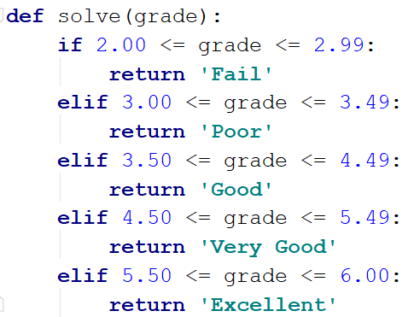

* Pass the input grade to the function:



## Calculations

Create a function which **receives** three parameters, **calculates** a result depending on the given operator and **returns** it. Print the result of the function.

The input comes as three parameters – an operator as a string and two integer numbers. The operator can be one of the following: '**multiply**', '**divide**', '**add**', '**subtract**'.

input_operator = input()  
first_num = int(input())  
second_num = int(input())  
  
def solve_func(a, b, operator):  
 result = None  
 if operator == 'multiply':  
 result = a * b  
 elif operator == 'divide':  
 result = int(a / b)  
 elif operator == 'subtract':  
 result = a - b  
 elif operator == 'add':  
 result = a + b  
 return result  
print(solve_func(first_num, second_num, input_operator))

### Example

|  |  |
| --- | --- |
| **Input** | **Output** |
| subtract  5  4 | 1 |
| divide  8  4 | 2 |

### Hints

* Read the input data from the console:

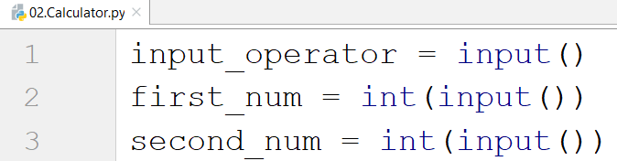

* Then, create the function and make an if statements for each case:

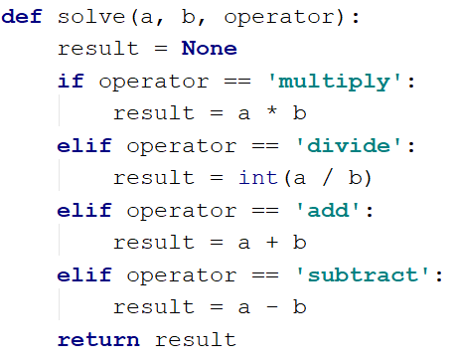

* Print the result by calling the function and passing the given parameters.

1. **Repeat String**

Write a function which receives a **string** and a **counter** **n**. The function should **return** a new string – the result of repeating the old string **n** times. Print the result of the function. Try using **lambda**.

string = input()  
n = int(input())  
  
repeat_str = lambda a, b: a * b  
result = repeat_str(string, n)  
  
print(result)

def repeat_str(string, n):  
 repeated_string = string * n  
 return repeated_string  
  
str = input()  
factor = int(input())  
  
print(repeat_str(str, factor))

**Examples**

|  |  |
| --- | --- |
| **Input** | **Output** |
| abc  3 | abcabcabc |
| String  2 | StringString |

**Hints**

1. Read the input data:



1. Create the function:



1. Print the result:



1. **Orders**

Write a function which **calculates** the **total** **price** of an order and **returns** it. The function should receive one of the following products: "**coffee", "coke", "water" or "snacks"**, and a **quantity** of the product. The **prices** for a single piece of each product are:

* coffee - 1.50
* water - 1.00
* coke - 1.40
* snacks - 2.00

Print the result **formatted** to the **second** **decimal** **place**.

def price_func(product, qty):  
 cost = 0  
 if product == 'coffee':  
 cost = 1.50 * qty  
 elif product == 'water':  
 cost = 1.00 * qty  
 elif product == 'coke':  
 cost = 1.40 * qty  
 elif product == 'snacks':  
 cost = 2.00 * qty  
 return cost  
  
my_product = input()  
my_qty = int(input())  
  
total_cost = price_func(my_product, my_qty)  
print(f"{total_cost:.2f}")

**Example**

|  |  |
| --- | --- |
| **Input** | **Output** |
| water  5 | 5.00 |
| coffee  2 | 3.00 |

## Calculate Rectangle Area

Create a function which **calculates** and **returns** the **area of a rectangle** by given **width** and **height**. **Print the result** on the console.

### Examples

|  |  |
| --- | --- |
| **Input** | **Output** |
| 3  4 | 12 |
| 6  2 | 12 |

def area_func(a,b):  
 area = a * b  
 return area  
  
side_a = int(input())  
side_b = int(input())  
  
print(area_func(side_a, side_b))