### 

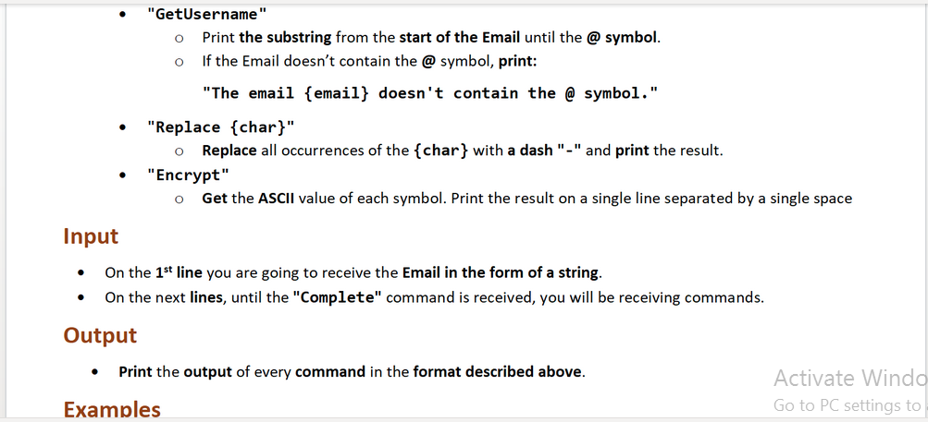

### Input

* The **possible** commands are:
  + **"Complete"**
  + **"Make Upper"**
  + **"Make Lower"**
  + **"GetDomain {count}"**
  + **"GetUsername"**
  + **"Replace {char}"**
  + "**Encrypt"**

### Output

* The **possible** outputs are:
  + **"The email {email} doesn't contain the @ symbol."**

### Examples

|  |  |
| --- | --- |
| **Input** | **Output** |
| Mike123@somemail.com  Make Upper  GetDomain 3  GetUsername  Encrypt  Complete | MIKE123@SOMEMAIL.COM  COM  MIKE123  77 73 75 69 49 50 51 64 83 79 77 69 77 65 73 76 46 67 79 77 |
| **Input** | **Output** |
| AnotherMail.com  Make Lower  GetUsername  Replace a  Complete | anothermail.com  The email anothermail.com doesn't contain the @ symbol.  -notherm-il.com |

### JS Input / Output

The input will be provided as an array of strings.

|  |  |
| --- | --- |
| **Input** | **Output** |
| (["Mike123@somemail.com",  "Make Upper",  "GetDomain 3",  "GetUsername",  "Encrypt",  "Complete"]) | MIKE123@SOMEMAIL.COM  COM  MIKE123  77 73 75 69 49 50 51 64 83 79 77 69 77 65 73 76 46 67 79 77 |
| **Input** | **Output** |
| (["AnotherMail.com",  "Make Lower",  "GetUsername",  "Replace a",  "Complete"]) | anothermail.com  The email anothermail.com doesn't contain the @ symbol.  -notherm-il.com |