## 

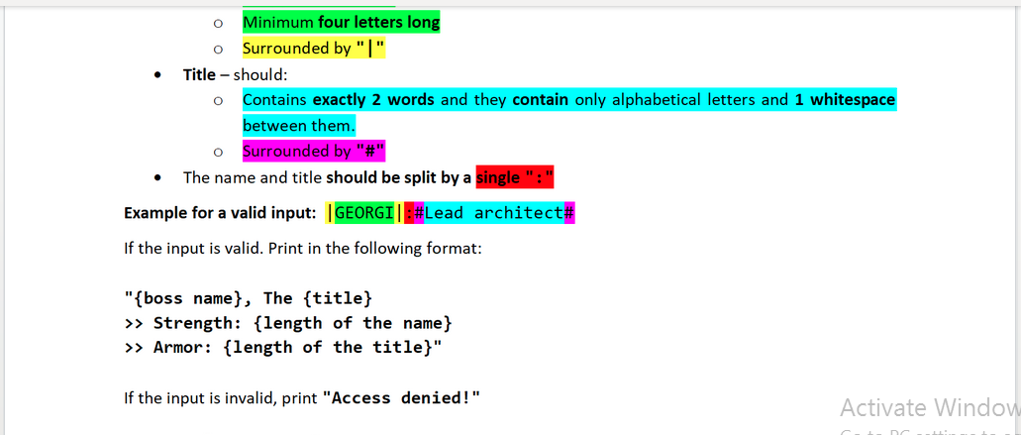

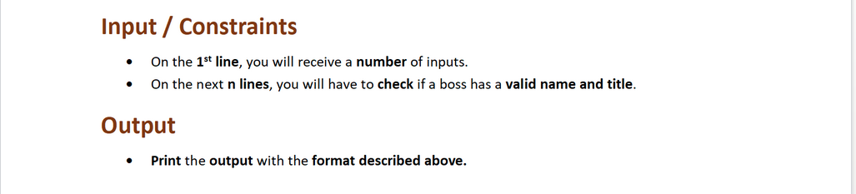

## Input

**Example for a valid input:**

|GEORGI|:#Lead architect#

## Output

* The **possible** outputs are:
  + **{boss name}, The {title}**

**>> Strength: {length of the name}**

**>> Armor: {length of the title}**

* + **Access denied!**

## Examples

|  |  |
| --- | --- |
| **Input** | **Output** |
| 3  |PETER|:#Lead architect#  |GEORGE|:#High Overseer#  |ALEX|:#Assistant Game Developer# | PETER, The Lead architect  >> Strength: 5  >> Armor: 14  GEORGE, The High Overseer  >> Strength: 6  >> Armor: 13  Access denied! |
| **Input** | **Output** |
| 3  |STEFAN|:#H1gh Overseer#  |IVAN|:#Master detective#  |KARL|: #Marketing lead# | Access denied!  IVAN, The Master detective  >> Strength: 4  >> Armor: 16  Access denied! |

## JS Input / Output

|  |  |
| --- | --- |
| **Input** | **Output** |
| (['3',  '|PETER|:#Lead architect#',  '|GEORGE|:#High Overseer#',  '|ALEX|:#Assistant Game Developer#']) | PETER, The Lead architect  >> Strength: 5  >> Armor: 14  GEORGE, The High Overseer  >> Strength: 6  >> Armor: 13  Access denied! |
| **Input** | **Output** |
| (['3',  '|STEFAN|:#H1gh Overseer#',  '|IVAN|:#Master detective#',  '|KARL|: #Marketing lead#']) | Access denied!  IVAN, The Master detective  >> Strength: 4  >> Armor: 16  Access denied! |