### 

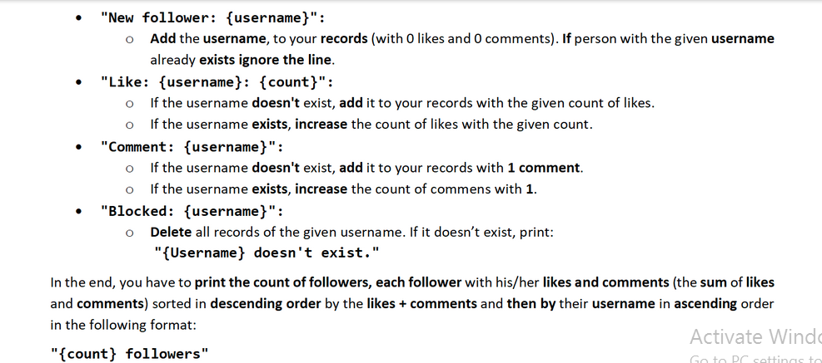

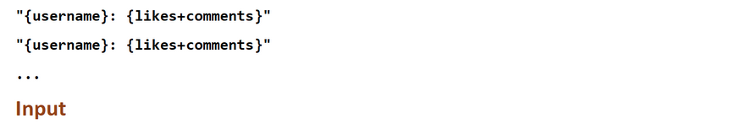

### Input

* The **possible** commands are:
  + **"Log out"**
  + **"New follower: {username}"**
  + **"Like: {username}: {count}"**
  + **"Comment: {username}"**
  + **"Blocked: {username}"**

### Output

* The **possible** outputs are:
* **"{Username} doesn't exist."**
  + **"{count} followers"**

**"{username}: {likes+comments}"**

**"{username}: {likes+comments}"**

**...**

### Examples

|  |  |
| --- | --- |
| **Input** | **Output** |
| New follower: George  Like: George: 5  New follower: George  Log out | 1 followers  George: 5 |
| **Input** | **Output** |
| Like: Katy: 3  Comment: Katy  New follower: Bob  Blocked: Bob  New follower: Amy  Like: Amy: 4  Log out | 2 followers  Amy: 4  Katy: 4 |
| **Input** | **Output** |
| Blocked: Amy  Comment: Amy  New follower: Amy  Like: Tom: 5  Like: Ellie: 5  Log out | Amy doesn't exist.  3 followers  Ellie: 5  Tom: 5  Amy: 1 |

### JS Input / Output

The input will be provided as an array of strings.

|  |  |
| --- | --- |
| **Input** | **Output** |
| (["New follower: George",  "Like: George: 5",  "New follower: George",  "Log out"]) | 1 followers  George: 5 |
| **Input** | **Output** |
| (["Like: Katy: 3",  "Comment: Katy",  "New follower: Bob",  "Blocked: Bob",  "New follower: Amy",  "Like: Amy: 4",  "Log out"]) | 2 followers  Amy: 4  Katy: 4 |
| **Input** | **Output** |
| (["Blocked: Amy",  "Comment: Amy",  "New follower: Amy",  "Like: Tom: 5",  "Like: Ellie: 5",  "Log out"]) | Amy doesn't exist.  3 followers  Ellie: 5  Tom: 5  Amy: 1 |