CST-256 Design Report Template

Topic: | Milestone 3
Date: | February 23, 2020
Revision: | 3.0
Team: | - Roland Steinebrunner
Team: | - Jack Sidrak
Team: | - Anthony Clayton
Weekly Team Status Summary:
  User Story | Team  Member | Hours  Worked | Hours Remaining
  Implemented a skills MVC | Jack | 1 | 0
  Implemented a JobHistory MVC | Jack | 2 | 0
  Implemented a JobPosting MVC | Anthony | .5 | 0
  Implemented a Portfolio MVC | Roland | 3 | 0
  Created views for skills, job history, job posting, and Portfolio | Roland, Anthony | 3 | 0
  Split SecurityService&DAO into Login/Register Service&DAO | Roland | 2 | 0
  Created a separate Admin MVC | Jack | 1 | 0
GIT URL: | https://github.com/RSteinebrunner/LaravelProject
Hosting URL: | https://laravelprojectclc.herokuapp.com/
Peer Review: | Y | We acknowledge that our team has reviewed this report and we agree to the approach we are all taking.

Design Documentation

Install Instructions:
Go to: https://laravelprojectclc.herokuapp.com/
General Technical Approach:
Using Laravel framework we created new MVC’s and views for adding user skills, previous job history, education, and new job postings. In addition, an overall MVC and view was made to display all this information on a user Portfolio. Edit and delete methods were implemented for each object. Original securityService and securityDAO were split into Login&Register service/DA. Website features portions of bootstrap, css, and html and will have a modern database.

Key Technical Design Decisions:
Using MVC design for code reusability and to increase security, scalability, and flexibility and decrease code redundancy. Mysqli database for ease of use.

Formatting Decisions:
File Headers have: Project Name |

ER Diagram:
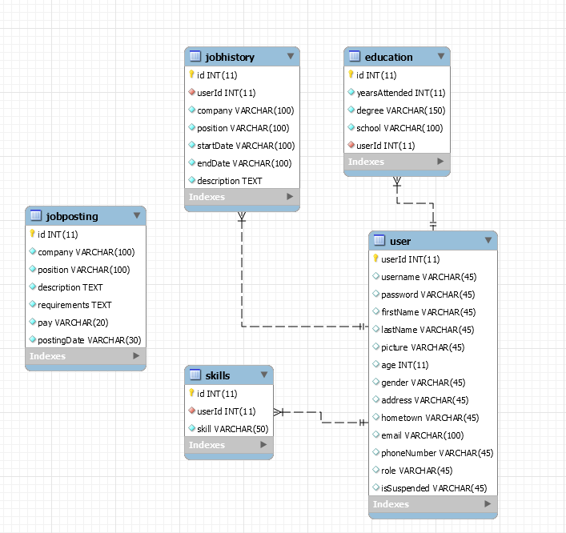
DDL Scripts:
-- MySQL Workbench Forward Engineering

SET @OLD_UNIQUE_CHECKS=@@UNIQUE_CHECKS, UNIQUE_CHECKS=0;
SET @OLD_FOREIGN_KEY_CHECKS=@@FOREIGN_KEY_CHECKS, FOREIGN_KEY_CHECKS=0;
SET @OLD_SQL_MODE=@@SQL_MODE, SQL_MODE='ONLY_FULL_GROUP_BY,STRICT_TRANS_TABLES,NO_ZERO_IN_DATE,NO_ZERO_DATE,ERROR_FOR_DIVISION_BY_ZERO,NO_ENGINE_SUBSTITUTION';

-- -----------------------------------------------------
-- Schema mydb
-- -----------------------------------------------------
-- -----------------------------------------------------
-- Schema laraveldb
-- -----------------------------------------------------

-- -----------------------------------------------------
-- Schema laraveldb
-- -----------------------------------------------------
CREATE SCHEMA IF NOT EXISTS `laraveldb` DEFAULT CHARACTER SET latin1 ;
USE `laraveldb` ;

-- -----------------------------------------------------
-- Table `laraveldb`.`user`
-- -----------------------------------------------------
CREATE TABLE IF NOT EXISTS `laraveldb`.`user` (
`userId` INT(11) NOT NULL AUTO_INCREMENT,
`username` VARCHAR(45) NULL DEFAULT NULL,
`password` VARCHAR(45) NULL DEFAULT NULL,
`firstName` VARCHAR(45) NULL DEFAULT NULL,
`lastName` VARCHAR(45) NULL DEFAULT NULL,
`picture` VARCHAR(45) NULL DEFAULT NULL,
`age` INT(11) NULL DEFAULT NULL,
`gender` VARCHAR(45) NULL DEFAULT NULL,
`address` VARCHAR(45) NULL DEFAULT NULL,
`hometown` VARCHAR(45) NULL DEFAULT NULL,
`email` VARCHAR(100) NULL DEFAULT NULL,
`phoneNumber` VARCHAR(45) NULL DEFAULT NULL,
`role` VARCHAR(45) NULL DEFAULT NULL,
`isSuspended` VARCHAR(45) NULL DEFAULT NULL,
PRIMARY KEY (`userId`))
ENGINE = InnoDB
AUTO_INCREMENT = 11
DEFAULT CHARACTER SET = latin1;

-- -----------------------------------------------------
-- Table `laraveldb`.`education`
-- -----------------------------------------------------
CREATE TABLE IF NOT EXISTS `laraveldb`.`education` (
`id` INT(11) NOT NULL AUTO_INCREMENT,
`yearsAttended` INT(11) NOT NULL,
`degree` VARCHAR(150) NOT NULL,
`school` VARCHAR(100) NOT NULL,
`userId` INT(11) NOT NULL,
PRIMARY KEY (`id`),
INDEX `userId` (`userId` ASC),
CONSTRAINT `education_ibfk_1`
FOREIGN KEY (`userId`)
REFERENCES `laraveldb`.`user` (`userId`)
ON DELETE CASCADE
ON UPDATE CASCADE)
ENGINE = InnoDB
AUTO_INCREMENT = 6
DEFAULT CHARACTER SET = latin1;

-- -----------------------------------------------------
-- Table `laraveldb`.`jobhistory`
-- -----------------------------------------------------
CREATE TABLE IF NOT EXISTS `laraveldb`.`jobhistory` (
`id` INT(11) NOT NULL AUTO_INCREMENT,
`userId` INT(11) NOT NULL,
`company` VARCHAR(100) NOT NULL,
`position` VARCHAR(100) NOT NULL,
`startDate` VARCHAR(100) NOT NULL,
`endDate` VARCHAR(100) NOT NULL,
`description` TEXT NOT NULL,
PRIMARY KEY (`id`),
INDEX `userId` (`userId` ASC),
CONSTRAINT `jobhistory_ibfk_1`
FOREIGN KEY (`userId`)
REFERENCES `laraveldb`.`user` (`userId`)
ON DELETE CASCADE
ON UPDATE CASCADE)
ENGINE = InnoDB
AUTO_INCREMENT = 10
DEFAULT CHARACTER SET = latin1;

-- -----------------------------------------------------
-- Table `laraveldb`.`jobposting`
-- -----------------------------------------------------
CREATE TABLE IF NOT EXISTS `laraveldb`.`jobposting` (
`id` INT(11) NOT NULL AUTO_INCREMENT,
`company` VARCHAR(100) NOT NULL,
`position` VARCHAR(100) NOT NULL,
`description` TEXT NOT NULL,
`requirements` TEXT NOT NULL,
`pay` VARCHAR(20) NOT NULL,
`postingDate` VARCHAR(30) NOT NULL,
PRIMARY KEY (`id`))
ENGINE = InnoDB
AUTO_INCREMENT = 8
DEFAULT CHARACTER SET = latin1;

-- -----------------------------------------------------
-- Table `laraveldb`.`skills`
-- -----------------------------------------------------
CREATE TABLE IF NOT EXISTS `laraveldb`.`skills` (
`id` INT(11) NOT NULL AUTO_INCREMENT,
`userId` INT(11) NOT NULL,
`skill` VARCHAR(50) NOT NULL,
PRIMARY KEY (`id`),
INDEX `userId` (`userId` ASC),
CONSTRAINT `skills_ibfk_1`
FOREIGN KEY (`userId`)
REFERENCES `laraveldb`.`user` (`userId`)
ON DELETE CASCADE
ON UPDATE CASCADE)
ENGINE = InnoDB
AUTO_INCREMENT = 11
DEFAULT CHARACTER SET = latin1;

SET SQL_MODE=@OLD_SQL_MODE;
SET FOREIGN_KEY_CHECKS=@OLD_FOREIGN_KEY_CHECKS;
SET UNIQUE_CHECKS=@OLD_UNIQUE_CHECKS;

Sitemap Diagram:
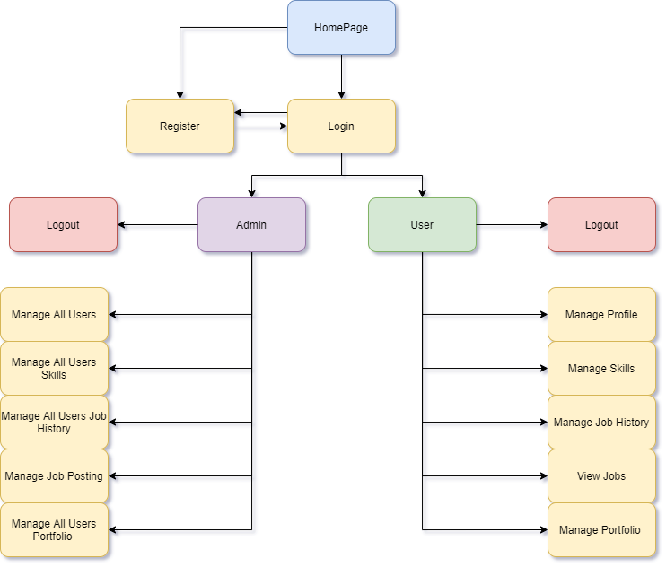
Security Design:
Extra privileges were added to users with the role ‘Admin’. Blade statements were used in the header page to control page navigation

Flowcharts:
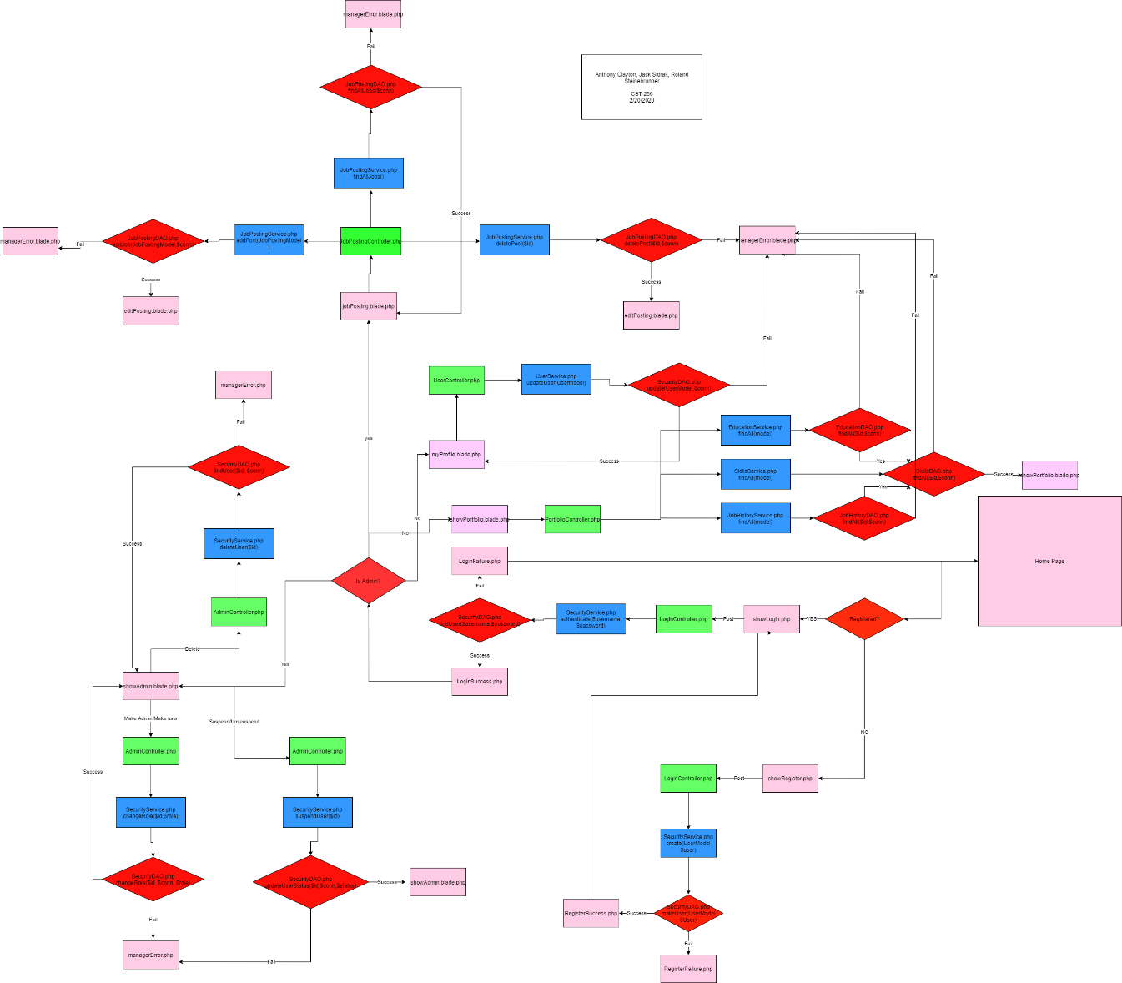

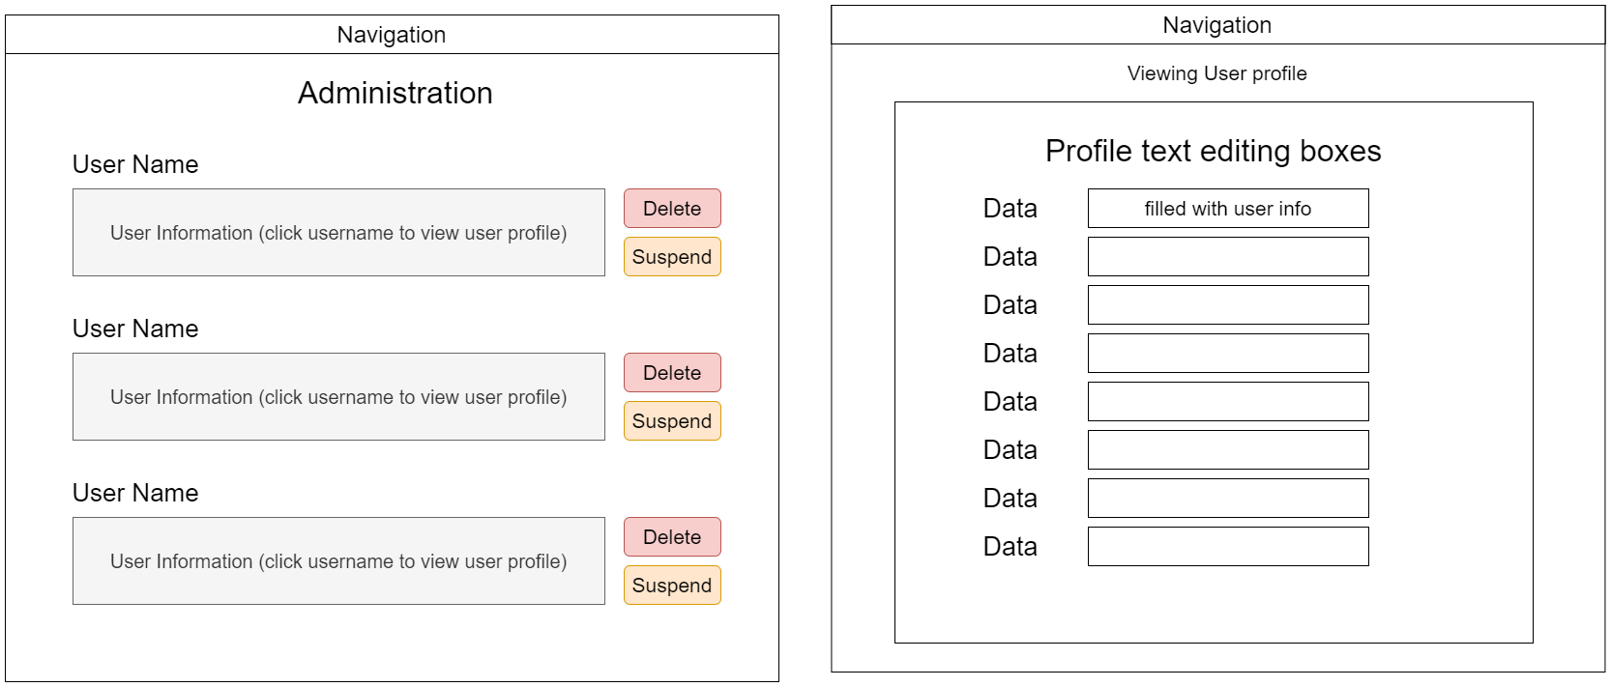
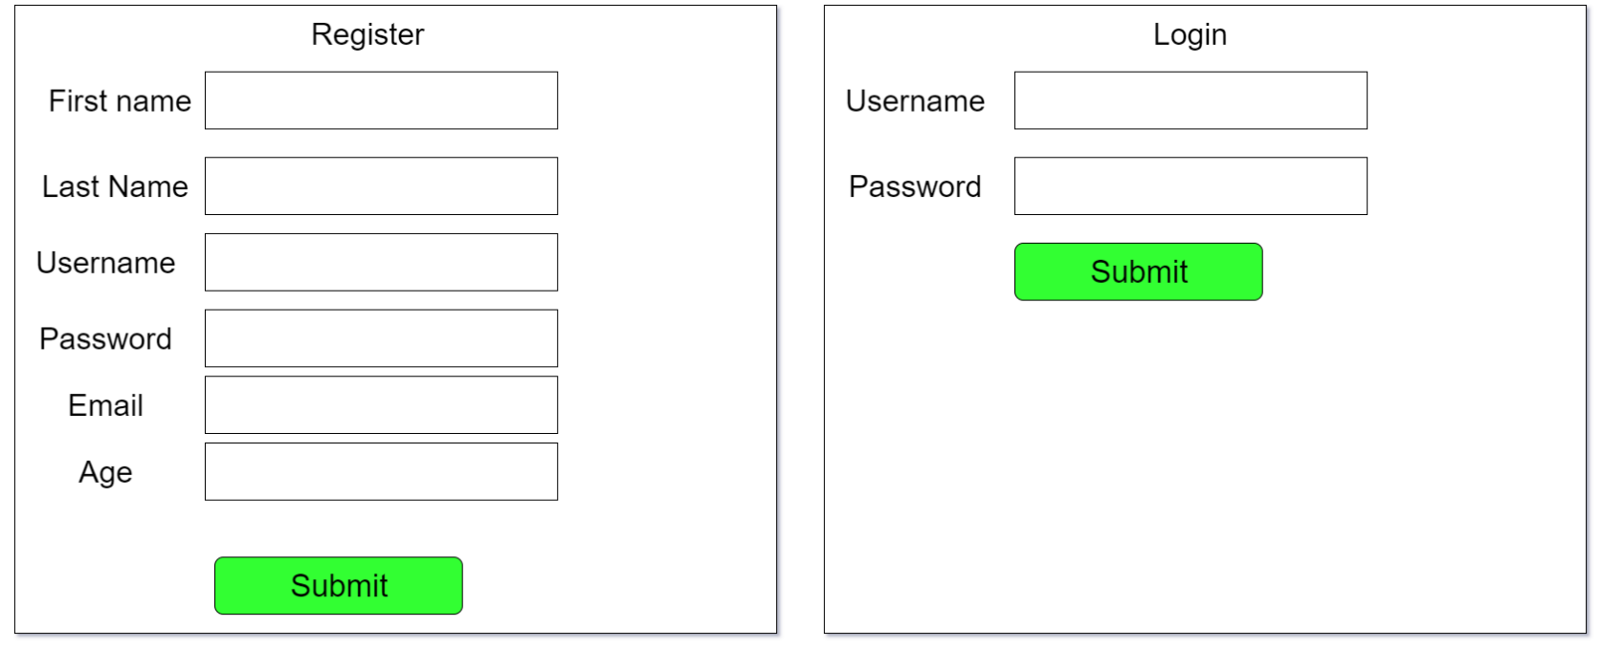
User Interface Diagrams:

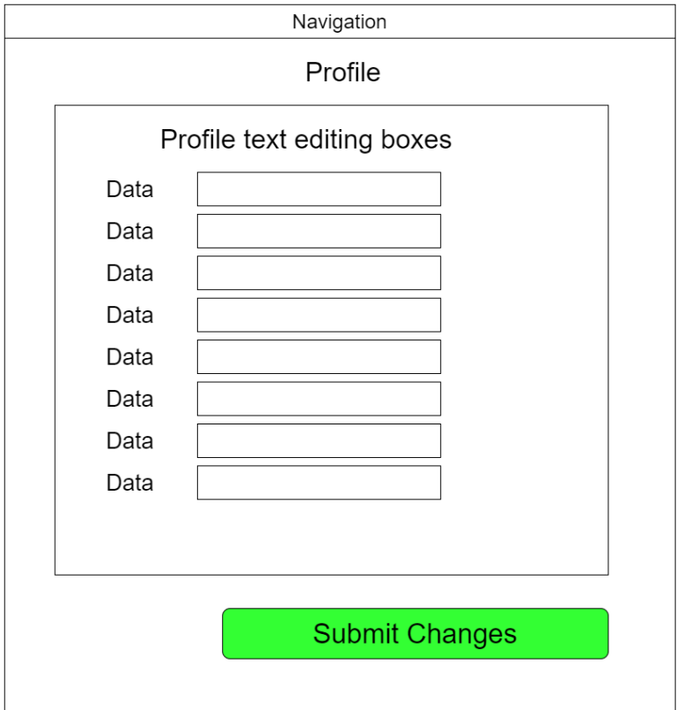
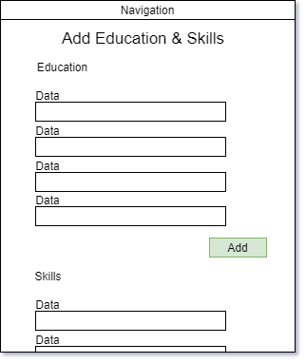

\

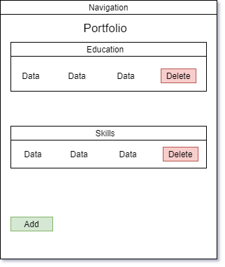
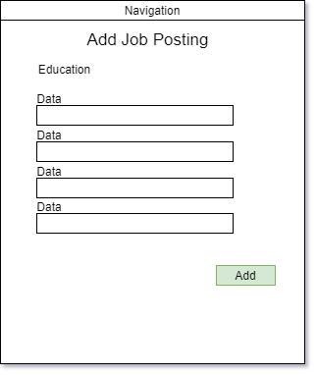

Class Diagrams:
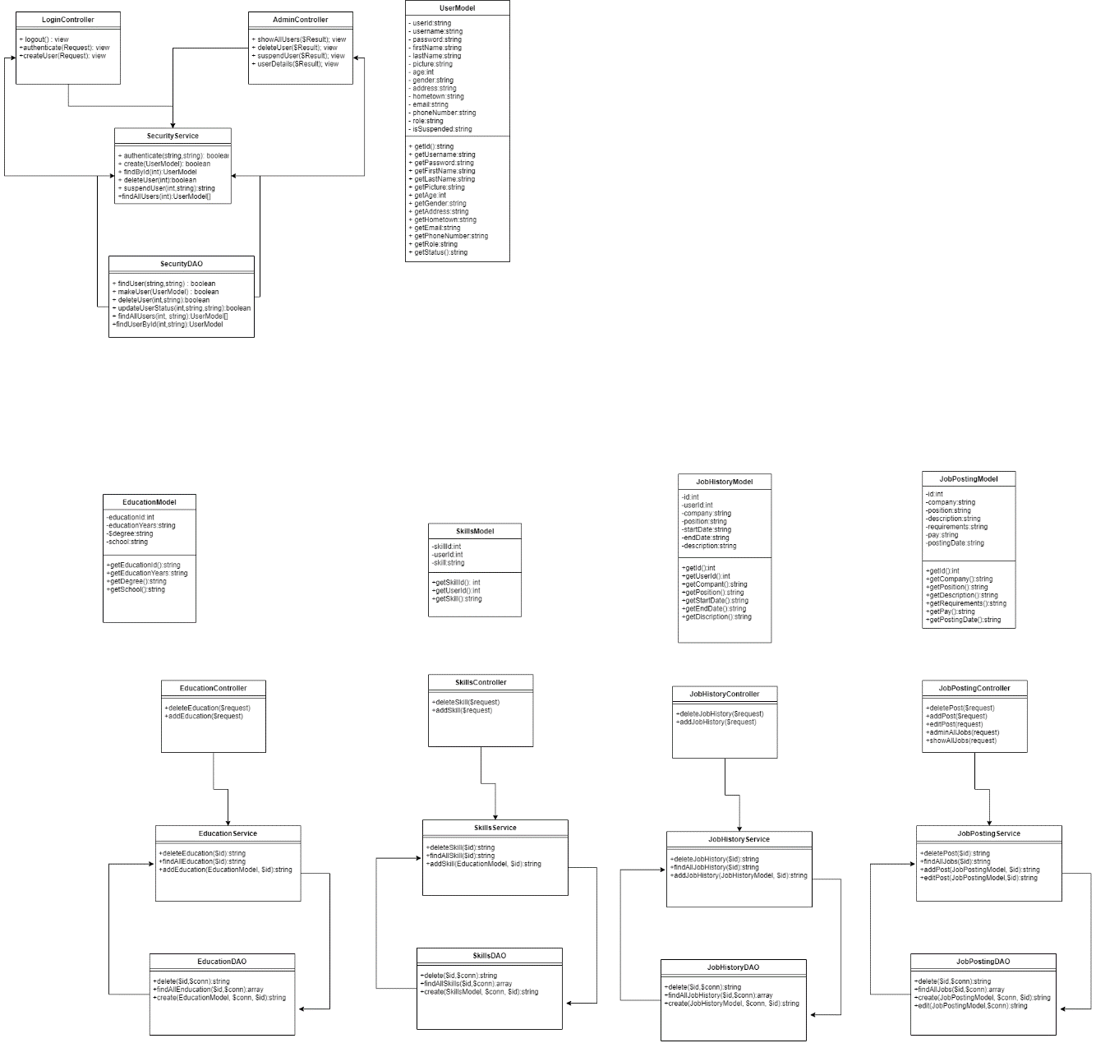
Pseudo Code:
N/A.

Other Documentation:
Loom Link: https://www.loom.com/share/7bbda396acb141459792a83c23164018

