**PART 1**

**TASK 1**

**Gender**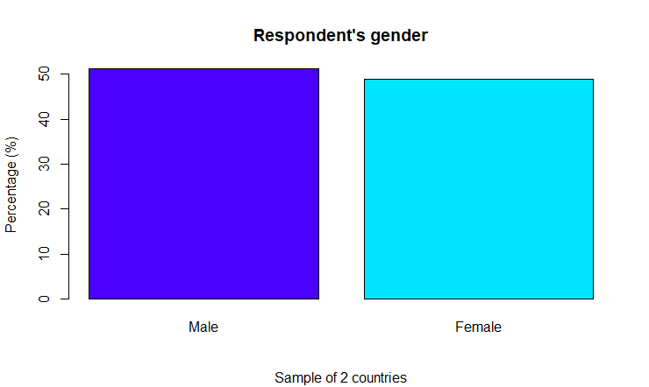

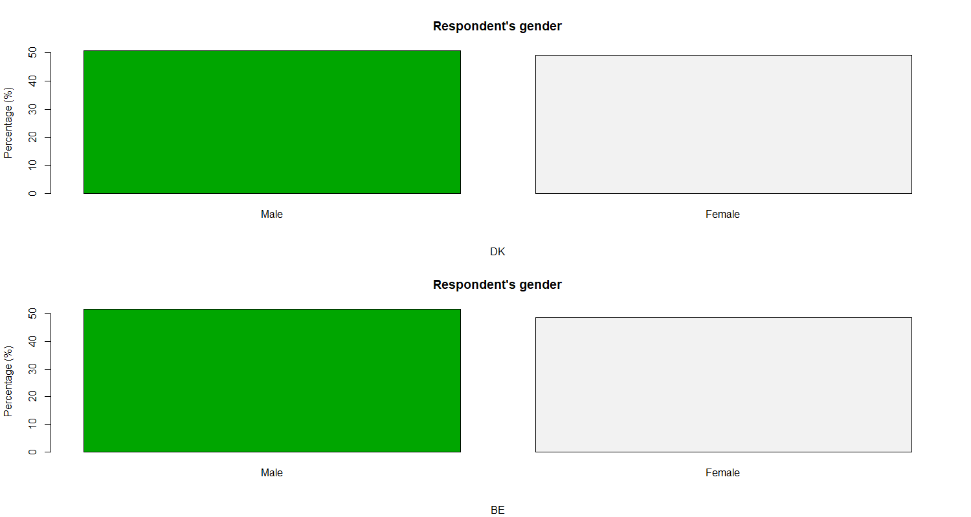

=======================================

Country

essw1$gndr_f BE DK Total

---------------------------------------

Male 963 762 1725

55.8% 44.2% 51.2%

51.5% 50.7%

0.442 -0.442

---------------------------------------

Female 907 740 1647

55.1% 44.9% 48.8%

48.5% 49.3%

-0.442 0.442

---------------------------------------

Total 1870 1502 3372

55.5% 44.5%

=======================================

***Similarities:***

Overall gender balance:

The overall male to female ratio in the total dataset is approximately 51.2% and 48.8%, respectively. In BE and DK, the ratio is also approximately 55.8% to 44.2% and 55.1% to 44.9%, respectively.

Deviations from equilibrium:

In the overall dataset and in each of the countries, a bias towards males at 0.442 and a bias towards females at -0.442 is visible. This suggests a small but existing imbalance in the sex ratio.

***Differences:***

Differences in the percentage ratio:

Overall, the percentage ratio of males to females in country BE is slightly higher than in country DK (by about 1-1.3%).

Representation deviations:

It is noteworthy that the male to female ratio is above 50% in country BE, while it is lower in country DK. This may indicate some differences in social structure or culture on gender representation.

**Age**

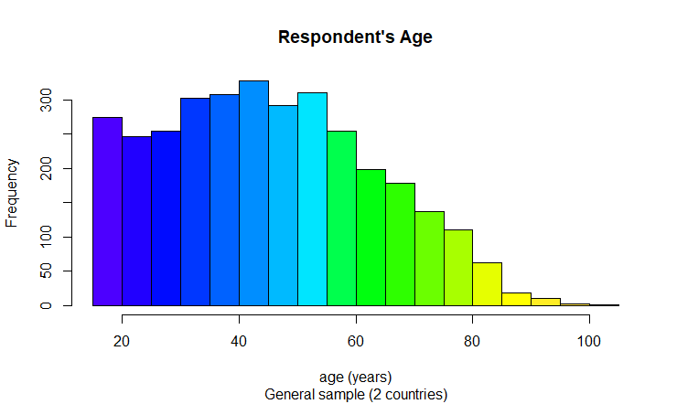

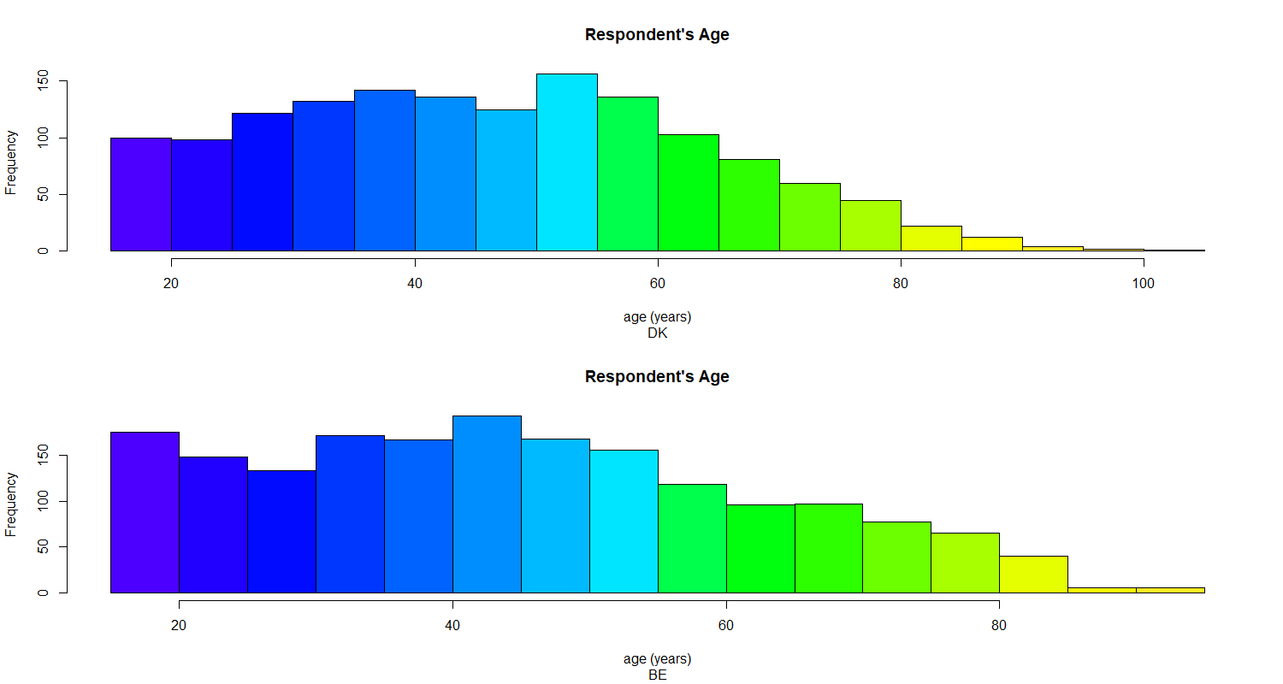

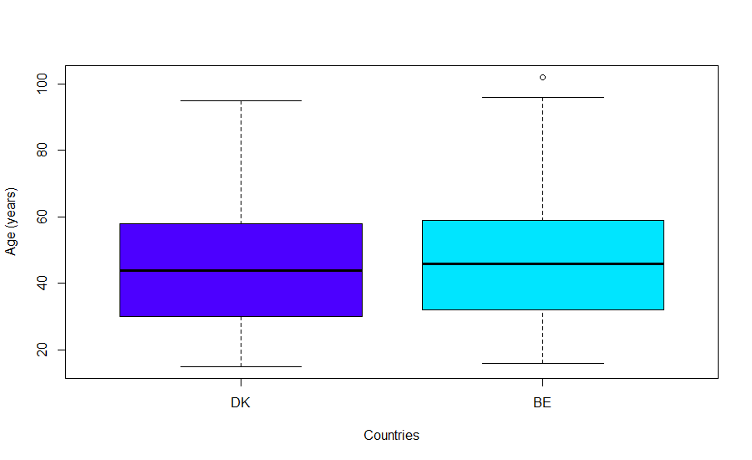

DENMARK

Min. 1st Qu. Median Mean 3rd Qu. Max. NA's

16.00 32.00 46.00 46.43 59.00 102.00 29

BELGIUM

Min. 1st Qu. Median Mean 3rd Qu. Max. NA's

15.00 30.00 44.00 44.83 58.00 95.00 87

*Median and mean age:*

The median age for respondents from Denmark (46 years) is slightly higher than for respondents from Belgium (44 years).

The median age in Denmark is also slightly higher (46.43 years) compared to Belgium (44.83 years).

*Age spread:*

There is a wide spread of ages in both countries, as can be seen in the difference between the minimum and maximum ages.

A difference in the number of missing values is present: 29 in Denmark and 87 in Belgium.

Belgium has more people under 20 years of age than Denmark. Also the dominant age of people in Belgium is 40+ years old. Belgium has more people over 80 years old compared to Denmark

**Employment**

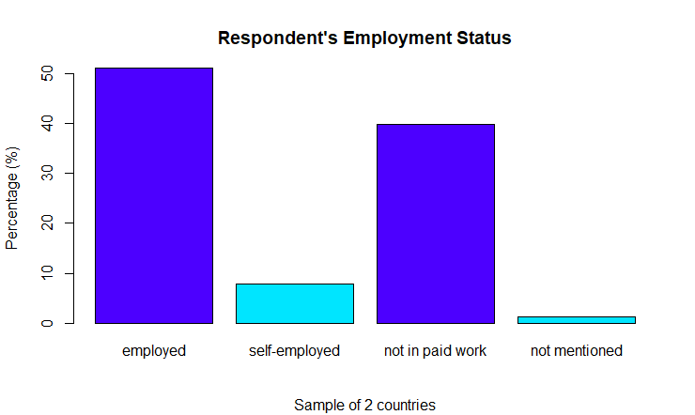

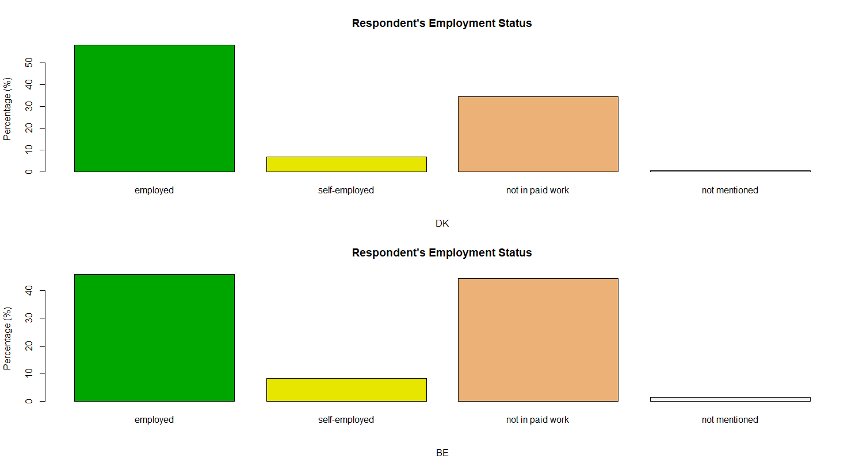

============================================

Country

essw1$empl_factor BE DK Total

--------------------------------------------

employed 869 873 1742

49.9% 50.1% 51.2%

45.8% 58.0%

-7.077 7.077

--------------------------------------------

self-employed 159 105 264

60.2% 39.8% 7.8%

8.4% 7.0%

1.518 -1.518

--------------------------------------------

not in paid work 842 517 1359

62.0% 38.0% 39.9%

44.3% 34.3%

5.924 -5.924

--------------------------------------------

not mentioned 29 11 40

72.5% 27.5% 1.2%

1.5% 0.7%

2.143 -2.143

--------------------------------------------

Total 1899 1506 3405

55.8% 44.2%

============================================

***Similarities:***

Distribution of employment categories:

The overall percentage of employed (employed) in the total dataset is 51.2%. In BE and DK countries this ratio is approximately 49.9% and 50.1% respectively.

There is some discrepancy between the percentages of employed, self-employed and people not in paid work in both the total dataset and in BE and DK countries.

***Differences:***

Differences in the proportion of employment categories:

Importantly, the percentage of self-employed in country BE (60.2%) is significantly higher than in country DK (39.8%).

It can also be seen that the percentage of people not in paid employment is higher in country BE (62.0%) than in country DK (38.0%).

Deviations from the total percentage:

Each of the employment categories has deviations from the overall percentage of employment. These deviations reflect the distribution of each category across countries relative to the overall average.

**Financial situation**

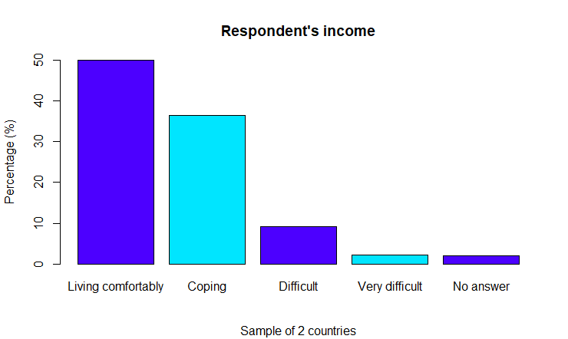

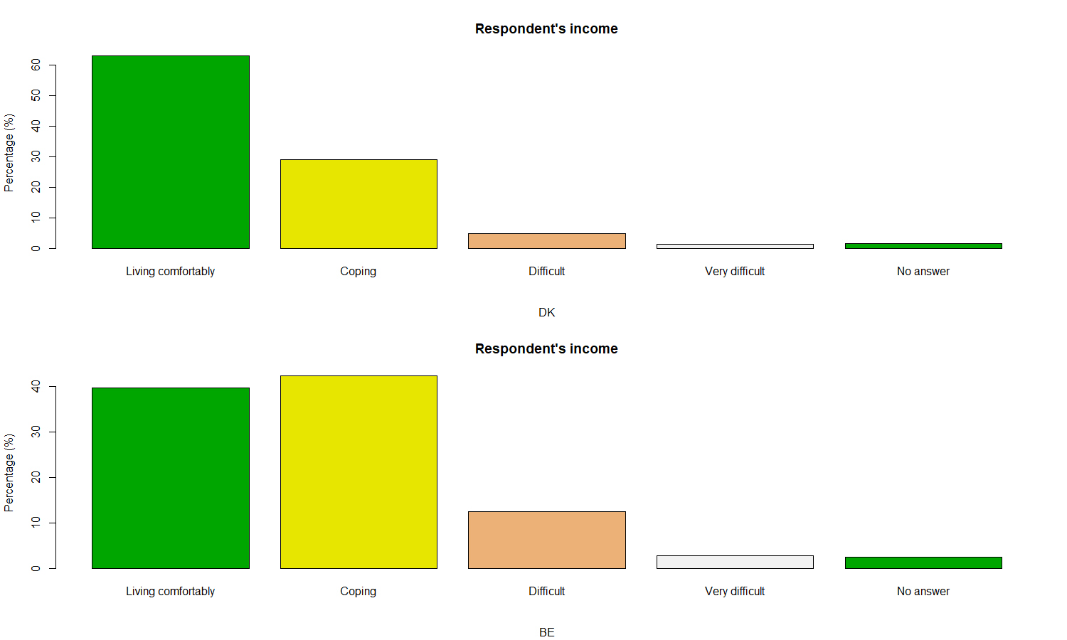

================================================

Country

essw1$hincfel_factor BE DK Total

------------------------------------------------

Living comfortably 755 948 1703

44.3% 55.7% 50.0%

39.8% 62.9%

-13.442 13.442

------------------------------------------------

Coping 805 439 1244

64.7% 35.3% 36.5%

42.4% 29.2%

7.969 -7.969

------------------------------------------------

Difficult 238 74 312

76.3% 23.7% 9.2%

12.5% 4.9%

7.654 -7.654

------------------------------------------------

Very difficult 54 22 76

71.1% 28.9% 2.2%

2.8% 1.5%

2.713 -2.713

------------------------------------------------

No answer 47 23 70

67.1% 32.9% 2.1%

2.5% 1.5%

1.936 -1.936

------------------------------------------------

Total 1899 1506 3405

55.8% 44.2%

================================================

***Similarities:***

Comparison of the overall distribution of income satisfaction levels:

The overall percentage of "Coping" income satisfaction levels in the overall dataset is 36.5%. In BE and DK, this ratio is approximately 35.3% and 64.7% respectively.

There is also a comparable overall distribution of "Difficult" and "Living comfortably" levels in the overall dataset and in BE and DK countries.

***Differences:***

Differences in the share of income satisfaction levels:

Denmark has a significantly higher level of income satisfaction with "Coping" (64.7%) than Belgium (35.3%). While the level of "Living comfortably" is higher in Belgium (44.3%) compared to Denmark (55.7%).

The deviations from the overall percentage for each category also reflect the distribution of each category across countries relative to the overall average.

**Education level**

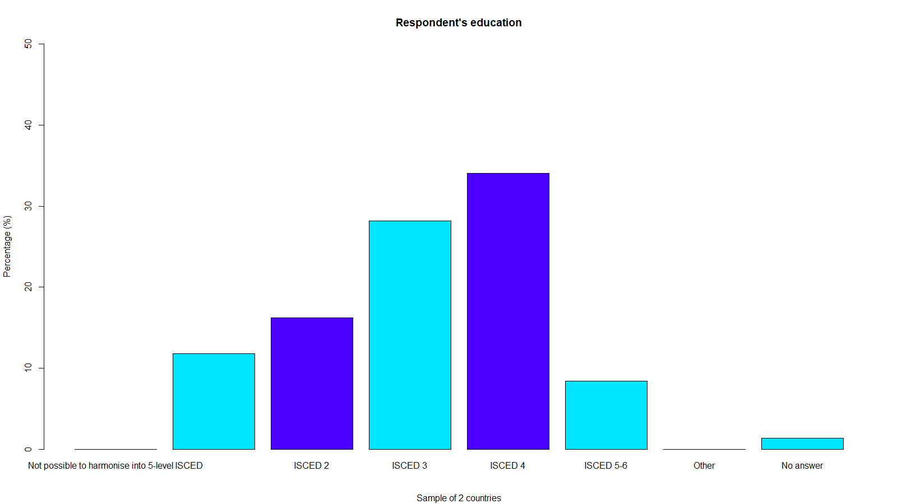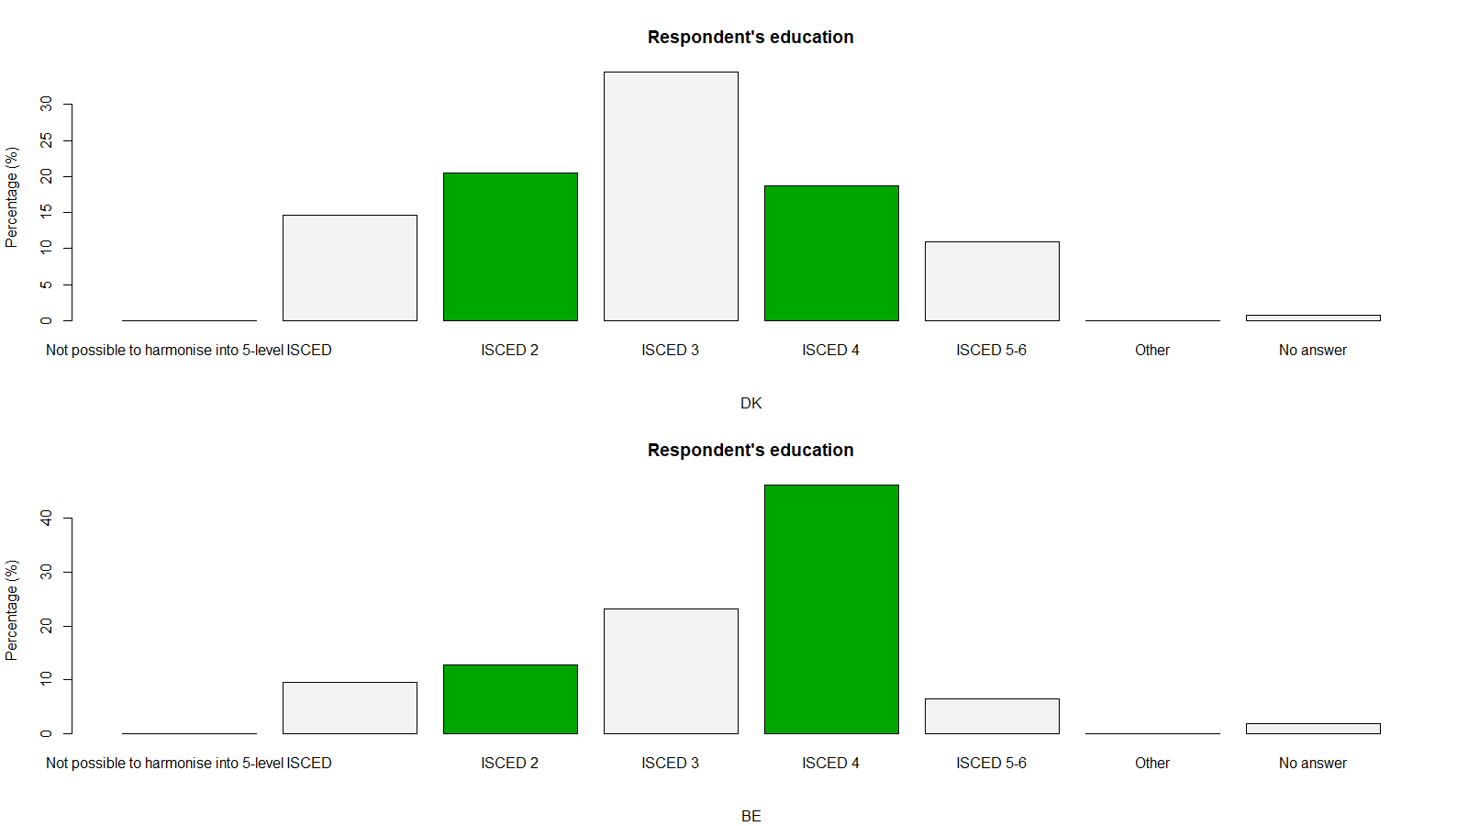

================================================

Country

essw1$edulvla_factor BE DK Total

------------------------------------------------

ISCED 0-1 180 221 401

44.9% 55.1% 11.8%

9.5% 14.7%

-4.672 4.672

------------------------------------------------

ISCED 2 244 309 553

44.1% 55.9% 16.2%

12.8% 20.5%

-6.026 6.026

------------------------------------------------

ISCED 3 440 519 959

45.9% 54.1% 28.2%

23.2% 34.5%

-7.276 7.276

------------------------------------------------

ISCED 4 877 282 1159

75.7% 24.3% 34.0%

46.2% 18.7%

16.794 -16.794

------------------------------------------------

ISCED 5-6 122 164 286

42.7% 57.3% 8.4%

6.4% 10.9%

-4.665 4.665

------------------------------------------------

No answer 36 11 47

76.6% 23.4% 1.4%

1.9% 0.7%

2.895 -2.895

------------------------------------------------

Total 1899 1506 3405

55.8% 44.2%

***Similarities***

Overall distribution of education levels:

The overall percentage of ISCED level 3 in the total dataset is 28.2%. In BE and DK countries this ratio is approximately 45.9% and 54.1% respectively.

There is also a comparable overall distribution of ISCED 0-1 and ISCED 2 education levels in the total dataset and in BE and DK countries.

***Differences:***

Differences in the proportion of education levels:

Denmark has a higher percentage of people with ISCED 3, ISCED 4 and ISCED 5-6 education levels than Belgium.

In contrast, Belgium has a higher percentage of people with ISCED 0-1 and ISCED 2 education levels than Denmark.

The deviations from the overall percentage for each category also reflect the distribution of each category across countries relative to the overall average.

**Residence**

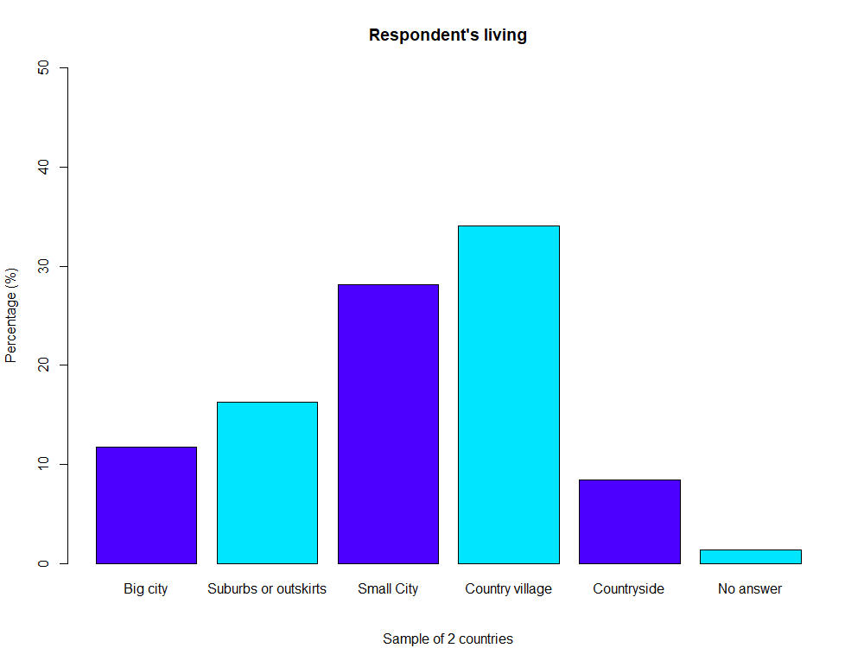

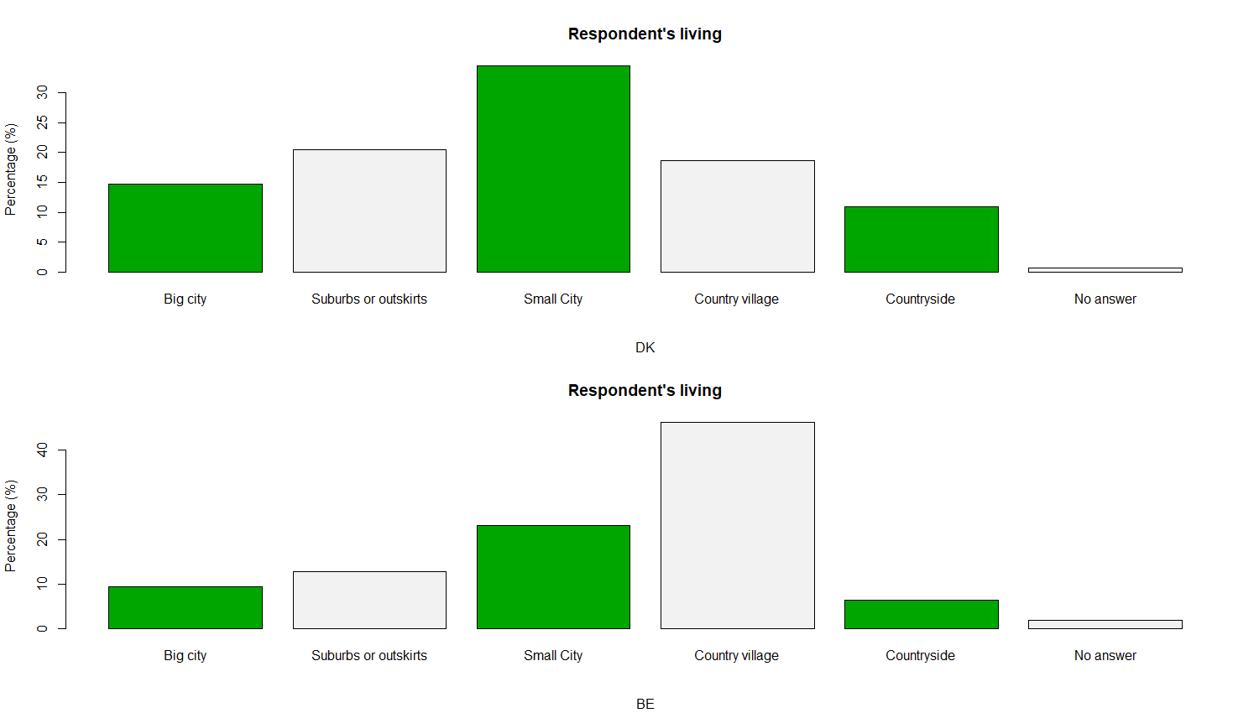

================================================

Country

essw1$domicil_factor BE DK Total

------------------------------------------------

Big city 180 221 401

44.9% 55.1% 11.8%

9.5% 14.7%

-4.672 4.672

------------------------------------------------

Suburbs or outskirts 244 309 553

44.1% 55.9% 16.2%

12.8% 20.5%

-6.026 6.026

------------------------------------------------

Small City 440 519 959

45.9% 54.1% 28.2%

23.2% 34.5%

-7.276 7.276

------------------------------------------------

Country village 877 282 1159

75.7% 24.3% 34.0%

46.2% 18.7%

16.794 -16.794

------------------------------------------------

Countryside 122 164 286

42.7% 57.3% 8.4%

6.4% 10.9%

-4.665 4.665

------------------------------------------------

No answer 36 11 47

76.6% 23.4% 1.4%

1.9% 0.7%

2.895 -2.895

------------------------------------------------

Total 1899 1506 3405

55.8% 44.2%

================================================

***Differences:***

Differences in the proportion of residence types:

The percentage of residence in Country village is significantly higher in Belgium (75.7%) than in Denmark (24.3%).

The percentage of residence in the city (Big city, Suburbs or outskirts, Small city, and Countryside) is higher in Denmark than in Belgium.

**TASK 2**

**ctbfsmv** - All countries benefit if people can move where their skills needed

Agree strongly - 484

Agree Neither agree nor disagree - 1806

Disagree - 461

Disagree strongly – 80

NA’s - 185

### imrsprc - Richer countries responsible to accept people from poorer countries

Agree strongly - 334

Agree Neither agree nor disagree - 1442

Disagree - 648

Disagree strongly -724

NA’s - 156

### imdfetn - Allow many/few immigrants of different race/ethnic group from majority

Allow many to come and live here - 304

Allow some - 1405

Allow a few - 1194

Allow none - 366

NA’s - 136

### imsmetn - Allow many/few immigrants of same race/ethnic group as majority

Allow many to come and live here - 568

Allow some - 1752

Allow a few - 768

Allow none - 171

NA’s - 146

### eimrcnt - Allow many/few immigrants from richer countries in Europe

Allow many to come and live here - 554

Allow some - 1547

Allow a few - 861

Allow none - 288

NA’s - 15

### eimpcnt - Allow many/few immigrants from poorer countries in Europe

Allow many to come and live here - 412

Allow some - 1537

Allow a few - 1058

Allow none - 265

NA’s - 133

### 

### Benefit of Skill Mobility (ctbfsmv):

### A significant portion of respondents in both countries agree that countries benefit from skill mobility, but a considerable number either disagree or remain neutral.

### Responsibility of Richer Countries (imrsprc):

### There's some disagreement about whether richer countries are obligated to accept people from poorer countries, with a significant number falling into the "neither agree nor disagree" category.

### Different Ethnic Groups (imdfetn):

### Over a thousand respondents in BE and DK combined are open to allowing many immigrants from different ethnic groups, but there's a substantial number of neutral opinions and some disagreement.

### Same Ethnic Groups (imsmetn):

### More individuals in both countries are open to allowing many immigrants from the same ethnic background, but there's a significant proportion with neutral opinions or disagreeing.

### Richer European Countries (eimrcnt) and Poorer European Countries (eimpcnt):

### Views differ, but there's a notable number in both countries that are open to allowing some immigrants from both richer and poorer European countries however there is a significant decline to “disagree strongly”. It may refer to Belgium where people think that their country is richer and their country couldn’t afford it.

### TASK 3.

***Results:***

ctbfsmv_factor:

Anderson-Darling test: A = 273.67, p-value < 2.2e-16

Shapiro-Wilk test: W = 0.82091, p-value < 2.2e-16

imrsprc_factor:

Anderson-Darling test: A = 186.18, p-value < 2.2e-16

Shapiro-Wilk test: W = 0.87767, p-value < 2.2e-16

***Interpretation:***

The obtained p-values for both variables from both tests are extremely small (p-value < 2.2e-16), indicating strong evidence against the null hypothesis that the data follows a normal distribution. Therefore, the data significantly deviates from normality for both variables.

***Choosing Test Strategy:***

Parametric Tests:

Parametric tests (e.g., t-tests, ANOVA) assume normality in the data. Given the violation of normality assumptions based on the tests, using parametric tests might lead to inaccurate results.

Nonparametric Tests:

Nonparametric tests (e.g., Mann-Whitney U test, Kruskal-Wallis test) are more robust to deviations from normality. These tests do not assume a specific distribution and are suitable when the data significantly deviates from normality.

**TASK 4.**

Wilcoxon rank sum test with continuity correction

data: ctbfsmv_male and ctbfsmv_female

W = 1242953, p-value = 0.2086

alternative hypothesis: true location shift is not equal to 0

There's insufficient evidence to reject the null hypothesis of no difference between the measures for males and females.

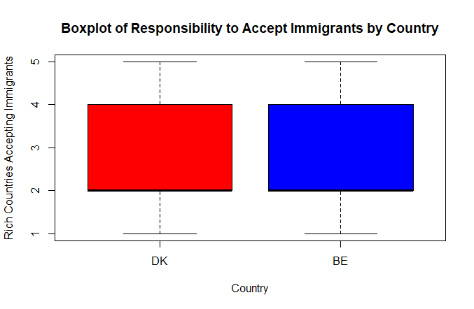

There is no correlation between country and level of responsibility to accept immigrants. The middle answer is “allow some”.

Wilcoxon rank sum test with continuity correction

data: ctbfsmv__Cntry1 and ctbfsmv__Cntry2

W = 1303740, p-value = 0.3531

alternative hypothesis: true location shift is not equal to 0

The difference in measures (ctbfsmv) between two countries (Denmark and Belgium) is not statistically significant at the conventional significance level. There's insufficient evidence to reject the null hypothesis of no difference between the measures for the two countries.

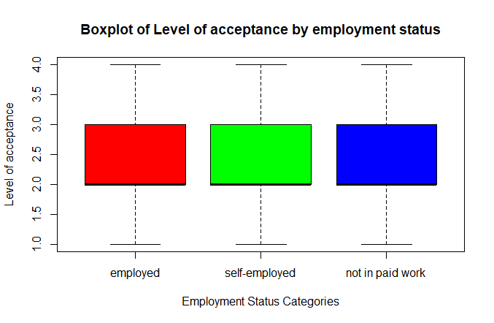There is no correlation between employment status and level of acceptance immigrants. The middle answer is “allow some”

Kruskal-Wallis rank sum test

data: list(group1_empl, group2_empl, group3_empl)

Kruskal-Wallis chi-squared = 28.344, df = 2, p-value = 7.002e-07

The p-values are extremely low, suggesting strong evidence against the null hypothesis.

Kruskal-Wallis rank sum test

data: list(group1_resid, group2_resid, group3_resid, group4_resid, group5_resid)

Kruskal-Wallis chi-squared = 26.821, df = 4, p-value = 2.16e-05

The p-values are extremely low, suggesting strong evidence against the null hypothesis. This means there are statistically significant differences between the groups being compared for measures related to migration variable (imdeftn) and residence

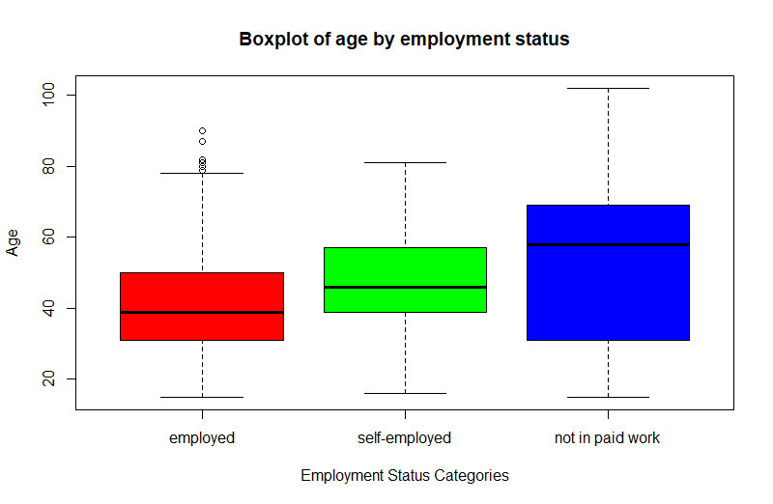

As we can observe, mostly people over 60 years old are not in paid work (probably retired/have pension). However, there are peculiarities in ‘employed’. Data has some employed people who are over 80 years old.

Kruskal-Wallis rank sum test

data: list(age_empl1, age_empl2, age_empl3)

Kruskal-Wallis chi-squared = 303.76, df = 2, p-value < 2.2e-16

The p-values are extremely low, suggesting strong evidence against the null hypothesis. This means there are statistically significant differences between the groups being compared for measures related to age and employment status.

**PART 2**

**TASK 5**

1. D section bthcld - Ever given birth to/fathered a child
2. D section ggchld - Have any great grandchildren
3. D section iagmr - Get married, ideal age. SPLIT BALLOT
4. D section iagrtr - Retire permanently, ideal age. SPLIT BALLOT
5. D section evmar - Are or ever been married
6. G section occinfr - Net [pay/pensions/social benefits] of people same occupation as you in country, how fair
7. G section grspfr - Would you say your gross pay is unfairly low, fair, or unfairly high
8. G section netifr - Your net [pay/pensions/social benefits] is unfairly low, fair, or unfairly high
9. G section netilet - Which letter describes your net [pay/pensions/social benefits]
10. G section evfrjob - Everyone in country fair chance get job they seek

**bthcld** and **ggchld**: These variables relate to familial aspects—childbearing and great-grandchildren. In certain cultures, the perception of family and the role of generations might influence societal expectations and values. Understanding how individuals perceive and experience these familial stages can shed light on cultural values around family and lineage.

**iagmr** and **iagrtr**: Examining the ideal age for marriage and retirement can reflect cultural norms and expectations within the country. Societal norms and expectations often shape the perception of when these life milestones should ideally occur. Variability in ideal ages may indicate changing societal attitudes or cultural influences.

**evmar**: This variable captures marital status, which can be influenced by cultural or societal norms regarding marriage, family structures, and relationships.

**occinfr, grspfr, netifr, netilet, evfrjob**: These variables explore perceptions of fairness in income, job opportunities, and social benefits. Understanding how individuals perceive fairness in income distribution, their own income status compared to others, and the perceived fairness of job opportunities for everyone in the country can offer insights into societal views on income equality and job access. These perceptions might be influenced by economic policies, social structures, and cultural beliefs regarding fairness and opportunity.

**TASK 6**

**Age**

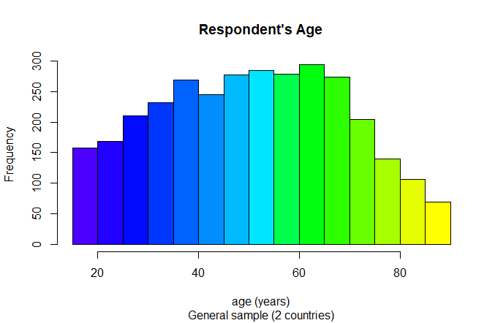

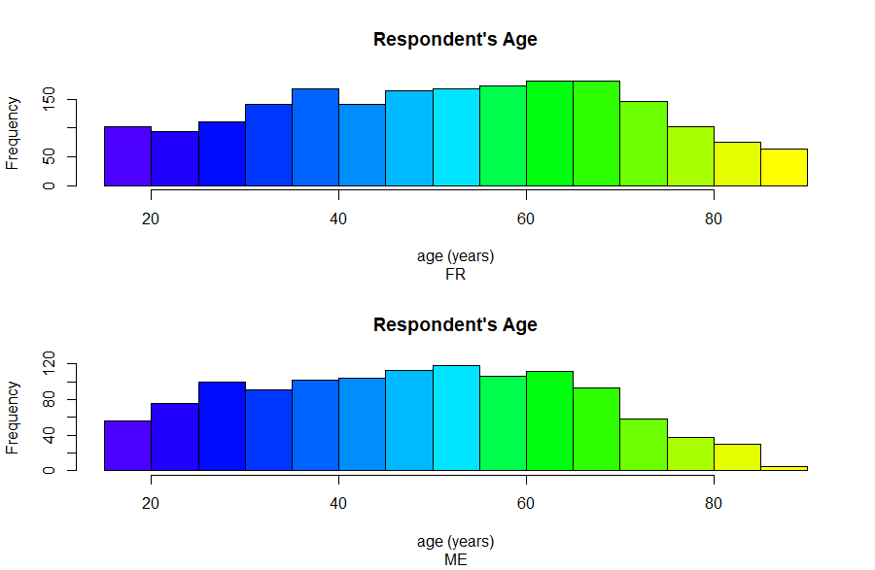

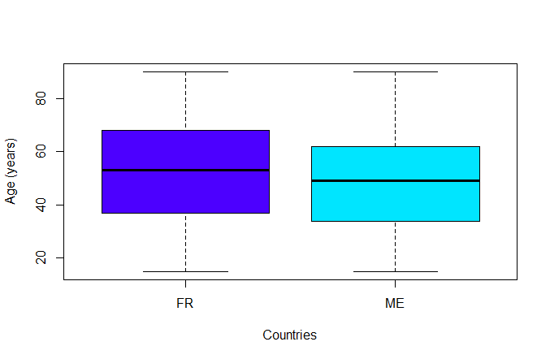

**FRANCE**

Min. 1st Qu. Median Mean 3rd Qu. Max.

15.00 37.00 53.00 52.37 68.00 90.00

**MONTENEGRO**

Min. 1st Qu. Median Mean 3rd Qu. Max.

15.00 34.00 49.00 48.42 62.00 90.00

Age Distribution in France (FR):

Minimum: 15 years

1st Quartile (25th percentile): 37 years

Median (50th percentile): 53 years

Mean: 52.37 years

3rd Quartile (75th percentile): 68 years

Maximum: 90 years

Age Distribution in Montenegro (ME):

Minimum: 15 years

1st Quartile (25th percentile): 34 years

Median (50th percentile): 49 years

Mean: 48.42 years

3rd Quartile (75th percentile): 62 years

Maximum: 90 years

**Similar Trends:**

Both countries have the same minimum and maximum age values (15 and 90 years, respectively).

In both countries, the median and mean ages are lower than the 3rd quartile age, indicating a slight right-skewed distribution or a concentration of younger respondents compared to older ones.

**Different Trends:**

Montenegro (ME) generally shows lower age values across quartiles compared to France (FR). For instance, the 1st quartile, median, mean, and 3rd quartile ages in Montenegro are lower than those in France.

The age distribution in France (FR) appears to be slightly shifted towards older ages compared to Montenegro (ME), as evidenced by higher quartile values.

**Years of education**

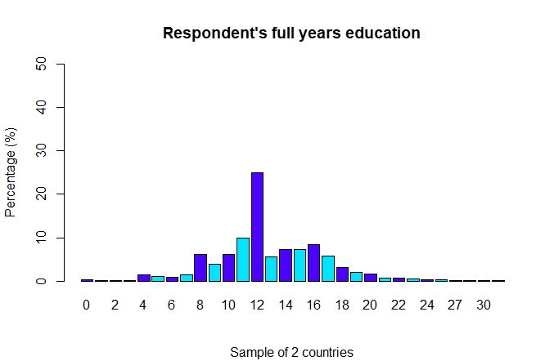

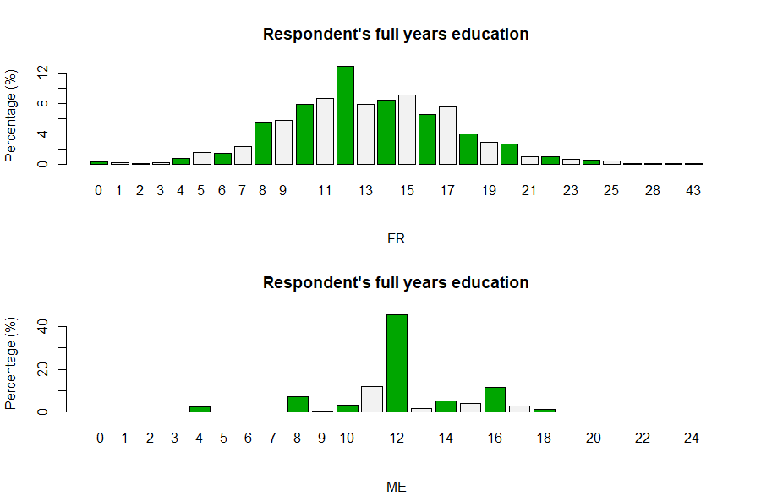

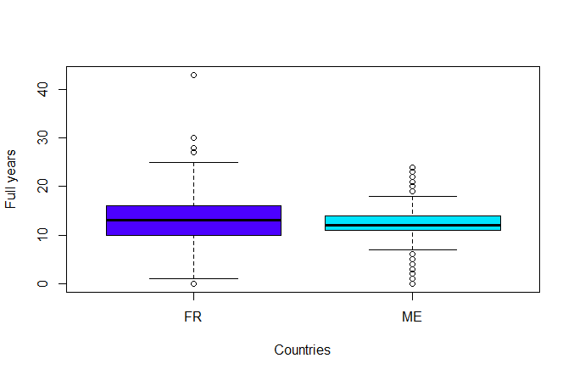

**Education Years in France (FR):**

Minimum: 0 years

1st Quartile (25th percentile): 10 years

Median (50th percentile): 13 years

Mean: 13.12 years

3rd Quartile (75th percentile): 16 years

Maximum: 43 years

NA's: 38

**Education Years in Montenegro (ME):**

Minimum: 0 years

1st Quartile (25th percentile): 11 years

Median (50th percentile): 12 years

Mean: 12.24 years

3rd Quartile (75th percentile): 14 years

Maximum: 24 years

NA's: 24

**Similar Trends:**

Both countries have the same minimum education duration (0 years).

The median education duration in both countries is relatively close, with France at 13 years and Montenegro at 12 years.

**Different Trends:**

France (FR) generally shows slightly higher quartile values (1st, 3rd) and a higher maximum education duration compared to Montenegro (ME).

Montenegro (ME) has a lower mean education duration (12.24 years) compared to France (FR) with a mean of 13.12 years.

There are more missing values (NA's) for education years in France (FR) compared to Montenegro (ME).

**EMPLOYMENT**

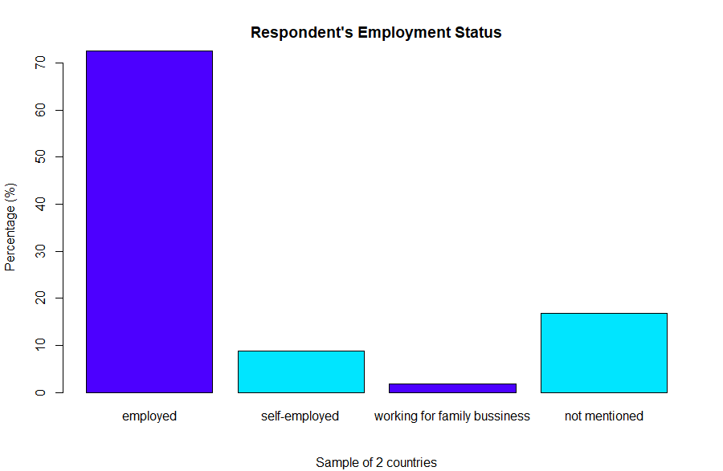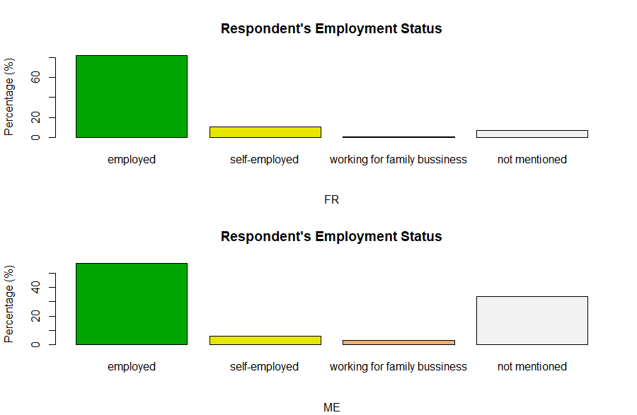

=========================================================

Country

essw9$empl_factor FR ME Total

---------------------------------------------------------

employed 1646 682 2328

70.7% 29.3% 72.5%

81.9% 56.8%

15.387 -15.387

---------------------------------------------------------

self-employed 211 74 285

74.0% 26.0% 8.9%

10.5% 6.2%

4.174 -4.174

---------------------------------------------------------

working for family bussiness 17 40 57

29.8% 70.2% 1.8%

0.8% 3.3%

-5.163 5.163

---------------------------------------------------------

not mentioned 136 404 540

25.2% 74.8% 16.8%

6.8% 33.7%

-19.713 19.713

---------------------------------------------------------

Total 2010 1200 3210

62.6% 37.4%

=========================================================

**Employed:**

FR: 1646 (70.7%)

ME: 682 (29.3%)

Total: 2328 (72.5%)

Employment percentages: FR (81.9%), ME (56.8%)

Difference (FR - ME): 15.387

**Self-employed:**

FR: 211 (74.0%)

ME: 74 (26.0%)

Total: 285 (8.9%)

Self-employment percentages: FR (10.5%), ME (6.2%)

Difference (FR - ME): 4.174

**Working for Family Business:**

FR: 17 (29.8%)

ME: 40 (70.2%)

Total: 57 (1.8%)

Percentages: FR (0.8%), ME (3.3%)

Difference (FR - ME): -5.163

**Not Mentioned:**

FR: 136 (25.2%)

ME: 404 (74.8%)

Total: 540 (16.8%)

Percentages: FR (6.8%), ME (33.7%)

Difference (FR - ME): -19.713

**Total:**

FR: 2010 (62.6%)

ME: 1200 (37.4%)

Total respondents: 3210

**Trends:**

France (FR) has a notably higher percentage of employed individuals compared to Montenegro (ME).

Self-employment percentages are higher in France (FR) than in Montenegro (ME), but both are relatively low.

Montenegro (ME) has a higher proportion of individuals working for family businesses compared to France (FR).

A substantial number of respondents in Montenegro (ME) have not mentioned their employment status compared to France (FR).

**Influence in employment**

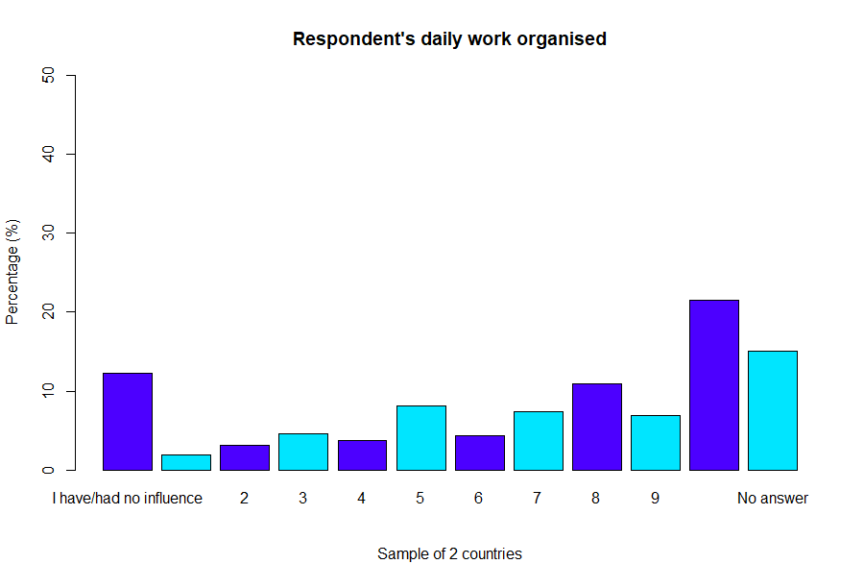

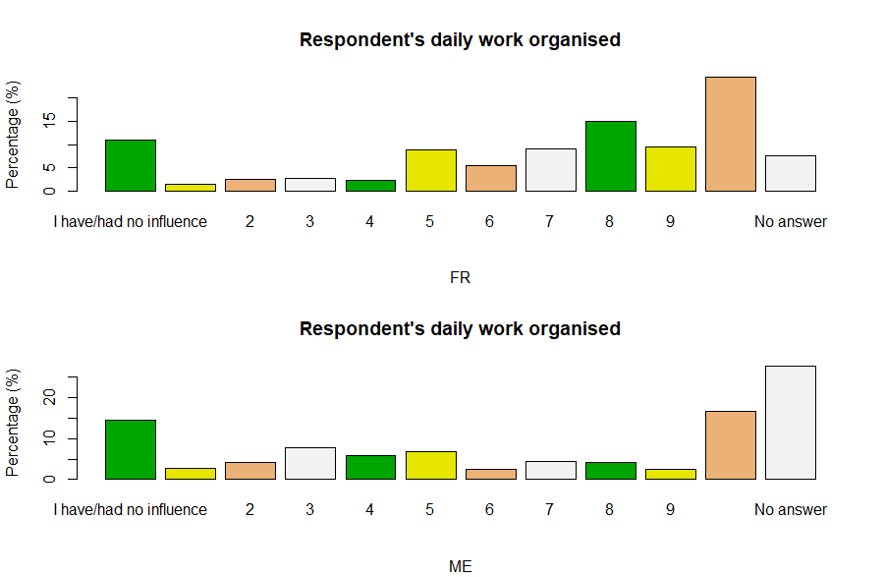

=======================================================

Country

essw9$wkdcorga_factor FR ME Total

-------------------------------------------------------

I have/had no influence 220 174 394

55.8% 44.2% 12.3%

10.9% 14.5%

-2.969 2.969

-------------------------------------------------------

1 28 33 61

45.9% 54.1% 1.9%

1.4% 2.8%

-2.724 2.724

-------------------------------------------------------

2 50 51 101

49.5% 50.5% 3.1%

2.5% 4.2%

-2.767 2.767

-------------------------------------------------------

3 56 92 148

37.8% 62.2% 4.6%

2.8% 7.7%

-6.379 6.379

-------------------------------------------------------

4 48 71 119

40.3% 59.7% 3.7%

2.4% 5.9%

-5.119 5.119

-------------------------------------------------------

5 180 82 262

68.7% 31.3% 8.2%

9.0% 6.8%

2.124 -2.124

-------------------------------------------------------

6 108 30 138

78.3% 21.7% 4.3%

5.4% 2.5%

3.883 -3.883

-------------------------------------------------------

7 184 53 237

77.6% 22.4% 7.4%

9.2% 4.4%

4.966 -4.966

-------------------------------------------------------

8 301 51 352

85.5% 14.5% 11.0%

15.0% 4.2%

9.409 -9.409

-------------------------------------------------------

9 191 31 222

86.0% 14.0% 6.9%

9.5% 2.6%

7.475 -7.475

-------------------------------------------------------

I have/had complete control 491 200 691

71.1% 28.9% 21.5%

24.4% 16.7%

5.176 -5.176

-------------------------------------------------------

No answer 153 332 485

31.5% 68.5% 15.1%

7.6% 27.7%

-15.350 15.350

-------------------------------------------------------

Total 2010 1200 3210

62.6% 37.4%

=======================================================

**No Influence:**

FR: 220 (55.8%)

ME: 174 (44.2%)

Total: 394 (12.3%)

Percentages: FR (10.9%), ME (14.5%)

Difference (FR - ME): -2.969

**Gradations of Influence Levels (1-9):**

Individuals from France tend to report higher levels of control (from 5 to 9) over their work compared to Montenegro. Montenegro has low level of influence (from 1 to 4) compare to France

**Complete Control:**

FR: 491 (71.1%)

ME: 200 (28.9%)

Total: 691 (21.5%)

Percentages: FR (24.4%), ME (16.7%)

Difference (FR - ME): 5.176

**No Answer:**

FR: 153 (31.5%)

ME: 332 (68.5%)

Total: 485 (15.1%)

Percentages: FR (7.6%), ME (27.7%)

Difference (FR - ME): -15.350

**Total Responses:**

FR: 2010 (62.6%)

ME: 1200 (37.4%)

Total respondents: 3210

**Trends:**

Individuals in Montenegro (ME) show a higher tendency to report varying degrees of control over their work compared to France (FR).

Montenegro (ME) has a higher proportion of individuals reporting complete control over their work compared to France (FR).

A notable number of respondents from Montenegro (ME) did not provide an answer regarding their level of control over their work, significantly higher than in France (FR).

**Contracted hours**

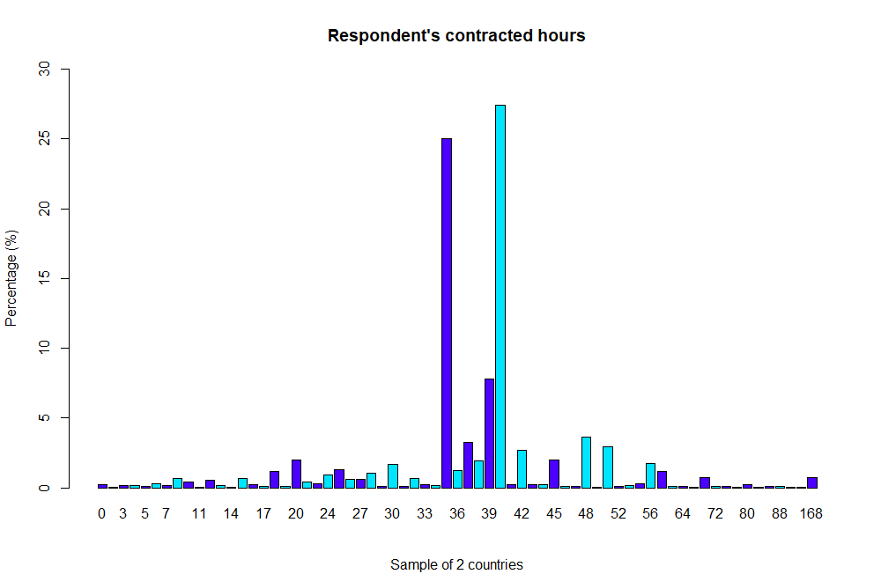

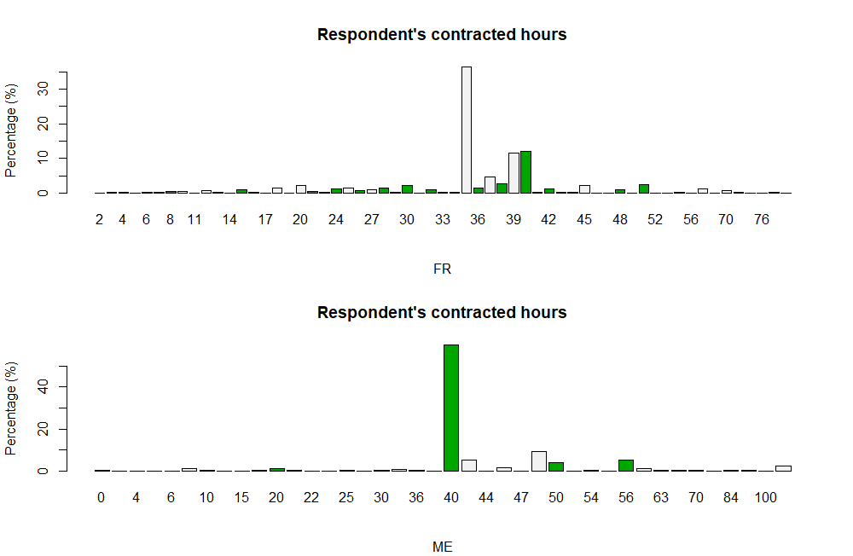

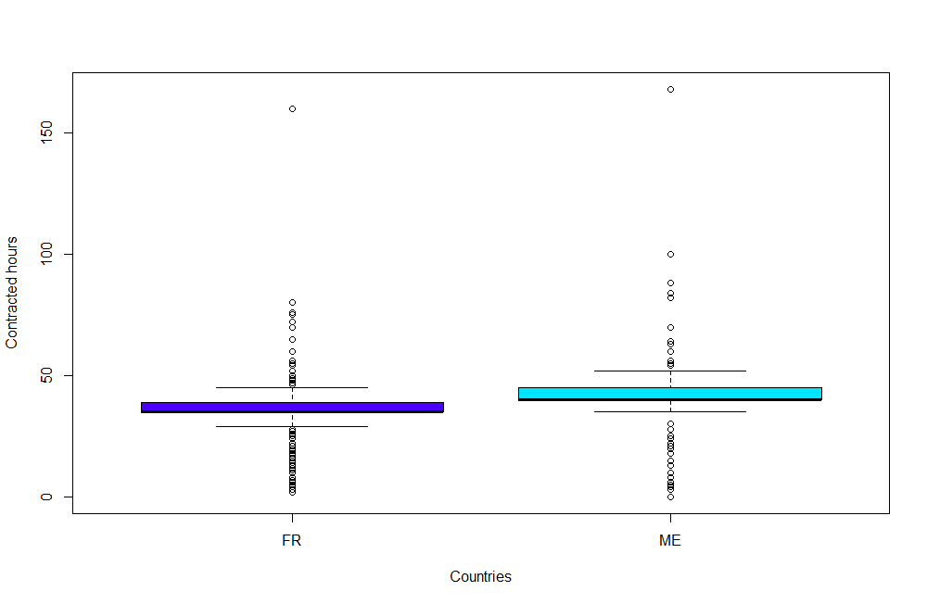

Work Hours per Week:

**France (FR):**

Minimum: 2 hours

1st Quartile: 35 hours

Median: 35 hours

Mean: 35.65 hours

3rd Quartile: 39 hours

Maximum: 160 hours

NA's: 357

**Montenegro (ME):**

Minimum: 0 hours

1st Quartile: 40 hours

Median: 40 hours

Mean: 44.63 hours

3rd Quartile: 45 hours

Maximum: 168 hours

NA's: 417

**France (FR):**

Work hours range from a minimum of 2 hours to a maximum of 160 hours per week.

The median and mean work hours are relatively similar, suggesting a moderate central tendency.

**Montenegro (ME):**

Work hours range from a minimum of 0 hours to a maximum of 168 hours per week.

The mean work hours are notably higher compared to the median, indicating potential outliers or a skewed distribution towards longer work hours.

**Trends:**

The mean work hours in Montenegro (ME) are notably higher than in France (FR), indicating a potential tendency towards longer work hours among respondents in Montenegro.

Montenegro (ME) shows a wider range of reported work hours, including cases of no reported work hours (minimum of 0) and instances with extremely high work hours (maximum of 168). France (FR) has a narrower range overall.

**Variables Section D**

***bthcld***

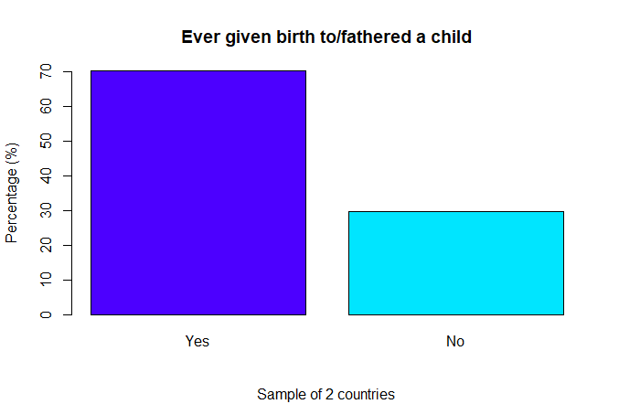

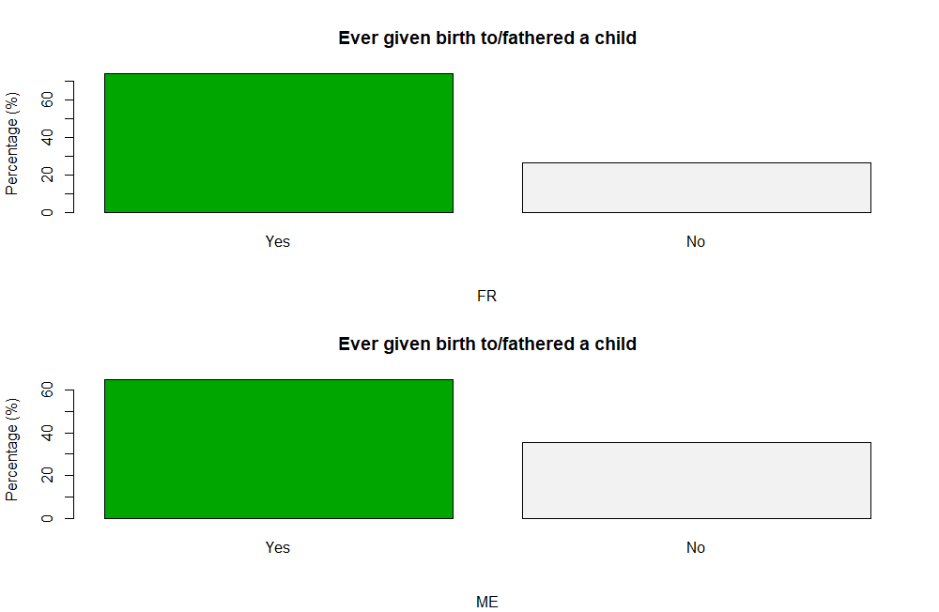

==============================================

Country

essw9$bthcld_factor FR ME Total

----------------------------------------------

Yes 1481 772 2253

65.7% 34.3% 70.2%

73.7% 64.3%

5.602 -5.602

----------------------------------------------

No 527 423 950

55.5% 44.5% 29.6%

26.2% 35.2%

-5.423 5.423

----------------------------------------------

NA 2 5 7

28.6% 71.4% 0.2%

0.1% 0.4%

-1.864 1.864

----------------------------------------------

Total 2010 1200 3210

62.6% 37.4%

==============================================

Ever Given Birth/Fathered a Child:

**France (FR):**

Yes: 1481 respondents (65.7%)

No: 527 respondents (23.4%)

NA: 2 respondents (0.1%)

Total: 2010 respondents

**Montenegro (ME):**

Yes: 772 respondents (34.3%)

No: 423 respondents (18.8%)

NA: 5 respondents (0.2%)

Total: 1200 respondents

**Trends:**

The percentage of respondents who have given birth or fathered a child is notably higher in France (FR) compared to Montenegro (ME).

Conversely, the percentage of respondents who have not given birth or fathered a child is higher in Montenegro (ME) compared to France (FR).

***ggchld***

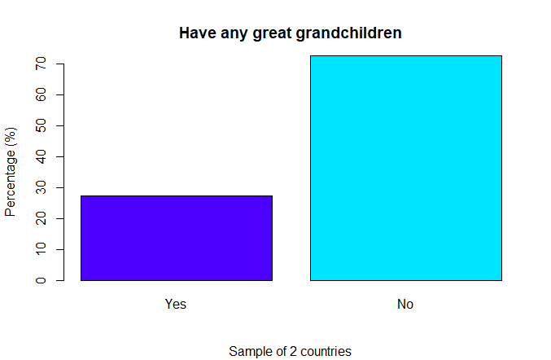

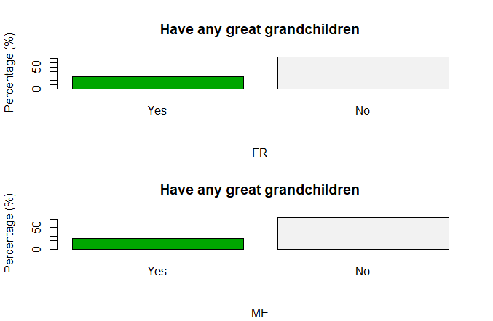

==============================================

Country

essw9$ggchld_factor FR ME Total

----------------------------------------------

Yes 98 26 124

79.0% 21.0% 3.9%

4.9% 2.2%

3.853 -3.853

----------------------------------------------

No 258 74 332

77.7% 22.3% 10.3%

12.8% 6.2%

6.003 -6.003

----------------------------------------------

NA 1654 1100 2754

60.1% 39.9% 85.8%

82.3% 91.7%

-7.364 7.364

----------------------------------------------

Total 2010 1200 3210

62.6% 37.4%

==============================================

Having Great Grandchildren:

**France (FR):**

Yes: 98 respondents (79.0% of the known responses)

No: 258 respondents (77.7% of the known responses)

NA: 1654 respondents (60.1% of the total)

**Montenegro (ME):**

Yes: 26 respondents (21.0% of the known responses)

No: 74 respondents (22.3% of the known responses)

NA: 1100 respondents (39.9% of the total)

**Trends:**

In both countries, there's a larger percentage of respondents who did not provide information about having great-grandchildren, which makes it challenging to draw comprehensive conclusions from these numbers.

**iagmr**

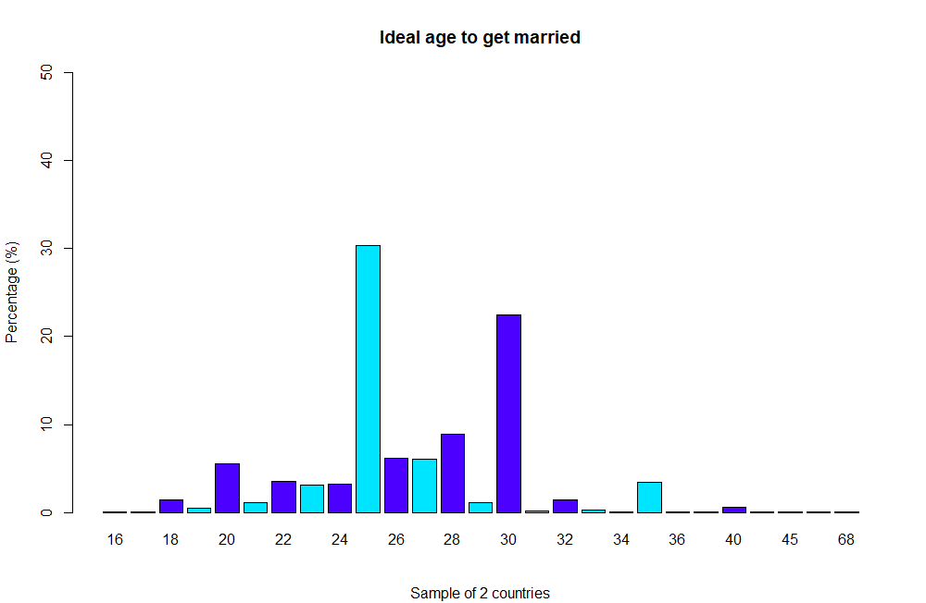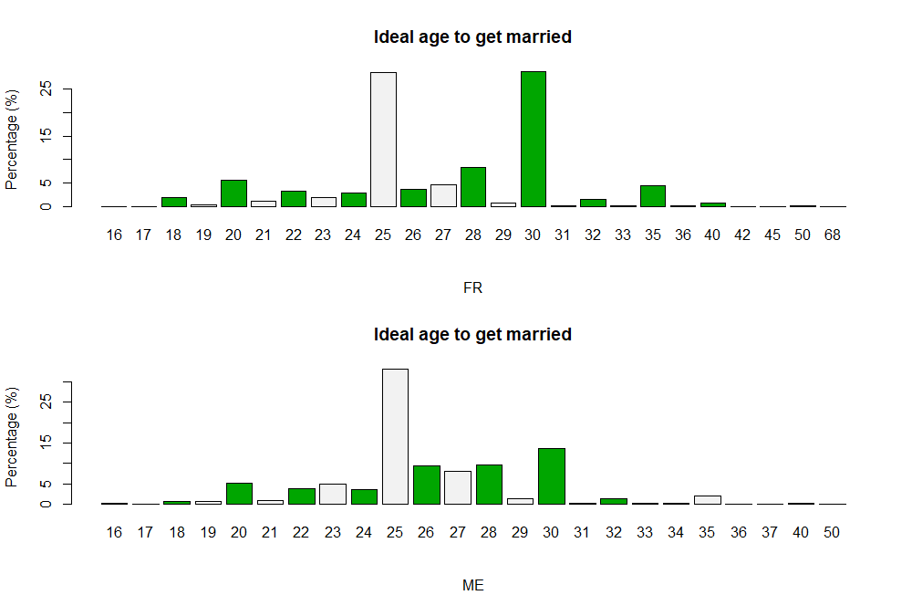

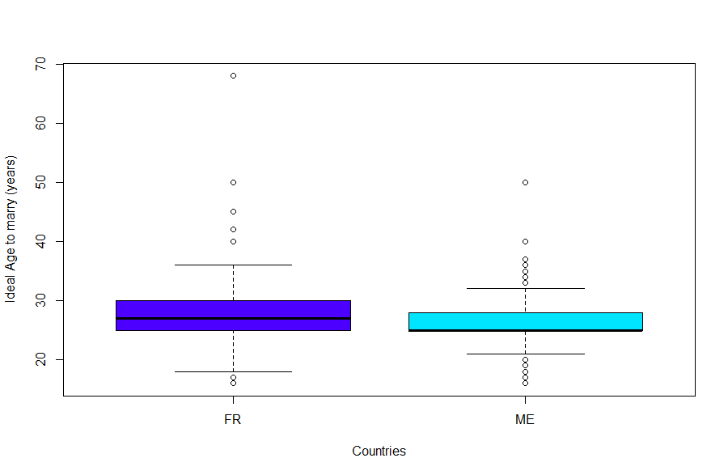

Ideal Age to Get Married:

**For France (FR):**

Minimum value: 16.00

1st Quartile: 25.00

Median: 27.00

Mean: 26.98

3rd Quartile: 30.00

Maximum value: 68.00

Number of missing values (NA): 348

**For Montenegro (ME):**

Minimum value: 16.00

1st Quartile: 25.00

Median: 25.00

Mean: 26.08

3rd Quartile: 28.00

Maximum value: 50.00

Number of missing values (NA): 54

**Trends:**

Overall, there is a similarity in the distribution of ideal marriage age between the two countries, with some differences in the mean and maximum values.

Respondents in France have a wider range of responses, as indicated by the higher maximum value.

The presence of significantly higher ages as the maximum reported ideal age for marriage might skew the mean, suggesting some extreme responses in both countries.

25 or 26 is an ideal age to get married. We can consider it because when you get to 25th ‘point’ in your life at least you have finished university, has some experience in job and you have some property like apartment or a car.

**iagrtr**

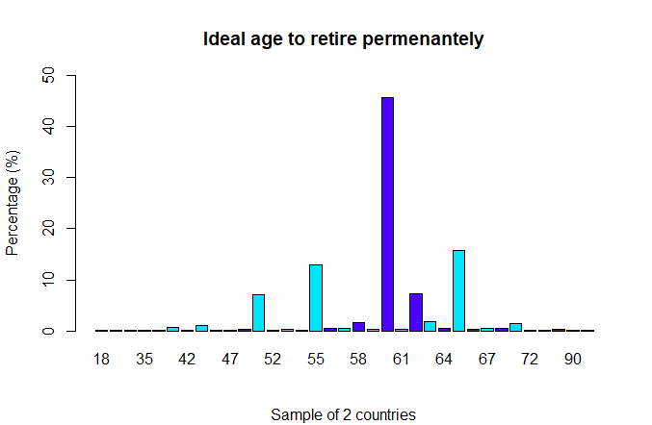

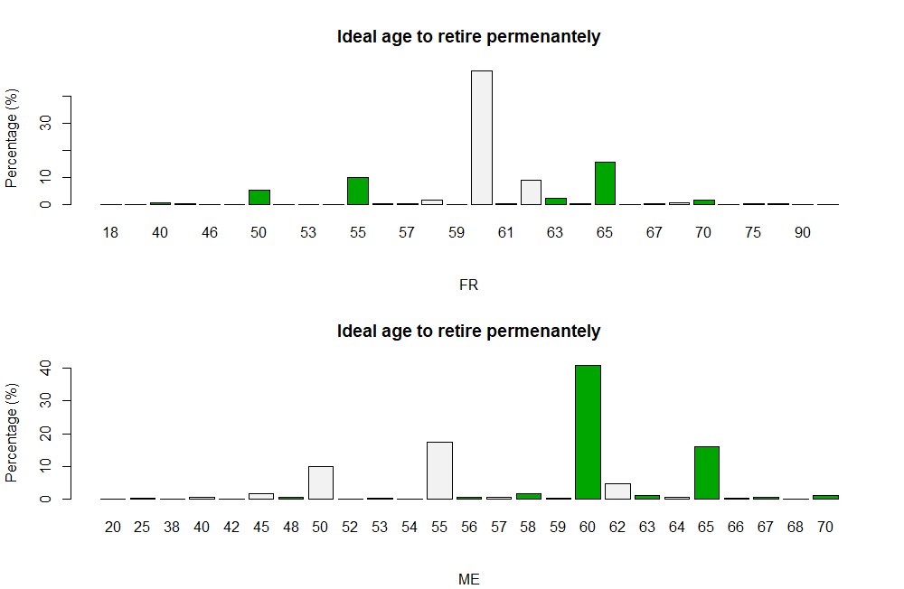

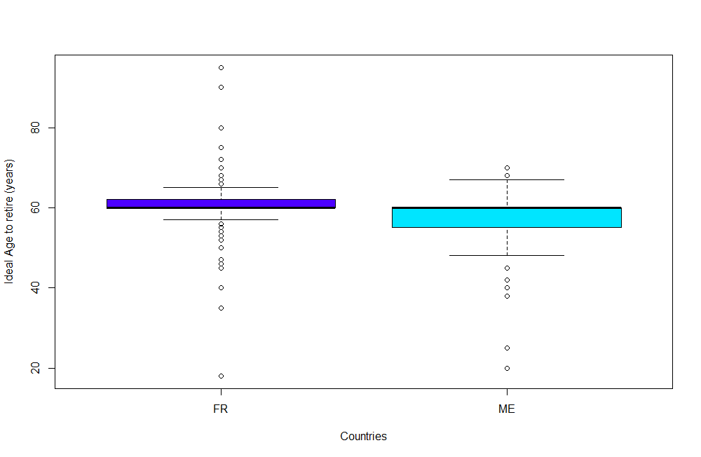

**France (FR):**

Minimum value: 18.00

1st Quartile: 60.00

Median: 60.00

Mean: 60.05

3rd Quartile: 62.00

Maximum value: 95.00

Number of missing values (NA): 288

**Montenegro (ME):**

Minimum value: 20.0

1st Quartile: 55.0

Median: 60.0

Mean: 58.6

3rd Quartile: 60.0

Maximum value: 70.0

Number of missing values (NA): 46

**Comparison:**

The minimum ideal retirement age (iagrtr) in France is lower (18.00) compared to Montenegro (20.0).

The median and 3rd quartile values are the same in both countries (60.00), indicating a common perception of the ideal retirement age at the middle and upper levels.

The mean ideal retirement age is slightly higher in France (60.05) than in Montenegro (58.6).

The maximum value representing the ideal retirement age is higher in France (95.00) compared to Montenegro (70.0).

There are more missing values (NA) in France (288) than in Montenegro (46).

**Trends:**

Both countries have a similar median and 3rd quartile for the ideal retirement age, suggesting a common perception in these segments.

France has a wider range of responses, as indicated by the higher maximum value for the ideal retirement age.

The mean retirement age is slightly higher in France compared to Montenegro, reflecting a marginal difference in the central tendency of the perceived ideal retirement age.

**evmar**

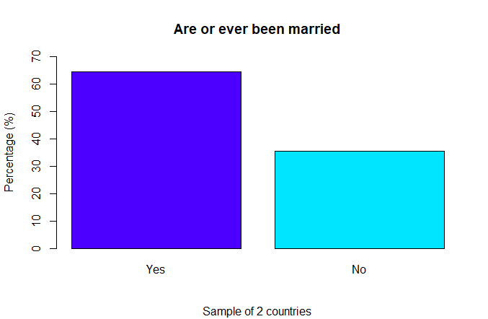

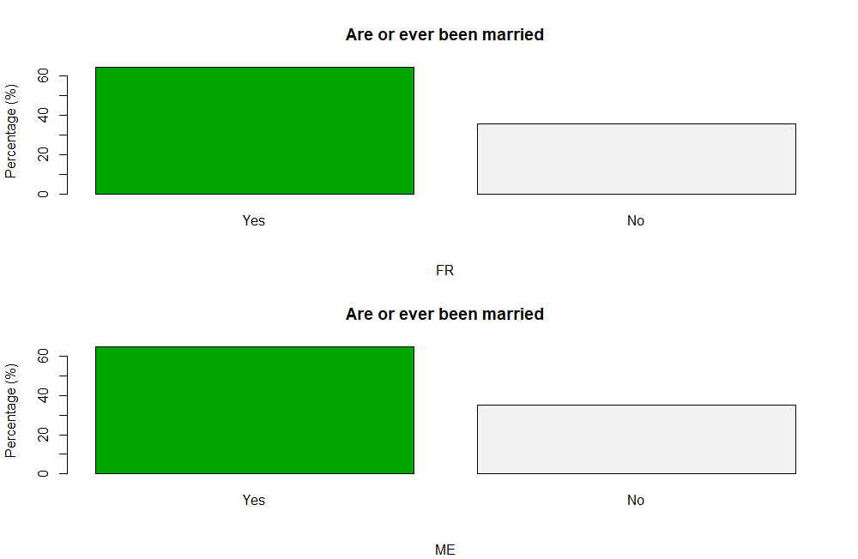

=============================================

Country

essw9$evmar_factor FR ME Total

---------------------------------------------

Yes 1291 774 2065

62.5% 37.5% 64.3%

64.2% 64.5%

-0.155 0.155

---------------------------------------------

No 718 418 1136

63.2% 36.8% 35.4%

35.7% 34.8%

0.509 -0.509

---------------------------------------------

NA 1 8 9

11.1% 88.9% 0.3%

0.0% 0.7%

-3.198 3.198

---------------------------------------------

Total 2010 1200 3210

62.6% 37.4%

=============================================

**France (FR):**

Yes: 1291 (62.5%)

No: 718 (63.2%)

NA: 1 (11.1%)

Total: 2010 (62.6%)

**Montenegro (ME):**

Yes: 774 (37.5%)

No: 418 (36.8%)

NA: 8 (88.9%)

Total: 1200 (37.4%)

**Comparison:**

In France, the proportion of individuals who have been or are currently married (evmar_factor) is higher (62.5%) compared to Montenegro (37.5%).

The proportion of individuals who have never been married is slightly higher in Montenegro (36.8%) compared to France (63.2%).

There are more missing values (NA) related to marital status in Montenegro (88.9%) than in France (11.1%).

**Trends:**

France shows a higher percentage of individuals who have experienced marriage, while Montenegro has a slightly higher proportion of individuals who have never been married.

The presence of a significantly higher percentage of missing values in Montenegro could indicate a greater reluctance or omission to disclose marital status in this country compared to France.

**Variable G Section**

**occinfr**

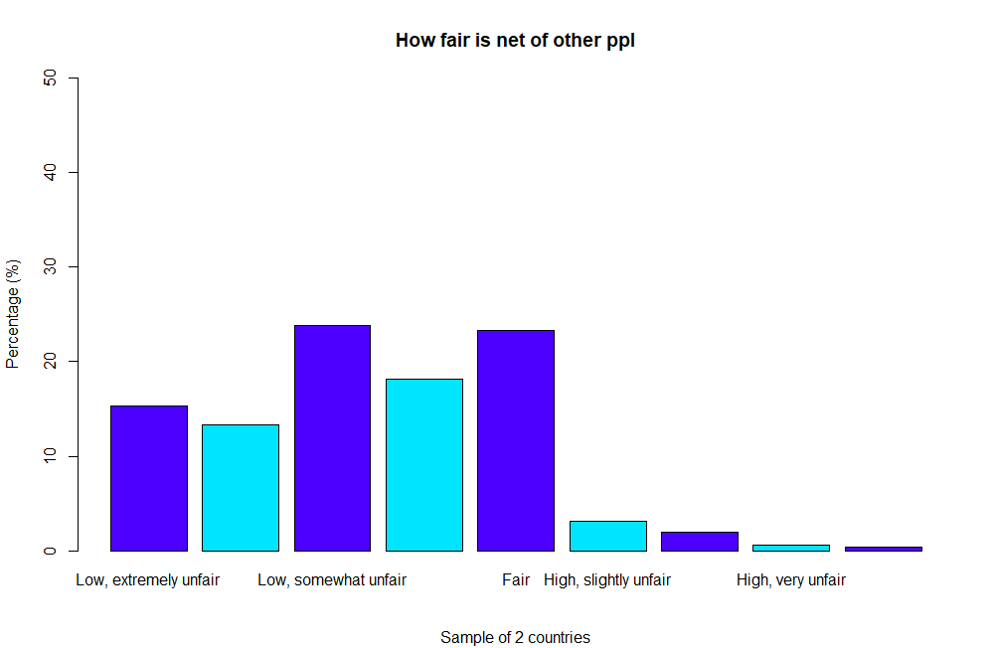

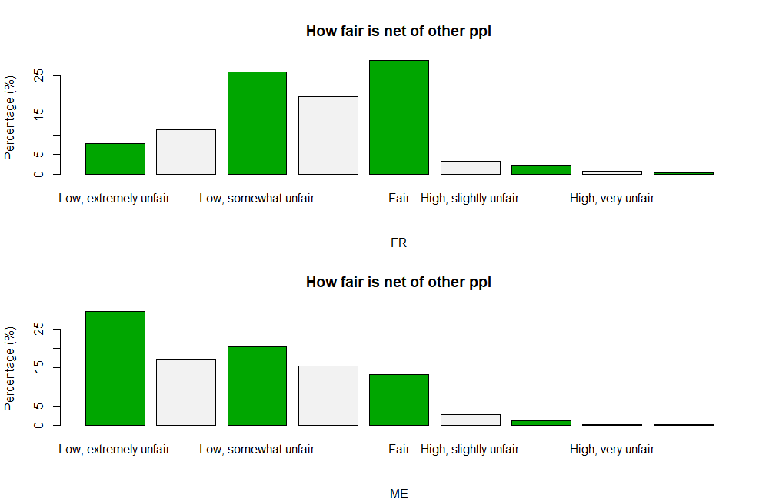

===================================================

Country

essw9$occinfr_factor FR ME Total

---------------------------------------------------

Low, extremely unfair 135 278 413

32.7% 67.3% 12.9%

6.7% 23.2%

-13.468 13.468

---------------------------------------------------

Low, very unfair 196 161 357

54.9% 45.1% 11.1%

9.8% 13.4%

-3.196 3.196

---------------------------------------------------

Low, somewhat unfair 451 191 642

70.2% 29.8% 20.0%

22.4% 15.9%

4.469 -4.469

---------------------------------------------------

Low, slightly unfair 344 145 489

70.3% 29.7% 15.2%

17.1% 12.1%

3.838 -3.838

---------------------------------------------------

Fair 502 125 627

80.1% 19.9% 19.5%

25.0% 10.4%

10.066 -10.066

---------------------------------------------------

High, slightly unfair 58 26 84

69.0% 31.0% 2.6%

2.9% 2.2%

1.234 -1.234

---------------------------------------------------

High, somewhat unfair 41 11 52

78.8% 21.2% 1.6%

2.0% 0.9%

2.439 -2.439

---------------------------------------------------

High, very unfair 13 3 16

81.2% 18.8% 0.5%

0.6% 0.2%

1.544 -1.544

---------------------------------------------------

High, extremely unfair 6 3 9

66.7% 33.3% 0.3%

0.3% 0.2%

0.251 -0.251

---------------------------------------------------

NA 264 257 521

50.7% 49.3% 16.2%

13.1% 21.4%

-6.157 6.157

---------------------------------------------------

Total 2010 1200 3210

62.6% 37.4%

**France (FR):**

Low, extremely unfair: 135 (32.7%)

Low, very unfair: 196 (54.9%)

Low, somewhat unfair: 451 (70.2%)

Low, slightly unfair: 344 (70.3%)

Fair: 502 (80.1%)

High, slightly unfair: 58 (69.0%)

High, somewhat unfair: 41 (78.8%)

High, very unfair: 13 (81.2%)

High, extremely unfair: 6 (66.7%)

NA: 264 (50.7%)

**Montenegro (ME):**

Low, extremely unfair: 278 (67.3%)

Low, very unfair: 161 (45.1%)

Low, somewhat unfair: 191 (29.8%)

Low, slightly unfair: 145 (29.7%)

Fair: 125 (19.9%)

High, slightly unfair: 26 (31.0%)

High, somewhat unfair: 11 (21.2%)

High, very unfair: 3 (18.8%)

High, extremely unfair: 3 (33.3%)

NA: 257 (49.3%)

**Comparison:**

The perception of fairness in terms of occupational income seems to differ notably between France and Montenegro.

In France, higher percentages are more inclined to rate their income as fair or slightly unfair, while in Montenegro, there's a higher percentage perceiving it as extremely unfair or having no opinion (NA).

Both countries share a similar pattern in the lower levels of perceived unfairness but diverge in the higher levels, with Montenegro showing higher percentages in these extreme categories.

**Trends:**

Montenegro displays a more polarized perspective regarding occupational income fairness, with more individuals leaning towards the extreme unfairness or having no opinion compared to France.

France showcases a more balanced distribution across the fairness spectrum, with a higher proportion perceiving their income as fair or slightly unfair.

**grspfr**

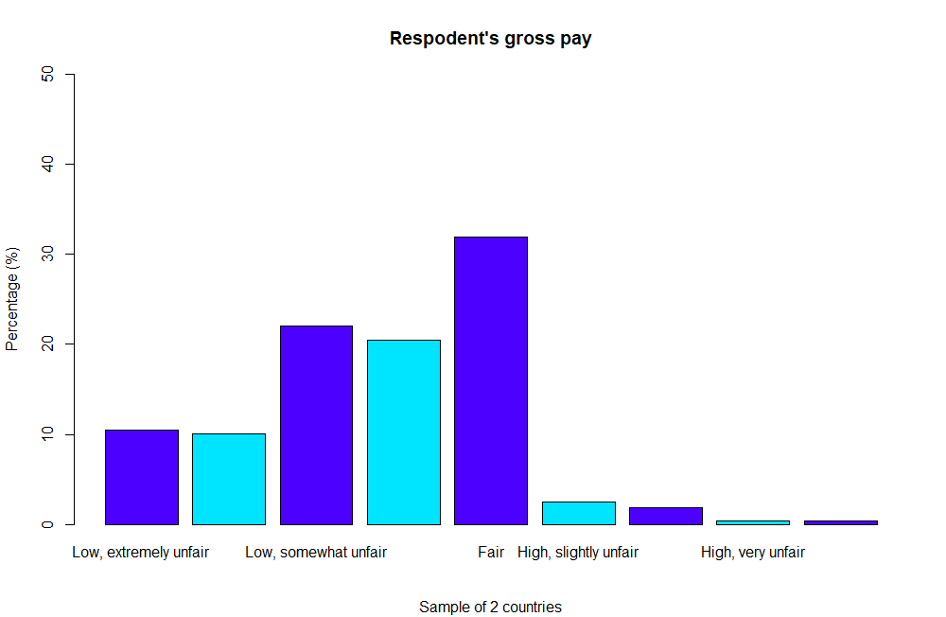

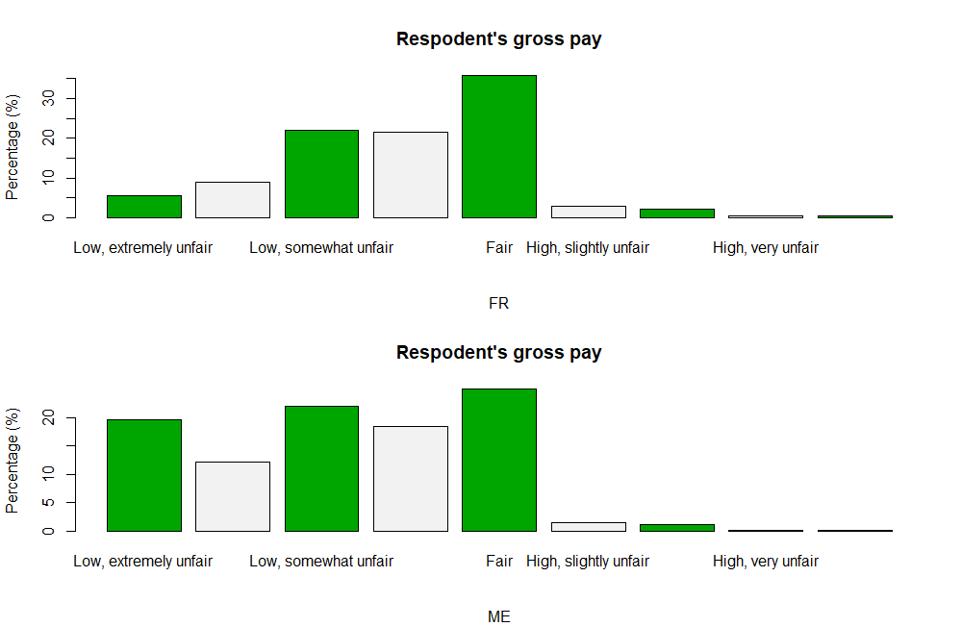

=================================================

Country

essw9$grspfr_factor FR ME Total

-------------------------------------------------

Low, extremely unfair 54 104 158

34.2% 65.8% 4.9%

2.7% 8.7%

-7.578 7.578

-------------------------------------------------

Low, very unfair 87 64 151

57.6% 42.4% 4.7%

4.3% 5.3%

-1.301 1.301

-------------------------------------------------

Low, somewhat unfair 216 116 332

65.1% 34.9% 10.3%

10.7% 9.7%

0.972 -0.972

-------------------------------------------------

Low, slightly unfair 212 97 309

68.6% 31.4% 9.6%

10.5% 8.1%

2.290 -2.290

-------------------------------------------------

Fair 350 132 482

72.6% 27.4% 15.0%

17.4% 11.0%

4.921 -4.921

-------------------------------------------------

High, slightly unfair 29 8 37

78.4% 21.6% 1.2%

1.4% 0.7%

1.993 -1.993

-------------------------------------------------

High, somewhat unfair 22 6 28

78.6% 21.4% 0.9%

1.1% 0.5%

1.753 -1.753

-------------------------------------------------

High, very unfair 4 1 5

80.0% 20.0% 0.2%

0.2% 0.1%

0.804 -0.804

-------------------------------------------------

High, extremely unfair 4 1 5

80.0% 20.0% 0.2%

0.2% 0.1%

0.804 -0.804

-------------------------------------------------

NA 1032 671 1703

60.6% 39.4% 53.1%

51.3% 55.9%

-2.512 2.512

-------------------------------------------------

Total 2010 1200 3210

62.6% 37.4%

=================================================

**France (FR):**

Low, extremely unfair: 34.2%

Low, very unfair: 57.6%

Low, somewhat unfair: 65.1%

Low, slightly unfair: 68.6%

Fair: 72.6%

High, slightly unfair: 78.4%

High, somewhat unfair: 78.6%

High, very unfair: 80.0%

High, extremely unfair: 80.0%

NA: 60.6%

**Montenegro (ME):**

Low, extremely unfair: 65.8%

Low, very unfair: 42.4%

Low, somewhat unfair: 34.9%

Low, slightly unfair: 31.4%

Fair: 27.4%

High, slightly unfair: 21.6%

High, somewhat unfair: 21.4%

High, very unfair: 20.0%

High, extremely unfair: 20.0%

NA: 39.4%

**Comparison:**

Montenegro (ME) has higher percentages in the extremely unfair and very unfair categories for gross pay compared to France (FR), where lower percentages are observed in these categories.

France shows a higher inclination towards the "Fair" category than Montenegro.

In both countries, the majority perceive their gross pay as unfairly low across different degrees of unfairness.

**Trends:**

Montenegro has a higher proportion of respondents perceiving their gross pay as extremely unfair or very unfair compared to France.

France has a more sign**i**ficant proportion perceiving their gross pay as fair than Montenegro.

**netifr**

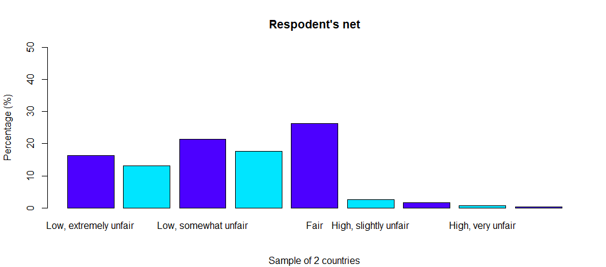

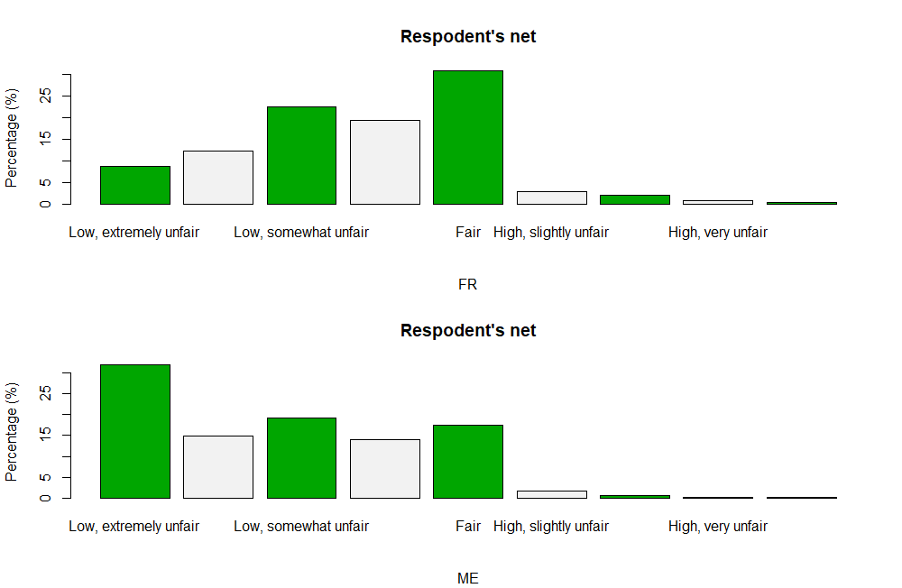

==================================================

Country

essw9$netifr_factor FR ME Total

--------------------------------------------------

Low, extremely unfair 159 290 449

35.4% 64.6% 14.0%

7.9% 24.2%

-12.847 12.847

--------------------------------------------------

Low, very unfair 225 136 361

62.3% 37.7% 11.2%

11.2% 11.3%

-0.121 0.121

--------------------------------------------------

Low, somewhat unfair 410 174 584

70.2% 29.8% 18.2%

20.4% 14.5%

4.191 -4.191

--------------------------------------------------

Low, slightly unfair 355 127 482

73.7% 26.3% 15.0%

17.7% 10.6%

5.432 -5.432

--------------------------------------------------

Fair 563 159 722

78.0% 22.0% 22.5%

28.0% 13.2%

9.690 -9.690

--------------------------------------------------

High, slightly unfair 54 15 69

78.3% 21.7% 2.1%

2.7% 1.2%

2.715 -2.715

--------------------------------------------------

High, somewhat unfair 40 6 46

87.0% 13.0% 1.4%

2.0% 0.5%

3.437 -3.437

--------------------------------------------------

High, very unfair 14 3 17

82.4% 17.6% 0.5%

0.7% 0.2%

1.686 -1.686

--------------------------------------------------

High, extremely unfair 8 2 10

80.0% 20.0% 0.3%

0.4% 0.2%

1.138 -1.138

--------------------------------------------------

NA 182 288 470

38.7% 61.3% 14.6%

9.1% 24.0%

-11.588 11.588

--------------------------------------------------

Total 2010 1200 3210

62.6% 37.4%

**France (FR):**

Low, extremely unfair: 35.4%

Low, very unfair: 62.3%

Low, somewhat unfair: 70.2%

Low, slightly unfair: 73.7%

Fair: 78.0%

High, slightly unfair: 78.3%

High, somewhat unfair: 87.0%

High, very unfair: 82.4%

High, extremely unfair: 80.0%

NA: 38.7%

**Montenegro (ME):**

Low, extremely unfair: 64.6%

Low, very unfair: 37.7%

Low, somewhat unfair: 29.8%

Low, slightly unfair: 26.3%

Fair: 22.0%

High, slightly unfair: 21.7%

High, somewhat unfair: 13.0%

High, very unfair: 17.6%

High, extremely unfair: 20.0%

NA: 61.3%

**Comparison:**

Montenegro (ME) has a higher percentage of individuals perceiving their net pay as extremely or very unfair compared to France (FR).

France shows higher percentages in fair categories than Montenegro.

**Trends:**

Montenegro demonstrates a notably higher proportion of respondents perceiving their net pay as extremely or very unfair compared to France.

France generally has a higher percentage of respondents perceiving their net pay as fair compared to Montenegro.

**netilet**

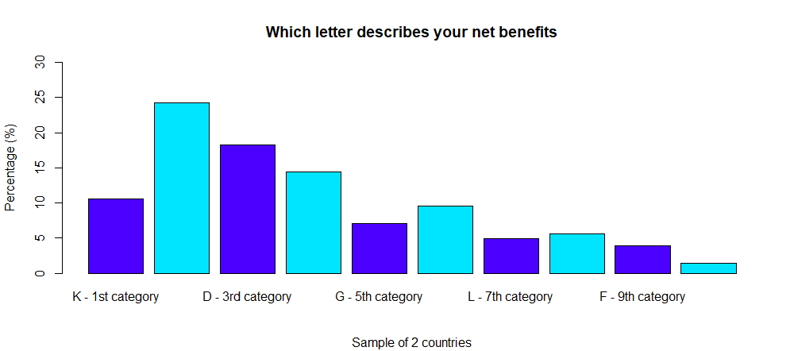

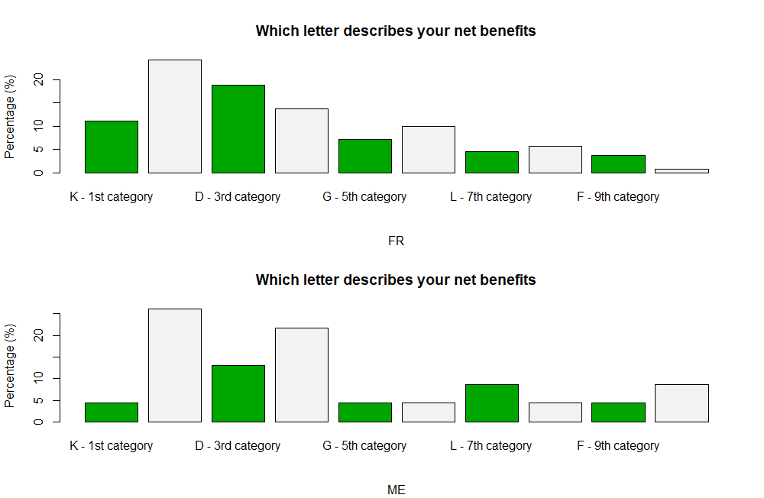

================================================

Country

essw9$netilet_factor FR ME Total

------------------------------------------------

K - 1st category 29 1 30

96.7% 3.3% 0.9%

1.4% 0.1%

3.873 -3.873

------------------------------------------------

S - 2nd category 63 6 69

91.3% 8.7% 2.1%

3.1% 0.5%

4.979 -4.979

------------------------------------------------

D - 3rd category 49 3 52

94.2% 5.8% 1.6%

2.4% 0.2%

4.751 -4.751

------------------------------------------------

N - 4th category 36 5 41

87.8% 12.2% 1.3%

1.8% 0.4%

3.355 -3.355

------------------------------------------------

G - 5th category 19 1 20

95.0% 5.0% 0.6%

0.9% 0.1%

3.003 -3.003

------------------------------------------------

T - 6th category 26 1 27

96.3% 3.7% 0.8%

1.3% 0.1%

3.632 -3.632

------------------------------------------------

L - 7th category 12 2 14

85.7% 14.3% 0.4%

0.6% 0.2%

1.790 -1.790

------------------------------------------------

Q - 8th category 15 1 16

93.8% 6.2% 0.5%

0.7% 0.1%

2.580 -2.580

------------------------------------------------

F - 9th category 10 1 11

90.9% 9.1% 0.3%

0.5% 0.1%

1.943 -1.943

------------------------------------------------

J - 10th category 2 2 4

50.0% 50.0% 0.1%

0.1% 0.2%

-0.522 0.522

------------------------------------------------

NA 1749 1177 2926

59.8% 40.2% 91.2%

87.0% 98.1%

-10.684 10.684

------------------------------------------------

Total 2010 1200 3210

62.6% 37.4%

**France (FR):**

K - 1st category: 96.7%

S - 2nd category: 91.3%

D - 3rd category: 94.2%

N - 4th category: 87.8%

G - 5th category: 95.0%

T - 6th category: 96.3%

L - 7th category: 85.7%

Q - 8th category: 93.8%

F - 9th category: 90.9%

J - 10th category: 50.0%

NA: 59.8%

**Montenegro (ME):**

K - 1st category: 3.3%

S - 2nd category: 8.7%

D - 3rd category: 5.8%

N - 4th category: 12.2%

G - 5th category: 5.0%

T - 6th category: 3.7%

L - 7th category: 14.3%

Q - 8th category: 6.2%

F - 9th category: 9.1%

J - 10th category: 50.0%

NA: 40.2%

**Comparison:**

The perception of fairness across categories is significantly different between the two countries.

France (FR) generally shows a higher proportion of respondents in all categories compared to Montenegro (ME), except for the 10th category (J).

**Observations:**

Montenegro has a notably lower percentage of respondents in all fairness categories and a higher proportion in the "Not Answered" (NA) category compared to France.

France demonstrates a consistent perception of higher fairness across various categories compared to Montenegro.

**evfrjob**

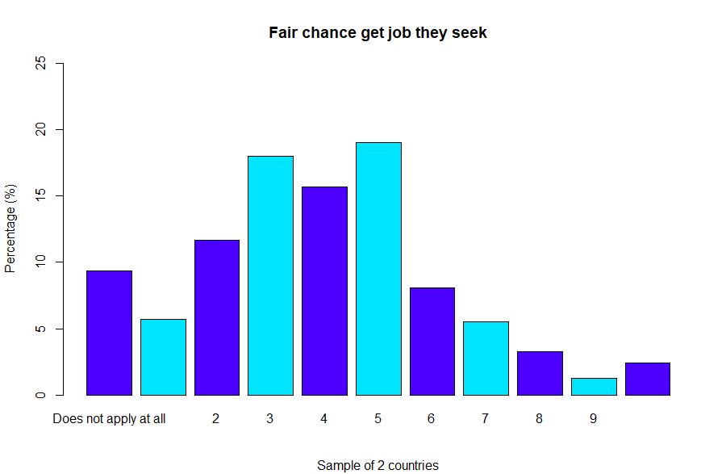

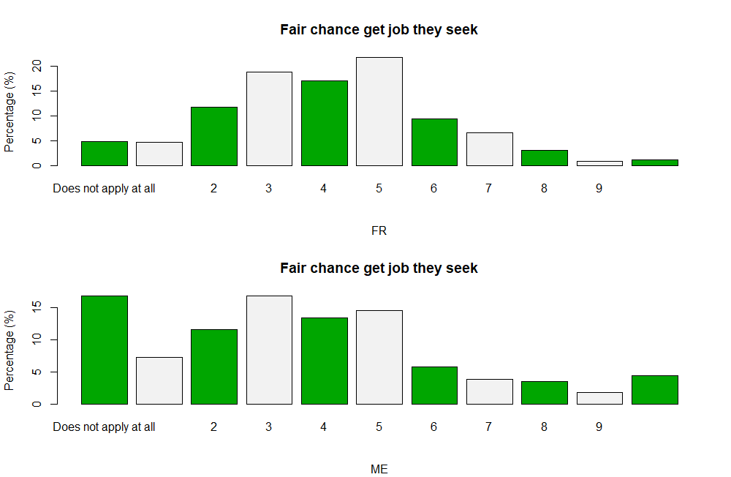

=================================================

Country

essw9$evfrjob_factor FR ME Total

-------------------------------------------------

Does not apply at all 96 198 294

32.7% 67.3% 9.2%

4.8% 16.5%

-11.142 11.142

-------------------------------------------------

1 93 86 179

52.0% 48.0% 5.6%

4.6% 7.2%

-3.034 3.034

-------------------------------------------------

2 231 137 368

62.8% 37.2% 11.5%

11.5% 11.4%

0.065 -0.065

-------------------------------------------------

3 369 198 567

65.1% 34.9% 17.7%

18.4% 16.5%

1.336 -1.336

-------------------------------------------------

4 336 158 494

68.0% 32.0% 15.4%

16.7% 13.2%

2.697 -2.697

-------------------------------------------------

5 427 172 599

71.3% 28.7% 18.7%

21.2% 14.3%

4.862 -4.862

-------------------------------------------------

6 186 69 255

72.9% 27.1% 7.9%

9.3% 5.8%

3.552 -3.552

-------------------------------------------------

7 129 45 174

74.1% 25.9% 5.4%

6.4% 3.8%

3.230 -3.230

-------------------------------------------------

8 61 41 102

59.8% 40.2% 3.2%

3.0% 3.4%

-0.597 0.597

-------------------------------------------------

9 18 22 40

45.0% 55.0% 1.2%

0.9% 1.8%

-2.317 2.317

-------------------------------------------------

Applies completely 24 52 76

31.6% 68.4% 2.4%

1.2% 4.3%

-5.660 5.660

-------------------------------------------------

NA 40 22 62

64.5% 35.5% 1.9%

2.0% 1.8%

0.312 -0.312

-------------------------------------------------

Total 2010 1200 3210

62.6% 37.4%

=================================================

**France (FR):**

Applies completely: 31.6%

9: 45.0%

8: 59.8%

7: 74.1%

6: 72.9%

5: 71.3%

4: 68.0%

3: 65.1%

2: 62.8%

1: 52.0%

Does not apply at all: 32.7%

NA: 64.5%

**Montenegro (ME):**

Applies completely: 68.4%

9: 55.0%

8: 40.2%

7: 25.9%

6: 27.1%

5: 28.7%

4: 32.0%

3: 34.9%

2: 37.2%

1: 48.0%

Does not apply at all: 67.3%

NA: 35.5%

**Comparison:**

In France, a higher proportion of respondents indicated "Does not apply at all" and lower levels of applying effort and initiative compared to Montenegro.

Montenegro showcases a higher percentage of respondents in categories indicating more effort and initiative compared to France.

Both countries exhibit a significant percentage of respondents choosing the "NA" option.

**Observations:**

The perceptions of effort and initiative in jobs differ notably between France and Montenegro, with Montenegro showing a higher inclination towards the application of effort and initiative compared to France.

The "NA" responses are notably higher in France compared to Montenegro, suggesting a greater uncertainty or reluctance to answer in France.

**TASK 7**

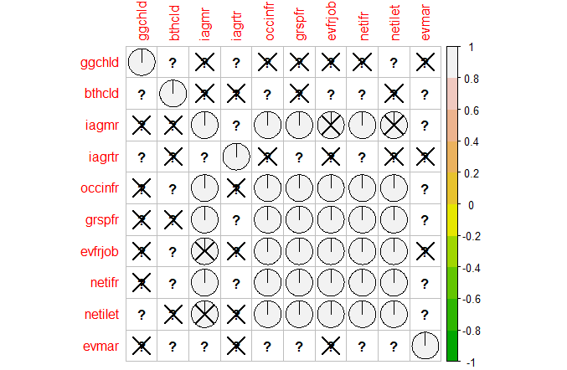

The Pearson correlation, which the code uses (using method = "pearson"), measures the linear relationship between two continuous variables. It takes values from -1 to 1  
A correlation close to 1 indicates a positive linear relationship (when both variables grow together).  
A correlation close to -1 indicates a negative linear relationship (when one variable increases and the other decreases).  
|A correlation near 0 indicates no linear relationship between the variables.

Colors indicate the strength of the correlation (green - negative, red - positive).

A question mark (?) may indicate incomplete data or that the values to perform a particular correlation calculation are missing from your dataset. This may be due to missing values (NA) or too few observations.

Crossed out cells indicate that there is not enough data to perform a statistical analysis. This can occur when there are too few values in the data for a given pair of variables to draw statistically significant conclusions about correlation.

Seemed interesting that there are correlation between iagmr (ideal age to get married) and such variables as occinfr (fairness of net), grspfr (fairness of gross pay) and netifr (how unfairly your net). While iagmr and occinfr may grow together, grspfr and netifr decrease.

**TASK 8**

The analysis examined multiple variables across different countries, highlighting correlations and distributions. It explored factors like retirement perceptions, fairness assessments, and job evaluations. One notable aspect was contrasting attitudes between countries, revealing intriguing disparities in opinions. Correlation plots showcased associations, indicating potential relationships worth exploring further. Interestingly, disparities in retirement perceptions and fairness assessments varied significantly among nations, hinting at cultural influences. The most compelling aspect was uncovering varying societal perspectives, underlining the complexity of opinions and attitudes across different cultural contexts. Overall, the analysis provided a window into diverse societal attitudes, inviting deeper investigations into cultural nuances shaping these perspectives.