**HA NOI UNIVERSITY OF SCIENCE AND TECHNOLOGY**



**NETWORK SOFTWARE ARCHITECTURE PROJECT**

**AUDIO SYSTEM**

**LECTURER:** PHAM HUY HOANG

**GROUP:** 5

CHU QUOC HUNG

NGUYEN NGOC THANH

NGUYEN DINH HAI NAM

Hanoi, 7th October 2018

Contents

I. Introduction 3

II. UPnP technology 3

III. Audio system functionalities 4

IV. Audio system architecture 5

V. Summary 6

# Introduction

* The growth in number of physical devices, home appliances, and other items embedded with electronics, connectivity joining the network has leverage the need of standard, easy-to-setup networking protocol that allows those devices communicate with each other. To meet these requirements, Universal Plug and Play or UPnP in short has been developed. This protocol specifies a communication method that allows devices to join the networks and transfer data easily.
* This report will discuss UPnP technology and its application in a simulated audio system. Next, the audio system functionalities and architecture will be reviewed in detail.
* In this scenario, the simulated audio system will communicate with a control point in a same computer, but it will be the same when standing alone. Both audio system and the control point are coded using Java with the help of Cling and JavaFX libraries.

# UPnP technology

* The UPnP architecture allows device-to-device networking of consumer electronics, personal computers, and networked home appliances. It is a distributed, open architecture protocol based on established standards such as Internet Protocol Suite (TCP/IP), HTTP, XML, and SOAP.

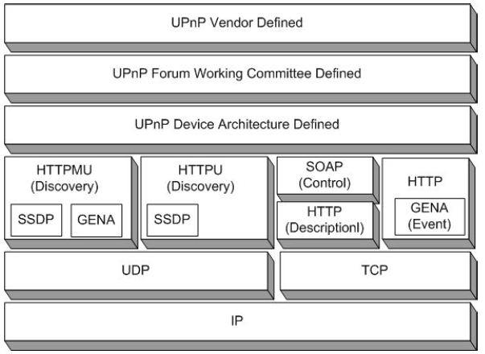

*UPnP based on many existed internet protocols such as UDP, TCP, IP, HTTP, SOAP, SSDP*

* UPnP architecture consists of control points (CPs) which are devices that use UPnP protocol to control UPnP controlled devices (CDs). The process is listed below:
  + CPs and CDs obtain their addresses to participate in the network. Each network interface has a unique IP to define itself across the network.
  + First step is CPs find all available devices and those devices advertises their availability on the network. UPnP uses Simple Service Discover Protocol (SSDP). When a device is added to the network, SSDP allows the device to advertise its services to control points on the network. This is achieved by sending SSDP alive messages. Difference from CD, if a CP is added to the network, the SSDP allow it to actively search for devices of interest on the network or listen passively to the SSDP alive message of CDs. This discovery process, CP will learn few essential specifics about the device or one of its services, for example, its identify.
  + After discovery step, CP still learn very little about the device. So that, in order to know about the device’s capabilities, or interact with it, the CP must retrieve the device’s description from the location (URL) provided by the device in the discovery message. The description is written in XML format, containing list of device’s services, URLs for control or eventing. Each service description includes a list of the commands, or actions, to which the service responds, and parameters, or arguments, for each action; the description for a service also includes a list of variables which are model’s state of service at runtime.
  + Next is the control process. In this step, CP can send actions to device’s service. To accomplice this, CP sends a suitable control message to URL defined in XML description; the service will return any action-specific value in response to the control message.
  + Another capability of UPnP technology along with invoking control is event notification or eventing. The mechanism is based on General Event Notification Architecture (GENA) and Publish/Subscribe mechanism.
* The next part will describe the audio system functionalities.

# Audio system functionalities

* The audio system’s services are SwitchPower, AudioControl, and PlayMusic. Each service will responsible for one or more action(s)/event(s).
* SwitchPower service will handle turning on/off event. PlayMusic is capable of play or pause the song, change the current track, or set stop timer so that the audio system will automatically pause after a user-input period of time (in minute).
* The last service is AudioControl. This service is responsible for adjust some properties of the current playing audio, including Volume, Bass level, Treble level, or changing between three audio mode which are normal, pop, and rock. (Volume is increased slowly with 0.1 of maximum volume each time; meanwhile, the Bass level and Treble level are adjustable on scale from 0 to 120 with minimum tick of 10).
* The user interface of the simulated audio system is as below:

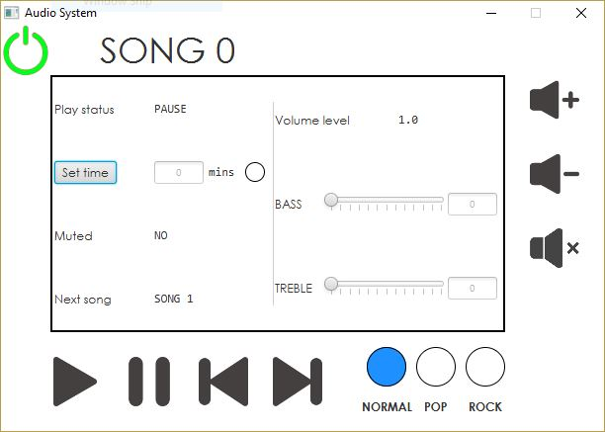

*Play/Pause button will change the PlayStatus of the device.*

*Increase/decrease volume button will change volume level every 0.1 between 0 and 1.*

*Next/Previous track button will skip to the next/previous song.*

*Normal/Pop/Rock button will change the PlayMode of the device.*

*Bass/Treble slider will change the level of bass/treble of the device.*

* An important function of the audio system is UPnP compatibility. In our simulation, there are two ways to control the audio system: using the user interface or via the network using other control points. When the control point invokes action, device’s status and view changes. When event changes, UPnP service will dispatch actions, and notifies changes to user interface.
* Next part is the description of audio system architecture.

# Audio system architecture

* The application contains the two main components which are Controller and View.
* Controller contains UPnP service instance, and is responsible for dispatching action, receiving events and notifying changes to view. The view component will handle the UI events (clicking buttons, sliding bar, set timer, play/pause the music, changing play mode between normal/pop/rock, or locking function when power off). Corresponding with those events, the view also calls to controller to update status instantly.
* Specific descriptions for each UPnP service are listed below:
  + SwitchPower:
    - Status: Boolean
  + PlayMusic:
    - PlayStatus: Boolean
    - TimerStatus: Boolean
    - TrackNo: INT
    - TimerValue: INT
  + AudioControl:
    - Volume: INT
    - Bass level: INT
    - Treble level: INT
    - AudioMode: ENUM
* The complete architecture described in the form of diagram can be seen as below:

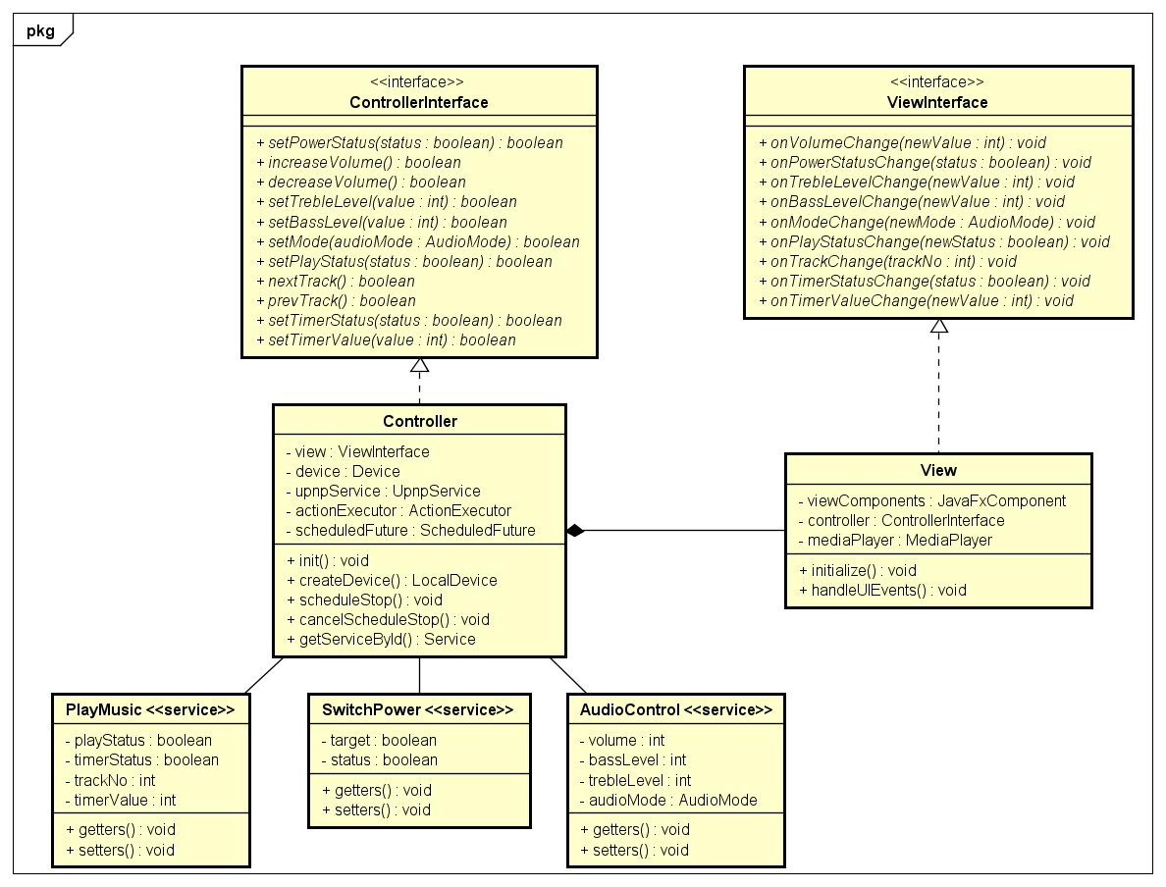

*The completed design of the application including classes, attributes, function, types and relationships.*

# Summary

* Universal Plug and Play is an architecture for pervasive peer-to-peer network connectivity of intelligent appliances, wireless devices, and PCs of all form factors. It is designed to bring easy-to-use, flexible, standards-based connectivity to ad-hoc or unmanaged networks.
* Simulated audio system built using Cling and JavaFX libraries has successfully stimulated network architecture based on UPnP technology.