Software Overview

Year: _2021_ Semester: __Spring_ Team: __16_ Project:Smart Conveyor Belt System____

Creation Date: ___Feb 2, 2021_____ Last Modified: Feb 2, 2021

Author: Zicong Wang____ Email: ____wang4166@purdue.edu____

Assignment Evaluation:

|  |  |  |  |  |
| --- | --- | --- | --- | --- |
| **Item** | **Score (0-5)** | **Weight** | **Points** | **Notes** |
| **Assignment-Specific Items** | | | | |
| **Software Overview** | 5 | x2 | 10 |  |
| **Description of Algorithms** | 5 | x2 | 10 |  |
| **Description of Data Structures** | 5 | x2 | 10 |  |
| **Program Flowcharts** | 4 | x3 | 12 |  |
| **State Machine Diagrams** | 4 | x3 | 12 |  |
| **Writing-Specific Items** | | | | |
| **Spelling and Grammar** | 4.5 | x2 | 9 |  |
| **Formatting and Citations** | 5 | x1 | 5 |  |
| **Figures and Graphs** | 5 | x2 | 10 |  |
| **Technical Writing Style** | 5 | x3 | 15 |  |
| **Total Score** | 93 | | |  |

5: Excellent 4: Good 3: Acceptable 2: Poor 1: Very Poor 0: Not attempted

General Comments:

*Nice work! Please see my comments.*

1.0 Software Overview

The Smart Conveyor Belt System consists of three firmware components. The first component is the barcode scanner that parcels initially interact with. The omnidirectional barcode scanner is capable of reading barcodes on the surface of parcels and sending over the barcode information to the microcontroller. The second component is the conveyor belt and its motor. The microcontroller is capable of starting the motor and initiating movement of the conveyor belt. The third component of the system is the flaps and their motors. The motor drivers should be able to instruct motors to adjust flap positions in order to guide parcels towards the sorted compartment from the instruction received from the microcontroller.

At the beginning, the microcontroller will wait for instruction to start up from the user's panel, which is currently scheduled to be integrated to the side of the barcode scanner tunnel. The user’s panel should have LED lights to indicate working/stopped status and startup/stop buttons. After startup, the microcontroller will instruct the motor driver to start the conveyor belt to begin the delivering and sorting process, and the microcontroller will start waiting on barcode information being sent from the barcode scanner. Once such information is received, the corresponding PWM signals will be sent to the servo motor driver and move the flaps in a way that will guide the parcels towards their right destinations.

2.0 Description of Algorithms

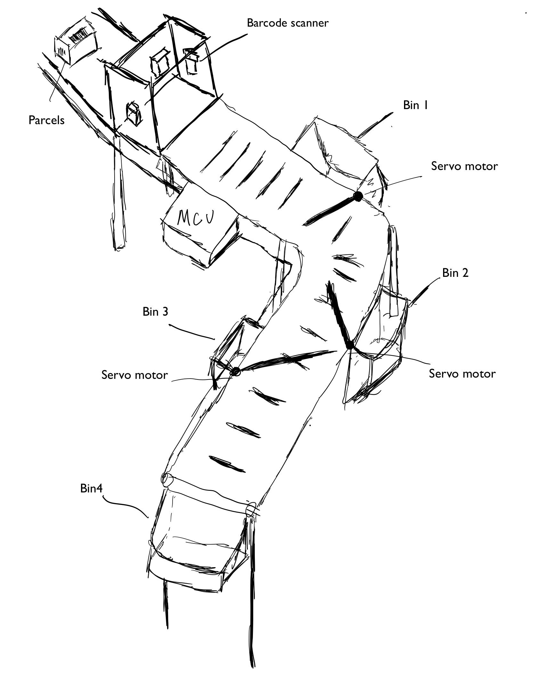

The algorithm used in this design is fairly straightforward. As mentioned in the last section, as soon as the user presses start and initiate the conveyor belt, the barcode scanner will be ready for reading barcode information. The information would be transmitted through the USART pins to the microcontroller, which will interpret the digital signal and convert it into ASCII texts. Our algorithm will have these texts looked up in the lookup table, pre-programmed onto the microcontroller. In such cases where the information of a scanned parcel cannot be identified to belong to any destination/compartment, a “not identified” flag will be raised, and there will be indicators (LED status light flashing for example) for these situations where there is a malfunction or when the barcode information received cannot be converted, or when the converted barcode texts do not match any pre-existing barcode information defined in the lookup table, so that the user can be alerted and react to the unusual circumstances to prevent missorting a parcel to default compartment when it’s unidentified. These sorts of parcels that do not belong to any one of the three destinations in the front will be delivered to the fourth compartment that will be designated to keep packages with issues.

3.0 Description of Data Structures

The core of data structure for almost all of the data handled in our design’s software will be the lookup table. In the process of programming our microcontroller, we will collect a set of scannable barcodes, and record their converted values. These values will be used to fill our lookup table, which will essentially be a key-value pair table. The key of these pairs will be the barcode IDs sticking onto the parcels, and the values will be the number indicating which sorting compartment it belongs to. At the time of operation, barcode IDs will be sent in, and the program will try to match with one of the IDs on the table, and retrieve the corresponding sorting compartment number.

After retrieving the destination, our program will use that reference to decide the PWM signal to be sent to each servo motor driver interfaced with the MCU to adjust the flaps’ positions. These flaps will adjust right after the first parcel is sorted and before the second parcel arrives in the sorting section of the conveyor belt. The information sent to the microcontroller will be through USART pins. The USART packets will be in 8 bit format, so we would have 8’b00000001 as the encoded command to rotate the flaps 45 degrees counterclockwise, and 8’b00000010 as the encoded command to rotate clockwise 45 degrees, since we only have two positions for the current design. The PWM signal being sent from the microcontroller will move the servo motors according to the output of the algorithm. The servo motors will be moving a controlled angel of 45 degrees in either direction determined by the PWM signal. More details of this part will be included in software formalization.

4.0 Sources Cited:

“GTIN Barcode Structure: GTIN Data Structure,” *Bar Code Graphics*, 28-Mar-2019. [Online]. Available: https://www.barcode.graphics/education-gtin-data-structures/. [Accessed: 03-Feb-2021].

“USART and Asynchronous Communication,” *http://web.engr.oregonstate.edu/~traylor/ece473/lectures/uart.pdf*. [Online]. Available: http://web.engr.oregonstate.edu/~traylor/ece473/lectures/uart.pdf.

Appendix 1: Program Flowcharts

Initial Configuration

Wait for barcode scanner information

Yes

Look up ID in database, retrieve destination ID

Barcode Info received?

No

ID found?

Yes

Control corresponding servo motor to rotate

Appendix 2: State Machine Diagrams

While no parcel is being scanned

Barcode ID

While destination ID not found

Retrieved destination ID

Parcel sorting complete