A PROJECT PLAN REPORT
ON
EV BATTERY MANAGEMENT SYSTEM


Submitted by:
Ankit Kumar (20234029)
Devanshi (20234057)
Satyam Tekriwal (20234153)

Under the Guidance of:
Dr. Yogendra Kumar Prajapati

Electronics and Communication Engineering Department,
Motilal Nehru National Institute of Technology Allahabad, Prayagraj
1. Executive Summary & Problem Context
Every Electric Vehicle Battery Management System (BMS) must continuously estimate State of Charge (SOC) and derive remaining runtime from it. Standard production systems rely on Coulomb Counting — a decades-old technique that integrates measured current over time — which accumulates drift and degrades sharply under the highly variable current draw of real driving (acceleration, braking, regenerative charging, idling).
This project re-engineers battery-runtime and multi-parameter estimation into a data-driven, machine-learning-based pipeline by integrating:
- Simulation — a Random Forest model trained on voltage, current, and temperature history, benchmarked directly against Coulomb Counting on a public NASA battery-cycling dataset.
- Experimentation — an expanded multi-parameter pipeline, developed using MATLAB Simulink, that maps driving-behaviour and electrical inputs to State of Charge, State of Health, Range, and Battery Life.
- Validation — deployment of the trained pipeline onto a real test vehicle, where live driving data both validates and incrementally retrains the model in real time.

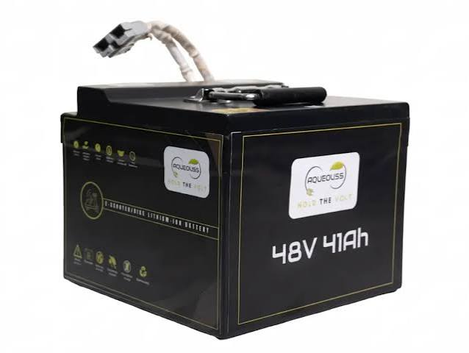
Typical Electric Vehicle Battery Pack

2. Project Objectives & Scope Boundaries
Primary Objectives:
- Train and benchmark a Random Forest Regressor against Coulomb Counting for remaining-runtime prediction on a public dataset, across multiple ambient-temperature conditions.
- Extend the model to multi-parameter estimation — State of Charge, State of Health, Range (km), and Battery Life — using a richer, simulation-generated driving dataset.
- Build and deploy a real-time embedded pipeline on a test vehicle, enabling on-the-fly model training and validation as the vehicle is driven.
- Validate all outputs against ground truth from vehicle instrumentation and against established literature baselines.

3. System Architecture & Technical Specifications
- Phase 1 Dataset: NASA Ames PCoE Randomized Battery Usage dataset (RW series, .mat files) — room, elevated (~40°C), and low-temperature groups.
- Phase 2 Simulation: MATLAB Simulink for parameter identification and synthetic driving-and-battery dataset generation, incorporating acceleration, velocity, and braking inputs.
- Modeling: Python, scikit-learn (Random Forest Regressor), pandas, numpy, matplotlib.
- Phase 3 Deployment: Embedded single-board computer, CAN bus logger, and on-vehicle sensors for real-time inference and incremental model retraining.
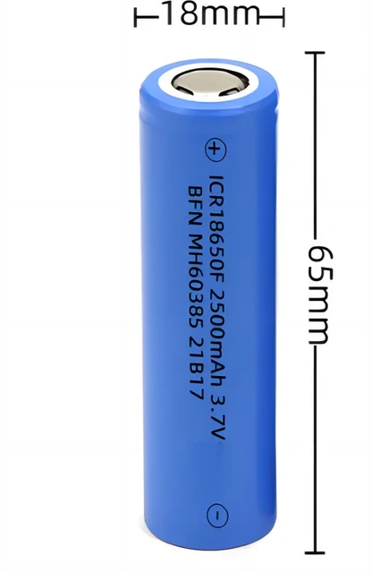
18650 Li-ion Cell — Basic Unit of EV Battery Packs

4. Work Plan

Phase | Step | Duration
Phase 1  Simulation | Total | 2 Weeks
 | Step 1 — Literature review finalized; NASA RW dataset parsed across 3 temperature groups; remaining-time target label derived; feature engineering (rolling windows, cumulative Ah) | Week 1
 | Step 2 — Coulomb Counting baseline computed; Random Forest trained on identical inputs; RMSE/MAE evaluated per temperature group; cross-temperature comparison; report finalized | Week 2
Phase 2  Experimentation | Total | 7 Months
 | Step 1 — Identify expanded input parameters (acceleration, velocity, braking, charge/discharge cycles, voltage, current, temperature); generate simulation dataset using MATLAB Simulink | Months 1–2
 | Step 2 — Develop and validate models for State of Health (SOH), Range (km), and Battery Life as additional outputs; benchmark against standard baselines per parameter | Months 3–5
 | Step 3 — Integrate Runtime, SOC, SOH, Range, and Battery Life into one unified multi-output model; prepare and validate software stack for deployment on test vehicle hardware | Months 6–7
Phase 3  Validation | Total | 4 Months
 | Step 1 — Live field testing on real vehicle; as the vehicle is driven, data is generated in real time and the model trains/updates incrementally on live sensor data | Months 1–2
 | Step 2 — Analysis and validation: all outputs (runtime, SOC, SOH, range, battery life) compared against ground truth from vehicle instruments | Month 3
 | Step 3 — Manuscript preparation and submission to a high-quality peer-reviewed journal (IEEE / Springer / Elsevier) | Month 4

5. Risk Assessment & Target Outcomes
- Dataset-to-Reality Gap: Phase 1 relies on a public benchmark dataset rather than real driving data; Phase 2's Simulink-generated dataset and Phase 3's live-vehicle validation are designed specifically to close this gap in stages.
- Extended Field-Testing Constraint: Live field trials in Phase 3 are scoped to a limited window and will therefore capture only the prevailing seasonal conditions available at that time, rather than full cross-seasonal variation.
- Incremental Retraining Overhead: Random Forest's comparatively low training time is leveraged specifically to make on-vehicle incremental retraining computationally feasible in real time.
- Model Generalization Across Chemistries: Models trained on one dataset/chemistry may not directly generalize; this is treated as a validation checkpoint during Phase 3 rather than assumed.
Target Outcomes:
- A validated, lightweight Random Forest baseline demonstrably outperforming Coulomb Counting under randomized load, across temperature conditions (Phase 1).
- A unified multi-output model estimating Runtime, SOC, SOH, Range, and Battery Life from a single pipeline (Phase 2).
- A working proof-of-concept in which a real vehicle both generates its own training data and improves its own model while in operation (Phase 3).
- A manuscript submitted to a reputable, properly peer-reviewed journal.

6. References

Author (Link) | Contribution | Findings | Limitations
Harinarayanan & Balamurugan (2025)  Scientific Reports — Springer Nature  nature.com/articles/s41598-025-94946-7 | Directly compares Coulomb Counting, Kalman Filter, and Random Forest for SOC estimation under full cycles, shallow cycles, and dynamic WLTP/HPPC load profiles | Random Forest achieved lowest error across all conditions — RMSE 0.0229, MAE 0.0139 — and specifically outperformed traditional methods during shallow cycling | SOC only; single pouch-cell chemistry; does not address SOH, Range, or multi-output prediction
Sulaiman & Mustaffa (2024)  Green Energy and Intelligent Transportation — Elsevier  doi.org/10.1016/j.geits.2024.100177 | Applies Random Forest to SOC estimation under real-world EV operating conditions to improve downstream range-prediction accuracy | RF captured non-linear dependencies between operating parameters and SOC more effectively than conventional estimation under dynamic driving conditions | Single-algorithm study; no comparison against deep learning alternatives; does not extend to SOH or direct range validation
Yuan, Liu, Zhou & Pei (2023)  Energies — MDPI  doi.org/10.3390/en16052155 | Systematically compares six ML algorithms (including RF, XGBoost, LSTM) combined with Kalman Filter frameworks for SOC estimation | Random Forest + Kalman Filter combination achieved highest accuracy and strong real-time performance, outperforming either approach individually | Hybrid architecture adds complexity; computational overhead not fully quantified for embedded/real-time deployment on vehicle hardware
Khan, Tariq & Sarwat (2024)  Energies — MDPI  doi.org/10.3390/en17225582 | Proposes Genetic Algorithm-tuned Random Forest for remaining capacity (SOH-adjacent) estimation, tested explicitly across varying thermal conditions (25°C to −20°C) | GA-optimized RF reduced MAE by 41–50% and RMSE by 18–31% vs. non-optimized RF baseline across tested temperature range | GA tuning adds significant training-time overhead — may work against the fast incremental-retraining goal of Phase 3
Lelli, Musa, Batista, Misul & Belingardi (2023)  Energies — MDPI  doi.org/10.3390/en16124639 | Real on-road data from 12 actual vehicles at Hyundai Motor Europe test center used to estimate SOH — closest published precedent to this project's Phase 3 live-vehicle validation goal | Random Forest outperformed five other ML methods (linear regression, k-NN, SVM, CART, neural network) with up to 96–97% MAE reduction over the weakest baseline | Requires specialized on-vehicle calibration tools (ETAS INCA/MDA) and manufacturer-level hardware access — a real constraint for Phase 3 hardware planning

_______________________________
Dr. Yogendra Kumar Prajapati
Project Coordinator
Department of Electronics and Communication Engineering
MNNIT Allahabad, Prayagraj

