Final Report Template

**Topic:**

Intelligent Question and Answer System Based on Large Language Modeling

**Abstract:**

The user inputs a question, is able to display the answer, and tries to use the knowledge points learned in the classroom, including: Basic Controls, Intermediate Controls (Buttons, Text Boxes, Dialog Boxes, etc.), Advanced Controls (Spinner, ListView, ViewPager), SQlite, SharedPreferences, ContentProvider, and so on.

User Interface: Provide intuitive and easy-to-use user interface to enhance user experience.

Natural Language Processing (NLP): able to understand the user's natural language input and give responses in the form of natural language.

Q&A system: able to answer user questions, including but not limited to general questions, factual inquiries, math problems, etc.

Intelligent Assistant Function: Provides intelligent assistant functions such as schedule management, reminder setting, weather forecast, etc.

Integration with third-party services: able to integrate with third-party services (e.g. social media, email, calendar, etc.) to provide richer services.

Offline Mode: able to provide basic Q&A services even when there is no internet connection.

Personalized Recommendations: Provide personalized content recommendations based on user interests and behaviors.

Voice Interaction: supports voice input and voice output, allowing users to interact with the APP by voice.

Feedback mechanism: allows users to provide feedback to improve the functionality and performance of the APP.

Advertisements and Business Models: Reasonable advertisement display or business models can be designed to support the continuous development and operation of the APP.

**Background:**

The rapid advancement of artificial intelligence (AI) and natural language processing (NLP) technologies has transformed how humans interact with digital systems. Intelligent Question and Answer (Q&A) systems, powered by large language models, have emerged as powerful tools capable of understanding and responding to user queries in a natural and intuitive manner. These systems leverage advanced machine learning techniques to provide accurate, context-aware answers and perform various assistant functions, enhancing user experience significantly.

The application of large language models in Q&A systems is particularly promising due to their ability to process and generate human-like text. These models, trained on vast amounts of data, can understand and generate language with remarkable accuracy, making them ideal for developing intelligent assistant applications. This project aims to develop an intelligent Q&A system that incorporates a range of features to deliver a comprehensive and user-friendly experience.

The proposed system will integrate multiple components, including basic and advanced user interface controls, SQLite databases for data storage, SharedPreferences for lightweight data management, and ContentProviders for data sharing across applications. Additionally, it will support offline mode functionality, ensuring basic Q&A services are available without internet connectivity.

The system will also focus on providing personalized recommendations, leveraging user data to tailor content and responses to individual preferences. Voice interaction capabilities will allow users to interact with the system using voice commands, enhancing accessibility and convenience. Furthermore, the integration with third-party services will enable the system to offer a wide range of functions, from managing schedules and setting reminders to fetching weather forecasts and accessing social media.

To ensure continuous improvement and relevance, the system will incorporate a feedback mechanism, allowing users to provide input on performance and suggest enhancements. Finally, a sustainable business model, potentially incorporating advertisements, will be explored to support ongoing development and operation.

This project aims to create a robust and versatile intelligent Q&A system that not only answers user questions but also acts as a comprehensive digital assistant, enhancing everyday tasks and providing valuable services to users.

**Main design:**

1. Main functions

User Interface:

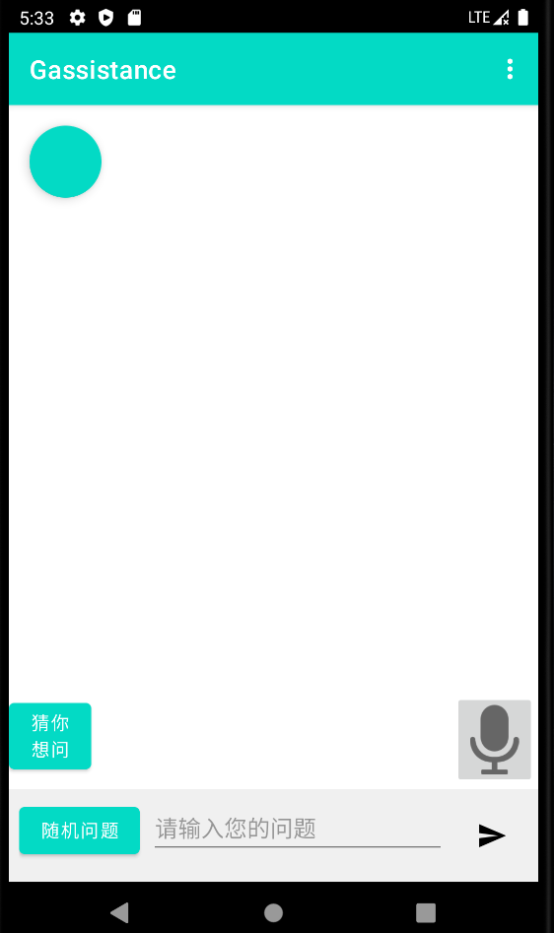

Natural Language Processing (NLP): Implement Q&A by calling bing

Q&A system: By calling openai’s api to generate answer then display on the dialog

Intelligent Assistant Function:

Integration with third-party services:

Offline Mode: Implemented by reading local record. Few query will be update to database while initialize action. Query record will be updated each time a new Q&A was completed.

Personalized Recommendations:

Voice Interaction: User can press a microphone button and say something. Your voice will be send to backend to convert into text, then send it to Openai then it will retrieve a text answer. The answer will be converted into sound by model deployed at the backend server.

Feedback mechanism:

Advertisements and Business Models:

1. Main technology (Introduce the key knowledge you exploited in each function, such as Activity, Intent, Fragment, Permission, User interfaces, Notifications, Alarms, Graphics, Sensors, Locations, Maps and Data management, etc.)

Main Technology

Activity and Intent

Activity: The backbone of the Android application, each screen in our Q&A system is an activity. Activities manage the lifecycle of the app and handle user interactions.

Intent: Intents are used for navigation between different activities and for communicating between components. For example, an intent can be used to open a new activity to display the answer to a user’s question or to start an activity for setting a reminder.

User Interfaces

Basic Controls: Includes buttons, text boxes, and dialog boxes for basic user interactions. For example, text boxes are used for inputting questions, and buttons are used for submitting questions or navigating the app.

Intermediate Controls: Includes components like spinners, ListView, and ViewPager. These controls enhance the user experience by providing interactive and dynamic content displays. For instance, a ListView might be used to display a list of recent questions and answers.

Advanced Controls: Advanced UI components like RecyclerView for efficiently displaying large sets of data, and custom views for unique UI elements. These controls ensure the app remains responsive and visually appealing.

Data Management

SQLite: SQLite databases are used for storing user data locally, including user questions, preferences, and app settings. This ensures that data is persistent and accessible even in offline mode.

SharedPreferences: Used for storing simple key-value pairs, such as user preferences and app settings, which do not require the complexity of a full database.

APIs: The app integrates with various third-party APIs to fetch data and provide extended services. For example, weather APIs for weather forecasts, calendar APIs for scheduling, and social media APIs for sharing content.

Voice Interaction

Voice Input and Output: The app supports voice commands and responses using backend service to convert sound into text and TTS(Text to Sound) by ChatTTS. This makes the app accessible to users who prefer hands-free interaction. Sound recorded by MediaRecorder played by MediaPlayer

Sensors and Location Services

Sensors: Utilizes device sensors for context-aware features.

Location Services: Provides location-based services such as weather forecasts and location-specific recommendations. This is achieved through Android’s location services and GPS data.

Feedback Mechanism

User Feedback: Implements a system for users to provide feedback on the app’s performance and suggest improvements. This feedback is stored and analyzed to guide future development and enhancements.

Advertisements and Business Models

Ad Integration: The app integrates with ad networks to display relevant advertisements. This provides a revenue stream to support the ongoing development and maintenance of the app.

Subscription Models: Explores subscription-based models for offering premium features, such as enhanced personalization, ad-free experience, and additional intelligent assistant functions.

Network Requests

OkHttp: OkHttp is used for efficient and reliable network requests, enabling the app to communicate with servers, fetch data, and handle network operations smoothly.

HttpURLConnection: Used for basic HTTP operations and network requests, providing a straightforward way to manage network connections and handle data transfer between the app and external servers.t

**Evaluation (Function demonstration):**

Capture the main screenshots of your app to show your results.

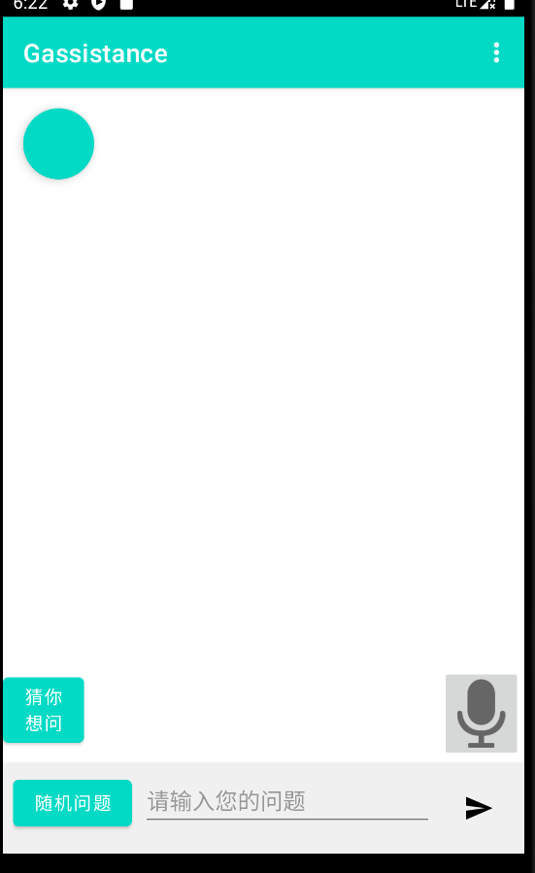 

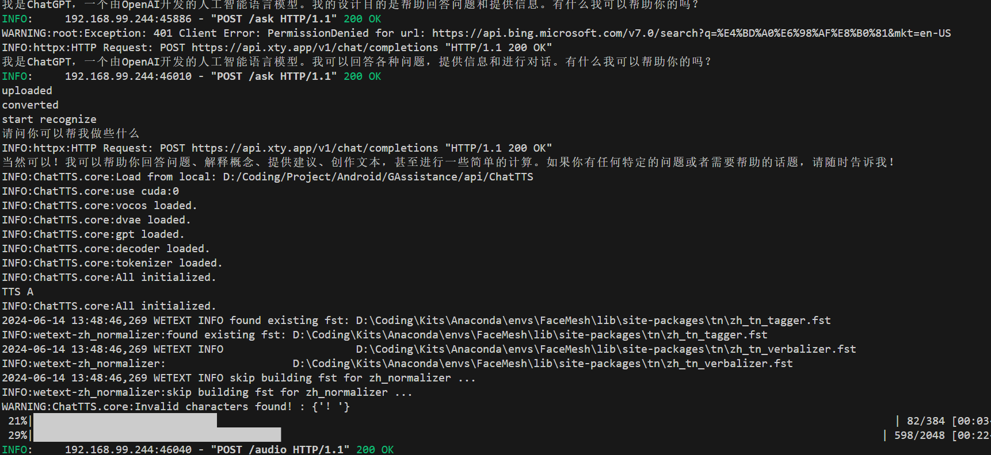

**Conclusion and future work:**

Conclusion

The development of the Intelligent Question and Answer System based on large language modeling has demonstrated the potential of AI and NLP technologies to significantly enhance user interactions with digital systems. By integrating various advanced features, such as intuitive user interfaces, robust data management, seamless third-party service integration, and versatile voice interaction capabilities, the system offers a comprehensive solution for answering user queries and providing intelligent assistant functions.

Key achievements of the project include:

Effective User Interface: A user-friendly interface that leverages basic, intermediate, and advanced controls to ensure a smooth and engaging user experience.

Advanced NLP Capabilities: Utilization of state-of-the-art NLP models to understand and generate natural language responses, providing accurate and context-aware answers to user queries.

Versatile Functionality: Incorporation of features such as personalized recommendations, offline mode, and integration with third-party services to cater to a wide range of user needs.

Robust Data Management: Use of SQLite, SharedPreferences, and ContentProviders for efficient and secure data storage and sharing.

Enhanced Interaction: Support for voice input and output, enabling hands-free operation and increasing accessibility for all users.

User Feedback and Business Model: Implementation of a feedback mechanism to continuously improve the app, along with exploring sustainable business models to support ongoing development.

Future Work

While the current implementation of the Intelligent Q&A System lays a solid foundation, there are several areas for future enhancement and expansion:

Enhanced NLP Models: Continuously update and refine the NLP models to improve accuracy and understanding of more complex and nuanced user queries. Exploring the use of transformer-based models like BERT or GPT-4 can provide even better performance.

Advanced Personalization: Implement more sophisticated machine learning algorithms to provide even more personalized recommendations based on detailed user behavior analysis and preferences.

Expanded Voice Interaction: Enhance the voice interaction capabilities by integrating more advanced speech recognition and synthesis technologies, potentially incorporating multilingual support to cater to a global user base.

Broader Third-party Integration: Expand the range of third-party services integrated with the app, including more social media platforms, productivity tools, and IoT devices to provide a richer user experience.

Improved Offline Functionality: Develop more comprehensive offline features, ensuring that users have access to a wider range of services and information even without an internet connection.

Security Enhancements: Continuously improve the security features of the app, including advanced encryption techniques, to ensure user data remains safe and secure, especially when integrating with third-party services.

User Interface Improvements: Regularly update the user interface based on user feedback and the latest design trends to maintain a modern and intuitive look and feel.

Scalability and Performance: Optimize the app’s architecture and backend systems to handle larger user bases and higher volumes of data, ensuring smooth performance and scalability.

By focusing on these areas for future work, the Intelligent Q&A System can continue to evolve, providing even greater value to users and staying at the forefront of AI-driven digital assistant technology.

(Option: the work division of your group members.)

王天磊

Integration with third-party services、Offline Mode、Personalized Recommendations、Feedback mechanism、Advertisements and Business Models

陈昊暄

Natural Language Processing (NLP)、Q&A system、Voice Interaction