Go to the link http://www.mysql.com/downloads/mysql/

For 32 bit OS, look for Windows (x86, 32-bit), (mysql-essential-5.1.45-win32.msi) , which is first link and download to env folder

For 32 bit OS, look for Windows (x86, 64-bit), (mysql-essential-5.1.45-winx64.msi) , which is second link and download to env folder

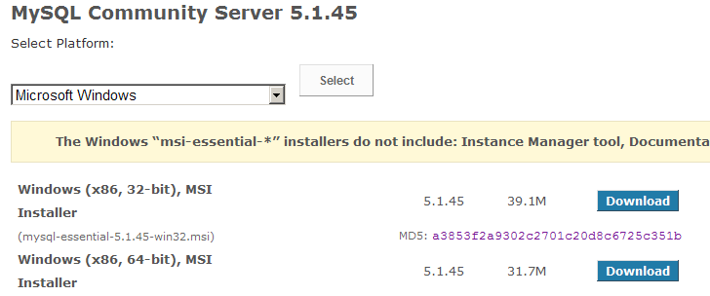

Double click on the downloaded file

From this point instructions are for 32 bit. Hopefully it’s the same for 64 bit.

Click Run

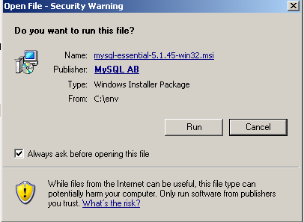

Select Next
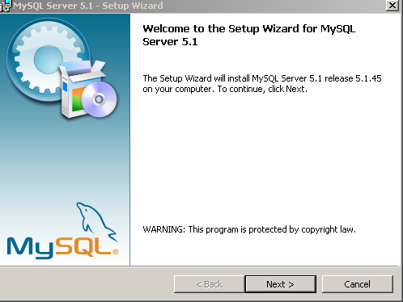

Select Typical
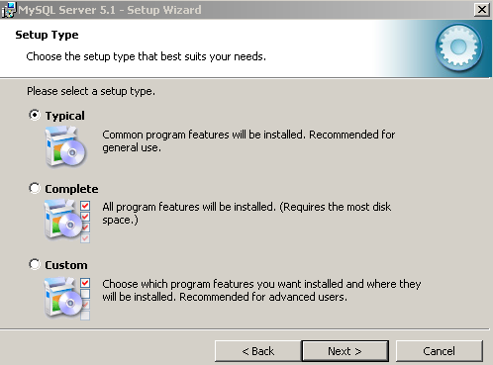

Click install
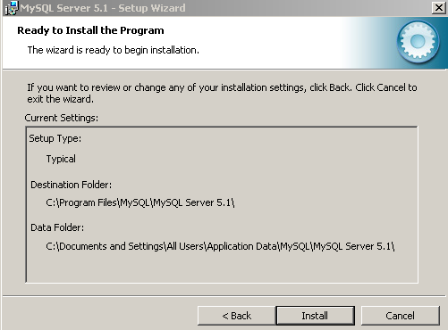

Select Next
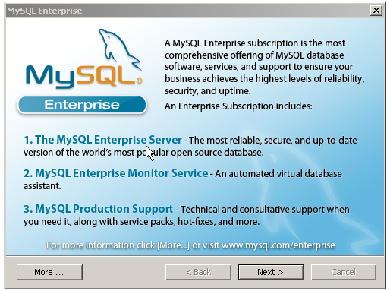

Select Next
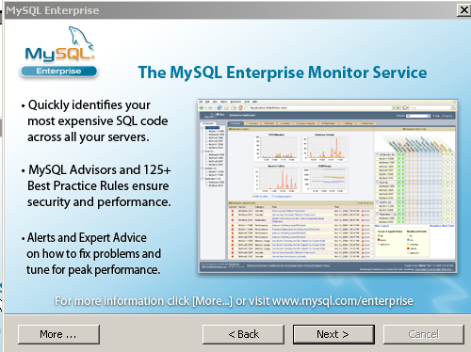

Select the configure check box.
Register is up to you. Not required. If you register you will get updates.
Click Finish
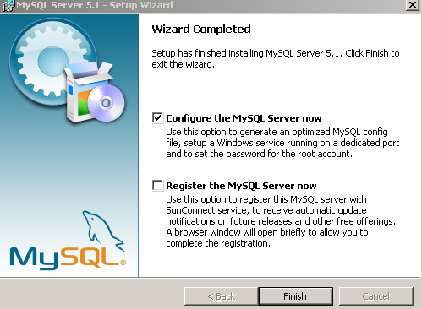

Click Next
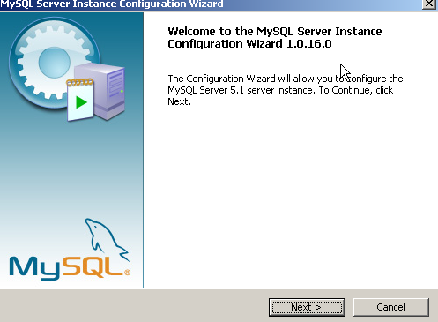

Select Standard Configuration and Click Next
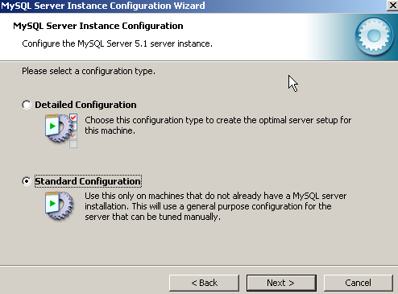

Select Both Install as Windows Service and Include Bin Directory in windows PATH options and click Next
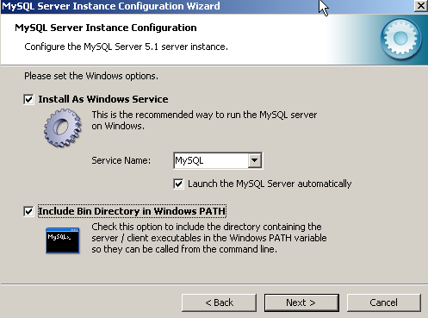

Select Modify Security settings and Enter the password for Root user and click Next
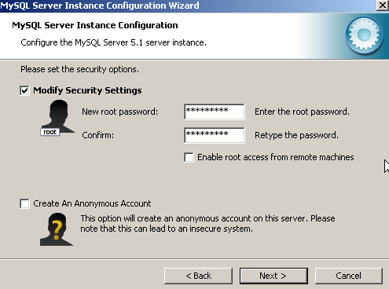

Click on Execute
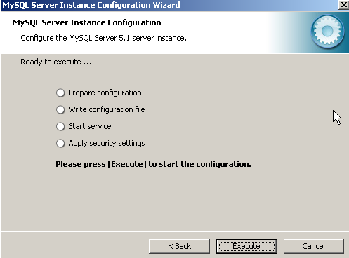

Click Finish
