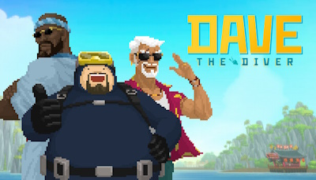
Rick Smith
CS 1010 – Intro to Interactive Entertainment
Cody Squadroni
09/18/2024

Module 2 - Challenge: Review a Video Game
The game I have picked to review is Dave the Diver. This game was released in 2023 by the studio Mintrocket. This game is primarily played in a 2D environment where you control Dave, a scuba-diver, where you explore a randomly generated underwater world. The story begins with Dave receiving a phone call from his friend about starting up a sushi restaurant at a place called the Blue Hole, which is supposed to contain unique fish from all around the world.
Dave the Diver combines multiple genres such as exploration, adventure, and RPG as you not only explore the world, but you collect and manage resources to operate a sushi restaurant as an additional portion of the game. The money you make from running the restaurant can be used to upgrade your diving gear, weapons for harvesting sea-life, hiring and increasing the productivity of restaurant staff, and more all while progressing through an fun story line.
The game contains a variety of charming mini-games as well that allow the player to utilize a different set of controls to complete various tasks such as sneaking through an ecological conservationists’ headquarters, which felt like a homage to Metal Gear Solid, a dream state dancing game, inspired by Dance Dance Revolution or any other rhythm game. There were even smaller one-off tasks like cleaning the fog off your diving goggles and welding, which felt like the mini-games from Mario Party.
The amount of different content that was available in this game was truly impressive! It felt that there was always something to do in this game without it feeling like a chore. Additional weapons, areas to explore, and things to do were unlocked at a quick-pace, which kept me glued to this game through the main story line, in which I discovered a race of sea-people, learned the back stories of my sushi restaurant staff, and helped certain sea animals from pirates and poachers.
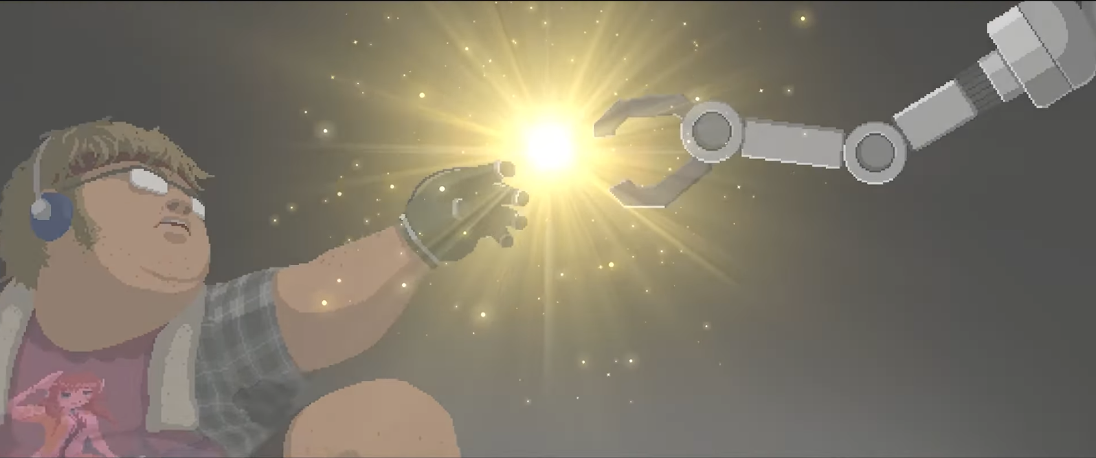
The artwork in the game is incredibly polished sprites, with cut scenes that add humor and charm. There are references to classical artwork, such as the anime obsessed gun smith who is framed in the same pose as Michelangelo’s The Creation of Adam (below).

Using these cut scenes, the game gives each character more depth and really brings the game to life.
In regards to sound design, the game boasts an atmospheric soundtrack that spans from relaxing diving music to energetic boss fight music. Sound effects were fitting and nothing I observed felt out of place.
One interesting thing I found as I looked into the history of this game was that it was originally partnered with National Geographic in an attempt to help bring awareness and excitement about marine biology. While the official release did not partner with National Geographic, I felt the original idea is something unique that I hadn’t seen in a game before.
When weighing out the game for a personal rating, I find myself counting way more pros than cons. The only real cons that I could give this game is that the occasional puzzles didn’t provide much of a challenge and seemed to be more busy work than any sort of puzzle that required real thought. However, these were also accompanied with story development that overshadowed any real disappointment that I had for these parts. Overall, I would rate this as a 9/10 and easily the best indie game I’ve played this year.


