NIGHTTIME POTHOLE DETECTION
Project Report
Subject: Image Processing and Computer Vision


S. No. | Team Member Name | Registration Number
1 | Ruchir Tripathi | 20235068
2 | Tanmay Paul | 20233292
3 | Souvik Sarkar | 20233275
4 | Tavishi Sharma | 20233577

Abstract
This project investigates pothole detection in low-light and nighttime road imagery using YOLO-based object detection. Real night-time pothole images are scarce, so the work builds a pothole-only synthetic-night dataset by transforming daytime road images, and tests whether such data is a useful substitute for real night images. The synthetic-night dataset was prepared from a three-class source dataset by retaining pothole-containing images, removing non-pothole annotations, and applying a day-to-night photometric transformation. YOLOv8n (Nano) and YOLOv8s (Small) were first trained and evaluated on the synthetic validation and test splits. A controlled YOLO11m experiment then trained three identical detectors on the same scenes as original day images, as transformed synthetic-night images, and on real night images (equal image counts, three seeds, with and without brightness alignment), and compared them on day, synthetic-night and real-night test sets. The transformation helps within the synthetic domain: the night-trained detector scores 0.59/0.57 mAP@0.5 on day images and 0.58/0.59 on night images (raw/aligned), whereas the day-trained detector falls from 0.65 on day images to 0.46/0.42 on night images. On real night images, however, the synthetic-night detector reached only 0.17 (raw) and 0.21 (aligned) mAP@0.5, compared with 0.60 and 0.58 for a detector trained on real night images, so it recovered only 27.8% and 36.3% of the real-data level. Its advantage over a day-trained detector on real night images was not established (-0.061 raw, 95% interval [-0.101, -0.025]; +0.019 aligned, [-0.019, 0.051]). Synthetic night data is therefore beneficial, but in this study it did not replace real night images.

1. Introduction
The objective is to detect potholes in road images under low-light or nighttime conditions, where the central practical difficulty is that real night-time pothole images are scarce. The project therefore asks whether day images that are transformed into synthetic night images can be used to train a detector for real night roads. Two groups of experiments were run. First, YOLOv8n and YOLOv8s were trained on the synthetically darkened pothole dataset as lightweight baselines. Second, a controlled YOLO11m experiment tested the central claim directly: three detectors with identical architecture, hyperparameters, image counts and seeds were trained on (a) the original day images, (b) the transformed night versions of the same images, and (c) real night images, and each was tested on day, synthetic-night and real-night test sets.
The two groups are reported separately and are not a single benchmark: the YOLOv8 runs used 640 × 640 inputs, Ultralytics validation and the original synthetic splits, whereas the YOLO11m experiment used a de-duplicated, balanced benchmark with its own splits (Section 2.4). The controlled design removes weaknesses of a simple synthetic-to-real test: it needs no zero-shot baseline that has never seen a pothole, it balances the training sets, it gives the real night data its own train, validation and test splits, and it audits near-duplicate images between splits.

2. Methodology
The synthetic-night dataset was derived from a three-class pothole dataset containing crocodile crack, longitudinal crack, and pothole labels. The original nighttime dataset intended for the initial work could not be downloaded, so the available dataset was converted into a single-class pothole-detection dataset and given a synthetic nighttime appearance.
- Images containing at least one pothole were retained, including images that also contained crack annotations.
- Images containing only cracks and no pothole were removed.
- Crack annotations were deleted, while pothole bounding boxes were retained.
- The original pothole class ID (class 2) was remapped to class ID 0.
- The final dataset was configured as one class: pothole (nc = 1).
- Synthetic nighttime appearance was produced by changing brightness, contrast, and colour. No geometric transformation was used during this darkening operation, so the bounding-box coordinates remained valid.

2.1.1 Process of generating synthetic nighttime images from daylight images
- Linear light: Convert pixel values to linear light (gamma 2.2) so the brightness maths behaves like physical light.
- Remove the daylight: Estimate the large-scale lighting with a heavy blur and divide most of it out (strength 0.85). Sun patches and tree shadows flatten, while surface colour and local detail such as potholes stay.
- Add night lighting: A warm headlight cone, strongest at the bottom centre and fading outward, plus a dim bluish ambient floor was added for overall night illumination.
- Auto-exposure: Binary search done on a range to find gain that makes the image’s mean brightness land on a target (0–255 scale). The target is capped at 70% of the original image’s brightness, so the output is always darker than its source, whatever the source brightness.
- Camera noise: Poisson (shot) noise and Gaussian (read) noise, as on a high-ISO sensor.
- Finish: Convert back to sRGB and desaturate by 30%, because colour fades in low light.

2.1.2 Dataset Split and Counts
Split | Images | Pothole instances
Training | 1,876 | 5,149
Validation | 533 | 1,444
Test | 270 | 677
Total | 2,679 | 7,270

The notebook integrity checks reported no unlabeled images, orphan label files, empty label files, corrupt images, or out-of-bound coordinates in the synthetic dataset. All retained annotations were YOLO bounding boxes.

2.2.1 Software and Hardware Environment
- Framework: Ultralytics YOLO 8.4.183 (as recorded for the original YOLOv8 experiments).
- Python: 3.13.15.
- PyTorch: 2.11.0+cu130.
- GPU: NVIDIA Tesla T4, with approximately 14.9 GB of reported GPU memory.
- Input image size: 640 × 640.
- Training and evaluation: notebook environment.
The software and hardware listed above were recorded for the YOLOv8 experiments. The YOLO11m experiment was run in a separate Kaggle notebook (ipcv-project-2-v2.ipynb); its framework and GPU versions were not saved in the result files and are therefore not quoted here.

2.3.1 Real-Night Dataset Preparation
The real-night dataset was accessed through Kaggle as “night-potholes-yolov8-format”. It contains a single train folder rather than separate train, validation, and test folders. Its data.yaml defines class 0 as “night-potholes” and class 1 as “pothole”. The notebook manually selected class ID 1 as the target pothole class after inspecting example annotations.
Quantity | Count
Original images in train folder | 1,445
Original class 0 boxes (night-potholes) | 330
Original class 1 boxes (pothole) | 3,055
Images without a class-1 box skipped | 115
Images retained | 1,330
Pothole boxes retained and remapped to class 0 | 3,055
Class 0 boxes dropped | 330

Every image containing at least one class-1 box was retained; only class-1 boxes were kept and remapped to class 0. The resulting set contains 1,330 images and 3,055 pothole boxes. Because the source has no validation or test folder, the filtered images were later divided into train, validation and test splits for the controlled experiment (Section 2.4.3).

2.3.2 Exploratory Data Analysis
The notebook compared mean image brightness on a random sample of up to 300 images per set, and bounding-box area and boxes per image over the full sets.
Dataset subset | Images | Boxes | Mean brightness | Median box area (% image) | Boxes/image
Synthetic train | 1,876 | 5,149 | 53.54 | 0.31% | 2.74
Synthetic test | 270 | 677 | 55.59 | 0.23% | 2.51
Filtered real night | 1,330 | 3,055 | 81.29 | 4.29% | 2.30

The real dataset is brighter on average than the synthetically darkened training and test images. Its median pothole box is also much larger: 4.29% of image area compared with 0.31% for synthetic training and 0.23% for synthetic testing. The mean number of boxes per image is broadly similar across the three sets.
For the filtered real set, the report classifies 510 boxes (16.69%) as small (<1% of image area), 1,763 (57.71%) as medium (1–10%), and 782 (25.60%) as large (≥10%). This distribution matters because model recall differs by object size.

2.4 Controlled Experiment: Day, Synthetic-Night and Real-Night Training (YOLO11m)
This experiment tests the claim that synthetic night images, made by transforming day images, can stand in for scarce real night images. It compares three models that differ only in their training images:
- Day: trained on the original daytime images.
- Night-synthetic: trained on the transformed night versions of the same images, with the same boxes.
- Night-real: trained on real night images; this is the reference ceiling for what real night data gives.
All three are YOLO11m detectors initialised from COCO-pretrained yolo11m.pt, with a one-class pothole head and identical hyperparameters. Each is evaluated on a day test set, a synthetic-night test set (the same scenes as the day test set) and a real-night test set, giving a 3 × 3 transfer matrix. The claim would be supported if (1) the Night-synthetic model works on real night images, (2) it recovers most of what the Night-real model achieves, and (3) it beats the Day model, which would show that the transformation, and not merely pothole training, causes the benefit. The real-night test set is never used for training, threshold selection or tuning.

2.4.1 Pairing day and synthetic-night images; leakage audit
The day originals come from the 'Original Dataset' folder of the three-class daytime dataset (2,722 images; Kaggle: phoenixz14/daytime-images-3-classes), from which the synthetic-night set was derived. Each synthetic-night image was paired with its day original by filename (after removing the export suffix) and accepted only if the boxes agreed (IoU ≥ 0.70). A second, content-based matching stage found no further pairs. In total 1,987 of 2,679 night images (74.2%) were paired; the 692 unpaired images were excluded. Day images were resized to the size of their night counterparts and given the night image's labels, so each pair has identical scenes and boxes and differs only by the transformation.
Near-duplicate images were detected with a 64-bit difference hash (Hamming distance ≤ 6, mirrored copies included). Validation and test images with a near-duplicate in the training split were removed:
Split | Night images | Paired | Share paired | Near-duplicates removed | Paired and leak-free
Training | 1,876 | 1,392 | 74.2% | not applied | 1,392
Validation | 533 | 395 | 74.1% | 187 of 395 (47.3%) | 208
Test | 270 | 200 | 74.1% | 86 of 200 (43.0%) | 114

Nearly half of the paired validation and test images therefore had a near-duplicate in the training split. This audit was not applied to the YOLOv8n and YOLOv8s runs (Sections 3.1 to 3.3), so their absolute scores may be somewhat optimistic.
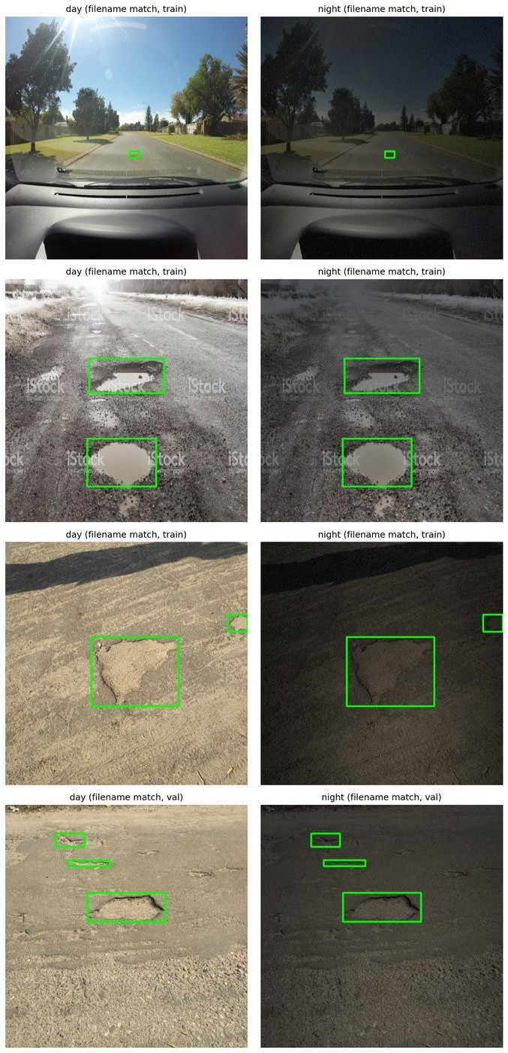
Figure 1. Day originals (left) and their synthetic-night versions (right) with the shared pothole boxes in green.

2.4.2 Real-night split
The 1,330 filtered real-night images (Section 2.3.1) were grouped by perceptual hash, including mirrored copies, and whole groups were assigned to the training, validation or test split (70/15/15), so that near-duplicates cannot straddle two splits. The real validation set was used only to choose the Night-real model's confidence threshold; the real test set was used only for final evaluation.

2.4.3 Balanced benchmark
Each domain was given the same number of images: 931 for training, 200 for validation and 114 for testing. The real validation and test sets were randomly subsampled to match the leak-free paired sets. The paired training images were sampled so that their object-size mix (size of the largest box per image) matches the real training set. Day and Night-synthetic share identical images and boxes, so their rows are identical except for brightness.
Domain | Split | Images | Boxes | Boxes/img | Median box area | Brightness (raw) | Brightness (aligned)
Day | Train | 931 | 2,128 | 2.29 | 1.86% | 131.2 | 128.6
Day | Val | 200 | 489 | 2.44 | 0.40% | 123.4 | 124.1
Day | Test | 114 | 239 | 2.10 | 0.54% | 120.9 | 122.9
Night-synthetic | Train | 931 | 2,128 | 2.29 | 1.86% | 54.7 | 110.8
Night-synthetic | Val | 200 | 489 | 2.44 | 0.40% | 56.8 | 111.2
Night-synthetic | Test | 114 | 239 | 2.10 | 0.54% | 57.5 | 111.3
Night-real | Train | 931 | 2,156 | 2.32 | 4.13% | 79.4 | 101.1
Night-real | Val | 200 | 469 | 2.35 | 5.03% | 75.1 | 100.0
Night-real | Test | 114 | 265 | 2.32 | 4.38% | 82.6 | 101.3

The training sets are balanced in image count and in object-size mix, but object scale is only partly matched: the median training box is 1.86% of the image for Day and Night-synthetic against 4.13% for Night-real, and in the validation and test sets the paired boxes (median 0.40% to 0.54%) remain far smaller than the real boxes (median 4.38% to 5.03%).
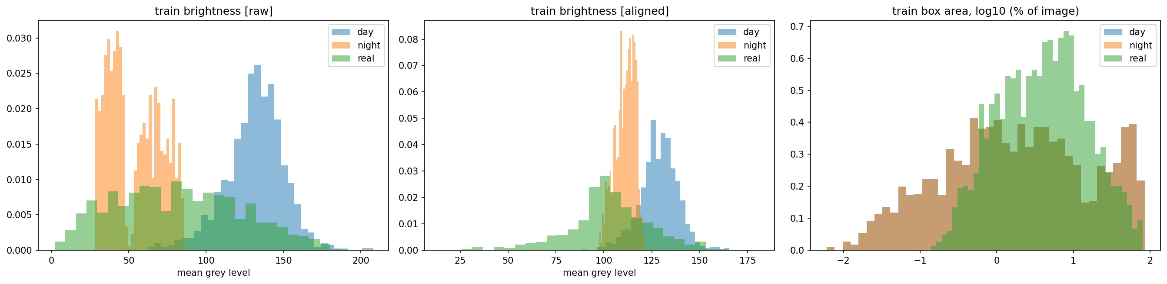
Figure 2. Training-set brightness before and after alignment, and box area, for the three domains.

2.4.4 Image processing: brightness alignment
Two image-processing conditions were run for every model. In the raw condition images are used unchanged. In the aligned condition, one label-free pipeline is applied to every image of every domain at both training and test time: (1) a per-image gamma correction that lifts dark images toward a target mean grey level of 90 (gamma limited to 0.4 to 1.0, so bright images are never darkened), followed by (2) CLAHE on the L channel (clip limit 2.0, 8 × 8 tiles). This raises the mean training brightness of the synthetic-night images from 54.7 to 110.8 and of the real-night images from 79.4 to 101.1, while the day images change little (131.2 to 128.6).
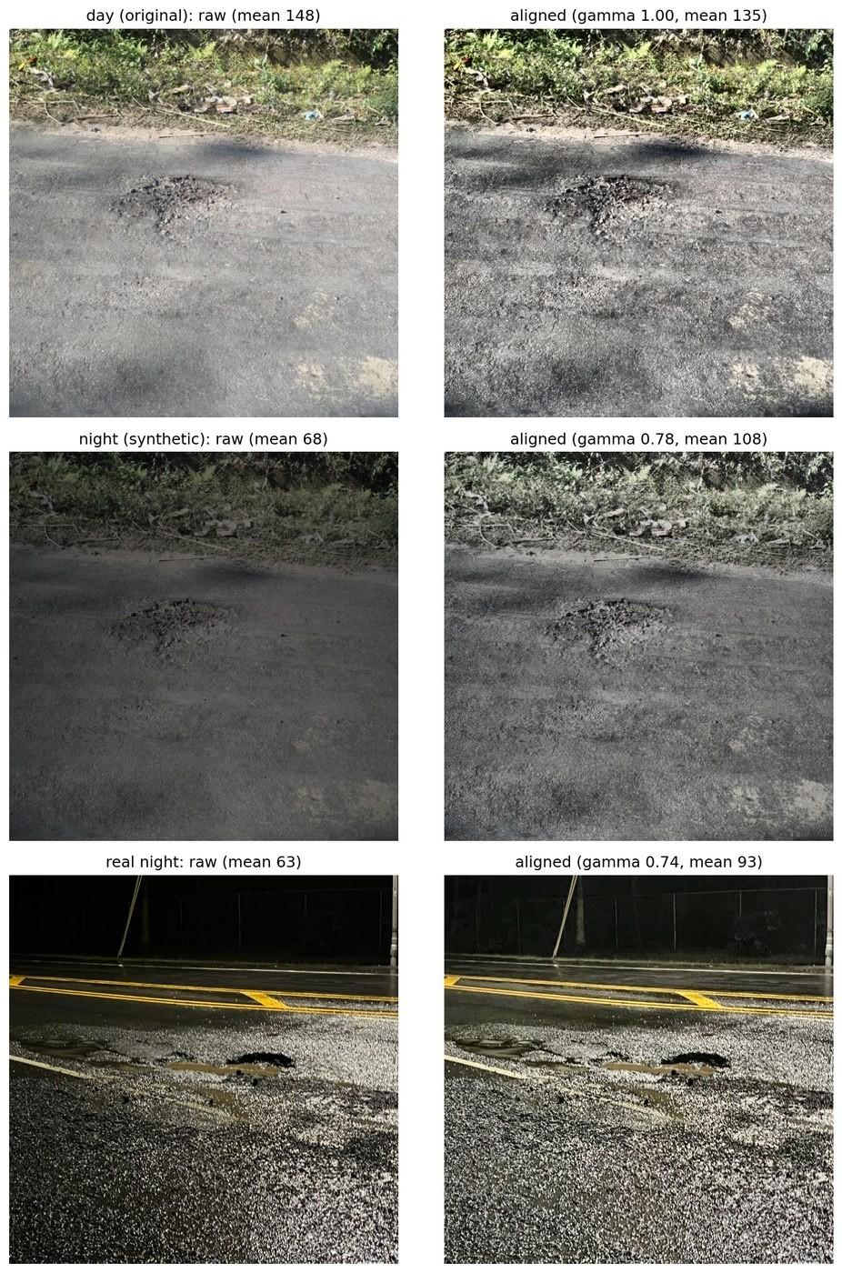
Figure 3. Raw (left) and aligned (right) versions of a day image, its synthetic-night version and a real night image.

2.4.5 Training configuration
Setting | Configuration
Initial weights / model | yolo11m.pt (COCO-pretrained); YOLO11m with a one-class pothole head
Input image size / batch | 640 × 640 / 16
Epochs / patience | 60 / 15 (the seed-42 runs trained for all 60 epochs)
Optimizer / schedule | auto; cosine learning-rate schedule; 3 warm-up epochs
Augmentation | Mosaic 1.0 (off for the final 8 epochs), MixUp 0, scale 0.7, horizontal flip 0.5, no vertical flip, no rotation, HSV 0.015 / 0.6 / 0.4
Other | RAM image cache, AMP, deterministic training, 2 workers
Seeds | 42, 43, 44
Training runs | 3 domains × 2 image-processing conditions × 3 seeds = 18 models
Environment | Kaggle notebook; framework and GPU versions not saved in the result files

2.4.6 Evaluation methodology
A model-agnostic evaluator was used for every model and test set: prediction at confidence 0.001 and NMS IoU 0.7, greedy IoU matching by descending confidence, and 101-point average precision at IoU 0.50 (mAP@0.5) and averaged over IoU 0.50 to 0.95 (mAP@0.5:0.95). Precision, recall and F1 are reported at an operating point chosen for each model on the validation set of its own training domain (the confidence that maximises F1; the mean thresholds were between 0.28 and 0.31), so a model trained without real night data never uses real night labels. Results are the mean and standard deviation over three seeds. The transformation gain (Night-synthetic minus Day on the real test set) has a 95% confidence interval from a paired bootstrap over test images (300 resamples, averaged over seeds). AP uses the Ultralytics interpolation convention, which can slightly flatter models with low recall; this applies to all models equally.

3. Results and Discussion

3.1 YOLOv8n (Nano) Results
YOLOv8n was trained as the lightweight baseline. Its model summary reported 3,132,707 parameters and approximately 8.6 GFLOPs.
Metric | Validation (533 images) | Test (270 images)
Precision | 69.95% | 67.25%
Recall | 50.90% | 53.62%
mAP@0.5 | 58.54% | 58.59%
mAP@0.5:0.95 | 29.83% | 28.99%

On validation, precision was higher than recall, indicating that the model's predictions were relatively selective but that a substantial proportion of actual potholes were missed. Test recall was slightly higher than validation recall. Test mAP@0.5 was almost unchanged, while mAP@0.5:0.95 was slightly lower.

3.2 YOLOv8s (Small) Results
YOLOv8s was trained with image size 640 × 640 and a configured maximum of 100 epochs. Training stopped after 86 epochs because the validation metric did not improve within the configured patience period. The best checkpoint was reported at epoch 76, and training took approximately 55.8 minutes. The model summary reported 11,125,971 parameters and approximately 28.4 GFLOPs.
Metric | Validation (533 images) | Test (270 images)
Precision | 69.00% | 68.50%
Recall | 50.80% | 54.80%
mAP@0.5 | 57.70% | 59.98%
mAP@0.5:0.95 | 29.70% | 30.43%

YOLOv8s scored slightly below YOLOv8n on validation, but above it on all four test metrics. Its test mAP@0.5 was 1.39 percentage points higher and its test mAP@0.5:0.95 was 1.44 percentage points higher.

3.3 YOLOv8n vs YOLOv8s
Metric | Nano validation | Small validation | Nano test | Small test
Precision | 69.95% | 69.00% | 67.25% | 68.50%
Recall | 50.90% | 50.80% | 53.62% | 54.80%
mAP@0.5 | 58.54% | 57.70% | 58.59% | 59.98%
mAP@0.5:0.95 | 29.83% | 29.70% | 28.99% | 30.43%

The validation split marginally favoured YOLOv8n across all four metrics. The held-out test split favoured YOLOv8s across all four metrics. YOLOv8s therefore had the stronger test results in these runs, while YOLOv8n remained substantially smaller and less computationally expensive. The differences are modest, and a single run per model does not establish statistical superiority.
The following sections report the controlled YOLO11m experiment (Section 2.4). All values are mean ± standard deviation over three seeds unless stated otherwise.

3.4 Training Behaviour
Validation mAP@0.5 on each model's own-domain validation set rose throughout the 60 epochs for all three domains (seed-42 curves, Figure 4). The Day model reached the highest own-domain value (about 0.69), while the Night-synthetic and Night-real models reached about 0.60 to 0.61. The curves were still rising slightly at epoch 60, so longer training might raise all scores; this was not tested.
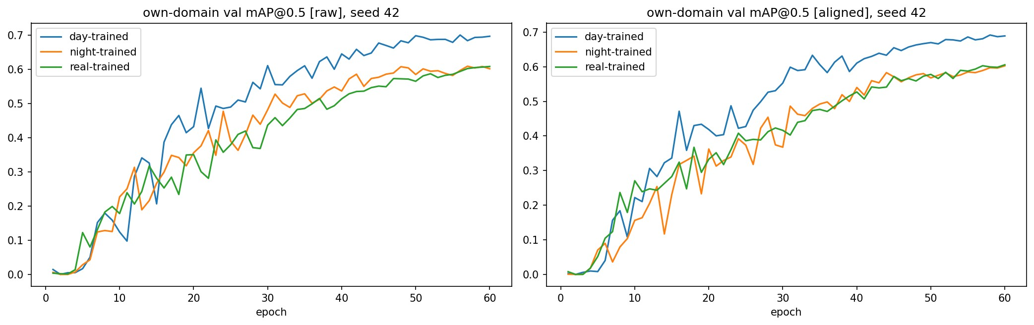
Figure 4. Own-domain validation mAP@0.5 per epoch for the three domains (seed 42), raw and aligned.

3.5 Transfer Matrix
mAP@0.5 of each training domain (rows) on each test set (columns), raw images:
 | Day test | Night-synthetic test | Real-night test
Trained on day | 0.652 ± 0.016 | 0.462 ± 0.025 | 0.227 ± 0.004
Trained on night-synthetic | 0.586 ± 0.020 | 0.576 ± 0.009 | 0.167 ± 0.018
Trained on night-real | 0.187 ± 0.007 | 0.123 ± 0.004 | 0.600 ± 0.008

The same matrix with brightness alignment applied to all images (aligned):
 | Day test | Night-synthetic test | Real-night test
Trained on day | 0.646 ± 0.020 | 0.416 ± 0.021 | 0.193 ± 0.015
Trained on night-synthetic | 0.568 ± 0.016 | 0.587 ± 0.010 | 0.212 ± 0.020
Trained on night-real | 0.196 ± 0.011 | 0.118 ± 0.011 | 0.583 ± 0.013

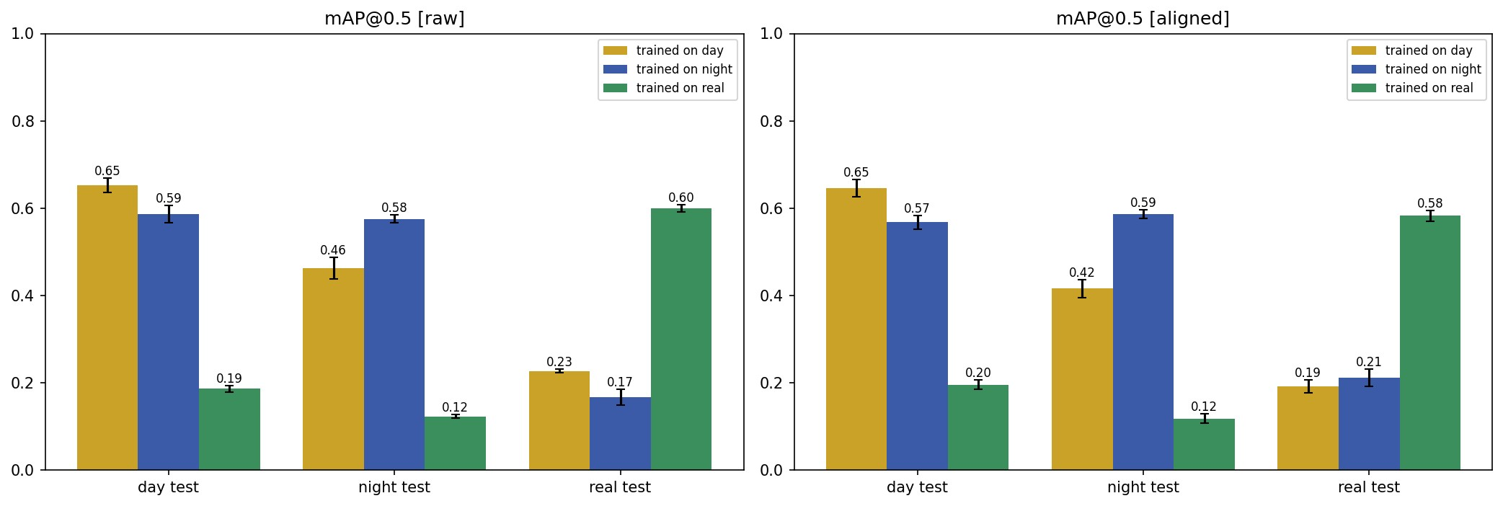
Figure 5. mAP@0.5 transfer matrix (error bars: standard deviation over three seeds).
mAP@0.5:0.95 for the same models (raw / aligned):
 | Day test (raw / aligned) | Night-synthetic test (raw / aligned) | Real-night test (raw / aligned)
Trained on day | 0.349 / 0.347 | 0.246 / 0.229 | 0.091 / 0.079
Trained on night-synthetic | 0.309 / 0.288 | 0.312 / 0.308 | 0.070 / 0.078
Trained on night-real | 0.083 / 0.085 | 0.058 / 0.056 | 0.275 / 0.269

- In-domain scores are similar: day→day 0.652 / 0.646, night-synthetic→night-synthetic 0.576 / 0.587, and real→real 0.600 / 0.583 (raw / aligned).
- The transformation gives robustness to lighting inside the synthetic domain. On night-synthetic images the Night-synthetic model beats the Day model by 0.113 (raw) and 0.171 (aligned) mAP@0.5. The Day model loses 0.19 (raw) and 0.23 (aligned) mAP@0.5 when moved from day to night images, whereas the Night-synthetic model changes by only +0.011 and -0.019 when moved from night to day images.
- The large gap is between datasets, not only between day and night. The Night-real model scores only 0.12 to 0.20 on the day and synthetic-night test sets, just as the Day and Night-synthetic models score only 0.17 to 0.23 on real night images. Differences in scene, camera, object scale and annotation style are plausible contributors, but this experiment does not isolate them.

3.6 Does the Transformation Help on Real Night Images?
Condition | Day → real | Night-synth. → real | Night-real → real (ceiling) | Gain (night − day) | 95% CI of gain | P(gain > 0) | Ceiling recovered: night | Ceiling recovered: day
raw | 0.227 | 0.167 | 0.600 | -0.061 | [-0.101, -0.025] | 0.00 | 27.8% | 37.9%
aligned | 0.193 | 0.212 | 0.583 | +0.019 | [-0.019, 0.051] | 0.83 | 36.3% | 33.0%

mAP@0.5 on the real-night test set (114 images, 265 boxes). 'Ceiling recovered' is the model's score divided by the Night-real model's score.
Per-seed mAP@0.5 on real night (seeds 42 / 43 / 44) | Day | Night-synthetic | Night-real
raw | 0.226 / 0.232 / 0.224 | 0.148 / 0.161 / 0.191 | 0.601 / 0.609 / 0.589
aligned | 0.173 / 0.194 / 0.210 | 0.231 / 0.184 / 0.221 | 0.574 / 0.574 / 0.601

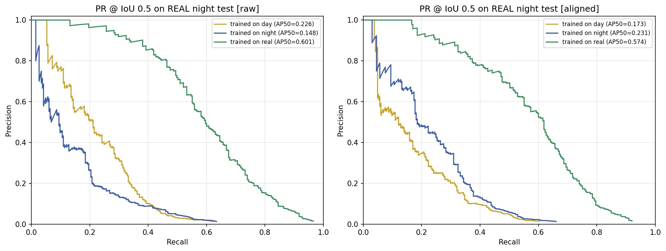
Figure 6. Precision-recall curves at IoU 0.5 on the real-night test set (seed 42): raw (left) and aligned (right).
- Raw images: the Day model is better than the Night-synthetic model on real night images (gain -0.061, 95% interval [-0.101, -0.025]).
- Aligned images: the two are indistinguishable (gain +0.019, 95% interval [-0.019, 0.051]), and the per-seed values overlap.
- Conclusion for this question: the experiment does not show that the day-to-night transformation improves transfer to real night images. The benefit of the synthetic data on real night images comes mainly from training on pothole images at all, and a Day model does about as well.
Operating-point results on the real-night test set (precision, recall and F1 at each model's own-domain threshold):
Condition | Model | Mean threshold | Precision | Recall | F1
raw | Day | 0.31 | 0.460 | 0.223 | 0.300
raw | Night-synthetic | 0.29 | 0.284 | 0.214 | 0.243
raw | Night-real | 0.29 | 0.653 | 0.523 | 0.580
aligned | Day | 0.31 | 0.311 | 0.214 | 0.253
aligned | Night-synthetic | 0.30 | 0.385 | 0.229 | 0.287
aligned | Night-real | 0.28 | 0.649 | 0.527 | 0.580

3.7 Effect of Brightness Alignment
Alignment raised the Night-synthetic model's real-night mAP@0.5 from 0.167 to 0.212 (+0.045); the change was positive for all three seeds (+0.083, +0.023, +0.029). It lowered the Day model's score from 0.227 to 0.193 (-0.035; all three seeds lower: -0.053, -0.038, -0.014) and the Night-real model's from 0.600 to 0.583. This is consistent with part of the synthetic-to-real gap being a brightness mismatch that the alignment reduces, but with three seeds and a small test set it is suggestive rather than conclusive. Alignment narrows but does not remove the brightness differences (Figure 2): real night images remain much more variable in brightness than the synthetic ones.

3.8 Recall by Object Size on Real Night Images
Condition | Object size (share of image) | Boxes | Day | Night-synthetic | Night-real
raw | Small (<1% of image) | 46 | 15.9% | 14.5% | 39.9%
raw | Medium (1-10%) | 145 | 20.2% | 15.9% | 50.3%
raw | Large (≥10%) | 74 | 30.2% | 36.5% | 64.0%
aligned | Small (<1% of image) | 46 | 17.4% | 15.2% | 42.8%
aligned | Medium (1-10%) | 145 | 17.7% | 18.4% | 48.7%
aligned | Large (≥10%) | 74 | 31.1% | 36.5% | 66.7%

Recall at each model's own-domain threshold, IoU 0.50. The Night-real model detects 40% to 67% of the boxes depending on size and condition, against 14% to 36% for the synthetic-trained models. Most real test boxes are medium or large (219 of 265), whereas the synthetic and day training boxes are mostly small, so the scale mismatch is a plausible contributor to the gap; it was not isolated.

3.9 Can Synthetic Night Data Replace Real Night Images?
The evidence supports a qualified answer: synthetic night data is beneficial, but it did not replace real night images.
- Beneficial: training on transformed night images made the detector robust to lighting changes inside the synthetic domain (Section 3.5), it produced a working real-night detector (mAP@0.5 0.17 raw, 0.21 aligned), and brightness alignment improved its real-night score in all three seeds.
- Not a replacement: a detector trained on the same number of real night images reached 0.60 / 0.58 mAP@0.5 and 0.58 F1 on the real test set, while the Night-synthetic detector reached 0.17 / 0.21 mAP@0.5 and 0.24 / 0.29 F1. It recovered only 27.8% (raw) and 36.3% (aligned) of the real-data level.
- The transformation itself was not shown to help on real night images: a detector trained on the untransformed day images scored the same or better.
The practical reading is that synthetic night data is a useful supplement, for example for lighting robustness or as pre-training, but real night images are still needed. Combining synthetic pre-training with a small amount of real night fine-tuning, a more realistic night simulation, scale-aware sampling and larger real test sets are natural next steps; none of these was tested here.

3.10 Qualitative Results
Figure 7 shows six randomly sampled real-night test images with the ground truth and the predictions of the Day, Night-synthetic and Night-real models (aligned condition, seed 42, each at its own threshold). The Night-real model usually localises the annotated potholes; the Day and Night-synthetic models find some but also miss several and sometimes produce large, loosely placed boxes. Some unmatched boxes may be unannotated potholes, which was not verified.
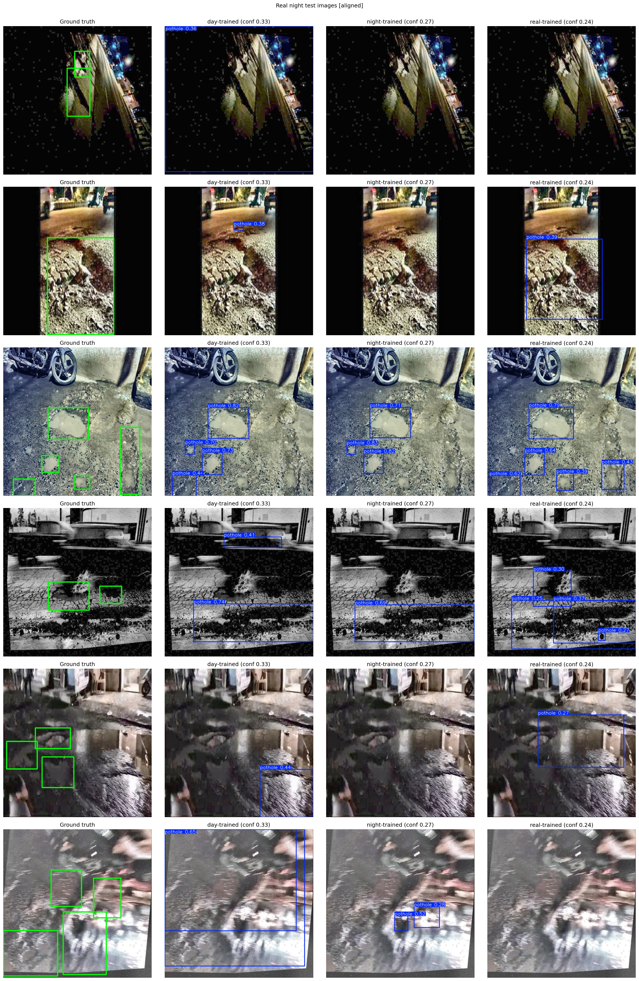
Figure 7. Real-night test images: ground truth, Day model, Night-synthetic model and Night-real model (aligned, seed 42).

3.11 Discussion and Limitations
Across the YOLOv8n, YOLOv8s and YOLO11m runs, all detectors learn the synthetic pothole domain to a broadly similar level: test mAP@0.5 is 58.59% (YOLOv8n) and 59.98% (YOLOv8s) on the original synthetic test split, and 57.56% / 58.66% (raw / aligned) for the YOLO11m Night-synthetic model on the smaller, de-duplicated synthetic test set. These are not a strict head-to-head benchmark: the architectures, test sets, software and evaluation procedures differ, and the YOLOv8 runs were not de-duplicated.
- The real-night test set is small (114 images, 265 boxes), because it was matched in size to the leak-free paired test set; confidence intervals are correspondingly wide.
- Three seeds per model and 60 epochs were used; the seed-42 validation curves were still rising at the end of training.
- Only 74.2% of the synthetic-night images could be paired with a day original; the unpaired images were excluded.
- The training sets are balanced in image count and object-size mix, but object scale, scene and annotation style still differ between datasets, and their individual contributions to the gap were not isolated.
- The real set's class-1 selection was manual. The meaning of class 0 ('night-potholes') is not documented, and a pothole annotated only as class 0 would be excluded from the evaluation labels. Some real images appear rotated, flipped, greyscale or bordered (Figure 7).
- Grouping by perceptual hash removes near-duplicates but does not establish the provenance of the real images.
- The YOLOv8n and YOLOv8s results come from one run each, so small differences between them do not establish superiority.

4. Conclusion
The project prepared a pothole-only synthetic-night dataset containing 2,679 images and 7,270 pothole instances by transforming daytime road images, and trained YOLOv8n, YOLOv8s and YOLO11m detectors on it. On the original synthetic test split, YOLOv8n and YOLOv8s achieved 58.59% and 59.98% mAP@0.5 (28.99% and 30.43% mAP@0.5:0.95).
A controlled YOLO11m experiment then tested whether the transformed images can stand in for real night images. Three identical detectors, trained on the original day images, the transformed night images and real night images with equal image counts, were compared on day, synthetic-night and real-night test sets over three seeds. The transformation made the detector robust to lighting inside the synthetic domain (night-trained 0.59/0.58 mAP@0.5 on day/night images, against 0.65/0.46 for the day-trained detector), and brightness alignment improved its real-night score from 0.17 to 0.21. On real night images, however, the synthetic-night detector recovered only 27.8% to 36.3% of what a detector trained on real night images achieved (0.60 / 0.58 mAP@0.5), and it was not better than a detector trained on the untransformed day images (gain -0.061 raw, +0.019 aligned).
The honest conclusion is that synthetic night data is beneficial, as a supplement that improves lighting robustness, but it was not able to replace real night images. Closing the remaining gap will probably require real night data, for example through fine-tuning on a small real set, together with more realistic night simulation.

Appendices
Original YOLOv8n validation and test outputs were reported under /content/runs/detect/val and /content/runs/detect/val-2. YOLOv8s outputs were reported under /content/nighttime-pothole-detection/exp3_yolov8s_100ep, including best.pt and last.pt.
The YOLO11m experiment was run in the notebook ipcv-project-2-v2.ipynb. It saves results_long.csv (every model, seed and test set), results_claims.csv, results_recall_by_size.csv, benchmark_balance.csv, pairing_summary.csv, results_summary.json, the figures, the first-seed best.pt weights and the training logs in report_outputs.zip under /kaggle/working. The 18 runs are named {domain}_{condition}_s{seed} (for example night_aligned_s42). These are Kaggle runtime paths and may not persist after a session reset unless saved as notebook outputs or copied to persistent storage.
- Precision: TP / (TP + FP), the fraction of predicted potholes that are correct.
- Recall: TP / (TP + FN), the fraction of ground-truth potholes detected.
- F1-score: harmonic mean of precision and recall, 2PR / (P + R).
- IoU: Intersection over Union, the area of overlap between a predicted box and a ground-truth box divided by their union.
- mAP@0.5: mean Average Precision at IoU threshold 0.50.
- mAP@0.5:0.95: mean Average Precision averaged over IoU thresholds 0.50, 0.55, ..., 0.95.
- TP / FP / FN: true positives, false positives, and false negatives under the specified confidence and IoU matching rules.
- Transformation gain: mAP@0.5 of the Night-synthetic model minus that of the Day model on the real-night test set.
- Ceiling recovered: a model's real-night mAP@0.5 divided by that of the Night-real model.
- Raw / aligned: images used unchanged / images passed through per-image gamma lift and CLAHE.

