Nighttime Pothole Detection
Final Project Report and Experimental Results

1. Project Overview
This project focuses on detecting potholes in low-light and nighttime road images using the YOLO object detector. YOLO11m, initialised from COCO-pretrained weights, was fine-tuned on a pothole-only dataset with synthetic nighttime appearance. The fine-tuned model was then run on a real nighttime pothole dataset to measure how well it transfers.
Two models are compared: (a) the original COCO-pretrained YOLO11m, which has no pothole class and is therefore evaluated class-agnostically, and (b) YOLO11m fine-tuned on the synthetic night dataset. The real dataset is used only for inference and evaluation, never for training or threshold tuning.

2. Dataset Preparation
Two datasets are used: a synthetic night dataset for training, validation and testing, and a real night dataset for evaluation only.

2.1 Synthetic Night Dataset
The synthetic dataset was derived from a three-class pothole dataset (crocodile crack, longitudinal crack and pothole). It was filtered into a single-class pothole-detection dataset and given a synthetic nighttime appearance.
- Kept images containing at least one pothole, including images that also contained cracks.
- Removed images containing cracks only and no pothole.
- Removed crack annotations and retained only pothole bounding boxes.
- Remapped the original pothole class ID (class 2) to class ID 0; the dataset has one class: pothole (nc = 1).
- Generated synthetic nighttime appearance by adjusting brightness, contrast and colour. No geometric transformations were used in this step, so the bounding-box coordinates remained applicable.
Table 1. Synthetic night dataset: split and counts (all images 640 × 640).
Split | Images | Pothole instances
Training | 1,876 | 5,149
Validation | 533 | 1,444
Test | 270 | 677
Total | 2,679 | 7,270
The notebook’s integrity check found no unlabeled images, orphan labels, empty label files, corrupt images or out-of-bound coordinates in any split. All annotations are bounding boxes. The validation split was used to monitor training and to select the reference confidence threshold; the test split was used for held-out synthetic results.

2.2 Real Night Dataset
The real set is a Roboflow night-pothole dataset, accessed through Kaggle as “night-potholes-yolov8-format”. It contains only a train folder (no validation or test folder) with 1,445 images of 640 × 640 pixels and 3,385 boxes. Its data.yaml defines two classes: 0 = night-potholes (330 boxes) and 1 = pothole (3,055 boxes). It was prepared as follows.
- Read the class names from data.yaml and counted boxes per class ID.
- Drew four example images per class (Figure 1) to inspect what each class marks.
- Set the pothole class ID manually to 1 (REAL_POTHOLE_CLASS_ID = 1).
- Kept every image with at least one class-1 box (the same rule used for the synthetic set), kept only the class-1 boxes, and remapped them to class 0.
- Wrote a one-class configuration (nc = 1, name: pothole) whose train, val and test paths all point to the filtered folder. The set is used for inference and evaluation only.
Table 2. Real night dataset: class selection and filtering.
Quantity | Count
Original images (train folder only) | 1,445
Original boxes, class 0 (night-potholes) | 330
Original boxes, class 1 (pothole) | 3,055
Images skipped (no class-1 box) | 115
Images kept | 1,330
Pothole boxes kept (remapped to class 0) | 3,055
Non-pothole (class 0) boxes dropped | 330
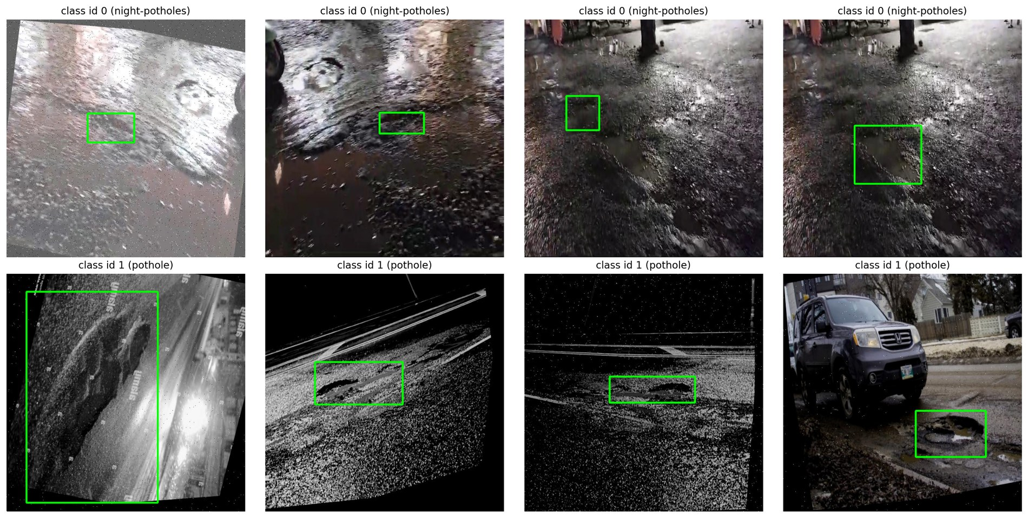
Figure 1. Example real-set images for class 0 (night-potholes, top row) and class 1 (pothole, bottom row). Green boxes are the ground-truth boxes of that class.

3. Dataset Analysis (EDA)
The synthetic and real sets were compared on mean image brightness, bounding-box area and boxes per image (Figure 2). Brightness was computed on a random sample of up to 300 images per set (grey level, 0 = black); box statistics use all images in the set.
Table 3. Synthetic vs real night: summary statistics.
Set | Images | Boxes | Mean brightness | Median box area (% of image) | Boxes per image
Synthetic (train) | 1,876 | 5,149 | 53.54 | 0.31% | 2.74
Synthetic (test) | 270 | 677 | 55.59 | 0.23% | 2.51
Real night (filtered) | 1,330 | 3,055 | 81.29 | 4.29% | 2.30
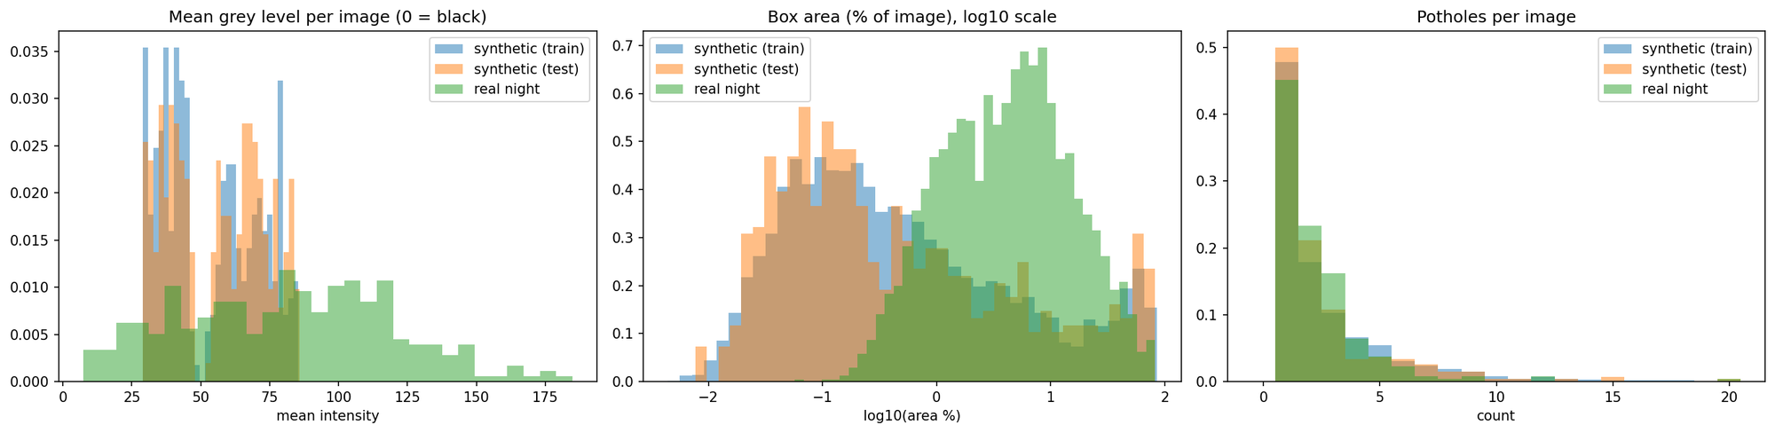
Figure 2. Synthetic vs real night: mean grey level per image (left), box area as % of image on a log10 scale (middle) and potholes per image (right).
- Box size: Real potholes are much larger than synthetic ones. The median real box covers 4.29% of the image, against 0.31% (synthetic train) and 0.23% (synthetic test), roughly 14 and 19 times larger (ratios of the rounded medians). The median synthetic box falls in the small bin (<1% of the image); the median real box falls in the medium bin (1–10%). On the real set, 510 boxes (16.69%) are small, 1,763 (57.71%) are medium and 782 (25.60%) are large (≥10%). Synthetic boxes reach up to 85.19% (train), 94.38% (validation) and 82.76% (test) of the image, but the synthetic medians are 0.31%, 0.26% and 0.23%.
- Brightness: Real images are brighter on average: 81.29 against 53.54 (train) and 55.59 (test), a difference of 27.75 and 25.70 grey levels. In the histogram, synthetic grey levels lie roughly between 30 and 85, while real images spread from roughly 5 to 185 (read from Figure 2).
- Boxes per image: Similar across sets: 2.74, 2.51 and 2.30 on average. The split-level EDA gives medians of 2.0 (train), 2.0 (validation) and 1.5 (test) for the synthetic splits; the median for the filtered real set was not reported.

4. Software and Hardware Environment
- Framework: Ultralytics YOLO, version 8.4.191.
- Python: 3.13.15.
- PyTorch: 2.11.0+cu128.
- GPU: NVIDIA Tesla T4; 14,912 MiB GPU memory was reported (CUDA:0).
- Image size: 800 × 800 for training, validation and inference (the source images are 640 × 640).
- Batch size: 8 for training; 16 for evaluation. Automatic mixed precision (AMP) was enabled.
- Model: YOLO11m with 231 layers, 20,053,779 parameters and 68.3 GFLOPs (training graph); 125 layers, 20,030,803 parameters and 67.8 GFLOPs after fusing for inference.
- Training and evaluation were carried out in a Kaggle notebook environment.

5. Evaluation Metrics
- Precision: Proportion of predicted potholes that are correct; higher precision generally means fewer false positives.
- Recall: Proportion of actual potholes detected; higher recall generally means fewer missed potholes.
- F1: Harmonic mean of precision and recall, 2PR/(P + R).
- mAP@0.5: Mean Average Precision at an Intersection over Union (IoU) threshold of 0.50.
- mAP@0.5:0.95: Mean Average Precision averaged across IoU thresholds from 0.50 to 0.95 in increments of 0.05; this is a stricter measure of localization quality.
- TP / FP / FN: True positives, false positives and false negatives at IoU 0.50 and a fixed confidence threshold.
- Recall by object size: Recall at IoU 0.50 and the reference threshold, split by ground-truth box area as a share of the image: small (<1%), medium (1–10%) and large (≥10%).
- Reference threshold (CONF_REF): The confidence threshold that maximised F1 on the synthetic validation set (grid 0.01–0.99), reused unchanged on all other sets. Its value is 0.30.
- Oracle threshold: The best-F1 threshold found on the evaluated set itself. Reported for information only; it was not used to choose any setting.
- Class-agnostic evaluation: Used for the COCO model, which has no pothole class: any detected object, whatever its COCO class, counts as a candidate pothole.
Two evaluation paths were used. Ultralytics val() (conf = 0.001, IoU = 0.7, image size 800, batch 16) gives official P, R, mAP@0.5 and mAP@0.5:0.95 for the fine-tuned model. A model-agnostic evaluator (predict() with conf = 0.001, NMS IoU = 0.7, greedy IoU matching, 101-point AP) scores any model, including the COCO model, and also gives TP/FP/FN and recall by size. It was cross-checked against val() where both apply. Differences in this report are in percentage points (pp), computed from the two-decimal values shown.

6. Training Setup
- Model: YOLO11m (yolo11m.pt), COCO-pretrained initialisation. The head was changed from 80 classes to 1, and 643 of 649 items were transferred from the pretrained weights.
- Data: synthetic night dataset; 1,876 training images, with the 533 validation images evaluated after every epoch.
- Image size 800; batch size 8.
- Epochs configured: 100. Early stopping patience: 25. Epochs actually run: 100; early stopping did not trigger.
- Optimizer: set to auto, which the log resolved to AdamW (lr = 0.002, momentum = 0.9), weight decay 0.0005, cosine learning-rate schedule (cos_lr = True), 3 warm-up epochs.
- Augmentation: mosaic 1.0 (switched off for the last 10 epochs, close_mosaic = 10), mixup 0.1, scale 0.5, translate 0.1, horizontal flip 0.5, vertical flip 0.0, rotation 0.0, HSV gains h/s/v = 0.015/0.6/0.4. Ultralytics defaults also applied (random erasing 0.4, RandAugment) together with Blur, MedianBlur, ToGray and CLAHE, each with p = 0.01.
- Seed: 42 (trainer seed, with Python, NumPy and PyTorch seeded to 42); deterministic = True; 2 data-loader workers.
- Training time: 2.361 hours for 100 epochs as reported by Ultralytics; 142.3 minutes on the notebook timer, which also covers the final validation pass.
- Best epoch: the highest validation mAP@0.5 was at epoch 100 (59.67%; mAP@0.5:0.95 of 30.34% at that epoch). The epoch of the saved best.pt checkpoint is not printed in the log (not reported).
Over training, the box loss fell from 2.328 (epoch 1) to 1.42 (epoch 100) and the classification loss from 2.917 to 1.089 (training losses from the log). After training, Ultralytics validated best.pt and logged mAP@0.5 of 0.592 and mAP@0.5:0.95 of 0.307 on the validation split (three decimals, as printed).

7. Results on the Synthetic Dataset
The fine-tuned model was evaluated on the synthetic validation and test splits with Ultralytics val(). F1 is computed from the reported mean precision and recall.
Table 4. Fine-tuned YOLO11m on the synthetic dataset (Ultralytics val()).
Metric | Validation (533 images) | Test (270 images)
Precision | 64.56% | 71.44%
Recall | 55.12% | 51.85%
F1 | 59.47% | 60.09%
mAP@0.5 | 59.14% | 60.72%
mAP@0.5:0.95 | 30.76% | 31.05%
On validation, precision was 9.44 pp higher than recall; on test, 19.59 pp higher. Test mAP@0.5 was 1.58 pp above validation and test mAP@0.5:0.95 was 0.29 pp above validation, while test recall was 3.27 pp below validation.
Table 5 shows the same splits scored with the model-agnostic evaluator at the reference threshold of 0.30. This evaluator is used for the model comparison in Section 8 because it scores both models identically.
Table 5. Fine-tuned YOLO11m on the synthetic dataset (model-agnostic evaluator).
Metric (conf 0.30) | Validation (533 images) | Test (270 images)
Precision | 64.75% | 66.79%
Recall | 52.29% | 52.88%
F1 | 57.85% | 59.03%
mAP@0.5 | 57.08% | 58.88%
mAP@0.5:0.95 | 29.04% | 29.30%
TP / FP / FN | 755 / 411 / 689 | 358 / 178 / 319
The model-agnostic evaluator gives lower mAP than Ultralytics on both splits: mAP@0.5 by 2.06 pp (validation) and 1.84 pp (test), and mAP@0.5:0.95 by 1.72 pp and 1.75 pp. Precision and recall in Table 4 come from Ultralytics’ own operating point, whereas Table 5 uses the fixed threshold of 0.30, so the two tables are not directly comparable on those rows.
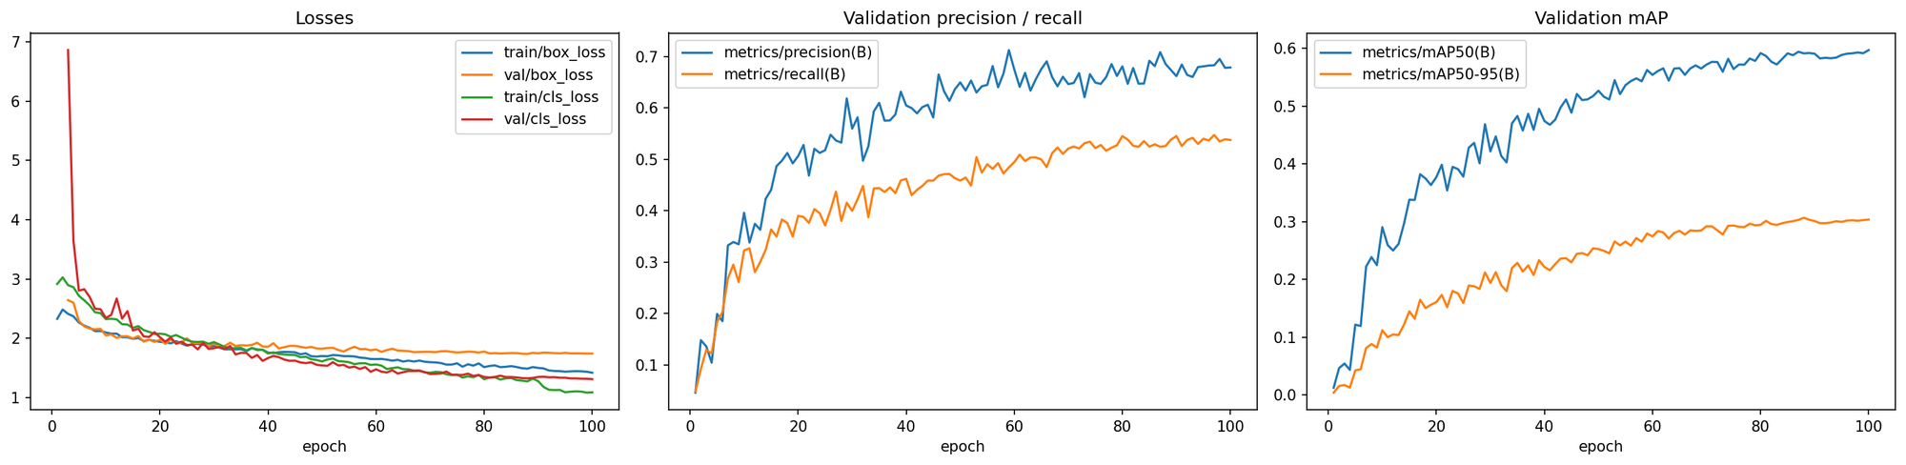
Figure 3. Training curves: losses (left), validation precision and recall (middle) and validation mAP (right).
Validation mAP@0.5 and mAP@0.5:0.95 were still rising slowly at the end of training, and the highest validation mAP@0.5 was reached at the final epoch.

8. Results on the Real Night Dataset
The real set contains 1,330 images and 3,055 pothole boxes. Both models were run at image size 800 with the same NMS settings and scored by the same evaluator. The fine-tuned model used the reference threshold of 0.30 chosen on the synthetic validation set; the same value was applied to the COCO model for P, R, F1 and TP/FP/FN. mAP uses all detections down to conf = 0.001.

8.1 Original YOLO11m vs Fine-tuned YOLO11m
Table 6. Master comparison of both models on both datasets (COCO model scored class-agnostically).
Metric | Original COCO, synthetic test | Fine-tuned, synthetic test | Original COCO, real night | Fine-tuned, real night
Images | 270 | 270 | 1,330 | 1,330
Ground-truth boxes | 677 | 677 | 3,055 | 3,055
mAP@0.5 | 0.58% | 58.88% | 1.29% | 16.79%
mAP@0.5:0.95 | 0.28% | 29.30% | 0.41% | 6.50%
Precision (conf 0.30) | 0.53% | 66.79% | 5.32% | 29.62%
Recall (conf 0.30) | 0.15% | 52.88% | 1.34% | 20.46%
F1 (conf 0.30) | 0.23% | 59.03% | 2.14% | 24.20%
TP | 1 | 358 | 41 | 625
FP | 188 | 178 | 729 | 1,485
FN | 676 | 319 | 3,014 | 2,430
Oracle best-F1 threshold | 0.02 | 0.26 | 0.06 | 0.29
Oracle F1 | 2.90% | 59.51% | 5.84% | 24.40%
On the real set the fine-tuned model is ahead of the original COCO model on every metric: mAP@0.5 by 15.50 pp (16.79% against 1.29%), mAP@0.5:0.95 by 6.09 pp, precision by 24.30 pp, recall by 19.12 pp and F1 by 22.06 pp. Compared with its own synthetic test result, the fine-tuned model loses 42.09 pp of mAP@0.5 and 22.80 pp of mAP@0.5:0.95.
Cross-check: Ultralytics val() on the real set gives the fine-tuned model mAP@0.5 of 19.01%, mAP@0.5:0.95 of 6.99%, precision 30.51%, recall 23.40% and F1 26.49%. The model-agnostic evaluator is lower by 2.22 pp (mAP@0.5) and 0.49 pp (mAP@0.5:0.95).
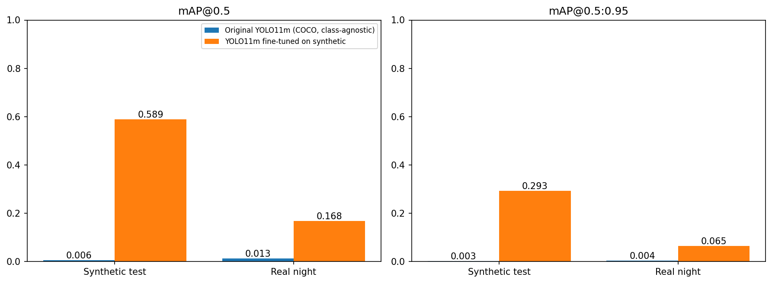
Figure 4. mAP@0.5 (left) and mAP@0.5:0.95 (right) for both models on the synthetic test and real night sets.

8.2 Recall by Object Size
Table 7. Recall by object size on the real night set (IoU 0.50, conf 0.30).
Object size (share of image) | Ground-truth boxes | Original COCO | Fine-tuned
Small (<1%) | 510 | 0.00% | 14.12%
Medium (1–10%) | 1,763 | 0.96% | 18.15%
Large (≥10%) | 782 | 3.07% | 29.80%
All sizes | 3,055 | 1.34% | 20.46%
Fine-tuned recall rises with object size, from 14.12% (small) to 18.15% (medium) and 29.80% (large), a spread of 15.68 pp. The COCO model reaches 0.00%, 0.96% and 3.07% on the same bins.

8.3 Qualitative Results
Figures 5 and 6 show six real images sampled at random (two halves of one figure). Green boxes are ground truth. The middle column is the raw output of the original COCO model at conf ≥ 0.25 with its COCO class names; the right column is the fine-tuned model at conf 0.30. The COCO panels use 0.25 rather than the 0.30 of Table 6.
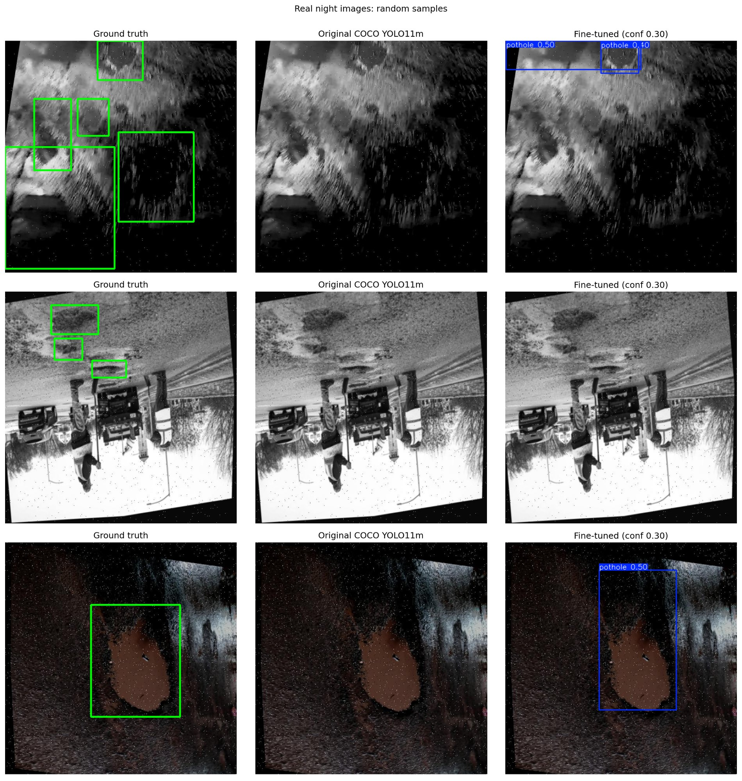
Figure 5. Real night images, samples 1–3 of 6: ground truth, original COCO YOLO11m, fine-tuned YOLO11m.
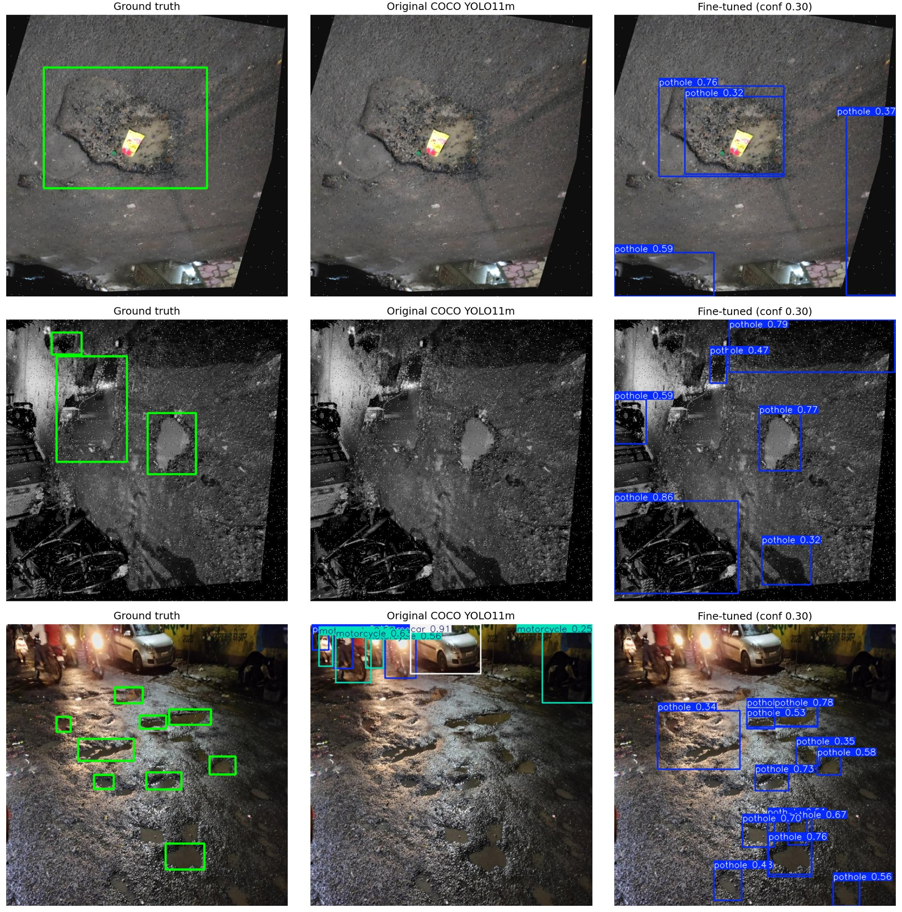
Figure 6. Real night images, samples 4–6 of 6: ground truth, original COCO YOLO11m, fine-tuned YOLO11m.
In these six samples the COCO model produced boxes only in the last image, labelled with COCO classes such as motorcycle. The fine-tuned model produced no detection in sample 2, a box near the ground truth in sample 3, and several boxes without a matching ground-truth box in samples 4 to 6. Whether those extra boxes are unannotated potholes was not checked.

8.4 Precision–Recall Curve
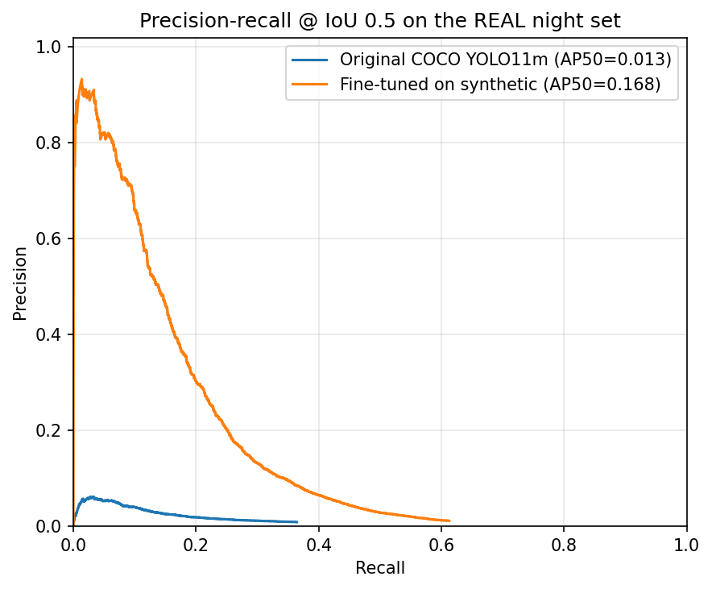
Figure 7. Precision–recall curves at IoU 0.5 on the real night set for both models.
The legend reports AP@0.5 of 0.013 (COCO) and 0.168 (fine-tuned). Read from the plot (approximate values): the fine-tuned curve peaks at about 0.93 precision at very low recall and ends at about 0.61 recall at the lowest confidence; the COCO curve stays below about 0.06 precision and ends at about 0.36 recall.

9. Discussion and Interpretation

9.1 Transfer from synthetic to real night images
Fine-tuning on synthetic night images improves real-night detection over the COCO model, but absolute performance stays far below the in-domain level. The fine-tuned model leads the COCO model on every real-set metric (Table 6): mAP@0.5 16.79% against 1.29%. Against its synthetic test result, mAP@0.5 falls from 58.88% to 16.79% (42.09 pp), mAP@0.5:0.95 from 29.30% to 6.50% (22.80 pp) and F1 at 0.30 from 59.03% to 24.20% (34.83 pp).
Localisation quality also drops: mAP@0.5:0.95 is 0.50 of mAP@0.5 on synthetic test and 0.39 on the real set. The experiments do not isolate the cause; possible factors (hypotheses) are the box-size gap, the brightness gap and differences in annotation style between the datasets.

9.2 Effect of the object-size gap
The real boxes are much larger than the training boxes (median 4.29% against 0.31% of the image), and 83.31% of real boxes are medium or large. Within the real set, recall is lowest for small boxes and highest for large ones (14.12% to 29.80%), so larger potholes are found more often, not less often.
The size gap alone therefore does not explain the drop: even for large real boxes, recall (29.80%) is 23.08 pp below the overall synthetic-test recall at the same threshold (52.88%). Recall by size on the synthetic test set was not reported, so size cannot be separated from brightness, scene and annotation differences. Hypothesis: a box-scale prior learned from training boxes with a 0.31% median may fit large real potholes poorly. This was not tested; size-matched subsets would be needed.

9.3 Precision and recall
At the reference threshold, real-set precision (29.62%) is 9.16 pp above recall (20.46%), but both are low: 1,485 false positives against 625 true positives (about 2.38 per true positive) and 2,430 of 3,055 boxes missed. On synthetic test the figures are 178 false positives against 358 true positives (about 0.50 per true positive) and 319 of 677 boxes missed.
The PR curve (Figure 7) shows that recall tops out at about 0.61 even at the lowest confidence (approximate, read from the plot), so lowering the threshold cannot recover all missed boxes at IoU 0.5. Hypothesis: part of the false positives may be potholes that are not annotated in the filtered real set, for example those marked only as class 0, which were dropped (330 boxes). This was not verified.

9.4 Behaviour of the COCO model
The original model scores 1.29% mAP@0.5 on the real set and 0.58% on synthetic test, with F1 at 0.30 of 2.14% and 0.23%. It has 41 true positives against 729 false positives on the real set and 1 against 188 on synthetic test, even though any detected object counts as a candidate pothole.
On the first 200 real images at conf ≥ 0.25 its most frequent COCO classes were car (69), person (34), truck (7), motorcycle (5), knife (4), train (2), dog (2) and umbrella (2). Its detections are mostly vehicles and people, consistent with the qualitative panels. Its recall by size on the real set is 3.07%, 0.96% and 0.00% for large, medium and small boxes.

9.5 Oracle vs reference threshold
On the real set the oracle threshold for the fine-tuned model is 0.29, giving F1 of 24.40% against 24.20% at 0.30, a gain of 0.20 pp. The threshold chosen on synthetic validation therefore transfers almost unchanged, and threshold choice does not explain the real-set gap. The same holds on synthetic test (oracle 0.26, 59.51% against 59.03%, +0.48 pp). For the COCO model on the real set the oracle threshold is 0.06 with F1 of 5.84% against 2.14% (+3.70 pp), still far below the fine-tuned model.

10. Limitations
- Synthetic darkening (brightness, contrast and colour changes) is not the same as capturing images at night. Mean brightness is 53.54 (train) and 55.59 (test) for the synthetic images against 81.29 for the real images.
- Results come from a single training run (seed 42) and a single evaluation pass. There are no repeated seeds or confidence intervals, so differences may not be statistically stable.
- Both datasets are filtered to one class. The synthetic set has the crack classes removed; the real set has class 0 (night-potholes) removed. Results apply to these prepared datasets only.
- The pothole class of the real set was selected manually (class 1). The class-0 examples in Figure 1 also show pothole-like regions, and the notebook does not document how the dataset defines the two classes. A pothole annotated only as class 0 would count as a false positive if detected.
- The real set was not examined for provenance. The examples in Figures 1, 5 and 6 include images that appear rotated, flipped or greyscale, with black borders and speckle noise, and at least one image that appears to be daytime. No duplicate or near-duplicate check was run.
- The COCO baseline is evaluated class-agnostically, with any detected object counted as a candidate pothole. This is the most generous reading and not a pothole-trained baseline. It also reuses the threshold of 0.30 rather than a tuned one.
- The real set was used only for evaluation: no real-data fine-tuning and no threshold tuning were done, so the results do not show what training on real night images would achieve.
- Absolute mAP depends on the evaluator: the model-agnostic evaluator is 0.49 to 2.22 pp lower than Ultralytics on mAP@0.5 and mAP@0.5:0.95 across the splits where both were run. Model comparisons use one evaluator throughout.

11. Training Artifacts and Saved Results
- Weights: /kaggle/working/runs/yolo11m_synthetic_ft/weights/best.pt and last.pt (40.6 MB each, optimizer stripped). Other training outputs, including results.csv, are in /kaggle/working/runs/yolo11m_synthetic_ft.
- Ultralytics val() outputs (PR, F1, precision and recall curves, confusion matrices, validation batch images): /kaggle/working/runs/eval/ft_synth_val, ft_synth_test and ft_real.
- Results files: /kaggle/working/results_comparison.csv, results_recall_by_size.csv and results_summary.json.
- Dataset configurations: /kaggle/working/synthetic_data.yaml and real_night_data.yaml. The filtered real set is in /kaggle/working/real_night_pothole/test (images and labels).
- Figures: /kaggle/working/figures (synthetic_vs_real_eda.png, training_curves.png, model_comparison.png, pr_curve_real.png, qualitative_real.png, qualitative_synth.png, real_class_examples.png).
- Archives: /kaggle/working/report_outputs.zip (the notebook reported 72 files, 74.7 MB) and report_artifacts.zip (figures).
- Input datasets: /kaggle/input/datasets/phoenixz14/pothole-only (synthetic) and /kaggle/input/datasets/tavishisharma09/night-potholes-yolov8-format (real).
- These are Kaggle notebook paths. Files stored only in the runtime may not survive a session reset unless they are saved as notebook output or copied to persistent storage.

12. Summary
A pothole-only dataset with synthetic nighttime appearance (2,679 images, 7,270 pothole instances) was used to fine-tune YOLO11m from COCO-pretrained weights for 100 epochs (2.361 hours on a Tesla T4). On the synthetic test split it reached mAP@0.5 of 60.72% and mAP@0.5:0.95 of 31.05% with Ultralytics val() (58.88% and 29.30% with the model-agnostic evaluator). On the real night set (1,330 images, 3,055 pothole boxes), used only for evaluation, the fine-tuned model reached mAP@0.5 of 16.79% and mAP@0.5:0.95 of 6.50%, against 1.29% and 0.41% for the original COCO model scored class-agnostically. At the threshold of 0.30 chosen on synthetic validation, F1 on the real set was 24.20% against 2.14%. Real potholes are much larger than synthetic ones (median 4.29% against 0.31% of the image), and fine-tuned recall on the real set rose with size, from 14.12% for small to 29.80% for large boxes. Fine-tuning on synthetic night images improved real-night detection over the COCO model, but a large gap to synthetic-test performance remains.

