**Schematic Diagram**

**Code**

**On board**

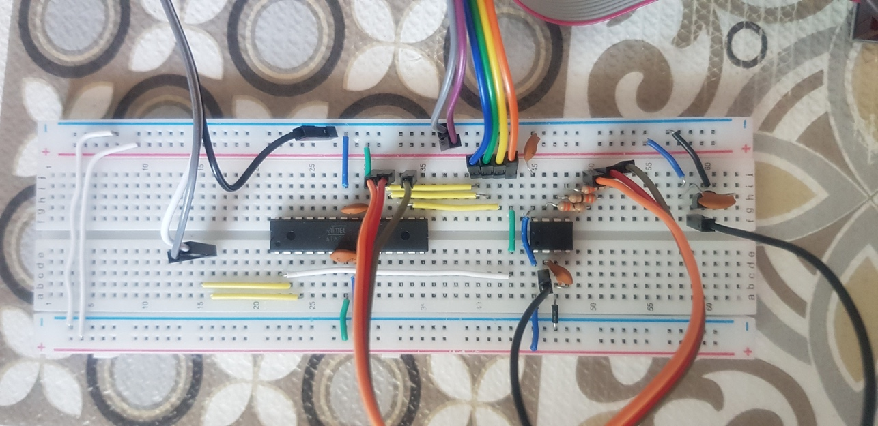

**Result**

