# Design and implementation Document

**I decided to use the Python language with object-oriented paradigms to implement the modified tic-tac-toe program. Below is the class diagram of the modified tic-tac-toe programme.**

Figure - Class diagram of tic-tac-toe

**In Figure 1 I have shown the class diagram, so I have followed the class diagram written on each function below:**

**Game class:**

1. __init__ Function

Figure - __init__function in game class

1. Switch Players Function

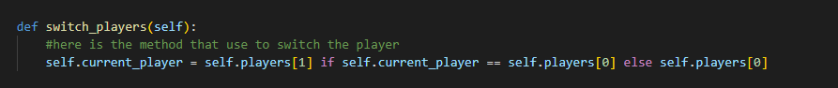

Figure - Switch players function in game class

1. Play Game Function

Figure - Play game function in game class

1. Display Function

Figure - Display function in game class

1. Make Move Function

Figure - Make move function in game class

1. Check Winner Function

Figure - Check Winner function in game class

**Board class:**

1. Display Function

Figure - Display Function in board class

1. Winner Function

Figure - Winner function in board class

1. Valid Move Function

Figure - Is_valid_move function in board class

1. Make Move Function

Figure - Make move function in board class

**Player class:**

1. __init__ Function

Figure - __init__ function in player class

1. Make Move Function

Figure - Make move function in player class

**In the iteration code of my implementation process, I wrote the following code:**

Figure - Iteration code part 1

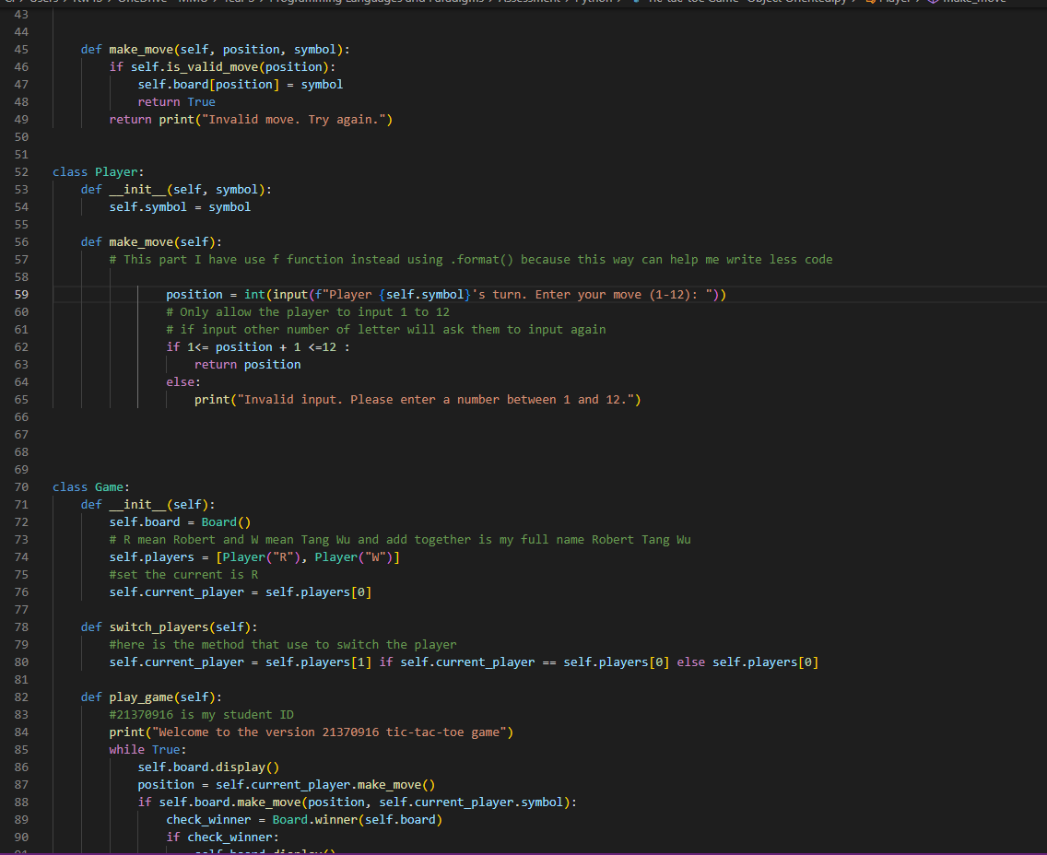

Figure - Iteration code part 2

Figure - Iteration code part 3

**In the iteration of my implementation, I have found some error, so I have updated the code**

Figure - The error of the code when input a letter

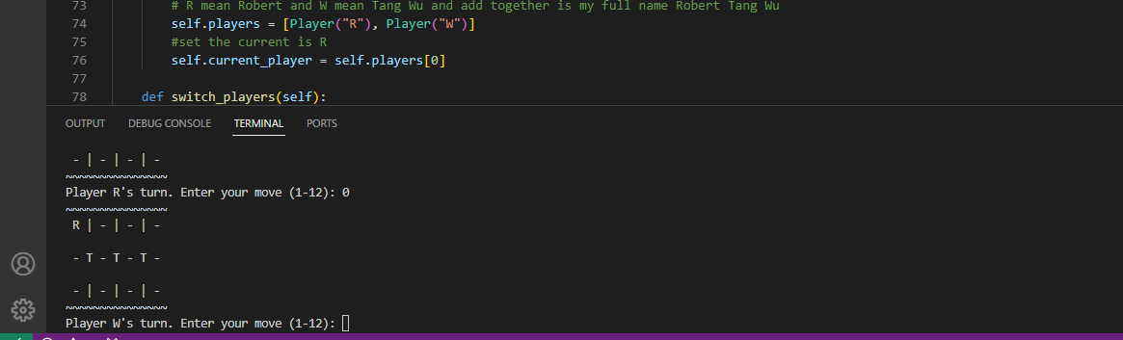

Figure -The error of the code the range should start from 1 to 12 not 0-11

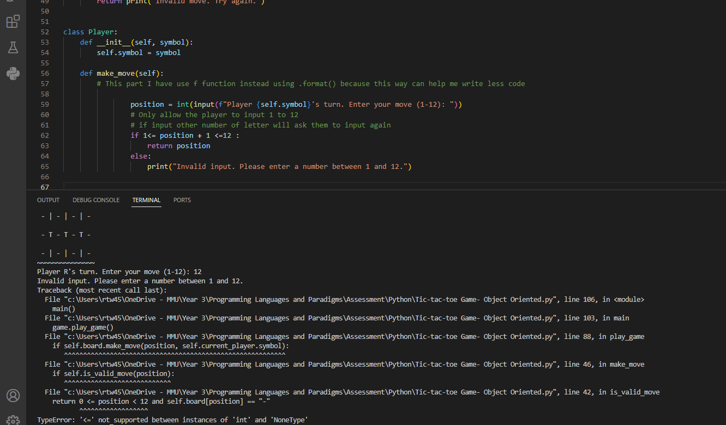

Figure - The error of the code when input the number that out of range

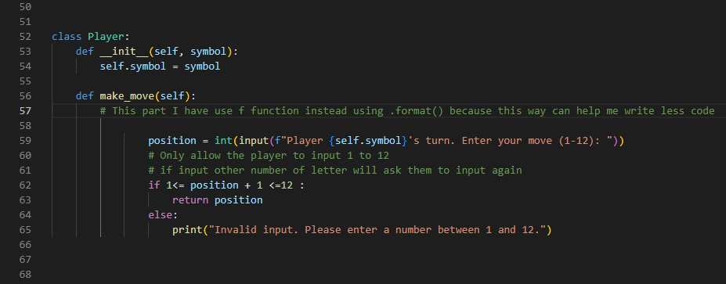

Figure - Found the issue from the code

Figure - Updated the code

Figure - After update the code the result of the input a letter

Figure - After update the code the result of the input a number that out of range

**When the whole program working, and I have tested the programming. These are the tests that I conducted:**

1. Run to the end with R player winning

Figure - Test R player wining (col)

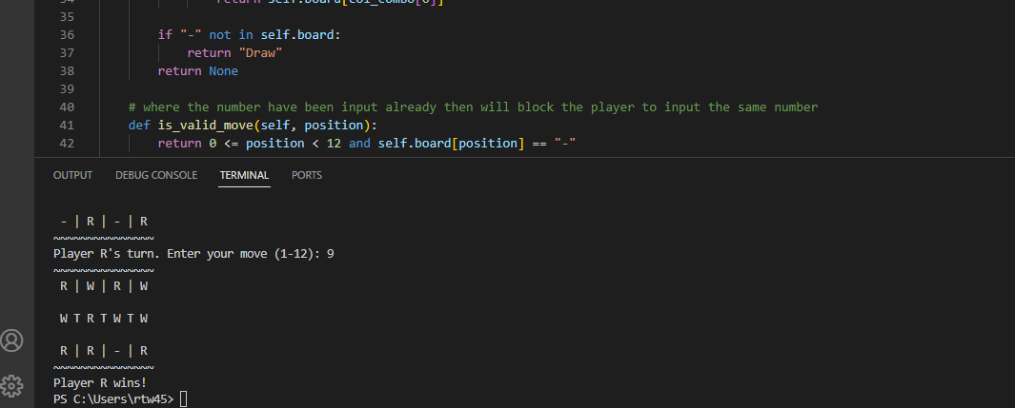

Figure - Test R player wining (diagonal)

Figure - Test R player wining (row)

1. Run to the end with W player winning

Figure - Test W player wining (col)

Figure - Test W player wining (diagonal)

Figure - Test W player wining (row)

1. Run to the end with a draw.

Figure - Test the game draw

1. Validation of input the out-of-range number

Figure - Test input out of range number

1. validation of input a letter

Figure - Test input a letter

1. Validation of input of the symbol to the cell that already exists

Figure - Test input of the symbol to the cell that already exists