Note: This template has been created as a supporting document to the Subsea Production Systems Budgetary Request Proposal Procedure (QP-SPS-GLO-ITO-001)
Note that when populating the Proposal, only pages 2 and onwards should be used.
Page 1 is for QMS purposes only, and must be removed from the completed Proposal

BUDGETARY PROPOSAL
for
Owner Name
Project Name
(Subsea Hardware)

SECTION 1 Summary & Overview of BHGE 5
1.1 Overview of BHGE 5
1.1.1 Local Service Facilities – BHGE Jandakot (JDK) 6
SECTION 2 Scope 9
2.1 Scope / Description of Work 9
SECTION 3 Proposed Equipment 10
3.1 Overall System 10
3.1.1 Abbreviations 10
3.2 ATTACHMENTS 11
3.3 Tree System 12
3.3.1 Technical Description 13
3.3.2 Tree Main Features 14
3.3.3 Specifications 15
3.3.4 Tree System Options 15
3.4 Wellhead System 16
3.5 Subsea Control System 16
3.5.1 General Requirements 16
3.5.2 Control System Overview 16
3.5.3 Materials 16
3.5.4 Corrosion Protection & Protective Coatings 16
3.5.5 Maintenance Requirements 16
3.6 Manifolds & CoNNECTIONS 17
3.6.1 General Requirements 17
3.6.2 Detailed Description 17
3.6.3 Materials 17
3.7 Spares 17
3.8 Rental Tooling 17
3.9 Project Management 17
3.10 Engineering 17
3.11 Testing Requirements 17
3.11.1 Qualification Testing 17
3.11.2 Factory Acceptance Test (FAT) 18
3.11.3 Extended FAT (EFAT & SIT) 18
3.11.4 Site Receipt Test (SRI / SRT) 18
3.11.5 Mechanical Completion 18
3.12 Quality 18
3.13 Environmental Health & Safety (EHS) 19
3.14 Integrity & Compliance 19
3.15 Life of Field 19
3.16 Training Capability 20
3.17 Wellstream Flexibles 21
SECTION 4 Subsea Equipment Prices & Services Rates 22
4.1 Budgetary Pricing 22
4.1.1 Base Scope 22
4.1.2 Project Management & Engineering 24
4.2 Estimated Delivery 25
4.3 Delivery Incoterms 25
SECTION 5 Terms & Conditions & Assumptions 26
5.1 Terms & Conditions 26
5.2 Pricing Assumptions 26
SECTION 6 Disclaimer 27
SECTION 7 List of Experience 28

Summary & Overview of BHGE

Overview of BHGE
BHGE, is a wholly owned subsidiary of General Electric Company and has been providing subsea equipment and services to its customers since the 1960s. With over 15,000 employees operating in 70 countries, BHGE can provide advanced technology through high quality products & services to meet its customer’s expectations.
BHGE believes that exemplary performance in the areas of Health, Safety, Environment, Quality, Integrity and Ethics and acting lawfully and in a socially responsive manner are essential to achieving its business goals whilst leveraging key capabilities to the benefit of their clients.
BHGE is a market leader providing large EPC subsea systems to customers in major fields across the globe. They have established a track record as a supplier of choice and this experience brings tremendous value and risk mitigation to projects. Furthermore, BHGE can continue to make a difference by providing Life of Field Support across all assets.
BHGE is committed to providing technically compliant products and services that conform to customer, regulatory and business requirements. It is BHGE mission is to be the leading upstream product, system & service provider with unyielding integrity and safety by creating value for customers through fulfilment excellence, technology leadership and continuous talent development.
BHGE understands that for any project to succeed, close communication and teamwork with the customer at all levels throughout the project life is required. As such BHGE continues to develop execution models that utilise learnings from prior projects, maximising continuity of experienced teams with experienced leadership and management.
BHGE can use its state of the art Telepresence video conferencing facilities globally to execute project meetings and minimise the need to travel for both BHGE and its customers.
LIFE OF FIELD
BHGE is one of the largest subsea systems providers, uniquely positioned in Australia and Asia with strategically placed facilities able to provide long-term partnering to deliver service and on-going support. BHGE continues to build its service organization in support of the growing assets in the region with focused training of Field Service Engineers (FSE’s) by participation in the assembly and the testing of the equipment as it is being built. This ensures that the personnel are already familiar with the equipment and ready for the offshore campaign.
TRAINING
BHGE is committed to train and grow its employees and those of its Customers, with facilities like our new Skills Development Centre in Australia. BHGE has become a Registered Training Organization (RTO) so that it can deliver all its training modules for the subsea and LNG equipment and train operators.
CONCLUSION
BHGE is committed to innovation in its products and services to ensure optimal customer responsiveness in regards to equipment provision, project resource availability and manufacturing capacity. Furthermore, it has extensive capability to provide long term ongoing support.

Local Service Facilities – BHGE Jandakot (JDK)
The BHGE Jandakot facility is located approximately 16km south of Perth. The site is accessed via adjacent heavy freight routes, it neighbours the Jandakot Airport and is within close proximity of the commercial port facilities at Fremantle. The heavy industrial area has major manufacturing around the site, which allows easy access to specialist services such as crane hire, fabrication and machining vendors and lay down/storage areas if required.
The site occupies over ten (10) hectares, incorporating business offices, workshops, storage facilities, a state-of-the-art Skills Development Centre and onsite parking.

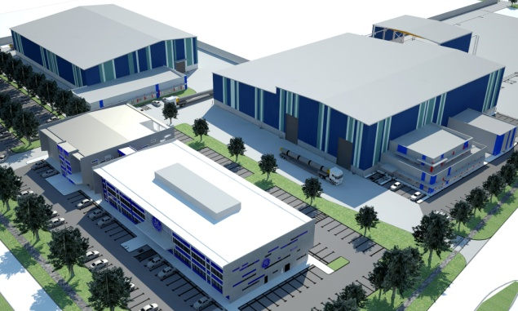
Figure 1 - BHGE Jandakot Facility
A summary of the general facilities and systems includes:
- Available office areas of approximately 6,500m²;
- Fully equipped conference rooms;
- A state of the art Skills Development Centre;
- Technical library and documentation archives;
- Office support tools, including scanning, fax, copying machines and a staffed telephone exchange;
- State-of-the-art teleconferencing facilities, including a Telepresence room;
- Gym and Change rooms;
- Staff kitchens and eating areas; and
- Canteen/cafeteria.
Jandakot Workshop Capabilities:
With a total workshop area of approximately 3,427m², the Jandakot workshops are equipped to conduct Repair, refurbishment, testing and assembly of subsea equipment, surface X-trees and capital drilling equipment; Hydrostatic testing up to 22,500psi; and Fabrication and welding of structural steel and piping in accordance with procedures, specification and processes according to API 6A 9 (major fabrication may be carried out in conjunction with a third party).
Subsea Workshop:
- The subsea workshop has an area of approximately 1,592m² and includes the following facilities:
- One (1) x 150T overhead crane;
- One (1) x 25T overhead crane;
- Large wash-down area;
- Two (2) x test bays for hydrostatic testing; and
- Testing fixtures.
Testing Facilities:
The state-of-the-art Jandakot facility can support extensive pressure and equipment testing activities and procedures, and provides one of the most extensive facilities of its kind in Australia. Test facilities available at the Jandakot Facility include:
- One (1) x nine (9) metre deep gas test pit;
- One (1) x six (6) metre deep gas test pit;
- Dummy wellhead test pit (0.75m x 5m); and
- Dedicated testing areas, with fixtures, for sub-assemblies and controls.
Testing Equipment:
The Jandakot workshops are equipped with a selection of assembly/test equipment including:
- Test and flushing HPU;
- Electronic Pressure Chart Recorder, ranging from 0-30,000 PSI;
- Test Pump, ranging from 0- 30,000 PSI;
- Range of hydraulic torque equipment; and
- An extensive range of test fixtures.
Subsea Production Controls Workshop:
The Jandakot facility has a Controls Workshop (area of approximately 245m²), including a dedicated clean room for the service of BHGE controls equipment. The clean room (area of approximately 16m²) is a positive pressure room, with a filtered air supply, and provides the capability to strip down controls equipment to its basic component level, without the risk of contamination to the hydraulic circuits or sealing faces. The Controls Workshop has the facilities and capability to provide:
- Site receipt testing of delivered controls equipment;
- Storage and maintenance of customer-owned equipment;
- Sourcing and storage of strategic spares for rental use;
- Repair and refurbishment of legacy Subsea Control Modules;
- Direct support of EFAT and SIT activities;
- Recalibration and recertification of controls equipment; and
- Obsolescence management and “design out” of legacy hardware/software.

Scope
BHGE is pleased to provide this budgetary pricing submission to Full Customer Name (shortened/abbreviated customer name) for their consideration.
We believe the information provided herein can serve well as a starting point for further discussions.

Scope / Description of Work
Include write up of project with as much detail as possible and list customer requirements as per below. Also include field layout if available.
This budgetary submission includes for the following items:
- xxoff – xxx
- xxoff – xxx
- xxoff – xxx
- xxoff – xxx
- xxoff - xxx

Proposed Equipment
The following section describes the equipment BHGE proposes based on their understanding of shortened/abbreviated customer name requirements. Note that there will be opportunity to further refine and optimise the concept outlined in this document as additional information is provided to BHGE.

Overall System
The proposed subsea system is based on proven reliable technology tailored for xxxx
Include schematic of proposed system below.
Include system level write up/summary as required.

Abbreviations
JUDR | Jackup Drilling Rig
MODU | Mobile Offshore Drilling Unit
PMV | Production Master Valve
PWV | Production Wing Valve
AMV | Annulus Master Valve
AAV | Annulus Access Valve
AWV | Annulus Wing Valve
XOV | Crossover Valve
PCV | Production Choke Valve
CIV | Chemical Injection Valve
MIV | Methanol Injection Valve
FIV | Flowline Isolation Valve
SCSSV | Surface Controlled Sub Surface Valve
MVB | Master Valve Block
TCT | Tree Cap Test
DPTT | Downstream Pressure Temperature Transducer
TCL | Tree Connector Lock
TCU | Tree Connector Unlock
APT | Annulus Pressure Transducer
WPS | Wellhead Protection Structure
UTA | Umbilical Termination Assembly
DHPTT | Downhole Pressure Temperature Transducer
SCM | Subsea Control Module
ITC | Internal Tree Cap
IWOCS | Installation and Workover Control System
BOP | Blowout Preventer
XT | Christmas Tree
HTOM | Horizontal Tree On Mudline

ATTACHMENTS
Attachment Number | Document Title
Attachment 01 | xxxxx
Attachment 02 | xxxxx
Attachment 03 | xxxxx
Attachment 04 | xxxxx
Attachment 05 | xxxxx
Attachment 06 | xxxxx

Tree System
Include over view of proposed Tree System and include image (example below).
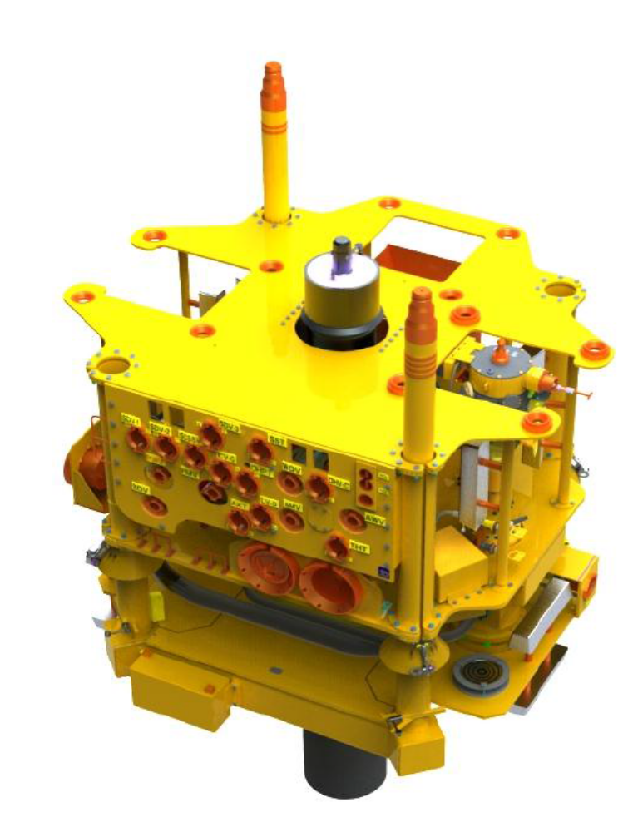
Figure 2 - Typical 5" x 2", 13-5/8", 5,000 psi Horizontal Tree on Mudline

Technical Description
Detailed technical description including X-Section view (example below).
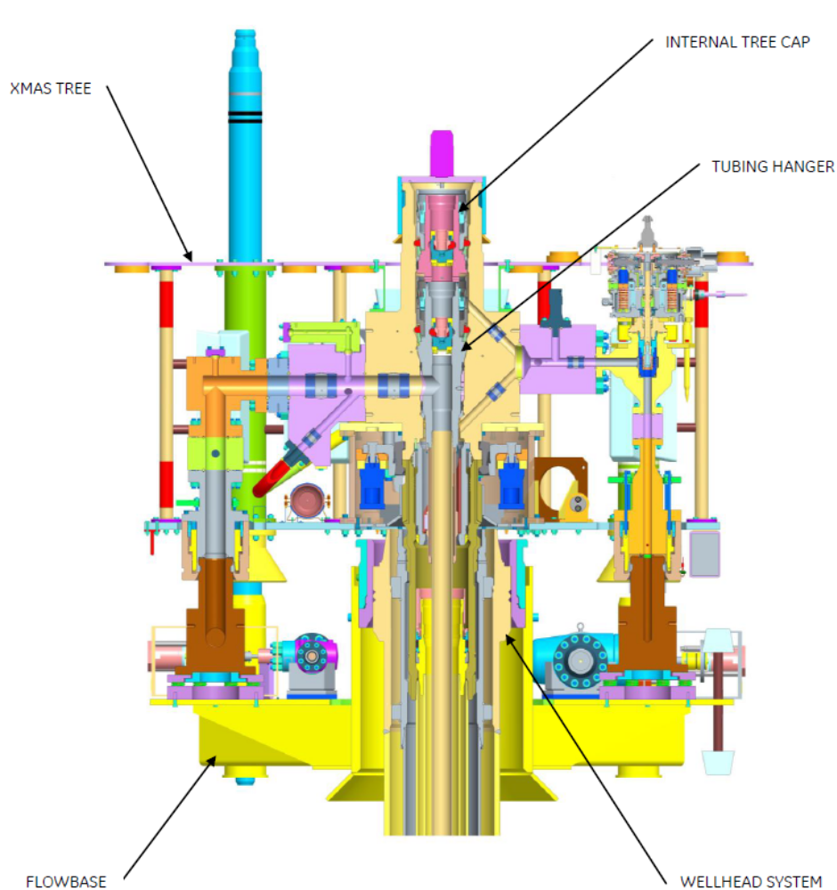
Figure 3 - X-Section View of Tree - Wellhead Stackup (Production Choke is not shown)

Tree Main Features
List Main features of proposed system & include image of Tree (example below)
- xxxx;
- xxxx;
- xxxx;
- xxxx;
- xxxx;
- xxxx;
- xxxx;
- xxxx.
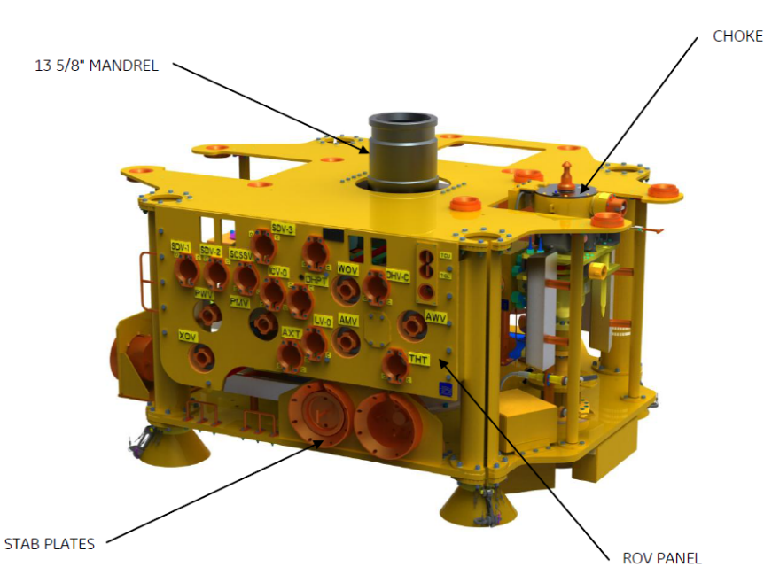
Figure 4 - Typical Shallow Water Horizontal Tree (or) Horizontal Tree on Mudline (HTOM)

Specifications
Item | Description
Tree Type | xxxxx
Size / Pressure | xxxxx
ISO 10423 Classification | xxxxx
Tree Water Depth Rating (Max) | xxxxx
Bore Sizes | xxxxx
Tree Trim | xxxxx
Tree Top Connection | xxxxx
Tree Bottom Connection | xxxxx
VG 300 Hydraulic Valves | xxxxx
VG 300 Manual Valves | xxxxx
Production Choke | xxxxx
TH Orientation | xxxxx
Controls Interfaces | xxxxx
Field Tie-In Connection | xxxxx
Design Life | xxxxx

Tree System Options
Include any optional features in this section to suit submission (examples provided below).
- Fisher friendly protection structure
- Direct Hydraulic Control instead of Electro Hydraulic
- Addition of a third chemical injection valve CIV3 downstream of Production Choke
- Flowbase mounted manifold valves and UTA's
- Daisy Chain Flowbase mounted manifold valves and UTA's

Wellhead System
Include detail of proposed wellhead system along with stack up diagram.

Subsea Control System

General Requirements
Include over view of standard control system and how it shall meet customer requirements.

Control System Overview
Include detailed overview of proposed control system.

Materials
Include details of proposed materials for use in the Control System.

Corrosion Protection & Protective Coatings
The proposed subsea control system shall be designed on the premise that it shall be used and operated in a saliferous environment. Equipment shall be designed so that protective coatings can be easily applied. The protective coating shall be in accordance with BHGE Coating Specification.
Each individual item of surface equipment shall have two earth bonding studs, positioned so that they can be electrically connected to earth. Subsea equipment which is not independently retrievable shall be bonded to the structure on which it is mounted by either welding or dedicated earth strap. Items considered to be permanent shall derive their corrosion protection from the main structural assembly. Additional anodes shall be provided to protect any parts of the control system which are shielded from the primary cathodic protection system.
The corrosion protection system shall employ Aluminium type anodes, which may be within the equipment, or which may be provided on the structure on which the unit is mounted. The location of the anodes shall ensure the protection of all exposed metalwork including all electrical connectors and hydraulic couplers. During the manufacturing and test process continuity shall be verified between the various component parts of each unit or assembly.
External electrical connectors and hydraulic couplings shall use materials which afford the degree of tolerance to corrosion mechanisms commensurate with the design life of the unit and, where relevant, the type of fluid being carried within them. Where necessary electrical connectors and hydraulic couplers shall be fully earthed when mated via their own structure and securing mechanisms or via earth straps.

Maintenance Requirements
The equipment shall be fully maintained in accordance with the maintenance manuals before deployment offshore. The equipment shall, as far as possible, be of modular design to facilitate easy repair of faulty items.
Permanently installed subsea equipment shall be designed to require zero routine maintenance.

Manifolds & CoNNECTIONS

General Requirements
Include over view of proposed structures etc.

Detailed Description
Include detailed overview of proposed structures, include images etc

Materials
Include details on standard materials used, corrosion protection etc.

Spares
Budgetary pricing has not been provided for spares at this stage.

Rental Tooling
Budgetary rates for rental tooling have been included for the various packages in Table 2 below.

Project Management
Project Management will be provided locally as required. An estimate has been included based on Project Management typically representing 8-10% of the total price.

Engineering
An estimate has been included based on Engineering typically representing 8-10% of the total price, depending on complexity and specific requirements.

Testing Requirements
The products proposed as part of this submission are based on qualified components and techniques. All equipment will be manufactured and controlled in accordance with approved BHGE procedures and routines. Planned BHGE inspection, review and verification activities shall be included in the Quality plan.

Qualification Testing
The purpose of qualification testing is to verify the suitability of an individual component for the intended application. Qualification testing is required if the component is novel or contains novel features/subcomponents or if the operating conditions (e.g. temperature, pressure, water depth) are outside the envelope established by previous qualification testing.

Factory Acceptance Test (FAT)
FAT will be performed on all components / assemblies to be delivered to demonstrate conformance with specification and suitability for safe operation. All sub components are tested prior to assembly in the full build of the products, and products are also tested to ensure correct fit and function. FAT shall, as a general rule, be performed at system supplier’s premises.
All FATs shall be performed prior to delivery and prior to further testing (EFAT, SIT or SRT).

Extended FAT (EFAT & SIT)
EFAT testing will include physical demonstration that an ROV can access required areas to perform installation and operational tasks, e.g. adequate physical space to allow Flowline connectors and flying leads to fit onto a Tree or Manifold. If an item of equipment - Tree, UTA, etc. - is the same materially and physically then a test on one item should give the same results as on another item of the same design; therefore, once a verification test has been done on the first unit of a unique design, then the same test would be considered redundant if performed on a second unit of that design. This will result in the first item or article of a batch being subject to an EFAT and subsequent items to an SIT test.
In summary, an EFAT contains more “First Article Type Testing“ of systems and components, whereas, a SIT is less complex due to the elimination of the “First Article Type Testing“ and will require less time and resources.

Site Receipt Test (SRI / SRT)
Site Receipt Testing will mainly verify that the equipment has not been damaged during shipment. The test may be limited to visual inspection (depending on the item of equipment) up to a functional test.

Mechanical Completion

Mechanical Completion (MC) for Equipment
MC check is defined as a separate activity for all equipment. The check will be performed according to predefined check-lists with participation from System Engineering personnel. The check will be performed before equipment is shipped for site integration testing and repeated prior to final delivery. Progress will be controlled through approval of MC Dossiers as part of Dispatch Dossiers. MC and Punch List status will be logged and reported in the MEL/EDL system.

Mechanical Completion (MC) for Fabrication of Template and Structures
To ensure that reported progress accurately reflects completion status, within each construction activity the duration and man-hour estimate will include a percentage allowance for the performance and documentation of MC activities. This will ensure that a construction activity cannot be reported as 100% complete until the necessary MC activities have been successfully performed.

Quality
BHGE is ISO 9001 certified.
BHGE Quality Management system would be utilised for this project, including document management system, interfaces and transmittal system as per BHGE standard procedure. This budgetary estimate is based upon utilising the BHGE standard Quality policy and processes.

Environmental Health & Safety (EHS)
This budgetary estimate is based upon utilising the BHGE standard EHS policy and processes.

Integrity & Compliance
This budgetary estimate is based upon utilising the BHGE standard Spirit & Letter policy.

Life of Field
Life of Field Services rates are included for information in Table 1 below.

Training Capability
BHGE is working to address Australia`s need for skilled local workers to support the Oil & gas industry through its Skills Development Centre in Jandakot, Western Australia. This facility provides training to both Customers and BHGE personnel to support operation of BHGE equipment, helping to maximise system availability through the improved capability of personnel.
The Skill Development Centre is immediately adjacent to the BHGE regional workshop facilities, thus ensuring the availability of true hands-on training. The facility also includes and experiential learning workshop, a range of flexible meeting rooms, 76 seat tiered training auditorium, expansive conference areas, collaboration hubs and fully serviced catering facilities.
Customised course material is developed to the specific training needs of the Customer for their BHGE supplied equipment and includes familiarisation, operation, maintenance and refresher training.
Training courses delivered to date include:
- Project specific MCS Control systems courses for a number of customers (Shell, PTTEP, Chevron, Apache, PETRONAS), including:
  - Field specific simulations
  - High-level equipment overviews (MCS, HPU, SCMs etc)
  - More detailed overviews by main system component
- Introduction to Subsea Wellhead Systems
- Introduction to Subsea Drilling Equipment
- Introduction to Subsea Production Control Systems

Wellstream Flexibles
Flexible flowlines confer a number of significant advantages, which have been summarised below.
- Flexible flowlines generally offer savings when compared to rigid flowlines on an as-installed basis;
- Flexibles offer increased competitiveness in selection of installation vessels, allowing a wider range of companies to tender;
- Reduced installation time and fewer joints, therefore providing fewer potential leak paths;
- Designed to be self-stabilising;
- Improved collapse, corrosion and erosion resistance compared to rigid flowlines;
- Allow for optimised routing, can be laid in tight bends etc;
- Flexibles eliminate the risk of upheaval buckling and lateral displacements;
- Minimal maintenance requirements; and
- Internal diameters can be precisely controlled ensuring they are optimised to meet flow assurance requirements.
The performance value of the Wellstream flexible pipe is further enhanced by BHGE broad industry experience which ranges from high-pressure/high-temperature and extremely corrosive applications, to the deepest water drilling record, longest subsea tieback and complete systems design for some of the world’s most ambitious offshore and subsea projects.
Wellstream products can be found in every major offshore production basin worldwide, and are robust, highly flexible and adaptable to unique project requirements.
Wellstream`s primary engineering design and manufacturing facilities are strategically located in Newcastle, UK, and Niterói, Brazil. These sites are supported by service teams in the US, France, Western Australia and Malaysia – with additional support capabilities available through the extensive resources of the BHGE network.
Wellstream are qualified to ISO 13628-2 and -11, API 17J specification, and their products hold Lloyds Register Type Approval. Their EHS and Quality management systems comply with OHSAS 18001:2007 and they are certified to ISO 14001:2004, ISO 9001:2008.

Subsea Equipment Prices & Services Rates
This budgetary estimate is based upon the terms, assumptions and descriptions provided in this document and the quantities shown in the pricing tables below. Any change in description or quantity, or any additional customer or quality requirements may affect the price and / or delivery.
All pricing is listed in USD
The pricing accuracy for this budgetary estimate is +30% /-30%.

Budgetary Pricing

Base Scope
Item. | Description | Unit | Qty | Unit Price (USD) | Total Price
1 | Subsea Wellhead System - 13 5/8” SG-1 Wellhead System – Excludes Conductor
1.1
1.2
1.3
1.4
1.5
1.6
1.7
 | SUB TOTAL – Wellheads:

2 | Subsea Xmas Tree
2.1 | Subsea Tree assembly | - Tree assembly  - Chokes  - Tubing Hanger  - Wear Bushing  - Internal Tree Cap  - Crown Plugs | Set
SUB TOTAL – Xmas Trees
3 | Controls System
3.1 | Topside Equipment | MCS, HPU, EPU, TUTU etc | Set
3.2 | Tree mounted hardware | SCM, SCMMB, Sensors, Harness etc | EA
3.3 | Distribution Equipment | UTA, HFL, STFL etc | Set
3.4 | Test tools and support equipment | Assumes rental availability for some items, TBC | Set
SUB TOTAL – Controls
4 | Manifolds & Connections
4.1
4.2
4.3
SUB TOTAL – Manifolds & Connections
BASE SCOPE TOTAL- All Hardware

Project Management & Engineering
Item. | Description | Unit | Qty | Unit Price (USD) | Total Price
5 | PROJECT MANAGEMENT & ENGINEERING
5.1 | Project Management - Typically 8-10% of price | 1 | EA
5.2 | Engineering - Typically 8-10% of price | 1 | EA
TOTAL - Project Management & Engineering
BASE SCOPE TOTAL

Table 1 - Field Service Personnel Rates
FSE Engineer Regional (offshore/onshore) | Unit | Unit Rate (USD) | Estimated Qty | Extended Price
Field Services Personnel | Days
Integrated Services Lead (per month) | Month
Travel at documented cost plus 15%

Table 2 - Rental Tooling Rates
FSE Engineer Regional (offshore/onshore) | Unit | Unit Rate (USD) | Estimated Qty | Extended Price
Tree System Tooling | Month
Wellhead Tooling | Month
xxxxxx | Month

Estimated Delivery
The table below provides indicative delivery times for the subsea equipment:
No. | Item | Duration After Receipt Of Order
1 | Wellhead | xxxxxxxxx
2 | Subsea Tree assembly | xxxxxxxxx
3 | Controls | xxxxxxxxx
4 | Manifolds | xxxxxxxxx

Delivery Incoterms
BHGE can manufacture equipment at different global locations and deliver [FCA], Incoterms 2010 from these facilities, however, please note that the pricing in this proposal is based on supply ex Works from the various manufacturing locations.
Delivery times are based on the assumption that manufacturing capacity is available at time of order.

Terms & Conditions & Assumptions

Terms & Conditions
This budgetary estimate is issued based upon utilising the BHGE General Terms and Conditions for Sale of Products, Parts and/or Services Subsea & Drilling Rev. A, (Dec 2015) as the basis for negotiation. It does not constitute an offer or firm quotation, is not binding and is subject to change at any time.

Pricing Assumptions
- All prices quoted currently are in USD, however actual firm quotes may be provided in multiple currencies.
- All taxes, duties, GST are excluded.
- All prices are based on current market rates.
- Market movement, currency fluctuations and necessary escalations have not been factored in. The final execution strategy may cause a price and currency adjustment.
- All travel costs are excluded.
- All office space requirements for the Customer are excluded.
- No provision is made for third party inspection requirements.
- All rental tooling rates are estimates and shall only be finalised post Engineering evaluation and after a detailed tooling list is established

Disclaimer
This budgetary estimate shall not be construed as an acceptance by BHGE to enter into any agreement with any party. The content in this budgetary proposal is provided as a general reference and for information or guidance purposes only. While BHGE has made every reasonable effort to provide accurate information, no claim is to be made as to the accuracy or authenticity of the content.
BHGE does not accept any liability to any person or Company for the information or advice (or the use of such information or advice) which is provided in this proposal or incorporated into it by reference. The information on this proposal is provided on the basis that all persons accessing this information undertake responsibility and will exercise their own skill and care with respect to its use.
The information contained in this proposal is not to be disclosed to any party outside of shortened/abbreviated customer name. No liability is accepted for any information provided herein. This condition shall continue to be in place, unless expressly waived in writing by BHGE.

List of Experience

