Approved By:

Process Owner


Gary Stanbrell
Manufacturing Engineering Leader

Other Functional / Section approval

P Dean
Electrical Section Leader

P Hatfield
Mechanical Section Leader

Document Revision Chart
The following chart lists the revisions made to this document tracked by version. Use this to describe the changes and additions each time this document is re-published. The description should include as many details of the changes as possible.

Rev | Section Modified and Revision Description | Date | Author
0 | Issued for use | 02/11/09 | A Hendy
1.0 | Migration to documentum | 29/03/10 | J Buss
2.0 | Process responsibilities re-defined | 14/04/11 | G Stanbrell
2.1 | Reference number change from WI-CS-QHSE-07 to QP-NAI-8.3-001 | 13/09/11 | M Hughes

1.0 Purpose

The aim is to provide a clear process to enable cost of poor quality to be captured and identified by manufacturing during production to enable data analysis and continuous improvement.

The purpose is to define clearly the use of Work Order Supplementary Allowance codes (‘X’ Code). It is applicable to all equipment manufactured at the Nailsea facility that require modification, rework or non-standard work to be completed.

2.0 Revision Chart

See front cover.

3.0 Process description

This document describes the process steps for creating supplementary work order operations. The process is initiated following identification equipment in manufacture requires modification or rework to be performed. To capture the cost of the unplanned activity (not included in the budget) supplementary operations are added to the work order routing. Supplementary operation “ID’s” (Identification) are similar to normal “ID’s” but are preceded with an “X” followed by a number 1 to 4. The “X” signifies supplementary work; the number indicates the reason for the rework.

Supplementary Allowance Codes (“X” codes)

X1 Engineering
X2 Supplier
X3 Manufacturing
X4 Project

4.0 Criteria for use of X-code operations

New build

Following the Pre final design review Production Engineer assesses whether the product can be manufactured within the allowance provided (arising from the bid). If there is a significant difference, either plus or minus, the Production Engineer should advise Projects and produce a routing for the product with a total estimate. Projects in turn should edit their estimate to complete

X-code operations should be assigned to Hard Allocated work orders whenever supplementary work needs to be done i.e. unplanned activity not included in the budget. Any impact upon the schedule and/or expectation of significant hours to be charged should be conveyed to Project.

Defective parts unkitted from Hard Allocated work orders should be routed to MRB for disposition. Parts requiring in house rework should be issued to Rework work orders. Since this is supplementary work Production Engineering should assign X code operations to the work orders.

Rework (Post handover to Project e.g. Post EFAT/Post SIT/Loan to customer)

Projects create a new demand on the original sales order. Scope of work is defined, schedule and budget are agreed. Rework work order is raised.

Production Engineer produces a routing in-line with the above. Routing lead-time should be within the lead-time on the work order.

X-code operations should be assigned to rework work orders whenever supplementary work needs to be done i.e. unplanned activity not included in the budget. Any impact upon the schedule and/or expectation of significant hours to be charged should be conveyed to Project.

Warranty Repairs

Projects create a new sales order and demand. Scope of work is defined, schedule and budget are agreed. Rework work order is raised.

Production Engineer produces a routing in-line with the above. Routing lead-time should be within the lead-time on the work order.

X-code operations should be assigned to rework work orders whenever supplementary work needs to be done i.e. unplanned activity not included in the budget. Any impact upon the schedule and/or expectation of significant hours to be charged should be conveyed to Project.

5.0 Supplementary Allowance & Reason Codes (X codes)

X1 Engineering Error
  - Drawing/Documentation Error
  - BOM Error
  - Software Error
  - Engineering change during production
  - Engineering Fault Finding/Investigation

X2 Supplier Error
  - Component Failure
  - Special Process failure
  - Packaging
  - Supplier Investigation/Fault finding

X3 Manufacturing Error
  - Operator Error
  - Breakdown in manufacturing process
  - Manufacturing Fault Finding/Investigation

X4 Project Error
  - Customer driven change (Non VO)
  - Project loan rework
  - Projects Investigation/Fault finding

6.0 Supplementary Allowance - Authorisation Levels

Job Title | Supplementary Allowance Code | Authorised Hours
Plant Manager | X1,X2,X3,X4 | 18hrs +
Production Engineer | X1,X2,X3,X4 | 0-18hrs
Section Head | X3 | 0-18hrs
Team Leader | X3 | 0-5hrs

The above authority levels define the limits of authority designated to specified positions of responsibility. It establishes the type of supplementary allowance (X Code) & amount of hours that can be approved by individuals.

The authorised hour limits relate to the total hours required for equipment modification, rework or fault finding to be performed, not to individual operations.

Temporary authority may be designated whenever an individual with approval authority will be out of the office.
Temporary authorization should be clearly communicated specifying the effective length of time.

Original estimated hours should not be exceeded; Team leaders / Sections heads are responsible for monitoring the rework hours & must obtain re-approval in accordance with the authorisation levels prior to perform any additional working hours.

7.0 Feedback & Review

To ensure active analysis and review of supplementary allowance codes, the previous weeks X codes shall be reviewed as part of the weekly quality forum led by manufacturing quality assurance. The purpose is to review X code hours by product family to understand root cause and discussion of opportunities for improvement to prevent future occurrence.

Output of the meeting shall be in the form of agreed actions and identification of improvements, specific topics shall be selected for feedback to production cells during weekly tool box talks. The template contained in Appendix B of this document shall be used for production cell feedback.

Monthly analysis and trending should be conducted as detailed in section 13 of this document to enable further understanding and continual improvement.

Reallocation of X codes should be discussed during the quality forum as appropriate; ensuring agreement from the affected function is obtained prior to reallocation. Following agreement from the function representative the Production Engineer Team Leader will organise for the X-code to be reallocated. If the work order is closed no change to X code allocation can be made.

8.0 Process Flowchart

WHO WHAT HOW
1) Equipment in manufacture requires modification, rework or non-standard work to be performed

2) Inform Team Leader of non-conformance
Technician

3) Assess the non-conformance & discuss with Production Engineer (If Required)
Team Leader / Supervisor

4) Raise GRS & decide on criticality rating
User Guide: GRR Workflow Responsibilities
WI-CS-QHSE-4-B

Team Leader / Supervisor

5) Minor, Moderate or Critical?
User Guide: GRR Workflow Responsibilities
WI-CS-QHSE-4-B

Moderate / Critical
Code: X1 X2, X3, X4
Minor (Code: X3)
User Guide: GRR Workflow Responsibilities
WI-CS-QHSE-4-B

Appendix A: Supplementary Allowance Form

6) Decide course of action & complete Supplementary Allowance Form, acknowledging associated Authorisation levels in Section 6.0
Team Leader / Supervisor

7) Approve hours prior to rework
Appendix A:
Sign Supplementary Allowance form

Section Head

8) Organise Completion of Rework

- Add supplementary x-code operations to work order routing within Visibility
- Re-print & issue work order routing
If the rework can not be completed within the original slot or
- Master Scheduler to be consulted to determine schedule impact & re-plan
Team Leader / Supervisor

B
A

WHO WHAT HOW
B
A

User Guide: GRR Workflow Responsibilities
WI-CS-QHSE-4-B

9) Material Review Board (MRB)
(Informal or Formal)
Production Engineer

10) Authorise supplementary work in accordance with MRB disposition decision
- Add supplementary x-code operations to work order routing within Visibility
- Re-print & issue work order routing

In accordance with authorisation levels approval may be required via completion of Supplementary Allowance Form (Shopfloor) or via Email submission (Production Engineer).

If the rework / fault finding can not be completed within the original slot - Master Scheduler to be consulted to determine schedule impact & re-plan

Production Engineer

11) Reschedule operations and link components (If necessary).
Notify Master scheduler.

Team Leader / Supervisor

Production Planner

12) Organise Completion of Rework

Ensure actual booked hours do not exceed estimated rework hours

Monitor Estimate Vs Actual hours. Original estimated hours should not be exceeded without re-approval of supplementary allowance form

13) Check prior to production receipt, x-code is correctly allocated in accordance with root cause identified on GRR

END

Final Inspection

9.0 User Guide - How to add an X Code operation

Add supplementary ‘X Code’ operation via the SC;09 screen option. Enter UDF (User Define Field) in the Action field then press the <Return> key. Note: The system will not permit the use of U (Update) in the Action field when User Defined Data entries have not been defined.

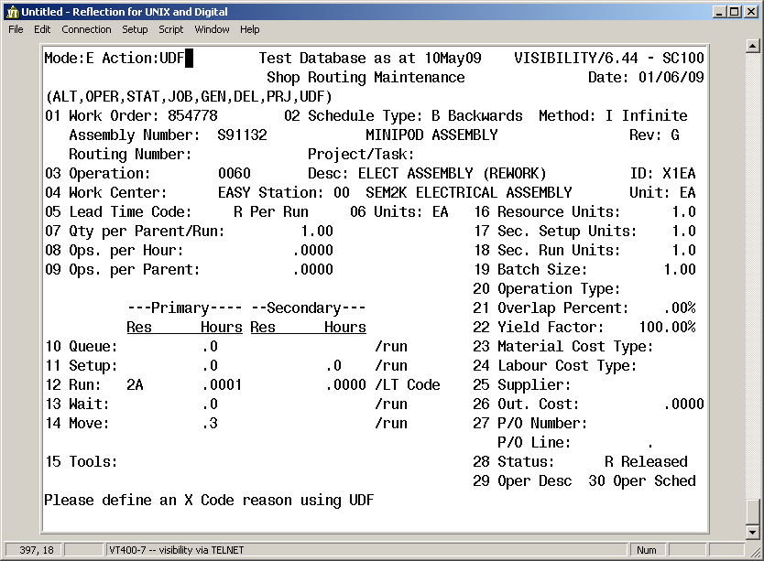

The UDF Maintenance screen is displayed. Enter 01 in the Record Number field then press the <Return> key.

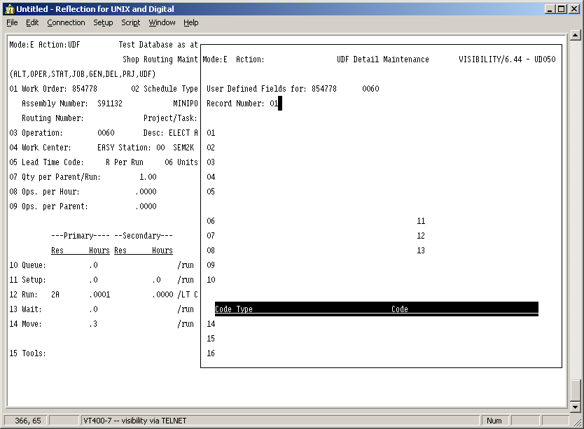

The cursor advances to field 01 – IRR/GRS No. Enter the applicable IRR or GRS number in the IRR/GRS No field then press the <Return> key. Note: If there is no IRR or GRS number to enter, press the <Return> key.

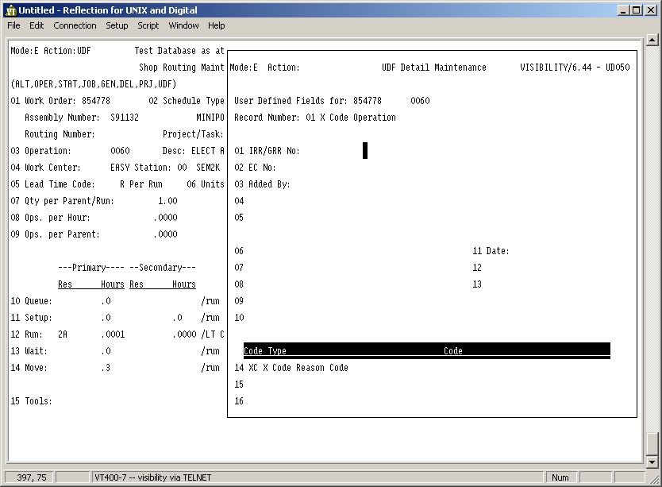

The cursor advances to field 02 – EC No. Enter the applicable EC number in the EC No field then press <Return>. Note: If there is no EC number to enter, press the <Return> key.

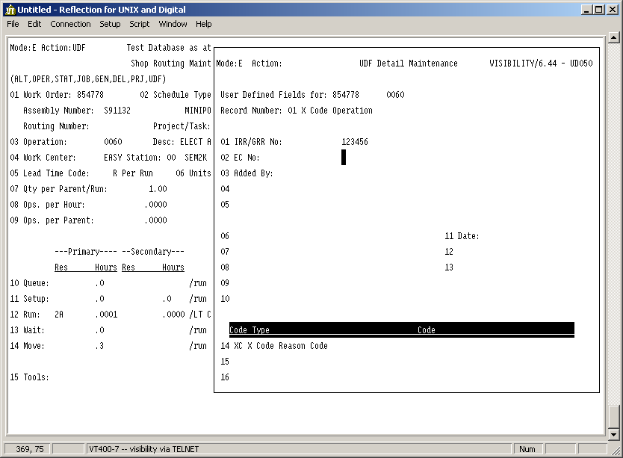

The cursor advances to field 03 – Added By. Enter user name In the Added By field then press the <Return> key.
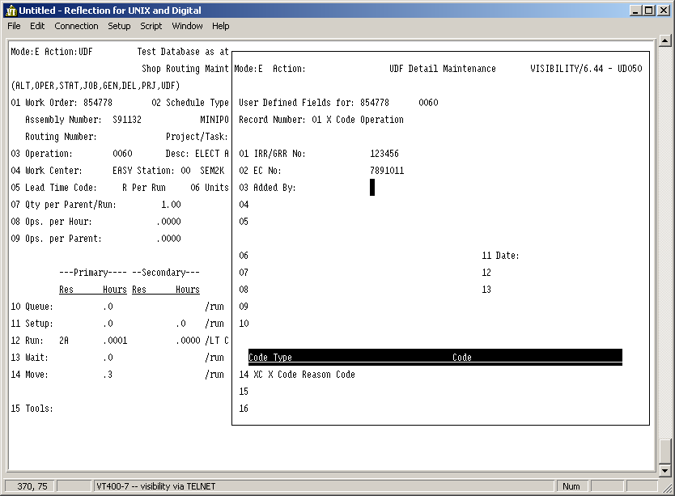

The cursor advances to field 14 – XC X Code Reason Code. Enter * in the XC X Code Reason Code code field then press the <Return> key.

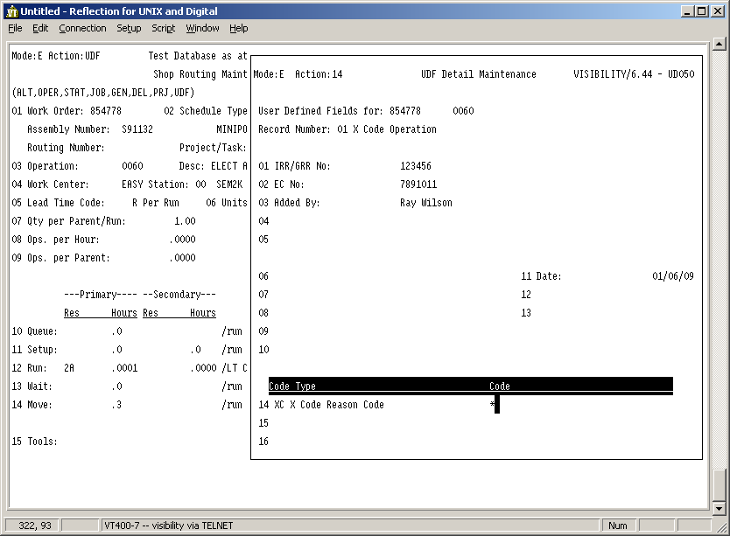

The UDF Code Table Inquiry screen is displayed. Select the applicable Reason Code required by entering the ID of the row in the Action field then press the <Return> key. If you do not see the Reason Code required, press the <Return> key to scroll through all available options. Select a reason code pertaining to the X Code operation created e.g. X1EA operation requires a reason code starting X1.
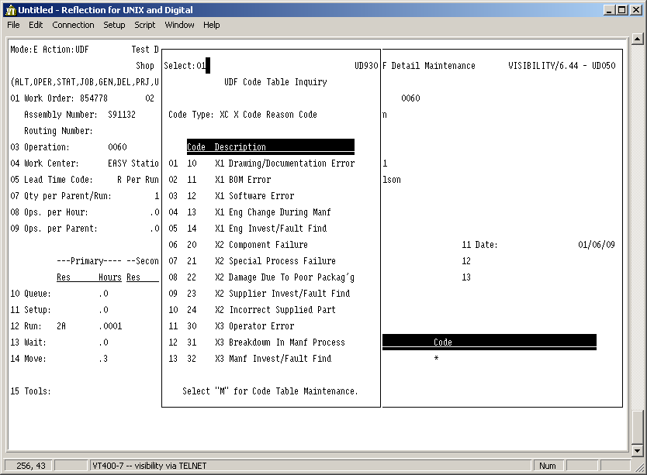

The cursor advances to Action field. Enter UR (Update Return) in the Action field then press the <Return> key.

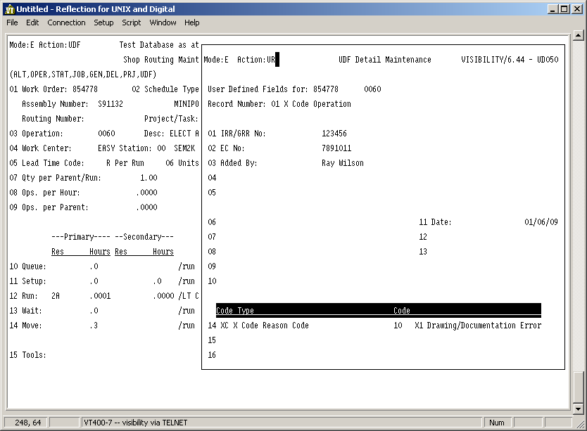

The cursor advances to Shop Routing maintenance Action field. Enter U (Update) in the Action field then press the <Return> key.
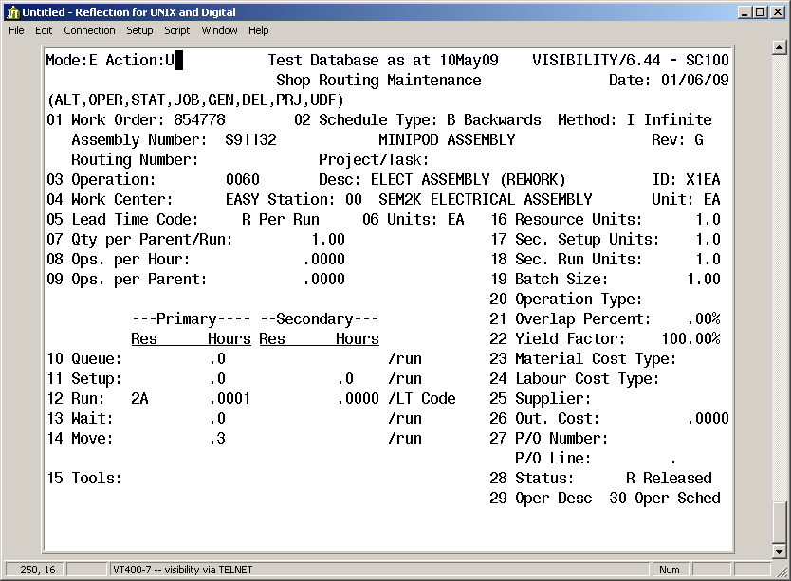

Press the <Page Up> key to return to the Shop Floor Control menu.

The X Code operation has now been created.

To view or edit X Code User Defined information

Find the operation via the SC;09 screen options.

The UDF Maintenance screen is displayed. Press the <Page Up> key.
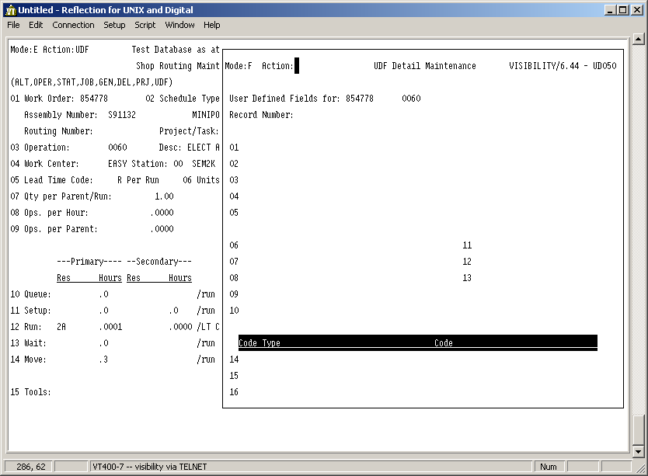

The cursor advances to the Action field. Enter F in the Action field then press the <Return> key twice.

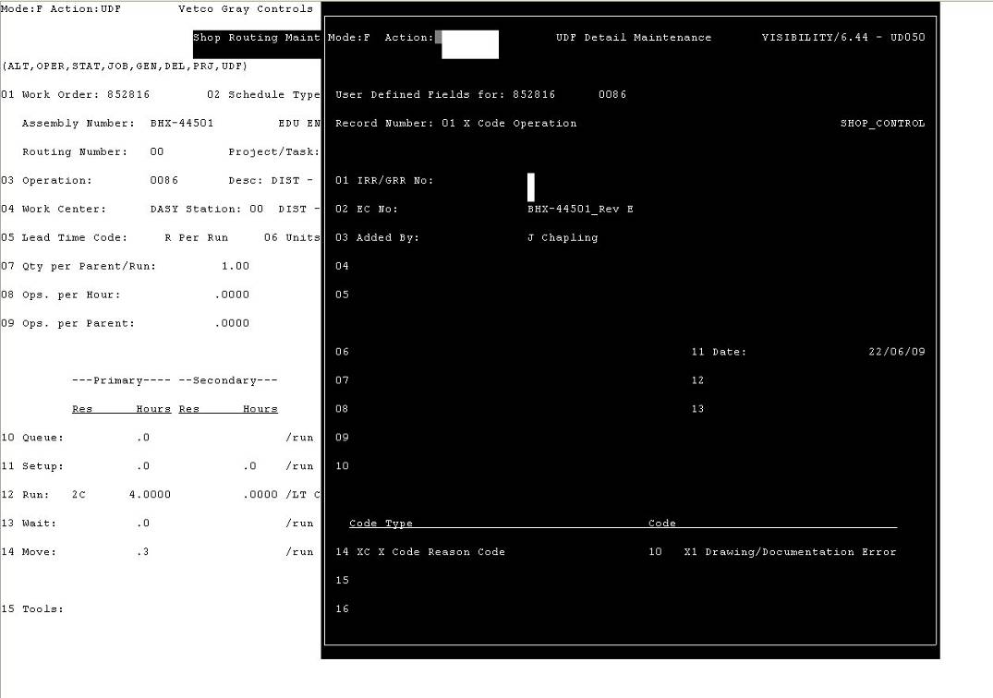

Previous entries are displayed. Select the record required by entering the ID of the field in the Action field then press the <Return> key.
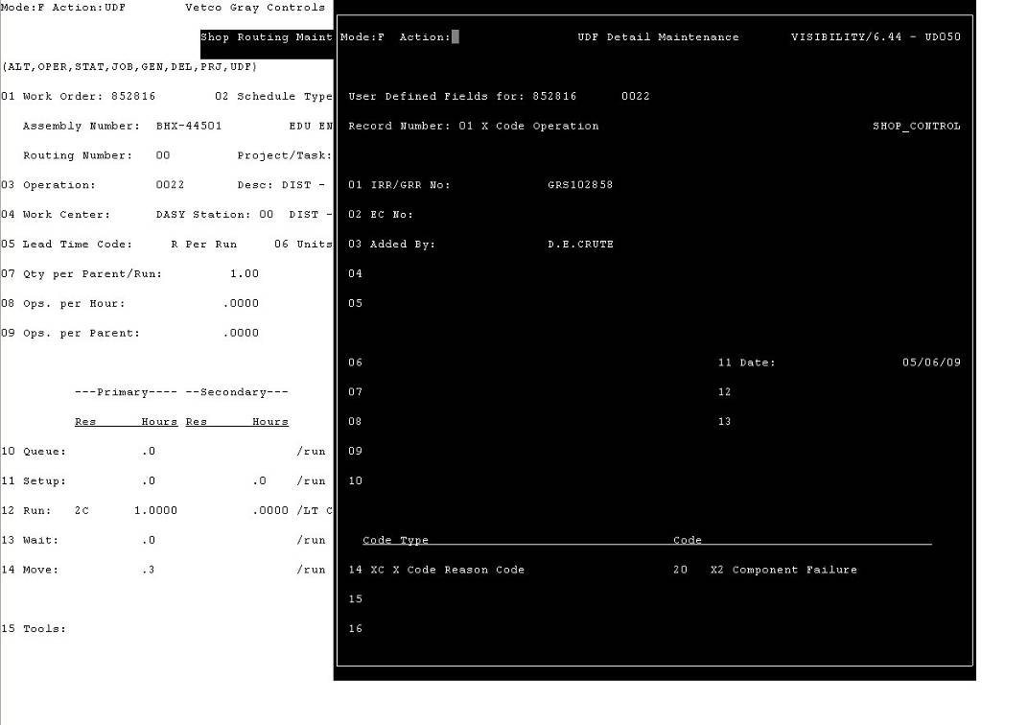

The cursor advances to the field selected. Edit the field then press the <Return> key.

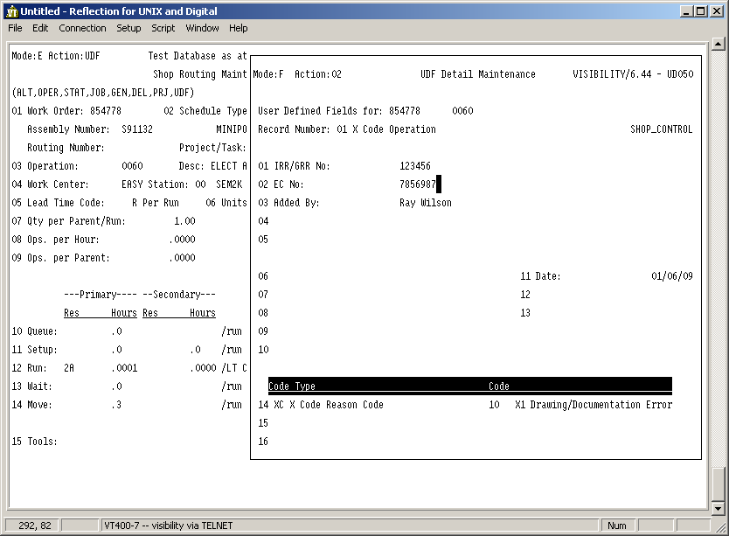

The cursor advances to Action field. Enter UR (Update Return) in the Action field then press the <Return> key.
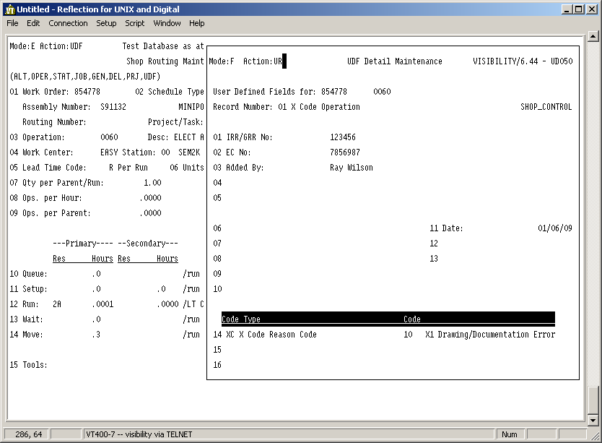

The cursor advances to Shop Routing maintenance Action field. Press the <Page Up> key to return to the Shop Floor Control menu.

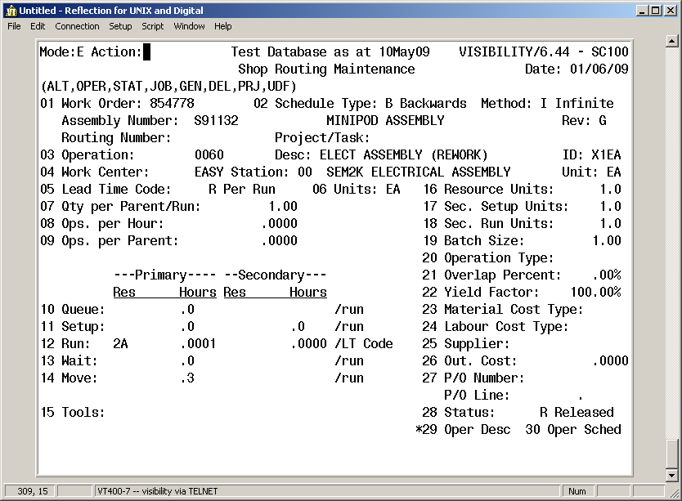

The X-Code operation has now been edited.
Operation detail and Time entry.

Entering information within the operation via the SC;09 screen options.

- Enter Identification Number (12) at the ‘Action line’ for data entry within Run field.
- Enter (*) under first field for selection of Resource type.
- Enter Run Time Value, based on activity length and save.

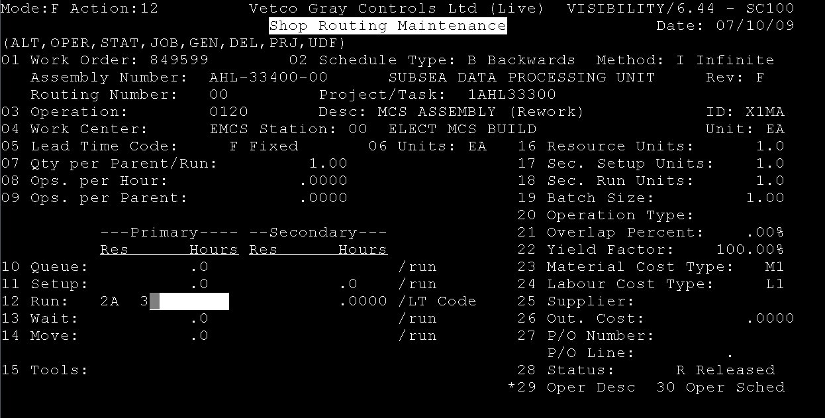

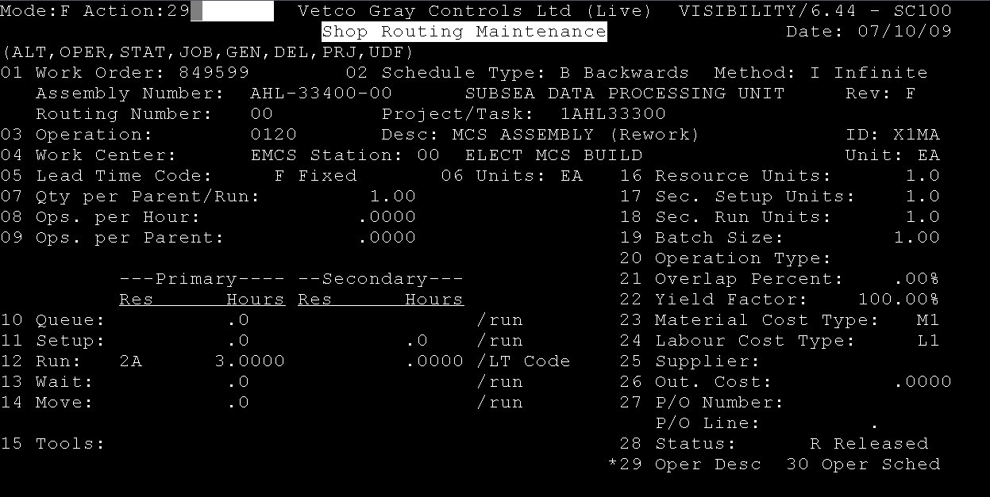
- Enter Identification Number (29) at the ‘Action line’ for Operation Description.

- Enter (E) at the ‘Action line’ for data entry.
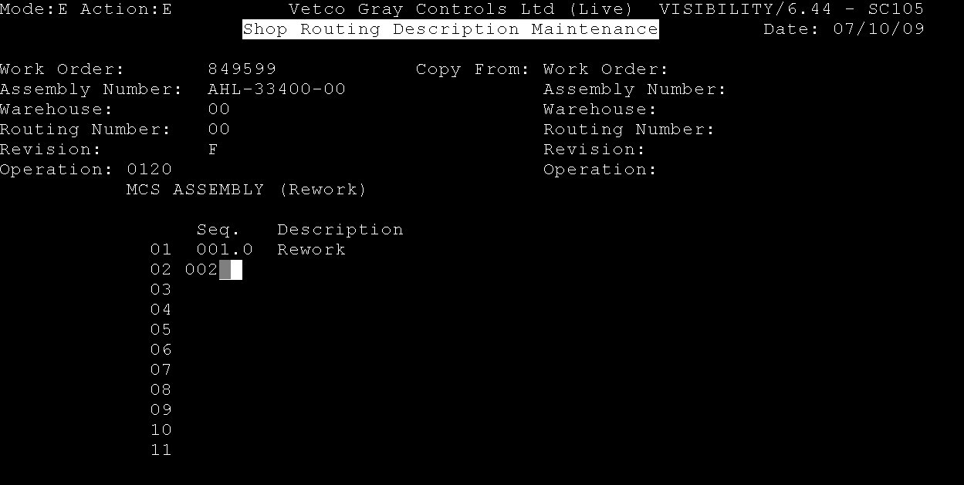
- Enter Sequence Number and then activity text description and details.

- Enter (‘US’) to save the information at the ‘Action line’.

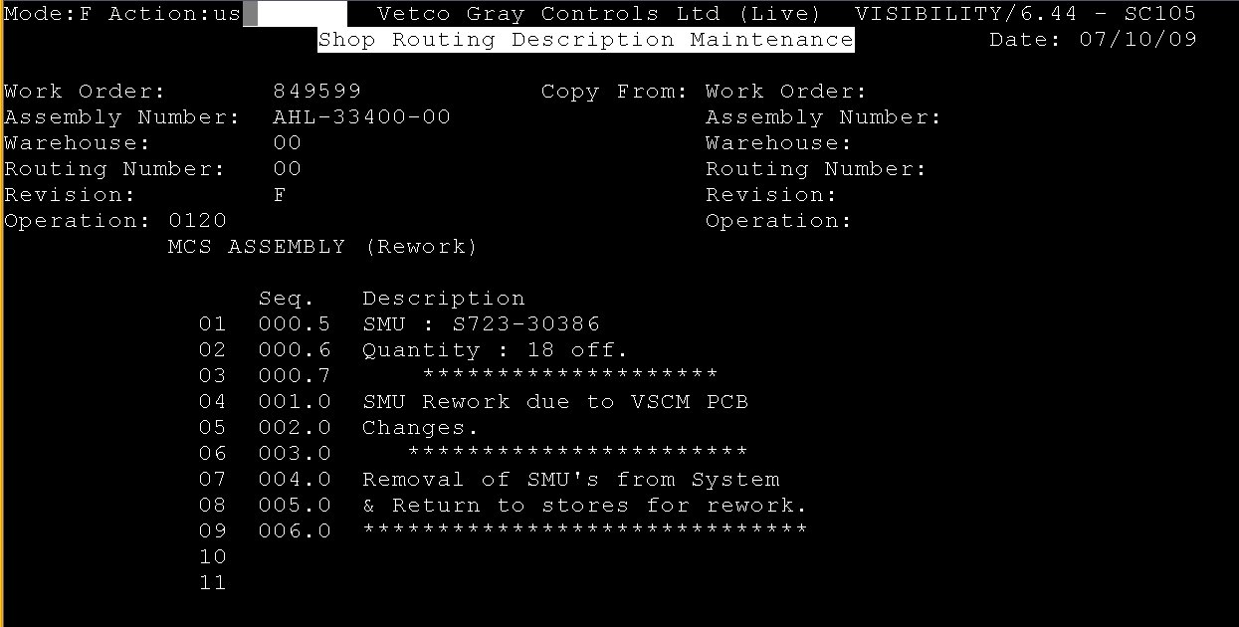

Copying operations and details across to another work order, using SC;11 within Shopfloor Control screen.

- Enter Identification Number (11) at the ‘Action line’ to select ‘Copy Shop Routing’.

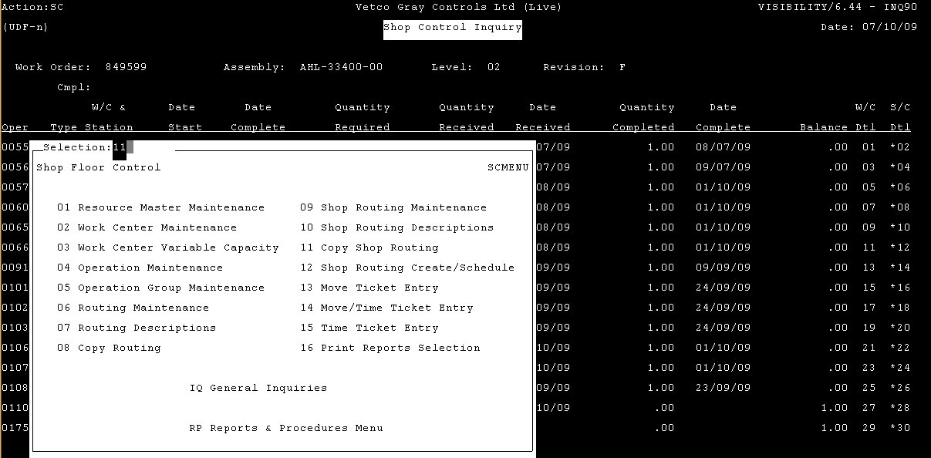

- Enter work order and the Start / End operations,
- Enter ‘Y’ to copy operation details.
- Then, enter the work order and operation position, then save (’US’).

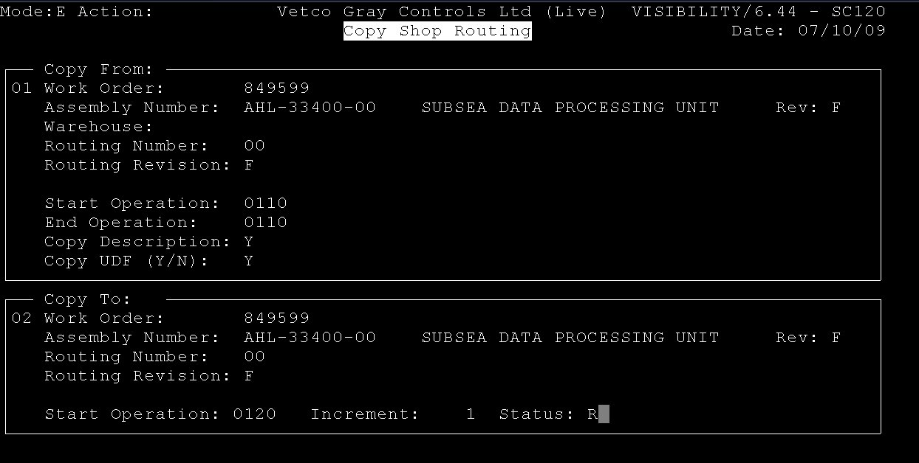
Note:
Ensure the UDF screen for the work order is updated with the actions and X-code reference listed within Song and Dance (Screen 97).

X Code UDF Work order (WP1)

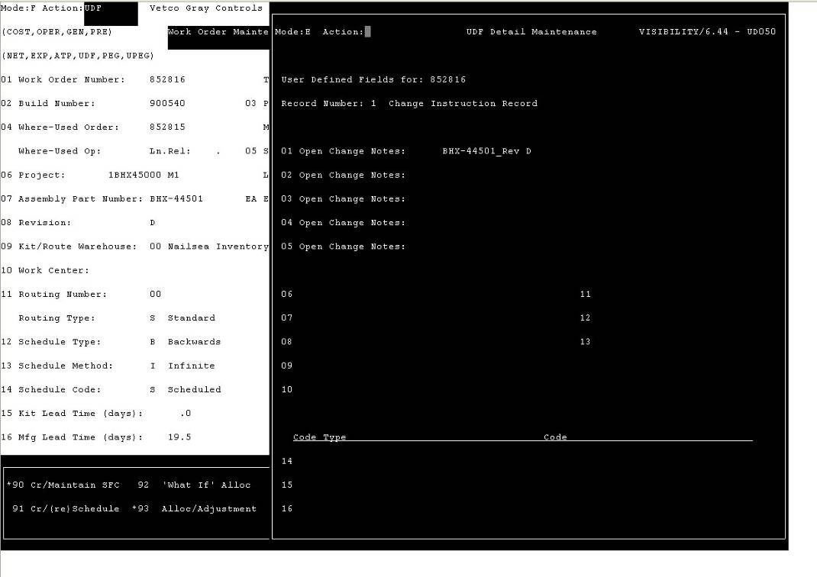

Work Order Song & Dance (97)

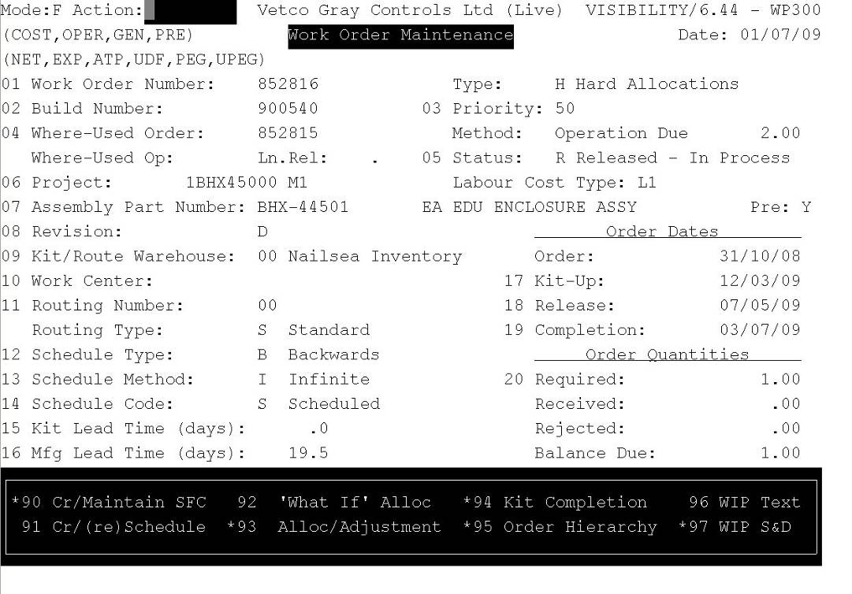

Work Order Song & Dance New Entry

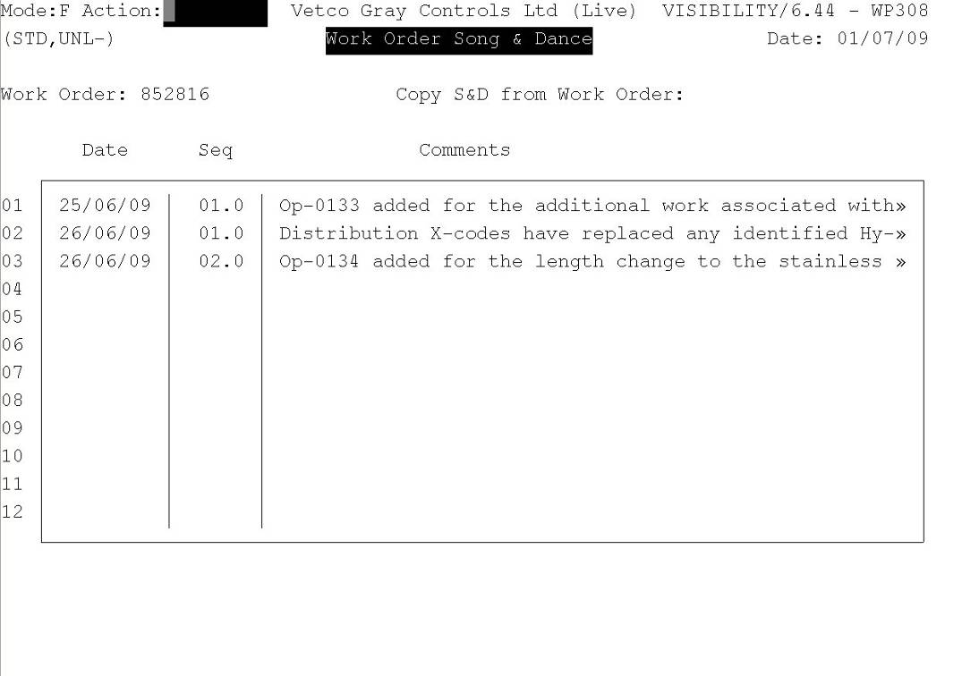

Work Order Song & Dance Text Update

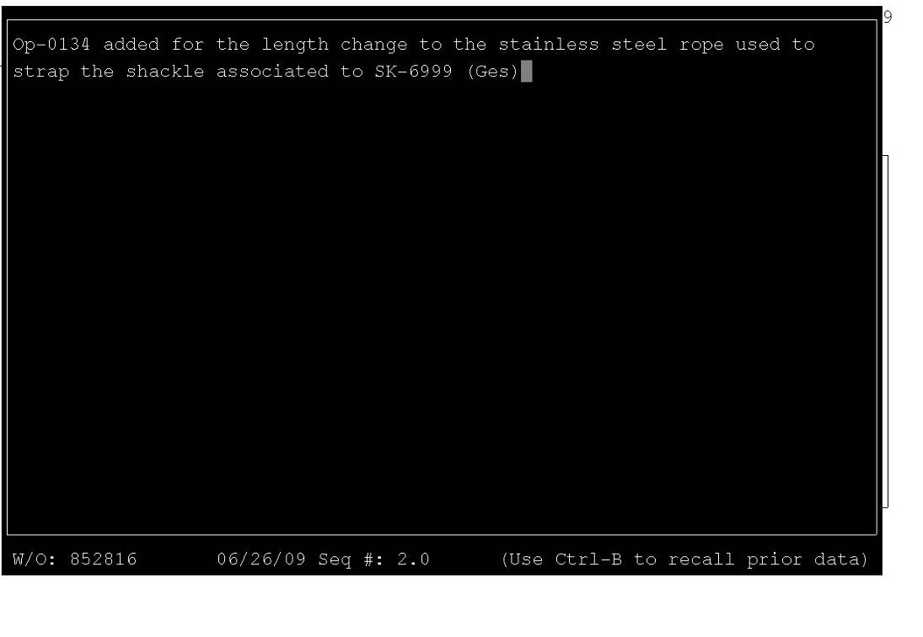
10.0 Key inputs/outputs
Inputs: Agreed scope of work and estimate to complete
Control of Non-Conforming Product (WI-CS-QHSE-4)
Global Rejection Report (WI-CS-QHSE-4-B)
Manufacturing Master Schedule
Manufacturing Work Order Routing
Material Review Board (QP-NAI-8.3-002)
Production Work Pack Control (QP-NAI-4.2.3-001)
Request for Technical Change (WI-CS-PROD-6)
Routing / Work Order Maintenance (WI-CS-xxxx-xx)
Supplementary Allowance & Reason Codes

Outputs: Supplementary operations added to work order routing to enable modification or rework of an item in manufacture

11.0 Records
Production Work Pack
Equipment work order routing
Visibility (MRP System) work order records

12.0 Competence, authorisation and training
Production Skills and Training Matrix and Training Records used to show competence, authorisation and training.
Visibility System - Routing / Work Order Maintenance
Global Rejection Report System

13.0 Performance measures
Monthly Review of Actual Vs Standard Hours – Section Head (Supported by Production
Engineering Leader)
Post 1st Off Review (Actual V’s Proto-type Hours) - Production Engineer / Team or Section Head
Actual versus estimate of supplementary allowance hours – Section Head / Leader
Monthly Time Series plot of cost of quality – Manufacturing Quality Assurance Engineer
Pareto of reason codes – Manufacturing Quality Assurance Engineer

14.0 Definitions
GRR Global Rejection Report
Lead Time Time taken from when the order is received until the product is delivered
RTC Request for Technical Change
JSA Job Safety Analysis
MRB Material Review Board
EC Engineering Change

15.0 Health Safety and Environmental
Task Risk Assessments and JSA’s are performed

16.0 Compliance
GE Oil & Gas Quality Compliance

17.0 Audit checklist
Supplementary hours are authorised
Modification / Rework clearly detailed within work order routing
Review of actual versus estimate x-code hours

Appendix A:
Request for Supplementary Allowance Form

Request for Supplementary Allowance (X Code) |  |  |  |  |  |  |  |  |  |  | 
Requested by: |  |  |  |  |  |  | Date: |  |  |  | Product:
W/O No. |  |  |  |  | Drawing No. |  |  |  |  | Description:
Op. No.
Operator Names:
Reason for Request: |  |  |  |  |  |  |  |  |  |  |  |  |  |  | GRS No.
 |  |  |  |  |  |  |  |  |  |  |  |  |  |  | X1 | Engineering
 |  |  |  |  |  |  |  |  |  |  |  |  |  |  | X2 | Supplier
 |  |  |  |  |  |  |  |  |  |  |  |  |  |  | X3 | Manufacturing
 |  |  |  |  |  |  |  |  |  |  |  |  |  |  | X4 | Project
Future Action:
Current Estimate: |  |  |  |  |  |  |  | Approved by
Estimated Time:
Actual Time:

Request for Supplementary Allowance (X Code)
Requested by: |  |  |  |  |  |  | Date: |  |  |  | Product:
W/O No. |  |  |  |  | Drawing No. |  |  |  |  | Description:
Op. No.
Operator Names:
Reason for Request: |  |  |  |  |  |  |  |  |  |  |  |  |  |  | GRS No.
 |  |  |  |  |  |  |  |  |  |  |  |  |  |  | X1 | Engineering
 |  |  |  |  |  |  |  |  |  |  |  |  |  |  | X2 | Supplier
 |  |  |  |  |  |  |  |  |  |  |  |  |  |  | X3 | Manufacturing
 |  |  |  |  |  |  |  |  |  |  |  |  |  |  | X4 | Project
Future Action:
Current Estimate: |  |  |  |  |  |  |  | Approved by
Estimated Time:
Actual Time:

Appendix B:
Cell Feedback Template Example

