Approved By:

Process Owner

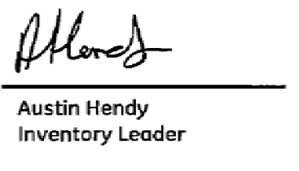

Other Functional / Section approval (if required)

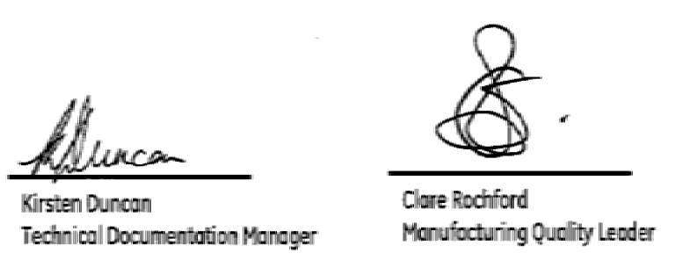

Document Revision Chart
The following chart lists the revisions made to this document tracked by version. Use this to describe the changes and additions each time this document is re-published. The description should include as many details of the changes as possible.

Rev | Section Modified and Revision Description | Date | Author
2.0 | Issued | 19/08/11 | A Hendy
2.1 | Number change from QP-NAI-MFG-001 to QP-NAI-7.5-008 | 14/09/11 | A Ganapathi

1.0 Purpose

To define the method used to receipt ‘Made on Works’ (MOW) items from a Works Order (W/O) to Stores.

2.0 Scope

This procedure applies to all production work orders that are used by GE Oil and Gas at their Nailsea facility.

3.0 Definitions and Acronyms
3.1 Definitions

- The Company- VetcoGray Controls Nailsea
- Visibility – VetcoGray Controls ERP system

3.2 Acronyms

- ERP- Enterprise Resource Planning tool
- P/R- Production Receipt
- WI- Work Instruction
- WIP- Work In Progress
- W/O- Work Order

4.0 Process
4.1 Production Receipt Process

INPUT | PROCESS ACTION | RESPONSIBILITY |  | OUTPUT
- Final Inspection | Confirm:  - All Work Order operations and move tickets are complete  - All GRRs are printed in work pack, reviewed and closed**  - All serial numbers on Config Sheet match serial numbers shown as being kitted on Visibility  - All shortages identified on Visibility are satisfied  - All part revisions on Config Sheet and, for parts not on Config Sheet, all part revisions on Impromptu Report match revisions on BoM or covered by approved concession  - All part marking correct and Ident label fully complete  **Note: If the work order is for Services Site Receipt Testing a GRS maybe left open to cover repair work that needs to be carried out | - Inspector |  | - Equipment Completion
- Sub-Contract W/O  (Supplier) | - Goods and documentation delivered to Nailsea  Follow WI-CS-LOG-01 (Inwards Goods procedure) | - Buyer |  | - Goods Booked To Inspection or Stores
- Completion of W/O  (Sub-Assembly) | - Production Receipt Form Completed  (QF-NAI-MFG-031)  - Goods and Documentation Passed To Stores.  Note: If the Goods/sub-assemblies are to be retained on the shop floor or delivered direct to another production area the location of the goods should be annotated on the production receipt form under the section “Location of Equipment” | - Production Team Leader |  | - Goods & Documentation moved from WIP to Stores
- Completion of W/O  (Finished Goods)  (Continued) | - Production Receipt Form Completed  (QF-NAI-MFG-031)  - Goods Passed To Stores  - Place documentation into central AIT depository for Databook team to collect  Note: If the Goods are too large for storage in the Stores area, the documentation is to be passed to stores annotated with the location of the goods | - Production Floor Team Leader |  | - Finished Goods Part moved from WIP to Stores  - Finished Goods Documentation moved from WIP to Databook Team
- W/O Documentation  (Finished Goods) | - Copy the configuration sheet(s)  - Pass original configuration sheet, cover sheet and production receipt form to stores  - Databook team retain work pack and copy of the configuration sheet to enable data book to be built | - Document Facilitator |  | - Selected documentation moved from Databook Team to Stores
- Acceptance of Goods & Documentation  (Sub-Assembly & Finished Goods) | - Record receipt of documentation and goods  - Production Receipt Register  (QF-NAI-MFG-032) | - Stores Operative | - Record of Receipt
- Production Receipt | Check & Confirm:  - All operations have been completed  - All shortages have been satisfied  - No special material control instructions are contained in final operation  - All serial numbers on configuration sheet match serial numbers shown as being kitted on Visibility  Action:  - Link all sub-Item serial numbers to the assembly serial number  - Complete Visibility production receipt transaction  - Locate Goods to stores location | - Stores Operative |  | - Work Order changed to complete  - Parts located in stores  - Costs moved from WIP to stock  Or  - Non-Conformance identified
- Non-Conformance identified | - Goods & documentation rejected back to Production Team Leader for correction and investigation  - Production Receipt Register Updated | - Stores Operative |  | - Goods & Documentation passed to Production Team Leader for correction
- Non-Conformance Notification | - Conduct investigation and correct documentation / system | - Production Team Leader |  | - Documentation corrected and passed to Stores to complete production receipt
- Documentation  (Sub-Assembly) | - Place Work Order documentation & PR Form into document scanning tray for collection  Note: All documents must be signed out by scanning department | - Stores Operative |  | - Documentation Passed to Scanning Department
- Documentation  (Finished Goods) | - Place Work Order documentation PR Form into data book compilation tray for collection.  - Copy Production Receipt form and attach to Finished goods  Note: All documents must be signed out by scanning department | - Stores Operative |  | - Documentation Passed to Data Book Department
- Documentation Passed to Data Book Department  (Finished Goods) | - Complete Data Book compilation  - Document transmittal sheet completed  (QF-NAI-MFG-033)  - Pass documentation to scanning department to scan and archive original documentation | - Document Facilitator |  | - Documentation Passed to Scanning Department.  - Original Work Pack documentation and PR Form scanned and archived

6.0 Quality Records

The following records produced by this document are considered Quality records and shall be maintained and controlled according to the requirements of GEEQMS 4.2.4- Record Control.

Document | Repository | Retention period
Work Orders | Visibility | 30 years
Purchase Orders | Visibility | 30 years
Production Receipt Form | Alchemy | 30 years
Production Receipt Register | Hard Copy – Stores | 1 year
Production Work Pack | Alchemy | 30 years

7.0 Responsibilities

Production Team leader is responsible for completion of move tickets on Visibility and completeness of data pack accompanying goods.

Stores Team Leader is responsible for production receipting goods to stock and passing data pack to Scanning & Data Book Team.

8.0 References

WI-CS-LOG-01-A Stores Step By Step
WI-CS-LOG-02-B Product Planners Step By Step instructions
WI-CS-SCM-01 Direct Shipment from Suppliers
WI-CS-QHSE-04 Non-Conforming Product
WI-CS-PROD-19 Preservation of Product

9.0 Appendix
Project Name:
Work Order:
Part Number:
Serial Number:
Equipment Description:
Location of Equipment:
PRE-PRODUCTION RECEIPT CHECKS |  |  |  |  |  |  | Yes | No
Does Equipment need packing
All Work Order operations and move tickets are complete
All GRRs are printed in work pack, reviewed and closed
All serial numbers on Configuration Sheet match serial numbers shown as being kitted on Visibility
All part marking correct and Ident label fully complete.
PACKING DETAILS

Packing Method
Length |  | mm |  |  | Accumulators
Width |  | mm |  |  | Volume  (litres) | Pre-Charge  (bar) |  |  | Qty
Height |  | mm
Gross Weight |  | kg
Net Weight |  | kg
Load Cell Used

Fluid Type

Verified By: Date: Stamp:

FINISHED GOODS ONLY
WORKPACK TO BE DELIVERED TO DATABOOK DEPARTMENT IMMEDIATELY

THESE DOCUMENTS TO BE COPIED BY DATABOOKS AND DELIVERED TO STORES IMMEDIATELY

Attached copy documents:

Configuration sheet Cover Sheet

Work Order No: | Received |  |  |  | PR Completion | Collection |  | Notes
Work Order No: | Doc | Part | Name | Date | Date | Name | Date | Notes
 | YES / NO | YES / NO |  | / / | / / |  | / /
 | YES / NO | YES / NO |  | / / | / / |  | / /
 | YES / NO | YES / NO |  | / / | / / |  | / /
 | YES / NO | YES / NO |  | / / | / / |  | / /
 | YES / NO | YES / NO |  | / / | / / |  | / /
 | YES / NO | YES / NO |  | / / | / / |  | / /
 | YES / NO | YES / NO |  | / / | / / |  | / /
 | YES / NO | YES / NO |  | / / | / / |  | / /
 | YES / NO | YES / NO |  | / / | / / |  | / /
 | YES / NO | YES / NO |  | / / | / / |  | / /
 | YES / NO | YES / NO |  | / / | / / |  | / /
 | YES / NO | YES / NO |  | / / | / / |  | / /
 | YES / NO | YES / NO |  | / / | / / |  | / /
 | YES / NO | YES / NO |  | / / | / / |  | / /
 | YES / NO | YES / NO |  | / / | / / |  | / /
 | YES / NO | YES / NO |  | / / | / / |  | / /
 | YES / NO | YES / NO |  | / / | / / |  | / /

To: NER (Scanning Dept)
From: Data Book Team

Transmittal No: Date: / /
.
We are transmitting the following:
Drawings Approved ✓ For Scanning
✓ Documents/W/O Packs Disapproved For Approval
Disk/CD For Correction For Information
SELECT AS APPROPRIATE
Work Order/PO No. | Description | Serial Number | Project

Issued by: Received by:
Name : ………………………………….. Name ……………………………………..
Signature………………………………… Signature …………………………………

