## Approved By:

|  |  |  |  |  |
| --- | --- | --- | --- | --- |
|  |  | [Link to Approval](https://ge.ent.box.com/files/email/Tim2.Sims@ge.com/0/f/40845638425) |  |  |
| Roy Mcintosh  Plant Manager  Subsea Services |  | Simon Mclernon  Engineering Lead |  | Tim Sims  Lead Process Improvement Specialist |

## 

## Document Revision Chart

The following chart lists the revisions made to this document tracked by version. Use this to describe the changes and additions each time this document is re-published. The description should include as many details of the changes as possible

|  |  |  |  |
| --- | --- | --- | --- |
| **#.#** | **Section Modified and Revision Description** | **Date** | **Author** |
| 1.0 | New Document | 1/02/2012 | Clare R. |
| 2.0 | Section 3.1. Reference to QW-QUA-PER-005 added, reference to the containment actions listed within the relevent WI’s added tosection 3.3.  Identification tag removed from Appendix A and the other appendices renumbered.  Amend Doc No# from QW-PER-8.3.1-1 to QW-QUA-PER-001.  Amend references to Document &Record Location Map for updates. Minor formatting changes. | |  | | --- | |  |   11/07/2012 | Mike Fisher |
| 3.0 | Addition of descriptors high (critical), medium (moderate), low (minor) to the Criticality Matrix and to all other references made. Changes to all sections. Corrections to Appendix references. Corrections to flow Charts. | 31/08/2012 | Mike Fisher |
| 3.1 | Refinement to the wording within section 1 with regards to customer owned equipment.  Corrections to spelling and grammar. | 10/12/2012 | Mike Fisher |
| **#.#** | **Section Modified and Revision Description** | **Date** | **Author** |
| 3.2 | Formatting of document changed, content remains the same. Amendment to section  3.6. Updated reference to invalid GRR in Section 4.3.5. Split Section 1.0 amongst Sections 1.0 & 2.0.  Moved instructions from Section 3.0 – Process Details & Section 3.4 – Global Rejection Report to Section 3.2. | 07/05/2013 | Olivia Leung & Richard E |
| 3.3 | Restructuring of formant and aligning to Global Procedure OGQ-0129 | 10/04/2014 | M. Fisher  O. Leung |
| 4.0 | Revision of all sections to add detailed information  RACI Table added.  Cost of Quality Section Added. | 02/06/2015 | Sagar Zende |
| 4.1 | Branded BHGE  Minor updates to correct audit ATS-503 RC in sections 3.3(1) / 3.3(6) / 3.6.3  3.1 updated RELEASE text to read –  Verifies compliance of rework performed against provided disposition, and uploads **disposition evidence** to close.  3.3 (1)  Where appropriate/possible, move NC product to Quarantine area. If it is expected the NC could affect other items report the issue to Quality.  and  3.3 (6).  Refer to QW-ENG-8.3-001 for Engineering disposition process  3.6.3 removed ‘CI/CIR lead review’ as not required.  6.2 Expanded acronyms listing | 23/10/2017 | Richard Edwards |

Table of Contents

1.0 Purpose 4

2.0 Scope / Application 4

3.0 Procedure 4

4.0 Responsibilities 12

5.0 Quality Records 15

6.0 Definitions and Acronyms 15

7.0 References 18

8.0 Compliance Requirements 18

9.0 Appendix / Attachments 19

# Purpose

# This work instruction defines the reporting and processing of nonconforming (NC) materials and products using the electronic Global Rejection System and is based on global procedure Control of Nonconforming Product (OGQ-0129).

# Scope / Application

This WI is applicable to all BHGE OFE Equipment and Customer Owned Equipment handled through the Jandakot facility.

# Procedure

The Global Rejection System (GRS) a module in ePIMS instance of eBIZ shall be used in accordance with this WI for all instances of nonconformity detected on BHGE equipment in the BHGE Jandakot premises and Customer Owned Equipment handled through the Jandakot facility.

As a minimum, GRR and where necessary, associated Concession Requests (Technical Queries) shall be raised if any of the following occur and are outside of the Manufacturing and/or Design Acceptance Criteria or other specified requirements:

1. Any deviation from drawing requirement which could adversely affect the operation or pressure integrity of the equipment.

Note – Definition is inclusive of design integrity (dimensional, material size and/or composition, operating parameters etc.).

1. Change in any thermal treatment. method or process.
2. Deviation of mechanical testing, out of specification condition.
3. Deviation from Bill of Material, agreed standards or technical specification or other applicable standards.
4. Weld repairs to correct machining, welding or material defects.

Note–

1. When weld repairs are approved in accordance with the applicable BHGE specification, repairs performed in accordance with said specification shall not be reported within the GRR.
2. Use of incorrect or non-qualified weld procedures shall be reported where material is offered for concession or use.
3. Use of non-qualified weld operators shall be reported where material is offered for concession or use.
4. Any deviation from purchase order specification.

For example –

1. Use of incorrect or non-approved NDE procedure where material is offered for concession or use.

2. NDE completed by incorrectly qualified operator where material is offered for concession or use.

3. Incorrect material origin source.

4. Missed or non-notified ITP surveillance points.

5. Other categories as applicable.

1. Non-conformances detected during Quality Control inspection activities and any failures during FAT, EFAT and SIT programs

No further work which may affect, change, mask or alter the identified NC shall be performed until disposition and sign off is received.

Part Disposition as “Scrap” shall be clearly identified & marked as per Work Instruction Identification and Traceability QW-FAC-PER-005.

Notify HSE & Product Safety Engineer if NC creates or may create unique environmental, health, or safety impacts. Forward accepted GRU to Dispositioner.

* 1. **Non-Conformance Process based on Global Rejection System**

The GRS serves as a documented workflow process for defects and inquiries. The system consists of five Stages:

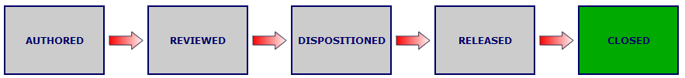

**Author**  Initiates the Global Rejection Reporting process.

**Review**  Reviews the Data and Discrepancy sections of the GRR for correctness

**Disposition**  Analyses the NC, provides a defect disposition & justification.

**Release**  Verifies compliance of rework performed against provided disposition, and uploads disposition evidence to close

**Close**  Verify GRR for correctness ensuring rework and evidence satisfies disposition

* 1. **Non-Conformance Types**

Following matrix describes the types of nonconformities and applicable flow charts for each type of non-conformity.

|  |  |  |  |  |
| --- | --- | --- | --- | --- |
| **Material Location** | **Technical Query** | **Material Substitution** | **Concession** | **Non-Conformance** |
| **at Supplier** | GRV | GRV | GRV | GRV |
| **at Supplier** | GRV | GRV | GRV | GRV |
| **at BHGE** | GRU | GRU | GRU | GRU |

Use link to apply ePIMS access [Request ePIMS](https://idm.infra.ge.com/idm/user/geidm/home.xhtml) **https://idm.infra.ge.com/idm/user/geidm/home.xhtml**

* 1. **Internal Non-Conformances (** **Flow chart Appendix 9.9** **)**

|  |  |  |  |  |
| --- | --- | --- | --- | --- |
| **#** | **INPUT** | **PROCESS ACTION** | **RESPONSIBILITY** | **OUTPUT** |
| 1 | NC Items | * Identify & Label NC product or material as Non-Conforming Product (Red Color Tag) Identification and Traceability [QW-FAC-PER-005](http://edms.pw.ge.com/dctmquality/home/components/drl/drl.jsp?objectId=0900f5ea804d51d3&showRendition=true)). * Where appropriate/possible, move NC product to Quarantine area. If it is expected the NC could affect other items report the issue to Quality. | Originator | NC Identified |
| 2 | NC Items tagged | * Log Global Rejection Report | Originator | GRU Authored |
| * Select GRR Type      * Enter PO and line item, Work Order and Sales Order, as applicable. Planner name is a mandatory requirement for Drilling GRRs. Update Preliminary Root Cause and Responsible. * Enter a detailed explanation of the discrepancy. Be brief and concise attach supporting files |
| **#** | **INPUT** | **PROCESS ACTION** | **RESPONSIBILITY** | **OUTPUT** |
| 3 | GRU Authored | * Forward GRU to Reviewer through work flow. | GRU Author | GRU Authored |
| 4 | Authored GRU | * Sign in as Reviewer & Review GRR      * Ensure all applicable personnel are copied on the GRR, e.g. Buyer, Planner, Supplier (If applicable), * Discuss potential COQ with APA Service Quality Leader * Identify COQ Project applicable for rework (Appendix 3) * Request COQ from CommOps as Applicable. * Add comment to define defect releaser (e.g. Potential BHGE Issue: Manufacturing Engineer OR Potential Supplier Issue: Supplier Quality Engineer) | Quality Engineer | GRR Sent for Disposition  To Engineering |
| 5 | Reviewed GRU | * Analyze the defect, define disposition based on [QW-SS-GLO-ENG-002](http://edms.pw.ge.com/dctmquality/home/components/drl/drl.jsp?objectId=0900f5ea805ff98e&showRendition=true). * Ensure as minimum the following documentation (if applicable) are attached disposition/ Justification boxes. * Relevant email/telephone, calculation and discussions with the Product Group, Material Group, Manufacturing. * Check if Customer notification / Approval are required for Disposition. * Provide a detailed justification | Dispositioner | GRR Disposition defined |
| **#** | **INPUT** | **PROCESS ACTION** | **RESPONSIBILITY** | **OUTPUT** |
| 6 | Dispositioned GRR | * If disposition is not acceptable record reasons & send back GRU to Dispositioner.     Refer section 3.5.10 & 3.5.11 | Releaser | GRR Release Complete. |
| Refer to QW-ENG-8.3-001 for Engineering disposition process   * Update Criticality based on Defect Criticality Matrix * Initiate CI Plan in [Gensuite](http://gensuite.ge.com/geog/qlty/ci/40t1) to conduct RCA in case of “Critical” & NCA for “Moderate” Nonconformance based on Appendix 7 * Confirm Root cause and update responsibility. | Quality Engineer |
| * Complete rework or arrange rework from supplier, Update work order Number, record COQ as applicable * Obtain & update customer approval and add attachments if required by disposition. * Arrange QC Inspection if required to ensure disposition is completed as per technical requirements. * Forward GRU for closure to CI /CIR Coordinator. | Releaser |
| **#** | **INPUT** | **PROCESS ACTION** | **RESPONSIBILITY** | **OUTPUT** |
| 7 | GRR Released | * Check root cause & responsibility & close GRR. * Verify rework actions meet disposition & evidence is attached. * Sign in as Closer | CI/CIR Coordinator | GRR Closed |

* 1. **Supplier TQ / Material Substitution Process (****Flow chart Appendix 9.10****)**

|  |  |  |  |  |
| --- | --- | --- | --- | --- |
| **#** | **INPUT** | **PROCESS ACTION** | **RESPONSIBILITY** | **OUTPUT** |
| 1 | Concession Required | * Log Global Rejection Report GRV * For supplier without SIMON Access a GRR should be raised in ePIMS and GRU should be changed to “GRV” keeping number unchanged | Supplier/  Sourcing Specialist | GRR  Authored |
| * Collect and Update Information for Header and Discrepancy Section * Forward GRR to Reviewer | GRU Author | GRU Sent to Reviewer |
| **#** | **INPUT** | **PROCESS ACTION** | **RESPONSIBILITY** | **OUTPUT** |
| 2 | GRR at Review Stage | * Check Completeness, Clarity, Duplicity and Accuracy of Information. * Send all Material Substitution GRVs to Material Engineer and Technical Query to Engineering Dept. * Send invalid GRR to APA Service Quality Lead for making it VOID. * Rejected GRV Sent to Author. | Reviewer | Sign GRR |
| 3 | Accepted GRR | * Determine & Record Disposition Requirement * Forward GRV to Sourcing specialist. | Dispositioner | GRR Disposition defined |
| 4 | GRR Disposition defined | * Review and Validate Disposition Requirement * Check Completeness, Clarity, Duplicity and Accuracy of Information & Reject non-fulfilling above requirements. * Record reasons in case of rejection for non-fulfilling above requirements and Rejected GRV Sent to Dispositioner. | Releaser | GRR Disposition Completed. |
| 5 | GRR Disposition Completed. | * Check root cause & responsibility & close GRR. * Verify rework actions meet disposition & evidence is attached. * Sign in as Closer | Closer | GRR Closed |

* 1. **Handling of Global Rejection Report**
     1. All GRR Specific communication shall be captured in GRR comments box as applicable Below is shown example of sending GRR for release

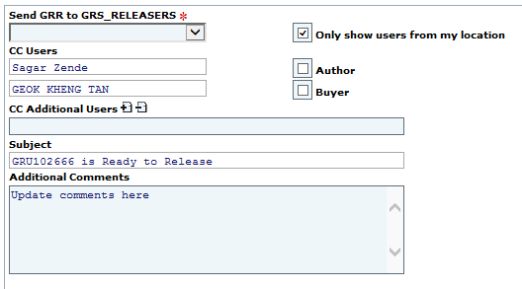

* + 1. If Disposition need to be changed, initial Disposition shall not be deleted from Disposition section. New disposition shall be recorded above old disposition keeping old disposition unchanged, example is as below. Support disposition and justification with applicable attachments and comments. Record reason for revision of disposition.

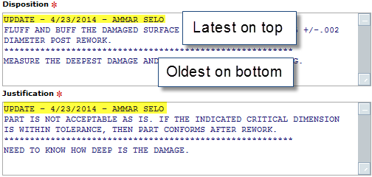

* + 1. GRR shall be rejected stating reason for rejection if found incomplete or not proving intended details.

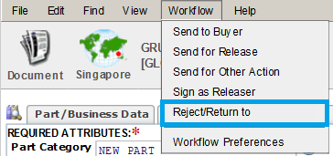

* + 1. If Disposition is not acceptable reject GRR and send back using following option 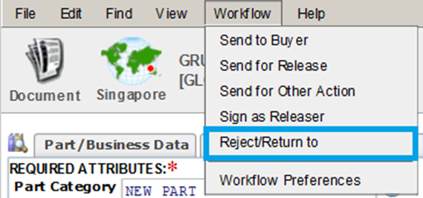

Once singed in as releaser Disposition cannot be changed or revised or cannot be rejected. To make changes in discrepancy / disposition use “Revise this Document” Option under Edit Tab.

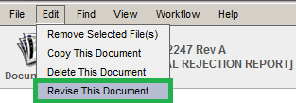

* + 1. GRR can be sent to another person for using “Send For Other Action” or send to Buyer as applicable to complete required action.

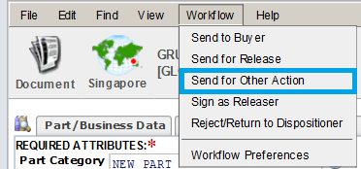

* + 1. The Customer Approval Date field when present is required to "Release" a GRR. In addition, a file must be attached prior to “Release” to support the Customer Approval.
    2. For Further guidance on GRR disposition refer to WI [QW-SS-GLO-ENG-002 Engineering GRR Disposition](http://edms.pw.ge.com/dctmquality/home/components/drl/drl.jsp?objectId=0900f5ea805ff98e&showRendition=true) and appendix 4 & 5.
    3. In case of revision to a GRR that impacts the original disposition, notify Quality department on modifications/changes Quality, the plant manager or delegate is responsible to stop rework if any that have begun without notification
    4. All Concessions and Technical Deviations are considered to be minor severity.
    5. Deviation from this procedure shall be obtained with written permission from the APA Service Quality Lead.
    6. Duplicate GRR, irrelevant GRR can be made void by APA Service Quality Lead upon providing justification.
  1. **Continuous Improvement**
     1. For Critical GRR RCA shall be performed & for Moderate GRR NCA shall be performed using Gensuite tool. <http://gensuite.ge.com/ge/home/>
     2. For minor GRR, analysis shall be carried out based on track & trend basis.
  2. **Cost of Quality**
     1. All rework cost shall be monitored under CoQ. Communicate information based on GRR to OTR CommOps to raise COQ project code.
     2. OTR CommOps shall provide Cost of Quality Project Code. & Cost should be recorded for applicable GRR.
     3. In case Non-conformance raised on purchased part and in-house rework is required, in such case after completion of rework cost shall be recovered from supplier. In case Work order to be raised for in-house rework, the WO shall be raised the same project number under which part is purchased. Sourcing specialist shall arrange relevant credit note from supplier for the cost required for rework, which can be account project. Refer Section 9.3
  3. **Standard Disposition**
     1. Refer to “Guideline for Standard Disposition” QO-PER-40

# Responsibilities

Refer RACI table for in Section 9.2

# Quality Records

The following records produced by this procedure are considered Quality Records and shall be maintained and controlled according to the requirements in OGQ-0102 - Record Control:

GRR Record in ePIMS

# Terms, Definitions and Acronyms

Refer to GE O&G QMS Lexicon for Terms, Definitions and Acronyms. Acronyms have been repeated here for convenience purposes.

# Terms & Definitions

|  |  |
| --- | --- |
| **Term** | **Description** |
| New Part | New manufactured or sourced products which is nonconforming to specified requirements, or previously used products in which additional nonconformities have been caused at the GE facility or affiliate (supplier, contractor etc.) site during repair / refurbishment / remanufacture processes. |
| Used Part | Products or components, which are being processed through the repair / refurbishment cycle, have been identified as nonconforming to specified requirements and which require formal disposition. |
| Concession | A request to deviate from a drawing and/or specification after a Purchase order has been raised. |
| Disposition Process | Analysing non-conformance(s), evaluating correction/acceptance options, and identifying activities to GE under taken based on documented justification. |
| eBIZ / ePIMS | Electronic Product Information Management System Software for Eng. Specs. |
| Technical Deviation (TQ) | A request to deviate from a drawing and/or specification before a Purchase order is raised. |
| Minor (Low) Non-conformance | - Minor deficiency, no effect on product integrity, single occurrence breakdown in quality system, requires action to correct and written response as to cause and corrective action program plan. May require minor document/drawing change. A minor (low) deficiency should not stop the activity being performed and can be dealt with on the shop floor locally. |
| Moderate (Medium) Non-Conformance | Significant deficiency, potential or actual impact on product integrity, systemic/generic breakdown of the quality system, may be a single significant item or a combination of items that are found for the first time, have recurred following corrective actions, or haven't been corrected since originally found, requires action to correct and requires written response as to cause and corrective action program plan. Has the potential of stopping the activity and may require a change to fit, form or function as well as intervention of Engineering to substantiate the disposition of the identified component/assembly. |
| Critical (High Non-Conformance | Potential or actual serious impact on product integrity or the safety of people, equipment, or product, major breakdown in the adequacy of or compliance to the quality system requirements, may be a single item or a combination of items. Requires full RCA activity to be documented within Gensuite. A critical (high) deficiency is likely to result in the activity being stopped or field failure and will require investigation to define the root cause of failure that may or may not result in design or operational change. A customer complaint (or poor customer perception of quality) should be classified as critical |

# Acronyms

|  |  |
| --- | --- |
| **Acronym** | **Definition** |
| BHGE | Bakers Hughes a GE Company |
| CAPA | Corrective Action / Preventive Action |
| COE | Customer Owned Equipment |
| CommOps | Commercial Operations |
| COQ | Cost of Quality |
| EFAT | Extended Factory Acceptance Testing |
| FAT | Factory Acceptance Testing |
| GRR | Global Reject Report in Global Rejection System (GRU/GRV) |
| GRS | Global Rejection System |
| GRU | Global Rejection Report authored in the Perth Jandakot Site |
| GRV | Global Rejection Variation/Vendor  (Deviation request generated by suppliers) |
| HSE | Health, Safety, Environmental |
| ISC/ISL | Integrated Service Coordinator / Leader |
| ME | Manufacturing Engineer |
| NC | Non-conformance |
| OFE | Oilfield Equipment |
| PO | Purchase Order |
| RACI | Responsible, Accountable, Consult, Inform |
| SIT | Systems Integration Testing |
| SQE | Supplier Quality Engineer |
| WI | Work Instruction |

# References

[GE O&G QMS Lexicon](http://supportcentral.ge.com/@lexicon)

[OGQ-0102 – Record Control](http://library.ps.ge.com/quality/home/components/drl/drl.jsp?objectId=0900f5ea804c7d93&showRendition=true)

[OGQ-0129 – Control of Non Confirming Product](http://library.ps.ge.com/quality/home/components/drl/drl.jsp?objectId=0900f5ea804c7881&showRendition=true)

[QW-SS-GLO-ENG-002 Engineering GRR Disposition](http://edms.pw.ge.com/dctmquality/home/components/drl/drl.jsp?objectId=0900f5ea805ff98e&showRendition=true)

[QW-SS-GLO-QUA-004](http://edms.pw.ge.com/dctmquality/home/components/drl/drl.jsp?objectId=0900f5ea805a2364&showRendition=true) Continuous Improvement (CI) Work Instruction

GIS 16.20 - Global Rejection System – User Documentation in EPIMS

GIS 16.20V – Global Rejection System – Supplier User Documentation

QP-D&S/SS-GLO-8.3-1 – Control of Nonconforming Product

[QW-QUA-PER-005 – Identification and Traceability](http://library.ps.ge.com/quality/home/components/drl/drl.jsp?objectId=0900f5ea804d51d3&showRendition=true)

[QW-FAC-PER-003 – Controlling Rental Agreement Work Instruction](http://library.ps.ge.com/quality/home/components/drl/drl.jsp?objectId=0900f5ea803fe8a2&showRendition=true)

[QW-SOU-PER-003](http://library.ps.ge.com/quality/home/components/drl/drl.jsp?objectId=0900f5ea8039fe06&showRendition=true) – Vendor Cost Recovery

[Gensuite CI Tool](http://gensuite.ge.com/geog/qlty/ci/1voj)

# Compliance Requirements

Full compliance required after one month after date of application.

|  | BHGE |
| --- | --- |
| Title : | Control of Nonconforming Product |
| Reference : | QW-QUA-PER-001 |
| Revision : | 4.1 |
| Application Date : | 31/10/2017 |
| Expiration Date : | 30/10/2020 |
| Author : | Richard Edwards |
|  |  |

# Appendix / Attachments

# Appendix 1: GRR Type

|  |  |
| --- | --- |
| **Defect Type** | **Defect Details** |
| 01 - PROCESS DEFECT | Includes documentation issues, missed operations, and other process mistakes. |
| 02 - PRODUCT DEFECT | Includes product non-conformance affecting fit, form, or function. |
| 03 - MATERIAL SUBSTITUTION | Includes material deviations/waiver requests from supplier. |
| 04 - TECHNICAL QUERY | Cannot read dimension, Conflicting Specification requirements, Drawing/Specification/Procedure not linked, Missing/incorrect BOM levels, Unclear Requirements, Ambiguous terms used, Open to misinterpretation, Unfamiliar terminology |

# Appendix 2: Defect & Root Cause Definitions as per GIS16.20 Rev 18

# 

# Appendix 3: Rework Cost Allocation

|  |  |  |  |
| --- | --- | --- | --- |
| **Root Cause** | **Action** | **Rework Cost billed** | **Responsibility** |
| Supplier Responsible | Repair at GE &  Arrange Credit Note from Supplier | To Supplier | Sourcing Specialist / CommOps |
| GE Responsible | Generate COQ Project Number  Raise POR Against COQ | GE as COQ to identified GE COE or department | Closer |

# Appendix 4: Disposition Guideline

|  |  |
| --- | --- |
|  |  |

# Appendix 5: [Disposition requirement as per OGQ-0129](http://library.ps.ge.com/quality/home/components/drl/drl.jsp?objectId=0900f5ea804c7881&showRendition=true) for Product & Process NC

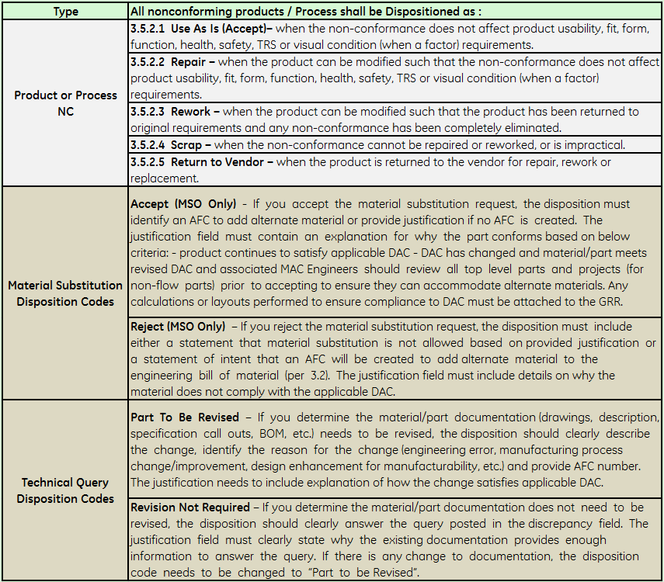

# Appendix 6: Defect Criticality Matrix

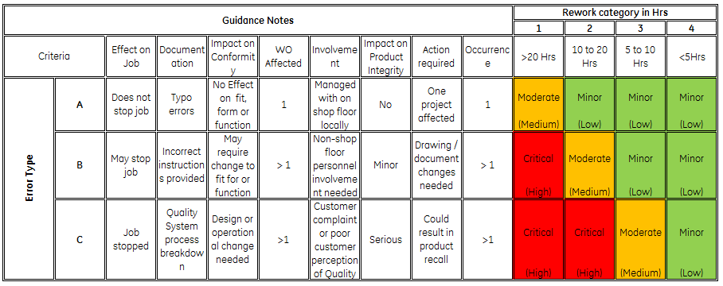

# 

# Appendix 7: Action Matrix

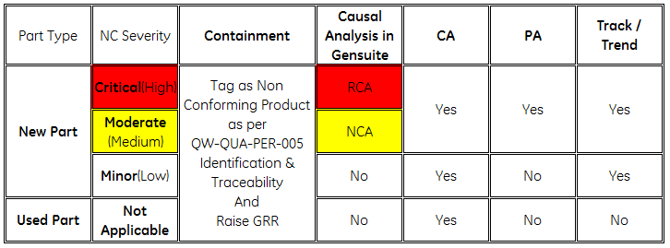

# 

# Appendix 8: Responsible, Accountable, Consult, Inform Table

# 

# Appendix 9: Indicative Flow Chart for Process 3.3 Internal Non-Conformities.

# Appendix 10: Indicative Flow Chart for Process 3.4 Internal & Supplier Concession.

# Appendix 10: Indicative Flow Chart for long open GRU Assessment meeting and sub actions details.