**Approved By:**

|  |  |  |  |  |
| --- | --- | --- | --- | --- |
| Commensurate with the requirements of QW-OFE-GLO-QUA-002 no signature required for Rev 5.0 |  | Commensurate with the requirements of QW-OFE-GLO-QUA-002 no signature required for Rev 5.0 |  | Commensurate with the requirements of QW-OFE-GLO-QUA-002 no signature required for Rev 5.0 |
| **Jay Southwell**  Senior Project Management Staff Manager – Jandakot Subsea Services OFE |  | **Mike Suk-udom**  Senior Customer Service Management Staff Manager – Jandakot Subsea Services OFE |  | **Scott Deacon**  Senior Customer Service Management Staff Manager – Jandakot Subsea Services OFE |

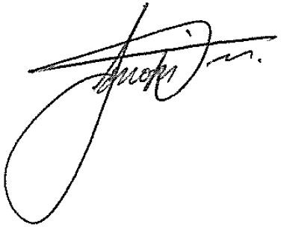

|  |  |  |  |  |
| --- | --- | --- | --- | --- |
| Commensurate with the requirements of QW-OFE-GLO-QUA-002 no signature required for Rev 5.0 |  |  |  |  |
| **Roy Mcintosh**  Senior General Operations Support Staff Manager – Jandakot Subsea Services OFE |  | **Jason Doss**  Material Manager - Jandakot Subsea Services OFE |  | **Tim Sims**  APA SPSS Quality Lead |

**For any feedback to the process, or the document, please contact the process owner - Materials Manager Jandakot Subsea Services OFE.**

|  |  |  |
| --- | --- | --- |
| APPLICABLE PRODUCT LINES | | |
| Subsea Drilling Systems | Subsea Production Systems (SPS) | |
| Subsea Services | Trees | Controls |
| Flexible Pipe Systems | MCS | Projects |
| Surface Pressure Control  Subsea Production Systems (SPS) |  |  |

**Document Revision Chart:**

|  |  |  |  |  |
| --- | --- | --- | --- | --- |
| Rev | Section modified and revision description | Issue date | Expiry date | Author(s) |
| 1.0 | New Document | 02/02/2012 | - | Clare Rochford |
| 1.1 | Amendments to some document titles this document makes reference to. | 21/03/2012 | - | Clare Rochford |
| 1.2 | Added references to QW-QUA-PER-005. Converted into latest format. | 31/08/2012 | - | Michael Fisher |
| 1.3 | Minor formatting changes | 15/11/2012 | - | Clare Rochford |
| 2.0 | Add contractual clauses 3.2 & 3.6, remove specifics of register 3.5 | 22/11/2012 | - | Jason Doss |
| 3.0 | IMR Program removed and mobilisation activities added, Work Instruction format changed as per Global template. | 01/07/2014 | - | Sagar Zende |
| 4.0 | Full document revision / re-write | 28.09.2017 | 27.09.2020 | Jason Doss |
| 5.0 | Section 3.1.4 Added ‘Refer to Preservation of Products Guideline QO-PER-059 for preservation recommendations, (Note: customer or project plans/contracts take precedence).’  Section 6.1 Reference:  Added Preservation of Product Guidelines QO-PER-059,  updated OGQ-0102 to BHGE-QUA-013  updated OGQ-0116 to BHGE-QUA-016 | 20.08.2018 | 19.08.2021 | Viraj Gharat |

**Table of Contents**

1 Purpose / outcome 4

2 Scope & applicability 4

3 Process overview / instruction 4

3.1 Storage 7

3.2 Mobilization and Dispatch Activities 8

3.3 Billing Activities 8

4 Roles & responsibilities 9

5 Quality records 9

6 References, terms, definitions & acronyms 10

6.1 References 10

6.2 Terms, definitions & acronyms 10

7 Appendices 10

**Notice**

*This document is strictly confidential and is the property of BHGE, and no person shall have any right to disseminate, reproduce, quote, report or in any manner whatsoever utilise or rely on the contents of this document to any third party (other than Parties to the Contract) without the prior written authorisation of BHGE. In no circumstances shall the use of this document by any person or by BHGE in any presentation, meeting or discussion with any person imply that any such authorisation is given. BHGE retains all rights to any intellectual property that may be contained in this document. The document disclosure if made, is deemed to be made on a without prejudice basis. This document is aimed at providing an insight into BHGE quality processes and procedures. It is not intended and cannot be construed as in any way expanding Parties obligations beyond that set out in the relevant Contract(s) for the Project, and the provisions of such Contract(s) are deemed to prevail over this document at all time.*

# Purpose / outcome

The purpose of this Work Instruction (WI) is to detail the BHGE Subsea Services OFE, Equipment Management process throughout the Order to Remittance (OTR) stage.

This WI provides guidelines as to how the different Service Product Management Systems (PMS) interact during the OTR stage to manage equipment received from customers.

Full compliance to this work instruction required by 20.08.2018.

# Scope & applicability

This WI is applicable to Customer Owned Equipment (COE) which forms part of the Equipment Management revenue stream only.

# Process overview / instruction

The following provides an overview of the EM OTR process:

1. Storage
2. Preservation Maintenance
3. Billing

The cycle below describes the Overview Process (Fig 3.1) and the EM Cycle (Fig 3.2) that is completed on customer equipment.

**Fig 3.1 Overview Process**

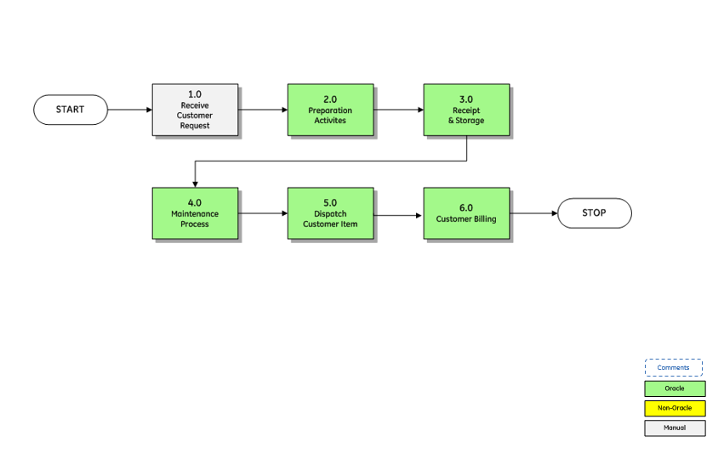

**Fig 3.2 Equipment Management Cycle**

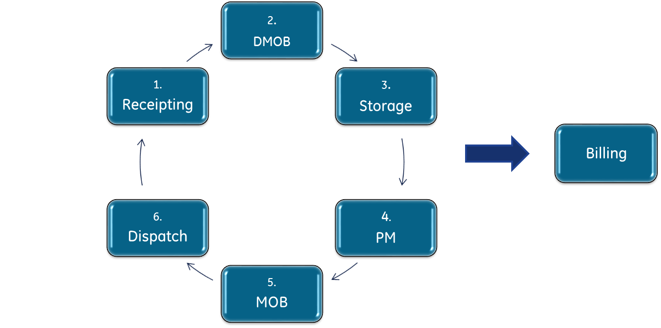

## 

## Storage

### **Receipt Customer Request**

### Customer request for EM revenue stream are typically in the form of Frame Agreements or Long Term Contracts. Upon receipt of PO’s from customer the ITO team will handover to the OTR team for execution. The process flow describes the steps typically employed to facilitate handover to OTR.

### Refer to Appendix 7.1.1 for process map.

### **Preparation Activities**

### The steps outlined in Appendix 7.1.2 explain the activities involved during the preparation phase; which includes Creating Costing Project, Contract, RMA, Asset & Routing Set-up. These activities are required to facilitate the receipting activity. To facilitate the volume of COE to be stored and maintained, the RMA upload tool can be used.

### Refer to Appendix 7.1.2 for process map.

### **Receipt and Storage Activities**

### The process to receipt COE upon it arriving physically consists of equipment identification and tagging plus physical putaway into respective locations as per customer requirements. Upon system receipt, preceeding activities can be followed up, such as finalizing asset set up in the ERP linking asset routings to individual assets. This can then feed into the maintenance forecasts. Demobilization activities can then be planned upon obtaining approval from customers.

### The RMA receipt tool can be used to upload multiple equipment in one instance.

### Asset Routings can be created for COE using the Asset Routing Utility Tool in order to facilitate the high volume of routings required.

### Refer to Appendix 7.1.3 for process map.

### **Preservation Maintenance Activities**

### Maintenance forecasts can be generated based on the preservation and maintenance requirements of COE for a stipulated forecast period.

### Depending on the customer contracts, preservation and maintenance shall be carried out upon customer approval. Upon customer approval, Preservation and Maintenance Work Orders will be generated for execution. Work Order picklists are used to request items to be sent to the workshop or to be worked on in it’s current physical location. This is transacted in the ERP system. Upon completion of the Preservation and Maintenance Work Order the Work Order will be closed. The customer item will then be transacted back to the warehouse in the ERP to denote that work has been completed and the item now resides in stores.

### Refer to Appendix 7.1.4 for process map. Refer to Preservation of Products Guideline QO-PER-059 for preservation recommendations, (Note: customer or project plans/contracts take precedence).

## Mobilization and Dispatch Activities

## Customer items that are called off to be dispatched will be mobilized accordingly as required. The ISL’s will receive the request from the respective customers and initiate the mobilization activities. Work Orders will be created and executed for the mobilization activities. Upon completion of the mobilization activities, the Work Order will be closed and transacted in the ERP accordingly. The customer item will be transacted out of the Work Order back to stores where the item is now pickable.

## The OTR team will issue a pick list for the items in order to pick the COE to be shipped. Upon dispatch of customer items, “Ship Confirm” transaction will be carried out in the ERP accordingly to denote that the item has been shipped.

## If the item is no longer required after mobilization it shall be moved back into storage and receipted in the ERP accordingly.

## Refer to Appendix 7.1.5 process map

## Billing Activities

## Depending on the contract requirements billing activities will be carried on a monthly basis for the storage and maintenance of customer owned equipment.

## Refer to Appendix 7.1.6 for process map.

# Roles & responsibilities

| Key Role | Responsibility |
| --- | --- |
| ISL | Liaise between customer and operations  Check & submit Inspection reports to customer as required.  Check inventory on periodic basis.  Initiate mobilization activities.  Receive ITC approval for job comencement. |
| Warehouse Coordinator | Receipt COE per Inward Goods Work Instruction QW-FAC-PER-001.  Identify & move COE to storage location.  Update ERP.  Arrange applicable shipment activities.  Movement, Picking and Shipping Activities. |
| Manufacturing Engineer | Set up assets and routing in ERP.  Link assets to routings in ERP  Generate work orders.  Generate forecast reports. |
| COE Coordinator | Create Inventory Attributes in ERP  Coordinate physical count & book balance match.  Report stock & relevant activities. |

# Quality records

The following is a summary of records produced by this work instruction that shall be maintained and controlled according to the requirements of [BHGE-QUA-013 Control of Records](http://edms.pw.ge.com/dctmquality/home/components/drl/drl.jsp?objectId=0900f5ea8095c4b7&showRendition=true).

| Record | Owner | Storage location |
| --- | --- | --- |
| Completed Work Orders | Document Control | GE Libraries |

# References, terms, definitions & acronyms

## References

| Number | Name | Training material & quiz |
| --- | --- | --- |
| n/a | BH[GE O&G QMS Lexicon](http://supportcentral.ge.com/@lexicon) | n/a |
| n/a | [Subsea Systems & Drilling QMS Lexicon](http://libraries.ge.com/download?fileid=697340101101&entity_id=55721334101&sid=101) | n/a |
| [BHGE-QUA-013](http://edms.pw.ge.com/dctmquality/home/components/drl/drl.jsp?objectId=0900f5ea8095c4b7&showRendition=true) | [Control of Records](http://edms.pw.ge.com/dctmquality/home/components/drl/drl.jsp?objectId=0900f5ea8095c4b7&showRendition=true) | n/a |
| [BHGE-QUA-016](http://edms.pw.ge.com/dctmquality/home/components/drl/drl.jsp?objectId=0900f5ea8097786b&showRendition=true) | [Design & Development Process](http://edms.pw.ge.com/dctmquality/home/components/drl/drl.jsp?objectId=0900f5ea8097786b&showRendition=true) | n/a |
| QW-FAC-PER-001 | Inward Goods Work Instruction | n/a |
| QO-PER-059 | Preservation of Product Guideline | n/a |
|  |  |  |
|  |  |  |

## Terms, definitions & acronyms

Italicized terms have been defined in [BHGE QMS Lexicon](http://supportcentral.ge.com/@lexicon) for Terms, Definitions and Acronyms. In case of conflict with [BHGE QMS Lexicon](http://supportcentral.ge.com/@lexicon). For this document, the below table will take precedence.

| Acronym | Term | Definition |
| --- | --- | --- |
| BHGE | Baker Hughes a GE Company |  |
| COE | Customer Owned Equipment |  |
| DMOB | Demobilization |  |
| ERP | Enterprise Resource Planning |  |
| EM | Equipment Management |  |
| FSE | Field Service Engineer |  |
| ISL | Integrated Service Lead |  |
| ITC | Instruction to Contractor |  |
| ITO | Inquiry to Order |  |
| MOB | Mobilization |  |
| OFE | Oilfield Equipment |  |
| OTR | Order to Remittance |  |
| PM | Preservation Maintenance |  |
| PMS | Product Management System |  |
| PO | Purchase Order |  |
| QMS | Quality Management System |  |
| RMA | Receipt Material Authorization |  |
| WI | Work Instruction |  |

# Appendices

Appendix 7.1.1

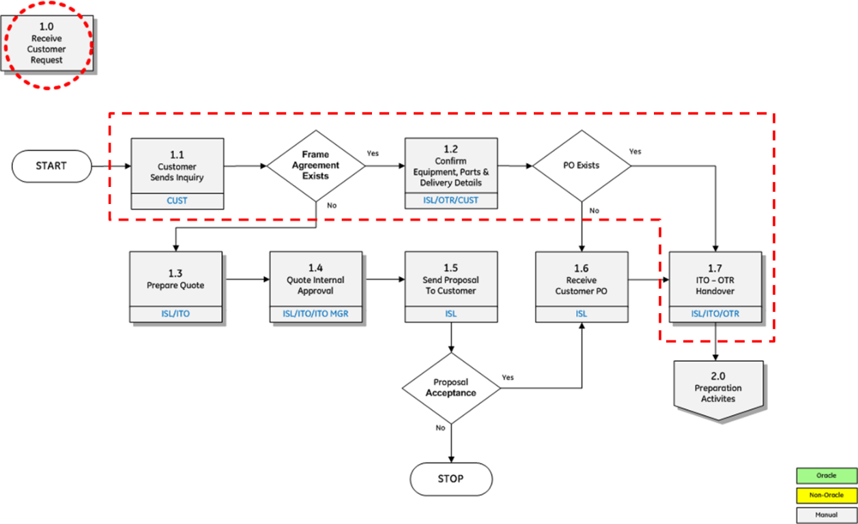

Appendix 7.1.2

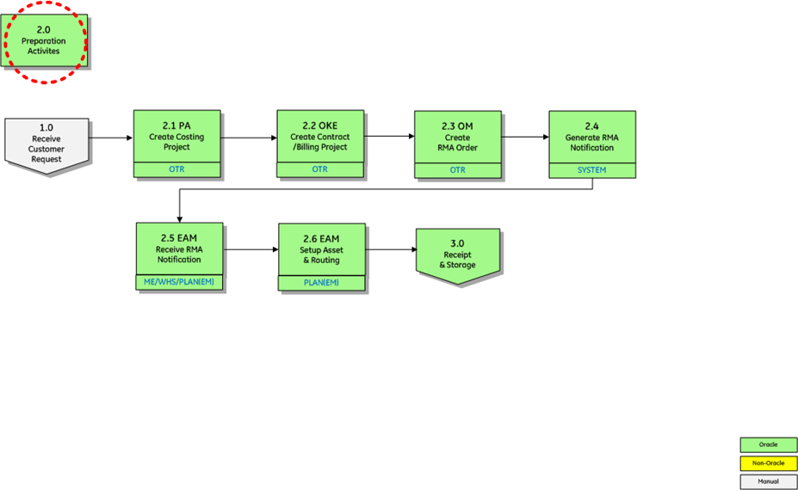

Appendix 7.1.3

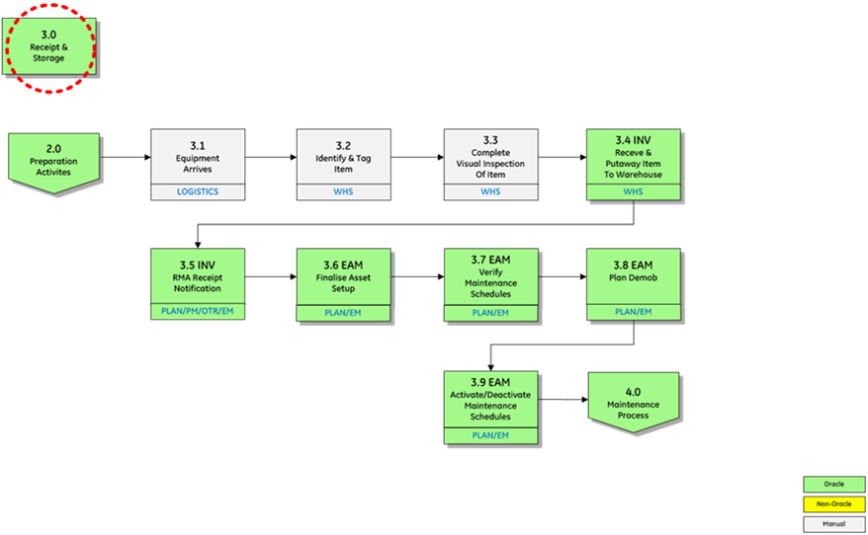

Appendix 7.1.4

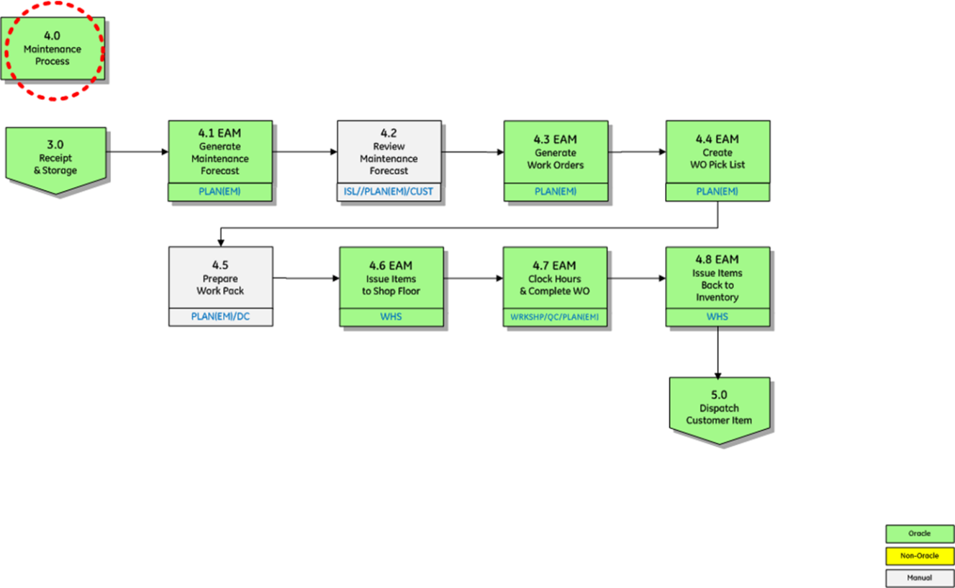

Appendix 7.1.5



Appendix 7.1.6

