**Background**

There are three types of seals used on tubing and casing:

1. interference sealing threads,
2. gasket seals and
3. metal to metal seals.

**Interference Sealing Threads**: The interference sealing threads use a tapered connection that is made up two or more turns beyond hand tight. This power tight makeup forces the mating surfaces together under pressure. Thread lubricant is used to close the gap between the root and crest of the mating threads. The size of the gap and the length of the thread helical make an effective seal.

**Gasket Seals:** Gasket seals use a ring of resilient material somewhere in the connection. The ring is ductile enough to form itself to the shape of the mating piece.

**Metal to Metal Seals:** Metal to metal seals are considered the premium seals in the oil field. The machined surface of the pin connection forms a seal around a mating machined surface in the box connection.

American Petroleum Institute (API) round and buttress threads are public property and are governed by API SPEC 5B. The inspection guidelines are available and well defined. Out-with these there are numerous thread designs that are proprietary. For these non-API threads, the inspection criteria may be confidential. The inspection of these connections can only be to examine the threads and set aside any suspect thread for the manufacturer’s evaluation. This information guideline aims to assist Goods Inward Inspection with the inspection of these type of threads.

**Goods Inwards Inspection**

Items delivered with premium type threads should have the thread protectors removed and threads inspected prior to Goods Inward acceptance.

Before inspection, the threads must be cleaned. During cleaning, the inspector should begin the inspection of the threads. Any obvious imperfections should be marked as soon as they are found. A critical consideration throughout the threaded area, regardless of the type of connection, is that there are no protrusions on the thread surfaces that could score the mating surface. If the surface has a protrusion, the pressure of makeup will be concentrated in the high spot causing friction and galling, instead of being distributed across the broad surface. Minor repair of high spots with a hand file may be permitted with the pipe owner’s permission. If the protrusion cannot be repaired the connection is rejected.

Inspection should then focus on the sealing areas of the connection. Any obvious imperfections on the seal face should be marked and recorded, in particular any scratches which could create a leak path should be rejected and a non-conformance (e.g. GRU) raised.

If in doubt over the location of the seal face, contact Engineering.

If burr’s or swarf are found, thread protectors should not be re-fitted until the thread has been inspected or dispositioned by Engineering. Threads should be suitably protected by other means until this is carried out. Thread protectors should also be checked and cleaned prior to re-fitting. Grease and dope should only be used as per thread manufacturer’s instructions. Thread protectors should be refitted prior to movement of goods.

Examples of premium threads:

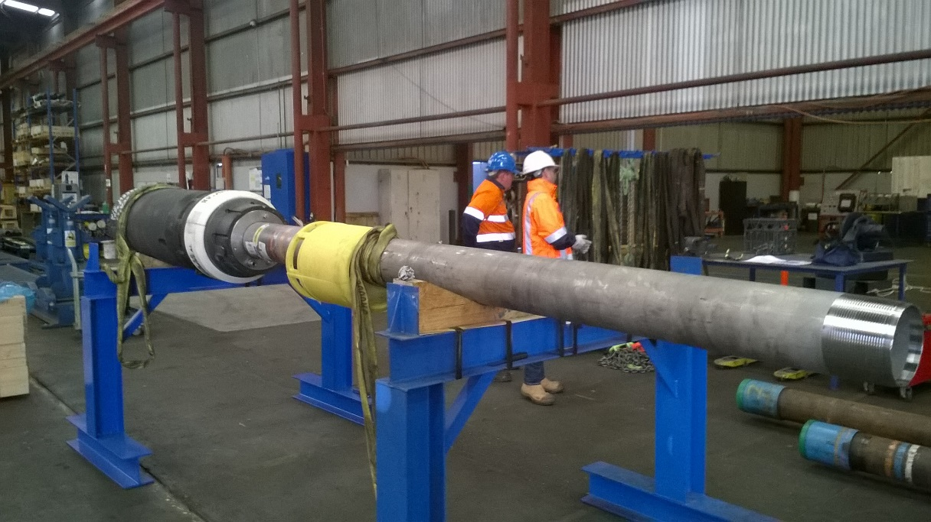

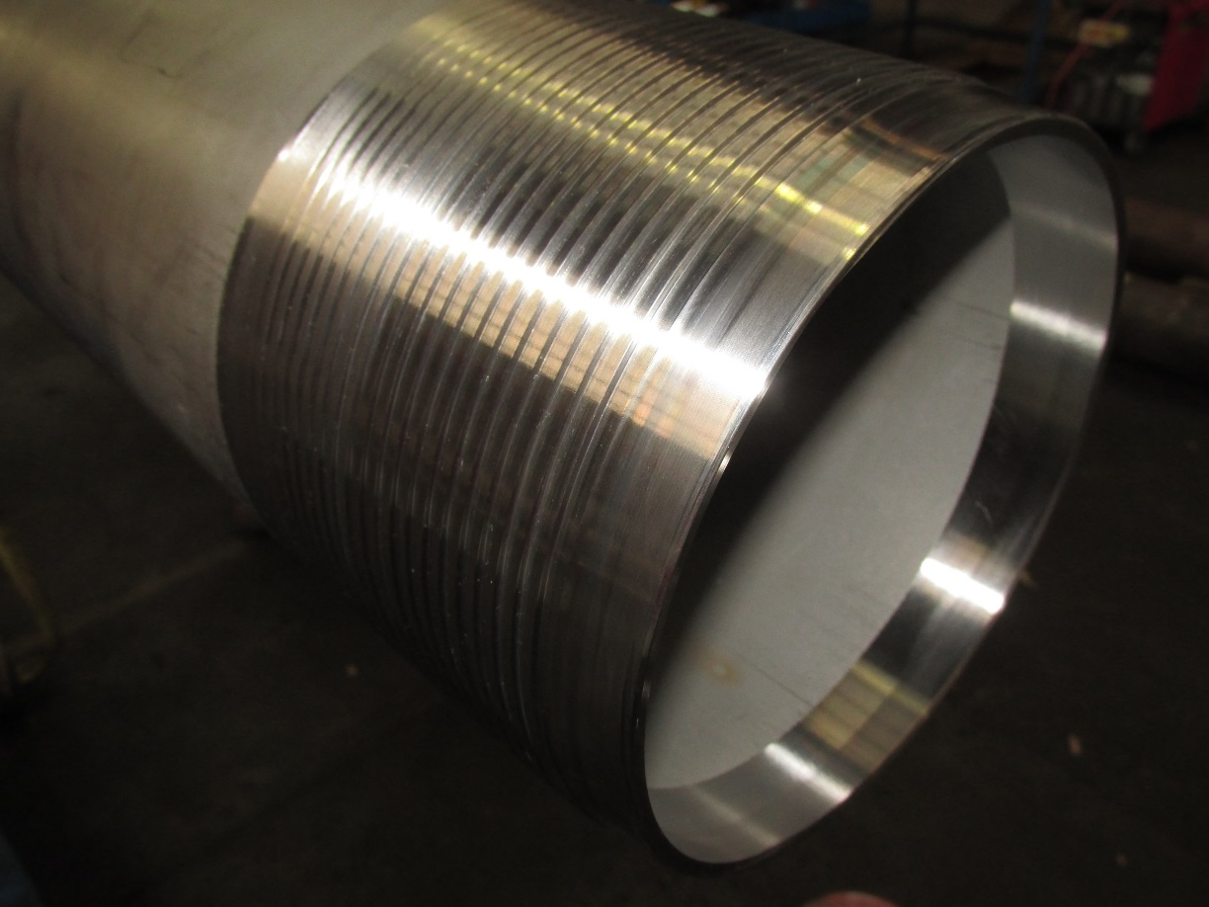

|  |  |  |  |
| --- | --- | --- | --- |
| **Document Revision Chart** | | | |
| **The following chart lists the revisions made to this document tracked by version. Use this to describe the changes and additions each time this document is re-published. The description should include as many details of the changes as possible.** | | | |
| **Revision #** | **Section Modified and Revision Description** | **Modification Date** | **Author** |
| 1.0 | First Issue | 18.09.2017 | A Mackie |
|  |  |  |  |

|  |
| --- |
| **Released By:** |
|  |
| **Tim Sims** |
| **QMS Lead ANZ** |
|  |