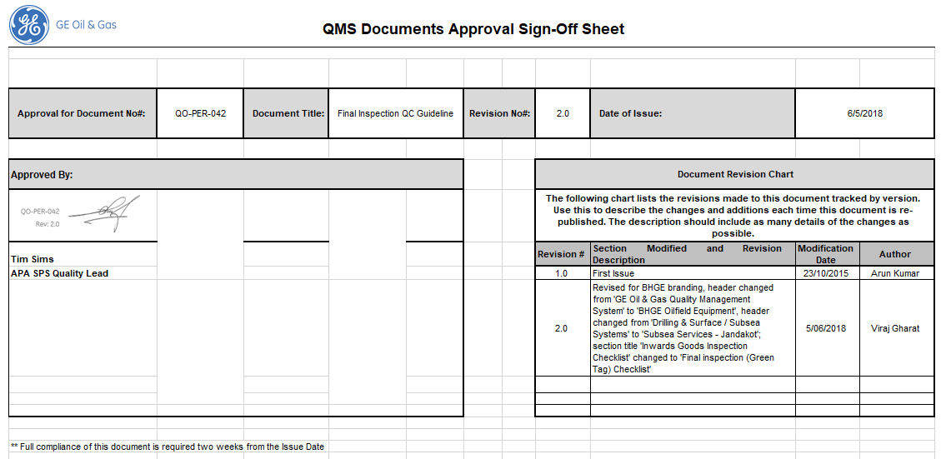

**Final inspection (Green Tag) QC Checkpoint**

QC should periodically inspect tools during workshop operations. Where workshop operations have been witnessed or reviewed, a QC stamp and initial will be captured on the associated record.

The Final QC inspection process for items at Jandakot is completed as part of Work Instruction ‘Repair and Solutions OTR Process’ (QW-FAC-PER-022).

This document acts as a guide only for the activities completed by an inspector during the QC Green tag Inspection of completed items.

**Final inspection (Green Tag) Checklist**

1. Review Workorder to ensure completeness of all previous operations and ensure correctly signed off
2. Ensure all records associated with the workorder scope of work are available
3. Inspect the tool to ensure:
   1. Marking data is correct as per BOM / Drawing and aligns with workorder
   2. Ensure tool has been built correct to BOM and Drawing ensuring all disposition activities are correctly completed

**NOTE:** *Some BOM items may include protective fittings / covers. These should be fitted at the time of final inspection.*

* 1. Ensure the part Rev aligns with ePims requirements
  2. Ensure trace sheet has been completed and aligns to physical part
  3. Ensure Critical sealing faces and connections are free from damage & paint
  4. Ensure appropriate protection caps and dope is applied to preserve the part

1. Populate Green tag and fit securely to part
2. Sign Green tag operation and pass WO to warehouse for packing/shipping

**NOTE:** *Should any specialised packing / preservation requirements exist, ensure these are understood by warehouse and verify prior to shipping.*

**NOTE:** *Raise a GRU for any identified discrepancies and tag / quarantine the item as per ‘Control of Non-Conforming Product’ (QW-QUA-PER-001) Work Instruction.*