**Approved By:**

|  |  |  |  |  |  |
| --- | --- | --- | --- | --- | --- |
|  |  |  |  |  |  |
| Name: Andrew Atkinson  Title: SPS & Services Commercial Operations Leader |  | Name: Kris Krishna  Title: Global ITO Quality Leader |  | Name: James Holroyd  Title: Global Commercial Leader, Subsea Tree Systems |  |

For any feedback to the process, or the document, please contact the process owner, SPS & Services Commercail Operations Leader .

**Applicability:**

|  |  |  |
| --- | --- | --- |
| **APPLICABLE PRODUCT LINES** | | |
| ​​   Subsea Drilling Systems | Subsea Production Systems (SPS) & Subsea Services (SRV) | |
| ​​​      Surface Pressure Control & Offshore | ​​  Trees | ​​    Controls |
| ​​   Flexible Pipe Systems (FPS) & Wellstream Construction Services (WCS) | ​   MCS | ​​   Projects |
| Subsea Production Systems (SPS) & Subsea Services (SRV) | Subsea Services | |

**Document Revision Chart:**

|  |  |  |  |  |
| --- | --- | --- | --- | --- |
| **Rev** | **Section modified and revision description** | **Issue date** | **Expiry date** | **Author(s)** |
| 1.0 | The purpose of the bid prioritization process is to review any new sales opportunity against a series of criteria in order to assess the opportunity’s attractiveness, ease of execution and winnability. | 03/Nov/2017 | 03/Nov/2020 | James Derek Holroyd |

Table of Contents

1 Purpose / Outcome 4

2 Scope & Applicability 4

3 Process 4

3.1 Bid prioritization and the ITO R-process 4

3.2 Overview of the bid prioritization tool 5

3.2.1 Bid prioritization bubble chart 5

3.2.2 Bid prioritization inputs 6

3.3 Assessment of the opportunity characteristics 7

3.3.1 Attractiveness 7

3.3.2 Ease of execution 8

3.3.3 Winnability 9

3.4 Bid prioritization characteristics score calculation 10

3.5 Process definitions 10

4 Roles & Responsibilities 11

5 Quality Records 12

6 References, Terms, Definitions & Acronyms 12

6.1 References 12

6.2 Terms, Definitions & Acronyms 12

7 Appendix 14

**Notice**

*This document is strictly confidential and is the property of BHGE, and no person shall have any right to disseminate, reproduce, quote, report or in any manner whatsoever utilise or rely on the contents of this document to any third party (other than Parties to the Contract) without the prior written authorisation of BHGE. In no circumstances shall the use of this document by any person or by BHGE in any presentation, meeting or discussion with any person imply that any such authorisation is given. BHGE retains all rights to any intellectual property that may be contained in this document. The document disclosure if made, is deemed to be made on a without prejudice basis. This document is aimed at providing an insight into BHGE quality processes and procedures. It is not intended and cannot be construed as in any way expanding Parties obligations beyond that set out in the relevant Contract(s) for the Project, and the provisions of such Contract(s) are deemed to prevail over this document at all times.*

# Purpose / Outcome

This work instruction describes the bid prioritization process which is a step of the broader Sales and ITO process. The purpose of the bid prioritization process is to review any new sales opportunity against a series of criteria in order to assess the opportunity’s attractiveness, ease of execution and winnability. This assessment is used to subsequently define the bidding strategy. This work instruction will address how this process should be followed.

Full compliance to this work instruction / procedure is required by one month after publication on the QMS (Documentum)

# Scope & Applicability

This work instruction is applicable to the 3 Subsea PL’s (Trees, PCS, MCS). It is mainly targeted at EPC deals but is also applicable to Subsea single PL and multi-product deals. The bid prioritization is not targeted at reviewing deals which are “call-off’s” from frame agreements as these require little or no ITO resource.

# Process

The following sections will:

* Explain where the bid prioritization process fits within the overall ITO process (section “3.1 Bid prioritization and ITO Commercial stages ”)
* Provide more insight on the actual tool and the graphical summary it generates (section “3.2 Overview of the bid prioritization tool”)
* Detail the underlying criteria enabling to assess the project’s 3 key characteristics (section “3.3 Assessment of the opportunity characteristics”)
* Provide high level explanation on the scoring mechanism (section “3.4 Bid prioritization characteristics score calculation”)
* Lay out the high level bid prioritization process with inputs, actions, owners and outputs (section “3.5 High level process & responsibilities”).

## Bid prioritization and the ITO Commercial Stages

The below illustration lays out the ITO process consists of six phases which involve transitions through risk management reviews (Pre-bid/Bid to Win) often referred to as the Commercial Stages. The bid prioritization process fits into the Prospecting and Qualifying phases where an opportunity is identified and needs to be subsequently assessed via the bid prioritization framework.

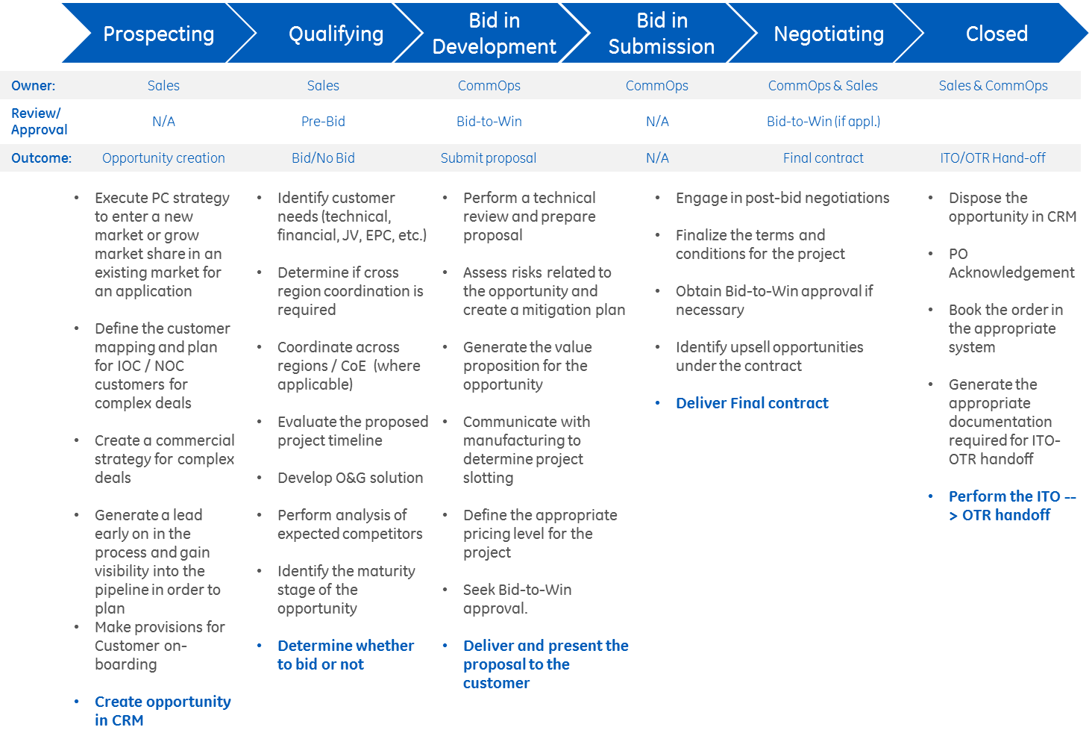

## Overview of the bid prioritization tool

## 3.2.1 Bid prioritization bubble chart

The bid prioritization tool produces a graphical representation which captures 3 deal characteristics: attractiveness, ease of execution and winnability. Each opportunity is represented by a bubble.

* The position of the opportunity bubble versus the vertical axis represents the attractiveness of the opportunity, on a scale from 1 (least attractive) to 9 (most attractive).
* The position of the opportunity bubble versus the horizontal axis (X axis) represents the ease of execution of the opportunity, on a scale from 1 (most complex) to 9 (easiest to execute).
* The size of the bubble represents the opportunity revenue in $MM
* The colour of the bubble represents the winnability of the opportunity. Green means high winnability, orange means medium winnability and red means low winnability.



## 3.2.2 Bid prioritization inputs

Each of the 3 characteristics is measured based on a series of questions. These questions need to be answered by the sales representative following opportunity identification and validated by the ITO operational leader. A mechanism of scoring based on the answer given to each question determines the overall score for each of the 3 characteristic and as a consequence, the position on the chart. This scoring mechanism is further explained in section 3.3 Assessment of the opportunity characteristics.

The figure below illustrates the tab in the bid prioritization tool, used to input the answers to each of the questions. The left greyed out section corresponds to the questions, while the right blue side corresponds to the fields where an answer is needed based on drop down boxes.

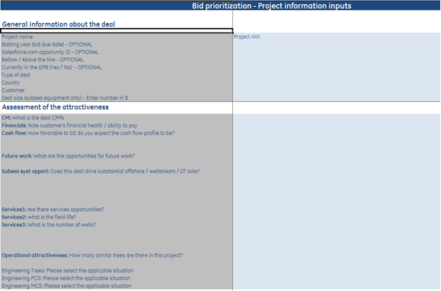

## Assessment of the opportunity characteristics

The following sections provide details about the criteria/questions as well as possible answers, enabling to assess and measure each of the 3 characteristics.

## 3.3.1 Attractiveness

The attractiveness is measured based on the following criteria:

* **Contribution Margin % (CM%):** the contribution margin of the deal expressed as percentage of the project’s revenue is key to measure the attractiveness of the project. For each PL, a target CM% has been defined by the PL leader in agreement with the BHGE Subsea Chief Financial Officer. The performance versus this target will determine the attractiveness score.
* **Customer financial health:** The opportunity attractiveness is influenced by the customer financial health and as a consequence his ability to provide BHGE Subsea with timely and complete payment.
* **Expected cash flow:** The cash flow profile i.e. the timed balance of cash received from the customer versus the cash disbursed by BHGE Subsea to execute the project impacts the attractiveness of the project. A deal with high upfront payment from the customer will be more attractive as it allows BHGE to execute the project with limited use of its capital.
* **Opportunities for future work:** The opportunities for future work associated with a project are also a criterion to take into consideration when assessing the attractiveness. A project could indeed contribute to generate further business growth due to the future opportunities associated.
* **Subsea opportunities:** The fact that a project provides substantial sales opportunity for the other Subsea Systems businesses (Offshore / Wellstream) is considered as a criterion of attractiveness.
* **Services opportunities:** The fact that a project provides opportunities of work for the Services business is considered as a criterion of attractiveness.
* **Potential for productivity:** A project with a high number of similar systems will results in higher productivity (hours spent by trees) from a manufacturing and engineering standpoint. This contributes to the attractiveness of a project.
* **Engineering assessment:** Due to the engineering resource constraints as well as the effort to develop structured product, the attractiveness of a project will be influenced by the engineering assessment. The different scenario/answers are as follows (in order of decreasing attractiveness): full repeat part, NPI in Portfolio; repeat part combination with no qualification; a repeat part combination with qualification needed; a NPI not in portfolio.
* **Strategic customer:** The project attractiveness is influenced by the customer and how strategic he is considered.
* **Growth region:** The region in which the project is located is a criterion influencing the attractiveness as it needs to be in line with BHGE Subsea regional growth strategy.

## 3.3.2 Ease of execution

The ease of execution is measured based on the following criteria:

* **Continuation phase:** Some projects are the continuation phase of a phase executed previously. For example the project Kizomba Phase II is the second phase of the Kizomba project. A continuation phase project is typically foreseen to be easier to execute given the lessons learned and experience acquired during the previous phase. This is the reason why this criteria is taken into consideration when assessing the ease of execution of a project.
* **Engineering complexity:** The engineering work required for a project is a key component to determine the ease of execution of a project.
* **Interfacing:** The presence of equipment provided by the customer and which need to be interfaced with the product manufactured by BHGE Subsea contribute to make the project more complex and therefore impacts the ease of execution.
* **Quality:** The ease of execution will be impacted by the customer accepting or not the BHGE Subsea quality standards.
* **Specific requirements:** The ease of execution will be impacted by the customer having any specific requirement such as TRS, country requirements or customer imposed suppliers.
* **Schedule vs. cycle time:** The project execution lead time imposed by the customer will influence the ease of execution and must be compared to the expected BHGE O&G Subsea cycle time.
* **Local requirements:** Certain projects require local content. These requirements can significantly increase the complexity of a project.
* **Risk of country:** The risk of the country based on the EHS TAS ranking is taken into account when assessing the ease of execution of a project.
* **Customer complexity:** Based on historical projects execution, a complexity rating can be allocated to each customer, helping to assess the ease of execution.

## 3.3.3 Winnability

The winnability is measured based on the following criteria:

* **Bidding position:** This criterion reflects the fact that a project will be highly winnable in case of closed bid versus a situation where the bid is open to other competitors.
* **Competitive landscape:** The competitive landscape is determined by the number of competitors, their ability and willingness to compete.
* **Incumbency position:** The incumbency position reflects if any of the bidders has a very strong competitive advantage due to previous relationship with the customer related to the opportunity.
* **Decision making unit position:** The position of each of the customer’s decision making unit for the commercial, engineering and project management area will influence the winnability.
* **Technical Ability:** The technical ability of BHGE Subsea versus the customer’s specifications as well as versus the competition’s technical ability will impact the winnability.
* **Ability to support installation:** The ability to support the installation will impact the winnability.
* **BHGE’s Presence (if important to the customer):** BHGE’s presence can be a strong element in the customer project award decision and is therefore considered when assessing the winnability.

## 3.4 Bid prioritization characteristics score calculation

As mentioned earlier, each of the characteristic (attractiveness, ease of execution, winnability) is measured on a scale from 1 to 9. The score is based on the answers provided to a series of questions. Each question results in a score from 1 to 9 based on the answer provided and a pre-defined logic integrated in the tool. The scores for all questions are then rolled based on a weighted average to determine the overall characteristic score.

The scores for each answer and the weightings are not detailed in this work instruction but are contained in the bid prioritization file stored under the following link:

<http://sp.vetco.com/sites/subseaitr/ITO%20Operations/bid_prioritisation/default.aspx>

These scores and weightings have been defined based on discussions with functional leaders and BHGE Subsea Systems senior leadership and can be subject to update based on changes in the market or the business strategy.

## 3.5 Process definitions

|  | **Flow Chart Process - Legend** | | | | |  | |  |
| --- | --- | --- | --- | --- | --- | --- | --- | --- |
|  | **Process Start/Stop** | Sales Manager | ITO Operations Leader | Comm Ops | Engineering |  | | |
| **Process Step Connector** |
| **Decision Point** |
| **Ultimate Step Responsibility** |
| **Key Step Contributor** |
| **Ref** | **Activity** | **Responsibility** | | | | **Additional Requirements** | **Links** | |
| 3.5.1 | Opportunity Identified |  |  |  |  | [1] New opportunity identification |  | |
| 3.5.2 | Opportunity entered in Salesforce.com |  |  |  |  | [2] Enter opportunity details in bid prioritization tool |  | |
| 3.5.3 | Upload bid prioritization template |  |  |  |  | The sales manager uploads the bid prioritization template from the Winning In Subsea library and enters details about the opportunity | <http://sp.vetco.com/sites/subseaitr/ITO%20Operations/bid_prioritisation/default.aspx> | |
| 3.5.4 | Provide the bid prioritization file |  |  |  |  | The sales manager provides the bid prioritization file with his opportunity information |  | |
| 3.5.5 | Reviews and validate details |  |  |  |  | [3] Opportunity details reviewed w/ ITO Ops Leader  Subsea ITO operations Leader who reviews and validates the details with the sales manager as well as the commercial operations and engineering if needed |  | |
| 3.5.6 | Add opportunity |  |  |  |  | Further to validation, the ITO operations manager adds the opportunity to the previous bid prioritization chart |  | |
| 3.5.7 | Share detail with Sales Manager |  |  |  |  | Shares bid prioritization chart with the sales manager as well as the S&OP meeting attendance. |  | |
| 3.5.8 | S&OP Meeting |  |  |  |  | [4] Bid prioritization chart shared in S&OP meeting  [5] Definition of bid strategy - Incorporate to S&OP  During the S&OP meeting, the new opportunities are reviewed by the group and the bid strategy is defined. The expected deliverables of the meeting related to the bid prioritization are:   1. The bubble chart showing the opportunities reviewed during the meeting 2. Minutes of the meeting detailing for each of the opportunity reviewed:    1. If any bid / no bid decision was made.    2. In case of bidding decision, indicate if the opportunity was considered as “high priority” or not.    3. Any specific decision regarding the bidding strategy. Examples of such a specific decision are “Bid standard repeat design and not compliant with a specific customer technical requirement”, “Need to influence the customer’s position in order to approve submission of BHGE standard quality requirements”… |  | |

**➃**

**➂**

**➁**

**➄**

**➀**

New opportunity identification

Bid prioritization chart shared in S&OP meeting

Enter opportunity details in bid prioritization tool

Opportunity details reviewed w/ ITO Ops Leader

Definition of bid strategy - Incorporate to S&OP

# Roles & Responsibilities

|  |  |
| --- | --- |
| **Key Role** | **Responsibility** |
| Sales Manager | The sales manager is in charge of ensuring that any new opportunity goes through the bid prioritization process before the S&OP meeting and before the Bid/No Bid meeting. Ideally, after Prospecting stage when the opportunity is entered in salesforce.com, he should upload the bid prioritization template to enter his opportunity details and share it with the ITO operations leader. |
| ITO Operations Leader | The ITO operations leader is in charge of ensuring the validity of information provided by the sales manager, and ensure that the bid prioritization review takes places during the S&OP meeting. He should also drive the discussion leading in decisions on the bidding strategy. |

# Quality Records

The following is a summary of records produced by this work instruction that shall be maintained and controlled according to the requirements of [**OGQ-0102 - Record Control**](http://edms.pw.ge.com/dctmquality/home/components/drl/drl.jsp?objectId=0900f5ea8063d167&showRendition=true). All records shall be in line with Records location map relevant for the Site/Organization.

|  |  |  |
| --- | --- | --- |
| **Record** | **Owner** | **Storage location** |
| Bubble Chart | ITO Operations Leader | Sharepoint |
| Minutes of the Meeting | ITO Operations Leader | Sharepoint |

Above documents should be stored under the same folder hosting the bid prioritization template:

<http://sp.vetco.com/sites/subseaitr/ITO%20Operations/bid_prioritisation/default.aspx>

# References, Terms, Definitions & Acronyms

## References

The following procedures and work instructions relate to the bid prioritization process:

|  |  |  |
| --- | --- | --- |
| **Number** | **Name** | **Training Material & Quiz** |
| n/a | [GE O&G QMS Lexicon](http://supportcentral.ge.com/@lexicon) | n/a |
| n/a | [Subsea Systems & Drilling QMS Lexicon](http://libraries.ge.com/download?fileid=697340101101&entity_id=55721334101&sid=101) | n/a |
| [OGQ-0102](http://edms.pw.ge.com/dctmquality/home/components/drl/drl.jsp?objectId=0900f5ea8063d167&showRendition=true) | [O&G Record Control Procedure](http://edms.pw.ge.com/dctmquality/home/components/drl/drl.jsp?objectId=0900f5ea8063d167&showRendition=true) | [OGQ-0102TM](http://edms.pw.ge.com/dctmquality/home/components/drl/drl.jsp?objectId=0900f5ea8063d169&showRendition=true) |
| [OGQ-0111](http://edms.pw.ge.com/dctmquality/home/components/drl/drl.jsp?objectId=0900f5ea807c31c6&showRendition=true) | [Inquiry to Order](http://edms.pw.ge.com/dctmquality/home/components/drl/drl.jsp?objectId=0900f5ea807c31c6&showRendition=true) | [OGQ-0111TM](http://edms.pw.ge.com/dctmquality/home/components/drl/drl.jsp?objectId=0900f5ea807f09ab&showRendition=true) |
| QW-SPS-GLO-001 | SPS Product Lines Strategic S&OP Meetings Work Instruction | n/a |
| QW-SPS-GLO-ITO-001 | Proposals Flow Chart & Notes | n/a |

The following link directs towards the bid prioritization file as well as WebEx training material:

<http://sp.vetco.com/sites/subseaitr/ITO%20Operations/bid_prioritisation/default.aspx>

## Terms, Definitions & Acronyms

Italicized terms have been defined in [GE O&G QMS Lexicon](http://supportcentral.ge.com/@lexicon) for Terms, Definitions and Acronyms. In case of conflict with [GE O&G QMS Lexicon](http://supportcentral.ge.com/@lexicon), QMS Lexiccon takes precedence

|  |  |  |
| --- | --- | --- |
| **Acronym** | **Term** | **Definition** |
|  | Bid | Process of preparing and submitting a proposal as a result of an invitation to tender. |
|  | Bid prioritization | Process of reviewing the attractiveness of the current prospect in relation to the future opportunities pipeline to aid a bid / no-bid decision strategic decision on resource allocation and the bidding approach for each opportunity. |
| CM | Contribution Margin |  |
|  | Decision Making Unit | Commercial term used to define a the customer team who participate in the buyer decision process. |
| EHS | Environment, Health and Safety | See Function Term below |
| EPC | Engineering, Procurement & Construction | A large project involving 3 or more Subsea PL’s is commonly named an “EPC” project. |
|  | Function | Business groups that support the execution of work per the contract e.g. ITO Commercial Operations, Application Engineering, Project Management, Engineering, Sourcing, Manufacturing, Logistics, Finance and EHS. |
| ITO | Inquiry to Order | The process for developing commercial opportunities that includes risk review, development of a proposal and handoff to OTR. Can also be used to describe the Organization within D&P that is responsible for the coordination of Tender activities. |
| ITT | Invitation to Tender | A package of work sent to several potential bidders inviting them to bid (submit a tender response), and if successful execute on, for the scope detailed within the documents. |
| NPI | New Product Introduction |  |
|  | Opportunity | a potential sale identified by the sales team in relation to the future plans of a new or existing customer. |
|  |  |  |
| PL | Product Line | Name commonly given to each of the Subsea sub-businesses (Trees, PCS, MCS, Wellstream). |
| POC | Point of Contact |  |
| S&OP | Sales and Operations Planning |  |
| TAS | Travel Advisory System |  |
| TRS | Technical Regulations and Standards |  |

End of Document.