**GCDGameStore System Tests**

Initial State (GCDGameStore running in Visual Studio):

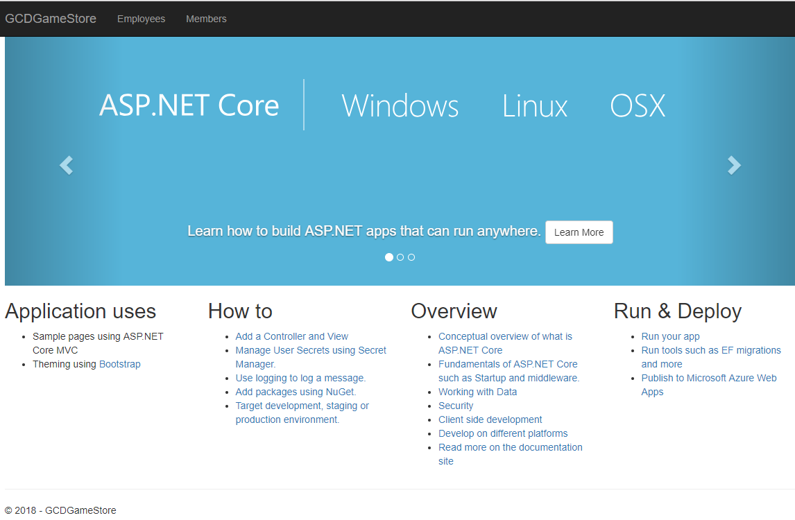

TESTER NAME: ___________________________________________________

TESTING DATE: ____________________________________________________

SIGNATURE: ____________________________________________________

TEST 1 – FAILED EMPLOYEE LOG IN (wrong password)

1. Click “Employees” link in navigation bar
2. Enter “Mike” in the Username field
3. Enter “Hello1!” in the Password field
4. Click the **Login** button

Expected Result:

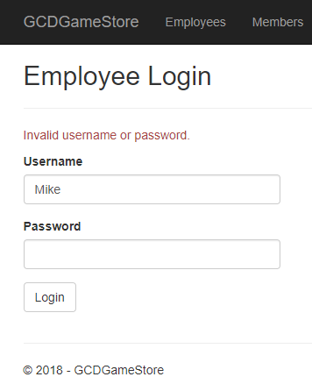

TESTER FEEDBACK:

Did you achieve the expected result? YES NO

Additional Comments:

TEST 2 – SUCCESSFUL EMPLOYEE LOG IN

1. Click “Employees” link in navigation bar
2. Enter “Mike” in the Username field
3. Enter “password” in the Password field
4. Click the **Login** button

Expected Result:

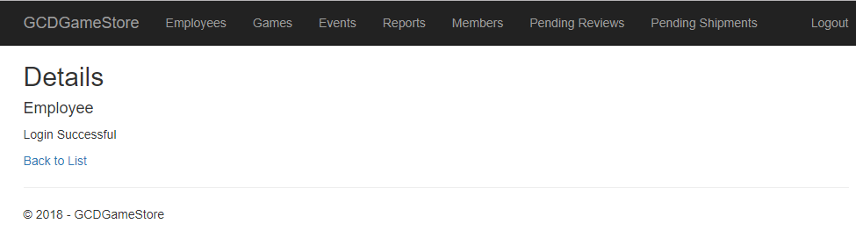

TESTER FEEDBACK:

Did you achieve the expected result? YES NO

Additional Comments:

TEST 3 – GET GAME DETAILS

(assumes user is already logged in per TEST 2 instructions)

1. Click on “GCDGameStore” link in the navigation bar to return to the Home Page
2. Click “Employees” link in the navigation bar
3. Click “Games” link in the navigation bar
4. You should see an Index of games displayed. Navigate to the “Monster Hunter: World” row and click the **Details** button

Expected Result:

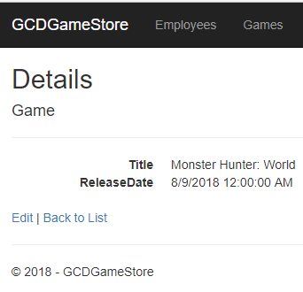

TESTER FEEDBACK:

Did you achieve the expected result? YES NO

Additional Comments:

TEST 4 – DELETE GAME

(assumes user is already logged in per TEST 2 instructions)

1. Click on “GCDGameStore” link in the navigation bar to return to the Home Page
2. Click “Employees” link in the navigation bar
3. Click “Games” link in the navigation bar
4. You should see an Index of games displayed. Navigate to the “Monster Hunter: World” row and click the **Delete** button
5. You should see a confirmation page. Click the **Delete** button

Expected Result (Note: the game “Monster Hunter: World” no longer appears in the game Index):

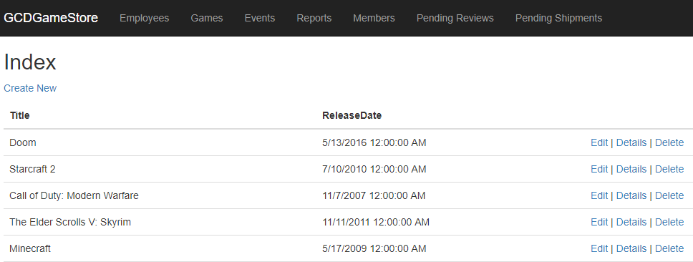

TESTER FEEDBACK:

Did you achieve the expected result? YES NO

Additional Comments:

TEST 5 – BEGIN PROCESSING ORDER SHIPMENT

(assumes user is already logged in per TEST 2 instructions)

1. Click on “GCDGameStore” link in the navigation bar to return to the Home Page
2. Click “Employees” link in the navigation bar
3. Click “Pending Shipments” link in the navigation bar
4. You should see a list of Pending Shipments. Navigate to the first entry (Order Date 11/12/2018) and click the **Begin Processing** button

Expected Result:

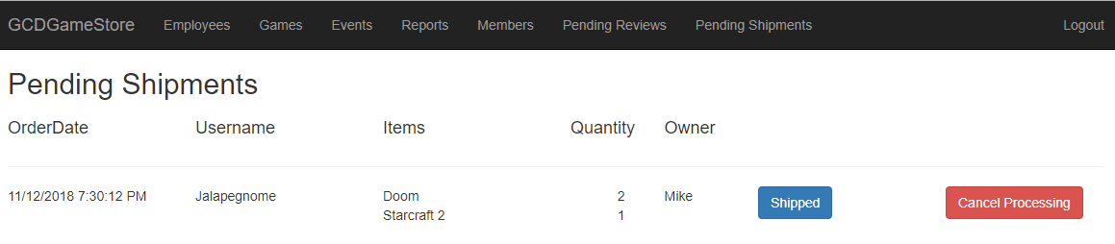

TESTER FEEDBACK:

Did you achieve the expected result? YES NO

Additional Comments:

TEST 6 – CONFIRM SHIPMENT PROCESSING LOCKED

(note: this TEST builds on steps of the previous TEST 5)

1. If the User is currently logged in, they must log out by clicking **Logout** in the upper right corner of the navigation bar
2. Click “Employees” link in the navigation bar
3. Enter “Steve” in the Username field
4. Enter “password” in the Password field
5. Click the **Login** button
6. Click the “Pending Shipments” link in the navigation bar
7. Attempt to confirm the 11/12/2018 shipment by clicking on the **Shipped** button. The interaction should be locked by employee “Mike”
8. Attempt to cancel the 11/12/2018 shipment by clicking on the **Cancel Processing** button. The interaction should be locked by employee “Mike”

Expected Result:

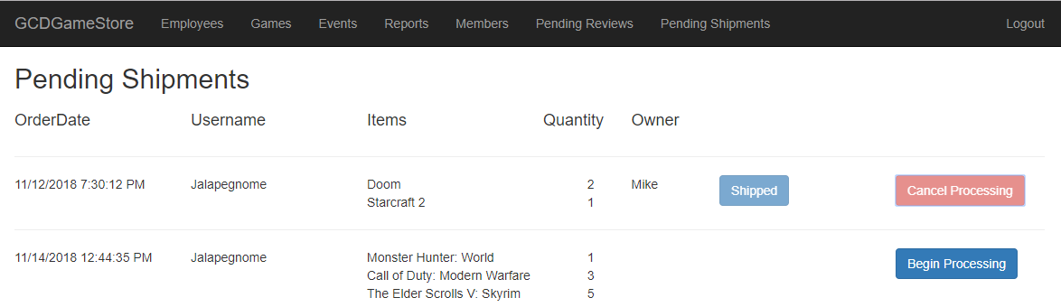

TESTER FEEDBACK:

Did you achieve the expected result? YES NO

Additional Comments:

THIS CONCLUDES TESTING OF THE EMPLOYEE PORTAL

PLEASE LOGOUT BY CLICKING **LOGOUT** IN THE UPPER-RIGHT CORNER OF THE NAVIGATION BAR

TEST 7 – FAILED MEMBER REGISTRATION (username already registered)

1. Click “Members” link in navigation bar
2. Click the Register New Account button
3. Enter “IdleCyborg” into the Username field
4. Enter “[XX@email.com](mailto:XX@email.com)“ into the Email field
5. Enter “12345” into the Password field
6. Enter “12345” into the PasswordConfirm field
7. Click the Register button

Expected Result:

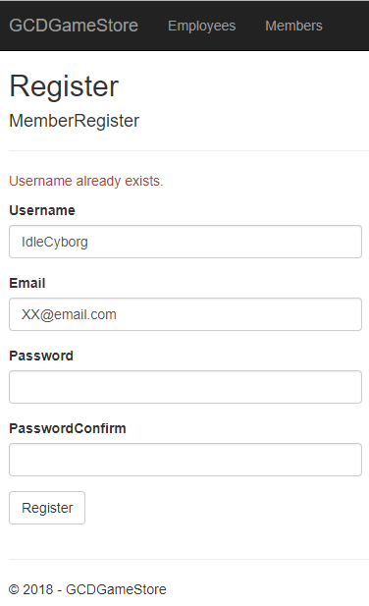

TESTER FEEDBACK:

Did you achieve the expected result? YES NO

Additional Comments:

TEST 8 – SUCCESSFUL MEMBER REGISTRATION

1. Click “Members” link in navigation bar
2. Click the Register New Account button
3. Enter “testerXX” into the Username field
4. Enter “[XX@email.com](mailto:XX@email.com)“ into the Email field
5. Enter “password” into the Password field
6. Enter “password” into the PasswordConfirm field
7. Click the Register button

Expected Result:

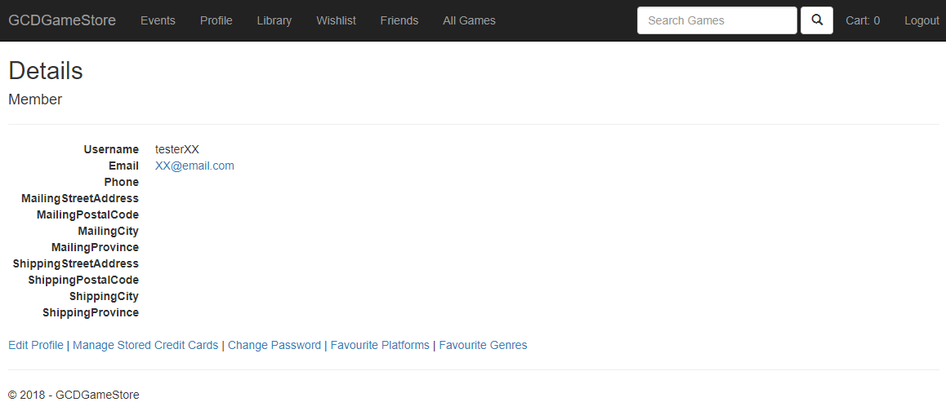

TESTER FEEDBACK:

Did you achieve the expected result? YES NO

Additional Comments:

TEST 9 – MEMBER LOGIN

1. If the User is currently logged in, they must log out by clicking **Logout** in the upper right corner of the navigation bar
2. Click “Members” link in the navigation bar
3. Enter “AdviceBoulder” in the Username field
4. Enter “password” in the Password field
5. Click the **Login** button

Expected Result:

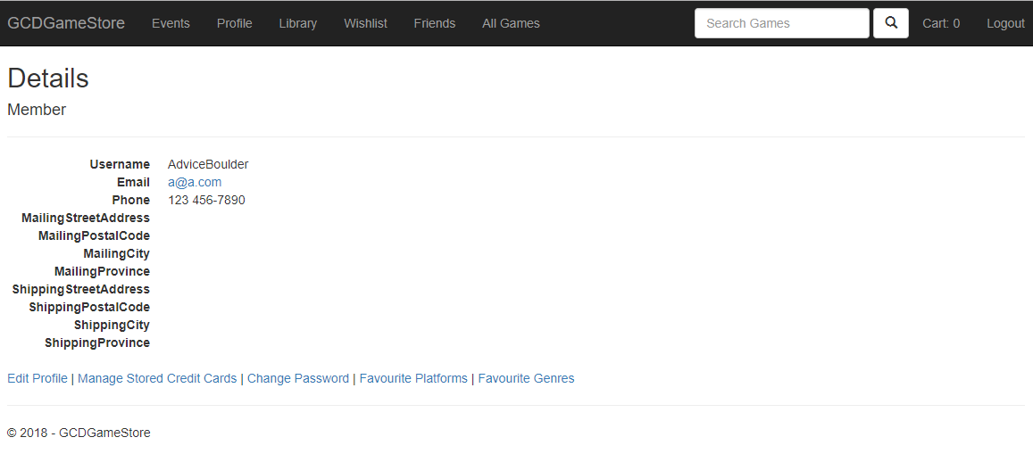

TESTER FEEDBACK:

Did you achieve the expected result? YES NO

Additional Comments:

TEST 10 – REGISTER MEMBER FOR EVENTS

(assumes user is already logged in per TEST 9 instructions)

1. Click the “Events” link in the navigation bar
2. You should see an Index of events displayed. Navigate to the “Tabletop Night” row and click the **Register** button
3. Navigate to the “LAN Party” row and click the **Register** button

Expected Result:

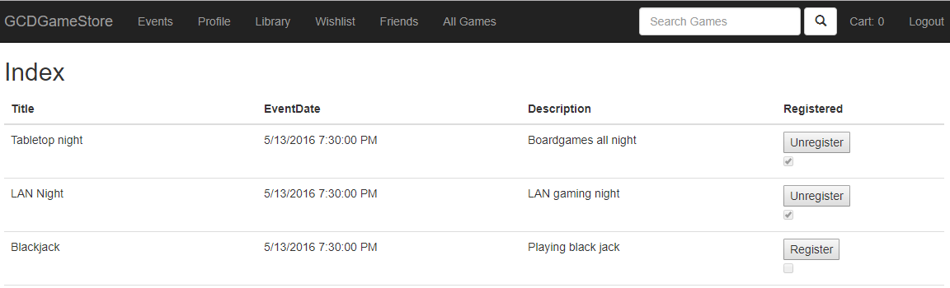

TESTER FEEDBACK:

Did you achieve the expected result? YES NO

Additional Comments:

TEST 11 – EDIT MEMBER DETAILS

(assumes user is already logged in per TEST 9 instructions)

1. Click the “Profile” link in the navigation bar
2. You should see the current user details. Click the “Edit Profile” link in the bottom row of links
3. You should see an editable list of user details. Enter “10 Main” into the MailingStreetAddress field
4. Enter “N2E3L4” into the MailingPostalCode field
5. Enter “Kitchener” into the MailingCity field
6. Enter “ON” into the MailingProvince field
7. Scroll to the bottom of the list and click **Save**

Expected Result:

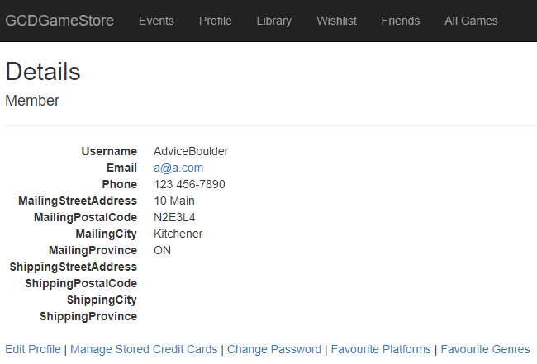

TESTER FEEDBACK:

Did you achieve the expected result? YES NO

Additional Comments:

TEST 12 – ADD CREDIT CARD

(assumes user is already logged in per TEST 9 instructions)

1. Click the “Profile” link in the navigation bar
2. You should see the current user details. Click the “Manage Stored Credit Cards” link in the bottom row of links
3. You should see the Credit Card view for the current user. Click the “Add New Credit Card” link
4. You should see a CreateCreditCard view. Enter “4916166419134725” into the CcNum field
5. Enter “5” into the ExpMonth field
6. Enter “2019” into the ExpField field
7. Enter “Jon Snow” into the Name field
8. Enter “10 Main” into the StreetAddress field
9. Enter “Kitchener” into the City field
10. Enter “ON” into the Province field
11. Enter “N2E3L4” into the PostalCode field
12. Scroll to the bottom of the list and click **Create**

Expected Result:

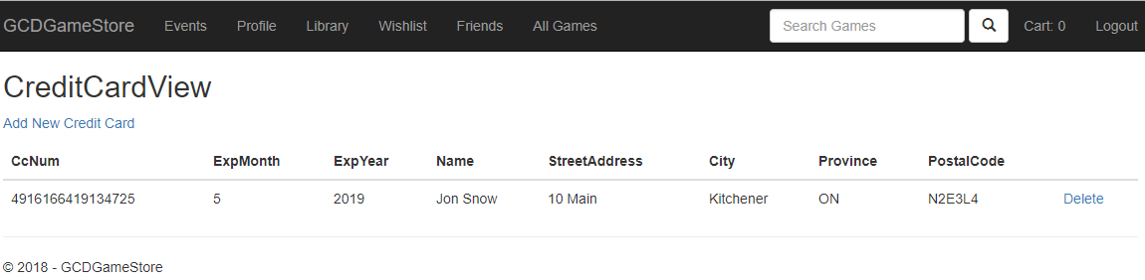

TESTER FEEDBACK:

Did you achieve the expected result? YES NO

Additional Comments:

TEST 13 – ADD FAVORITE GENRES

(assumes user is already logged in per TEST 9 instructions)

1. Click the “Profile” link in the navigation bar
2. You should see the current user details. Click the “Favorite Genres” link in the bottom row of links
3. You should see a list of Genres. Navigate to the “RPG” row and click the **Add Favorite** button
4. Navigate to the “Puzzle” row and click the **Add Favorite** button

Expected Result:

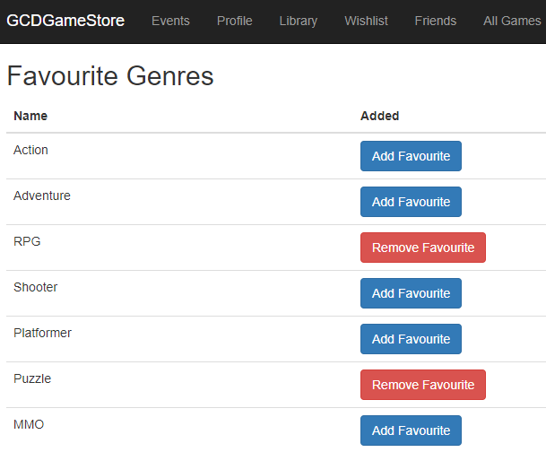

TESTER FEEDBACK:

Did you achieve the expected result? YES NO

Additional Comments:

TEST 14 – ADD A FRIEND

(assumes user is already logged in per TEST 9 instructions)

1. Click the “Friends” link in the navigation bar
2. You should see an Index of the current user’s friends. Click the “Add New Friend” link
3. You should see a Create view. Enter “IdleCyborg” into the Friend’s Username field
4. Click the **Create** button

Expected Result:

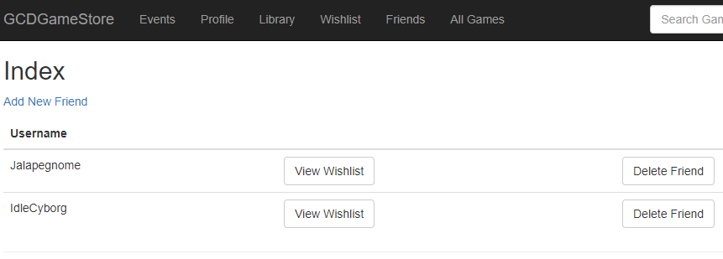

TESTER FEEDBACK:

Did you achieve the expected result? YES NO

Additional Comments:

TEST 15 – VIEW A FRIEND’S WISHLIST

(assumes user is already logged in per TEST 9 instructions)

1. Click the “Friends” link in the navigation bar
2. You should see an Index of the current user’s friends. Navigate to the “Jalapegnome” row and click the **View Wishlist** button

Expected Result:

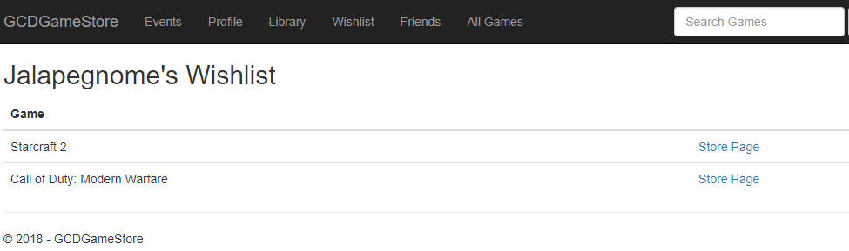

TESTER FEEDBACK:

Did you achieve the expected result? YES NO

Additional Comments:

TEST 16 – ADD DIGITAL VERSION OF GAME TO CART

(assumes user is already logged in per TEST 9 instructions)

1. Click the “Library” link in the navigation bar
2. You should see the current user’s library (it should be empty)
3. Click “All Games” link in the navigation bar
4. Navigate to the “Minecraft” row and click the “Store Page” link
5. Click the **Add to Cart** button for the *digital* version of the game
6. Click the “Cart” link in the navigation bar

Expected Result:

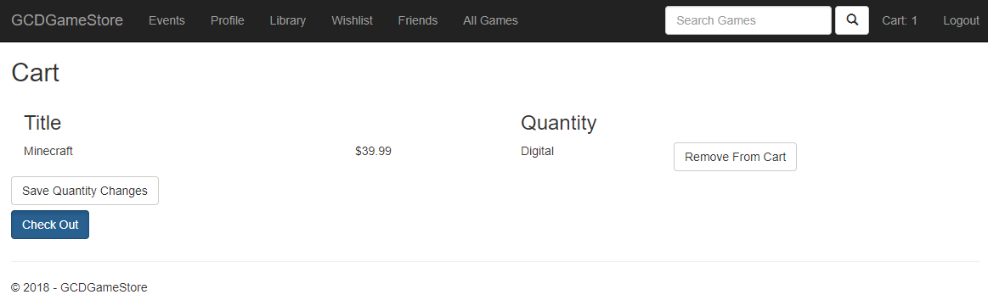

TESTER FEEDBACK:

Did you achieve the expected result? YES NO

Additional Comments:

TEST 17 – SUBMIT ORDER

(assumes user has added game to cart per TEST 16 instructions)

1. Click the “Cart” link in the navigation bar
2. You should see the current user’s cart (it should contain one title). Click the **Check Out** button
3. Hit the **Submit Order** button

Expected Results:

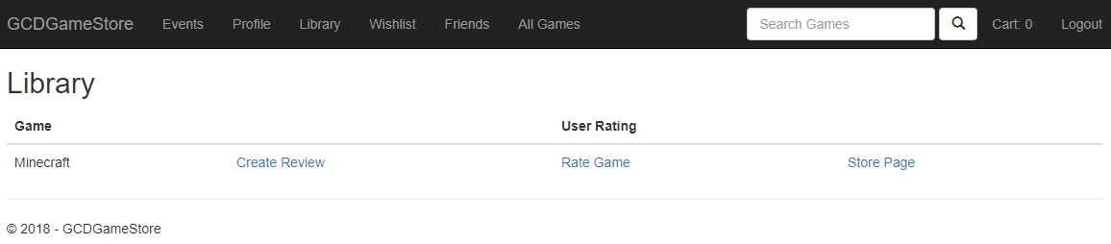

TESTER FEEDBACK:

Did you achieve the expected result? YES NO

Additional Comments:

TEST 18 – SUBMIT ORDER FOR PHYSICAL VERSION OF GAME

(assumes user is already logged in per TEST 9 instructions and has submitted order per TEST 17 instructions)

1. Click the “All Games” link in the navigation bar
2. Navigate to the “Starcraft 2” row and click the “Store Page” link
3. Click the **Add to Cart** button for the *physical* version of the game
4. Click the “Cart” link in the navigation bar
5. You should see the current user’s cart (it should contain one title). Click the **Check Out** button
6. Hit the **Submit Order** button

Expected Results:

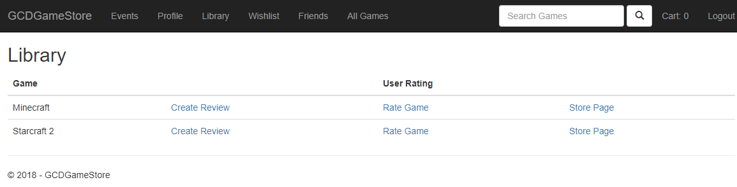

TESTER FEEDBACK:

Did you achieve the expected result? YES NO

Additional Comments:

TEST 19 – RATE GAME

(assumes user is already logged in per TEST 9 instructions and has submitted orders per TEST 17 and TEST 18 instructions)

1. Click the “Library” link in the navigation bar
2. Navigate to the “Starcraft 2” row and click the “Rate Game” link
3. Navigate to the “Rating (1-5)” and enter a value of 5
4. Click the **Create** button

Expected Results:

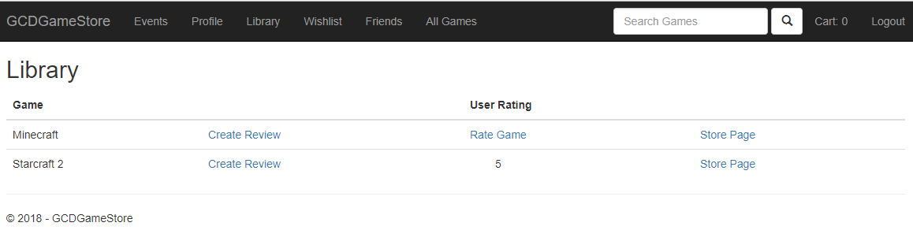

TESTER FEEDBACK:

Did you achieve the expected result? YES NO

Additional Comments:

THIS CONCLUDES TESTING OF THE MEMBER PORTAL

PLEASE LOGOUT BY CLICKING **LOGOUT** IN THE UPPER-RIGHT CORNER OF THE NAVIGATION BAR

TEST 20 – VERIFY and SHIP NEW PHYSICAL ORDER

1. Click “Employees” link in navigation bar
2. Enter “Mike” in the Username field
3. Enter “password” in the Password field
4. Click the **Login** button
5. Click the “Pending Shipments” link in the navigation bar
6. Navigate to the bottom-most row in the Pending Shipments list and click the **Begin Processing** button
7. Click the **Shipped** button

Expected Results:

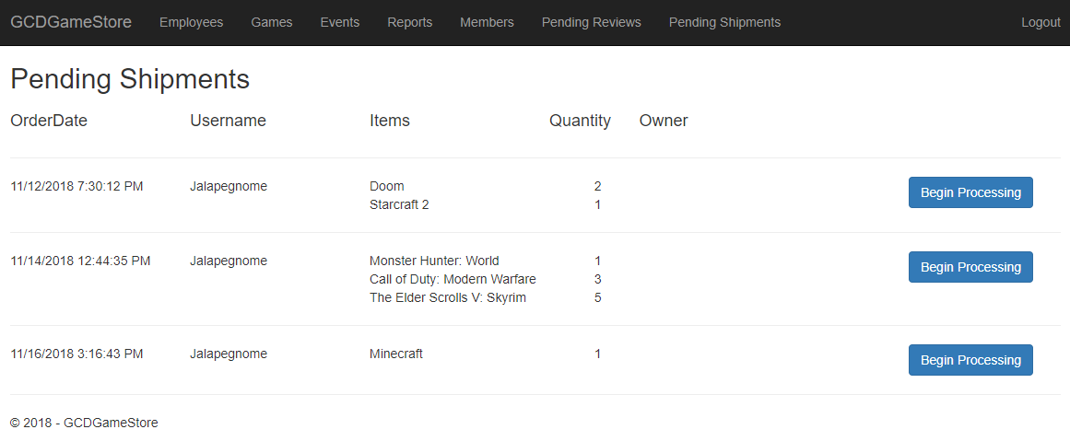

TESTER FEEDBACK:

Did you achieve the expected result? YES NO

Additional Comments:

**THANK YOU! THIS CONCLUDES SYSTEM TESTING FOR THE GCDGAMESTORE APPLICATION**