1. Go to [this website](https://www.xilinx.com/support/download/index.html/content/xilinx/en/downloadNav/vivado-design-tools/archive.html) and download the “Self Extracting Web Installer” for the latest version available. (This will prompt you to create an account & a name and address verification)

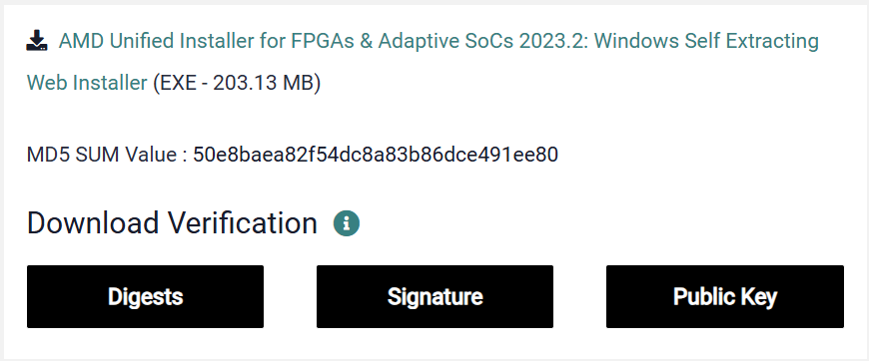

1. Run the downloaded file
2. This will take you to a welcome screen, click “Next”. Then it takes you to a sign-in screen. Enter your information and select “Download and Install Now”, then click “Next”.
3. This will take you to a “Select Product to Install” screen. Make sure you ONLY select “Vivado”. Click “Next”.

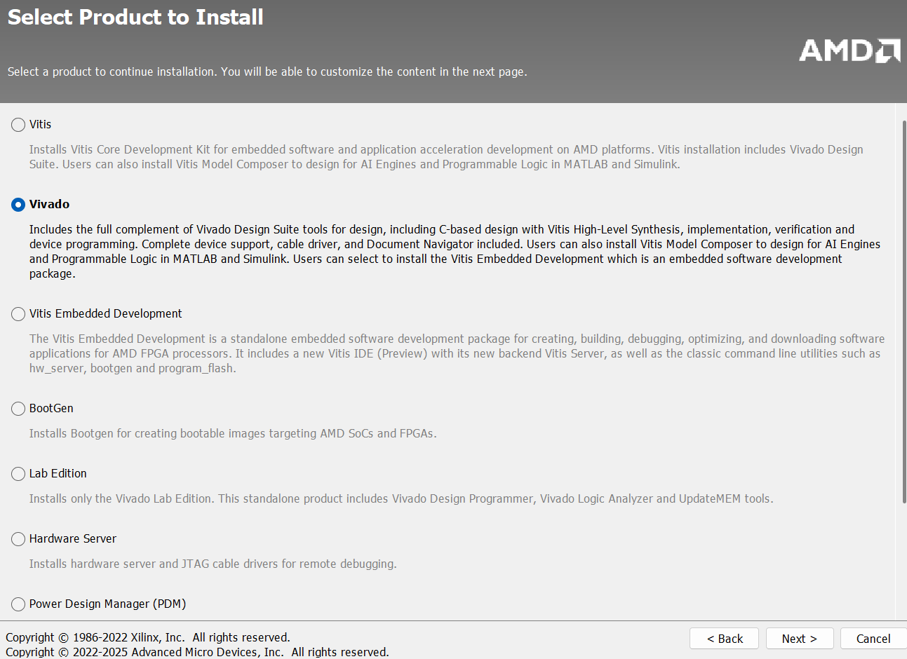

1. This will take you to a “Select Edition to Install” screen. Select “Vivado ML Standard”. Click “Next”.

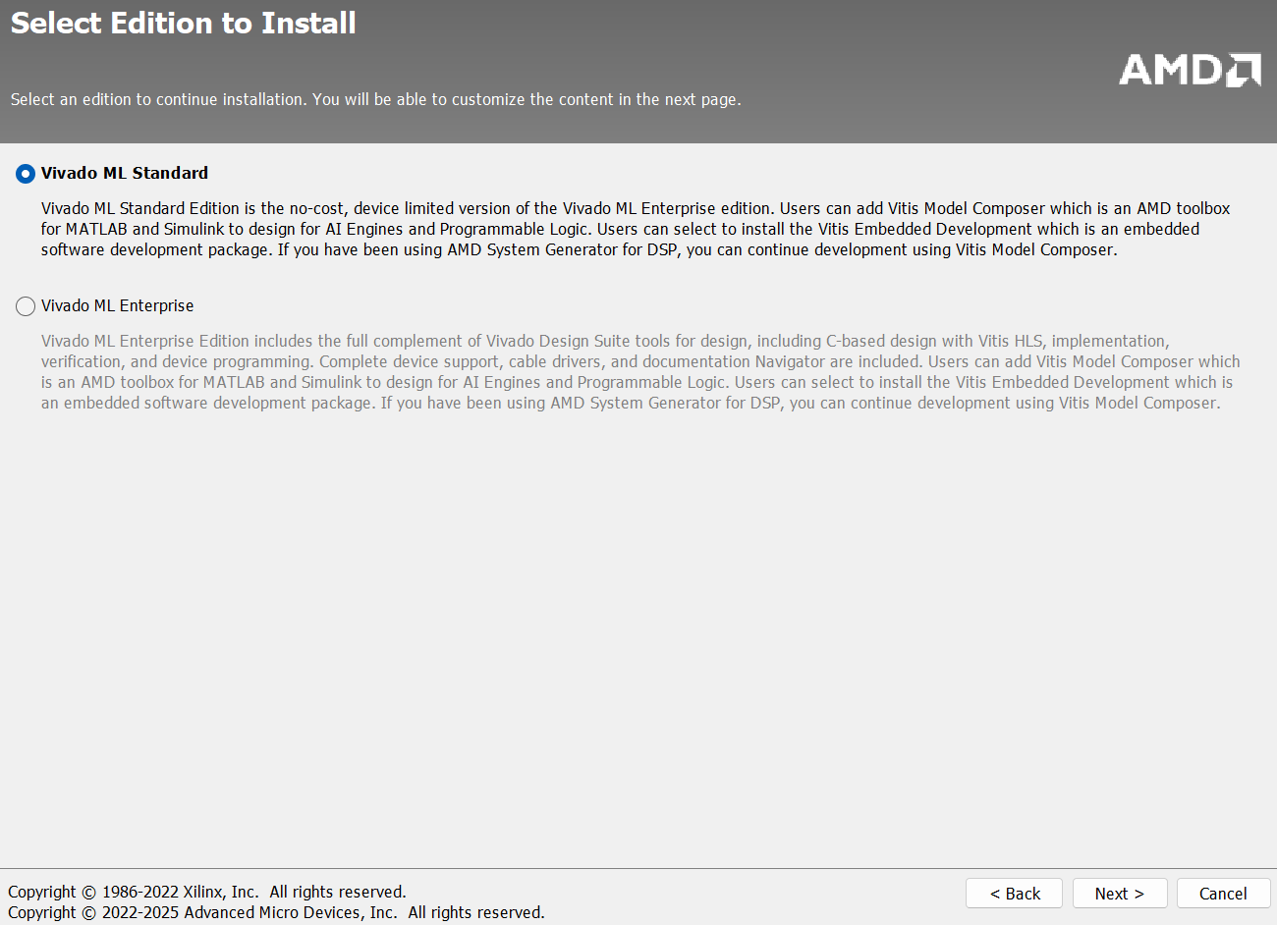

1. This will take you to a selection page. Match your selections with the image provided:

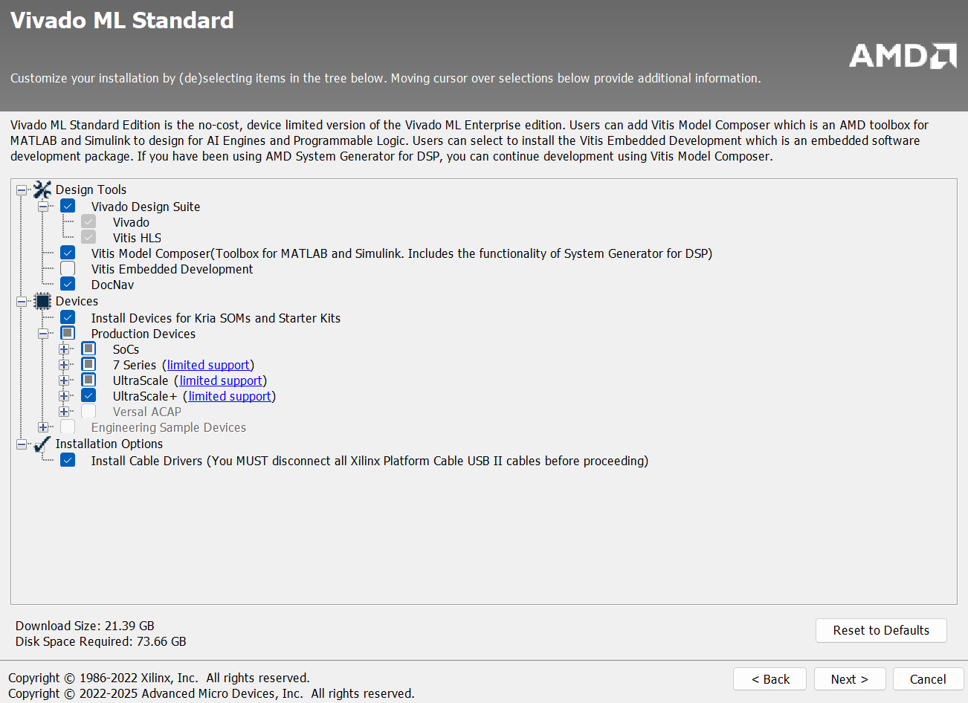

1. This will take you to a “License Agreements” page. Select “I Agree” for all, then click “Next”.
2. This will take you to a “Select Destination Directory” page. Enter your desired directory and then click next. (Most will just leave the default selection). Click “Next”
3. This will take you to an “Installation Summary” page. Click “Install”

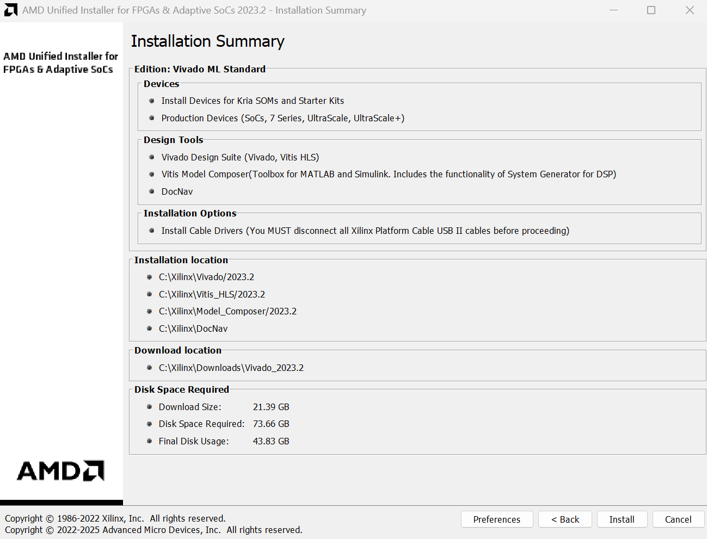

**Testing Vivado**

1. Open Vivado (should be an icon on your desktop). Should take you to a screen like this:

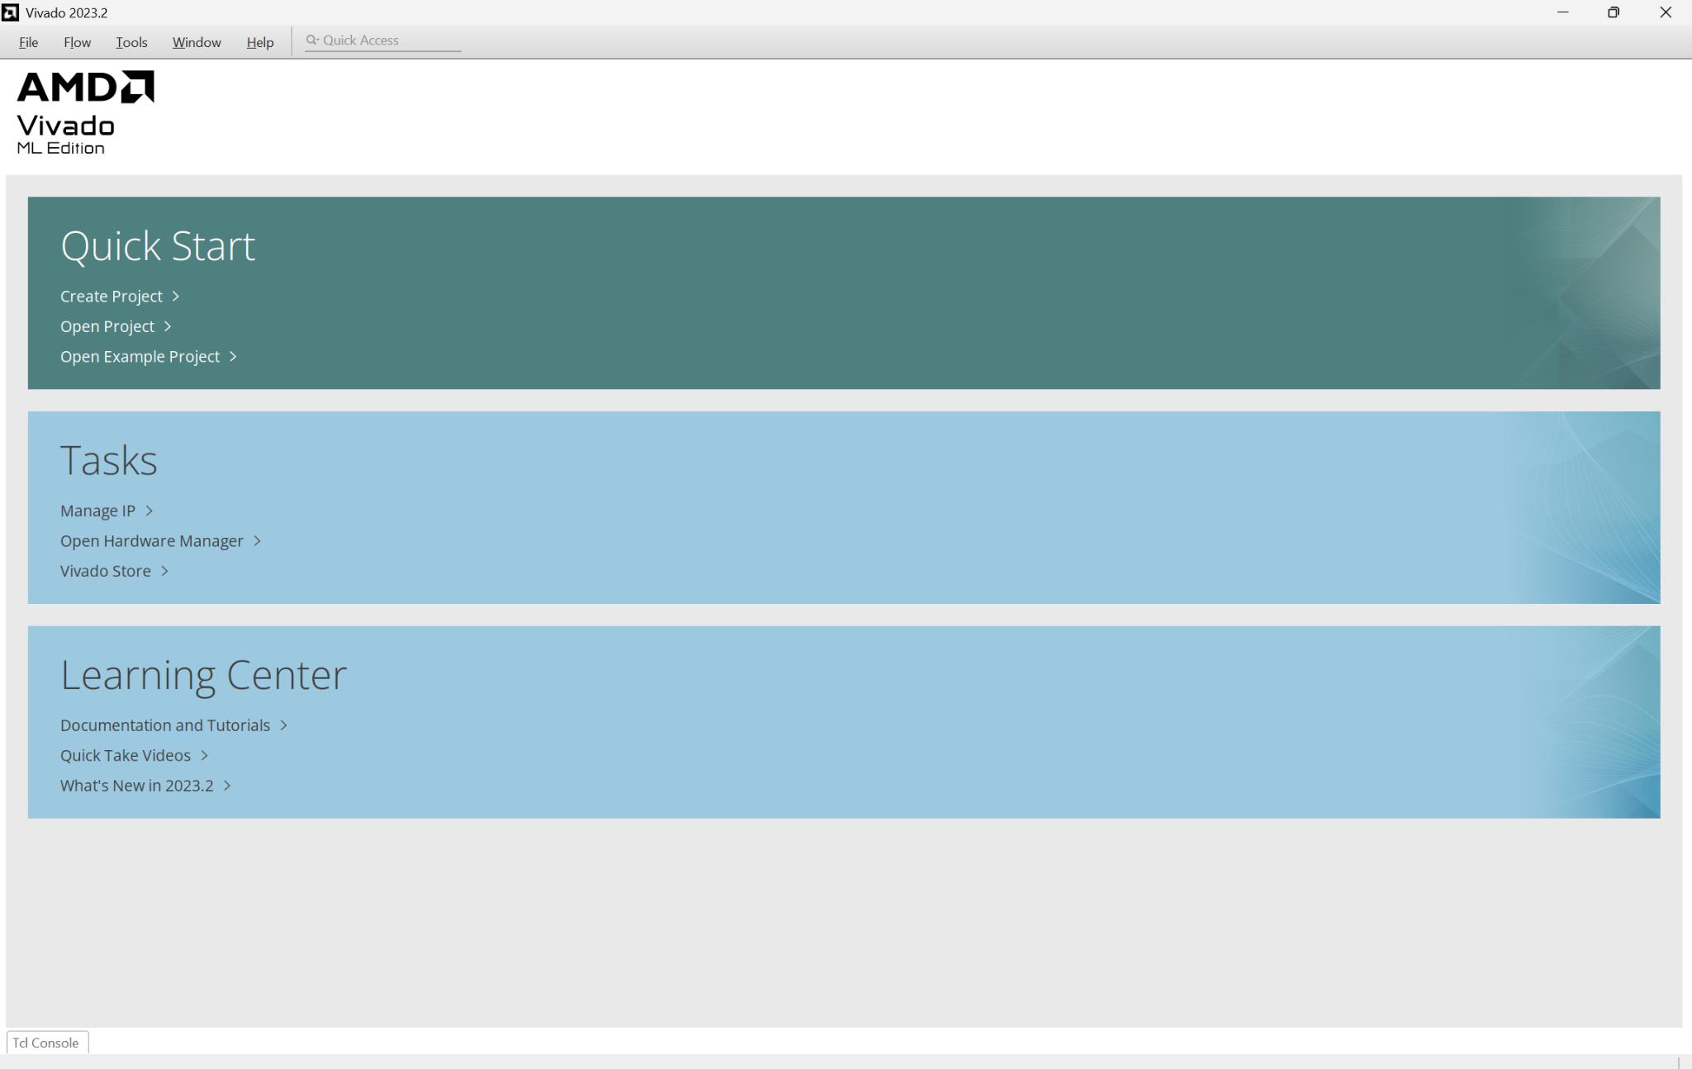

1. Select “Create Project” under Quick Start, click next, and name your project “hello_world”. Should look like this:  
   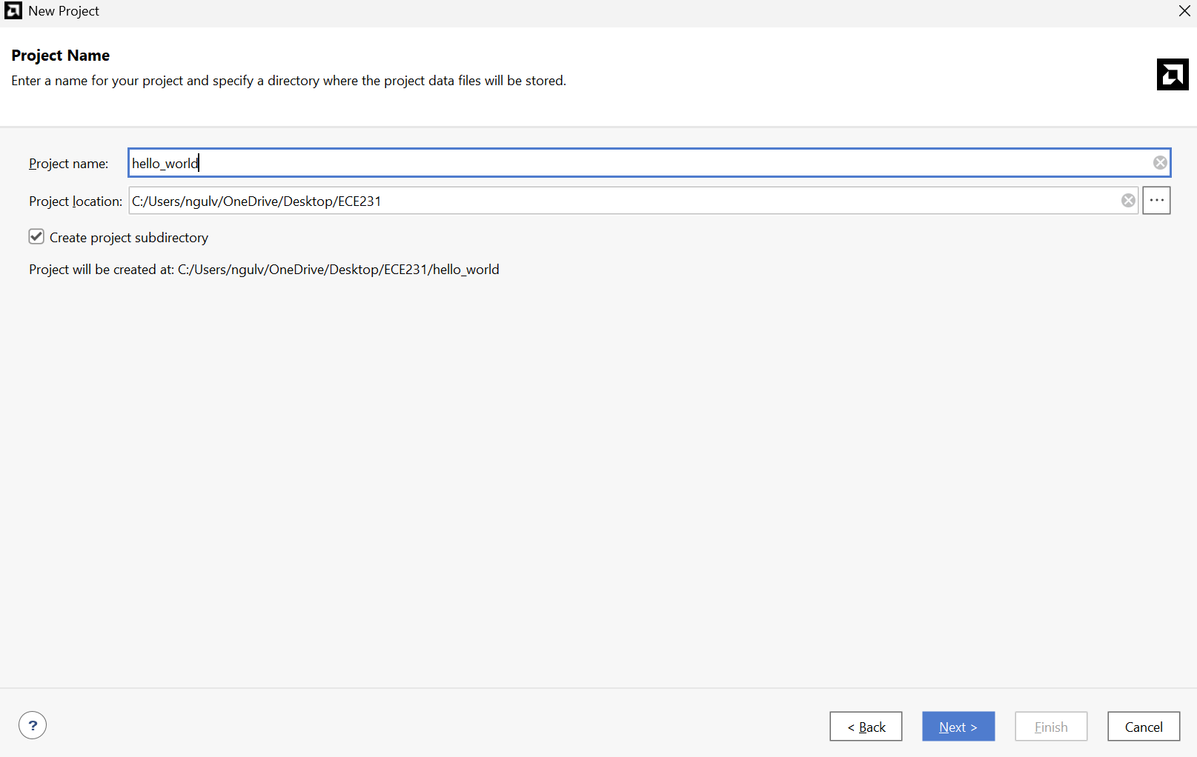
2. Choose RTL Project (Don’t Specify Souces):  
   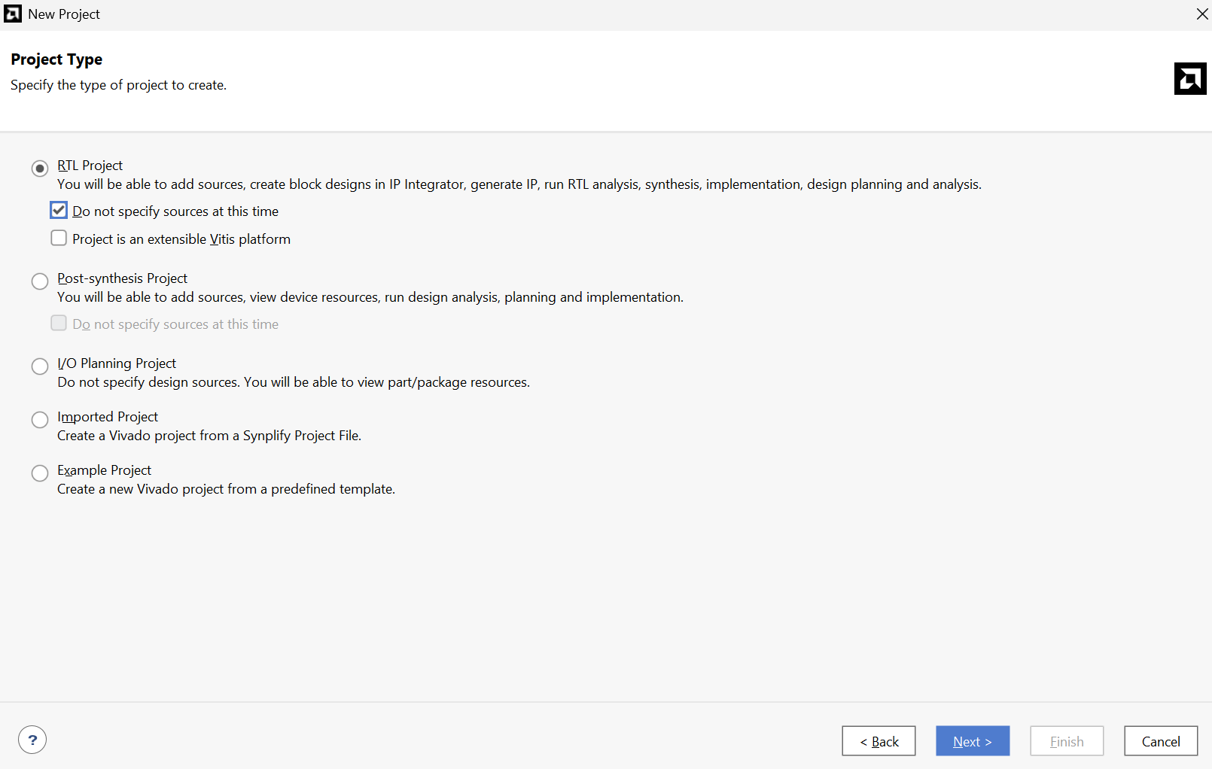
3. Leave the next page as default, and select next, then finish:  
   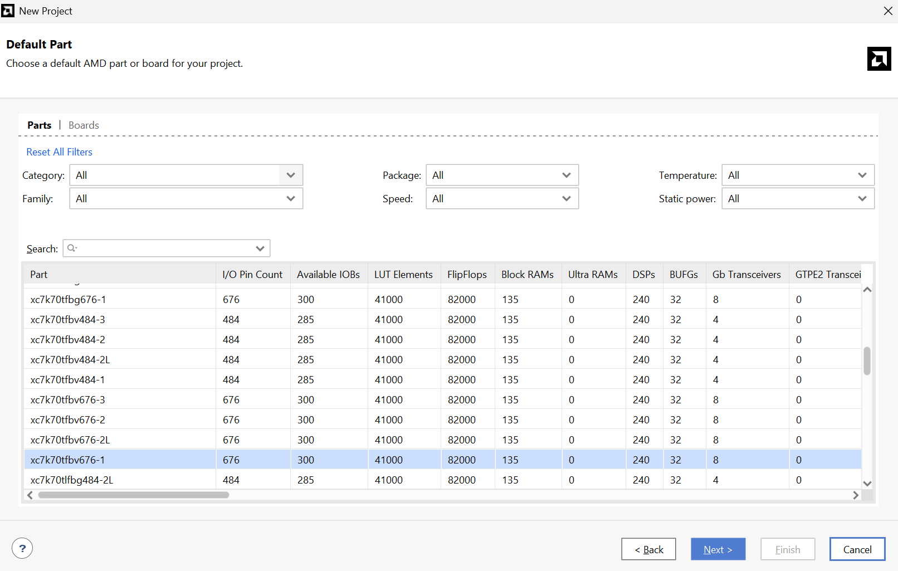
4. Add Your Hello World SystemVerilog File
   1. In the Flow Navigator (left panel), click Add Sources.
   2. Choose Add or Create Simulation Sources.  
      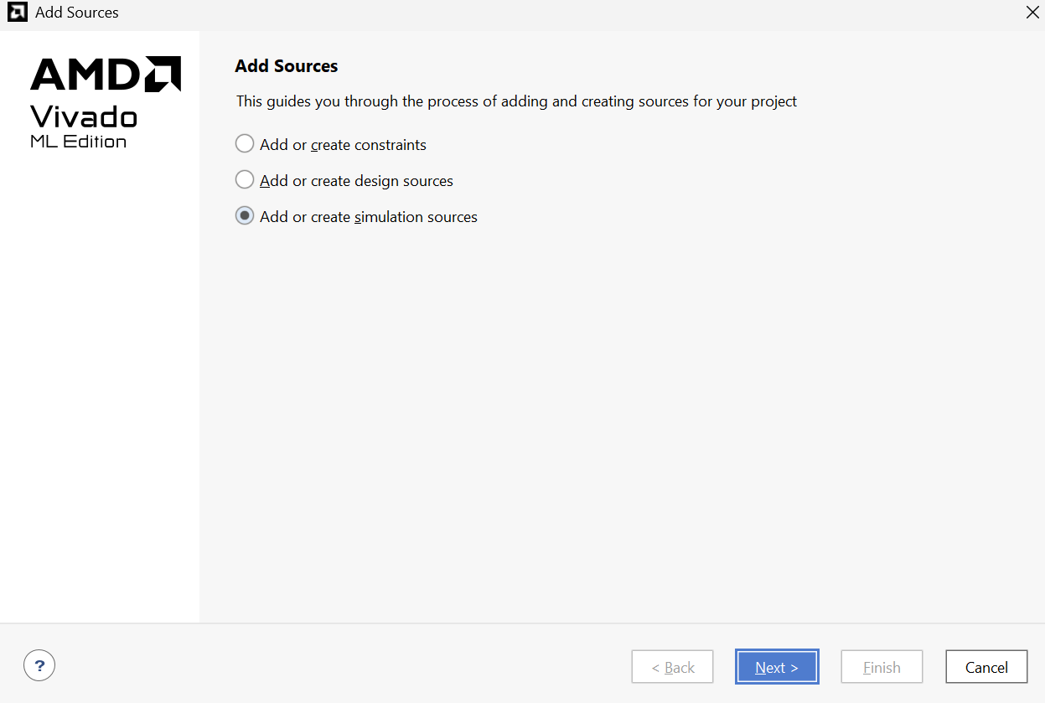
   3. Click Create File.  
      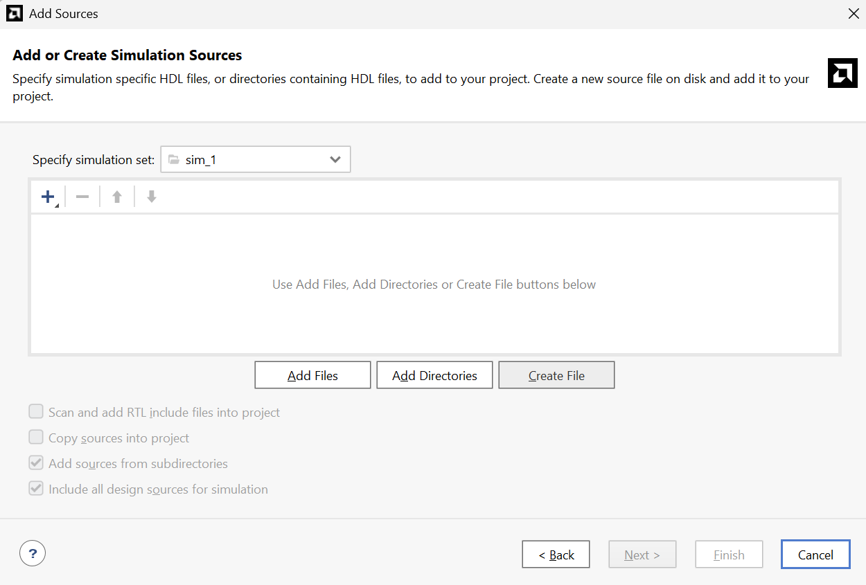
   4. File type: SystemVerilog
   5. File name: hello.sv
   6. Click OK.  
      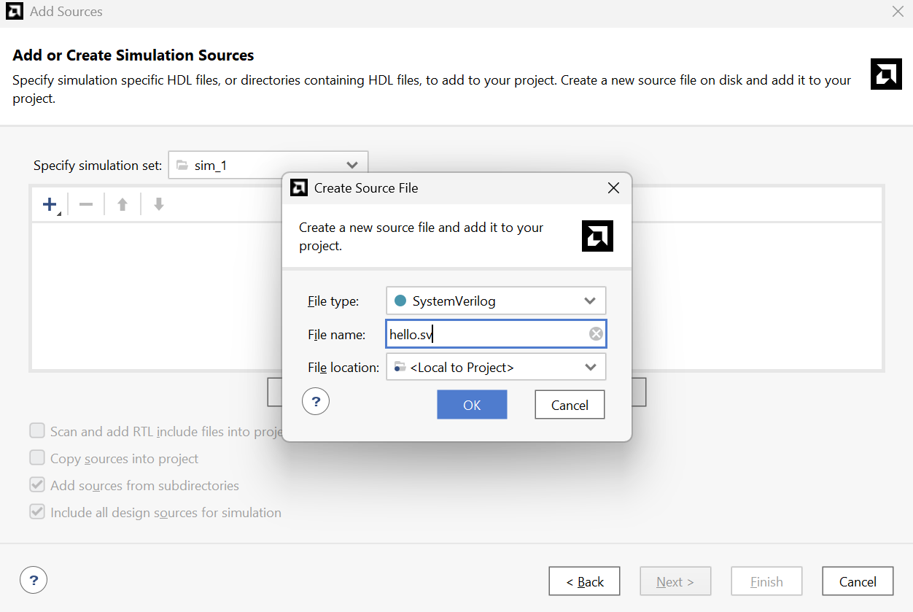
   7. Select the new file in the list and click Finish.  
      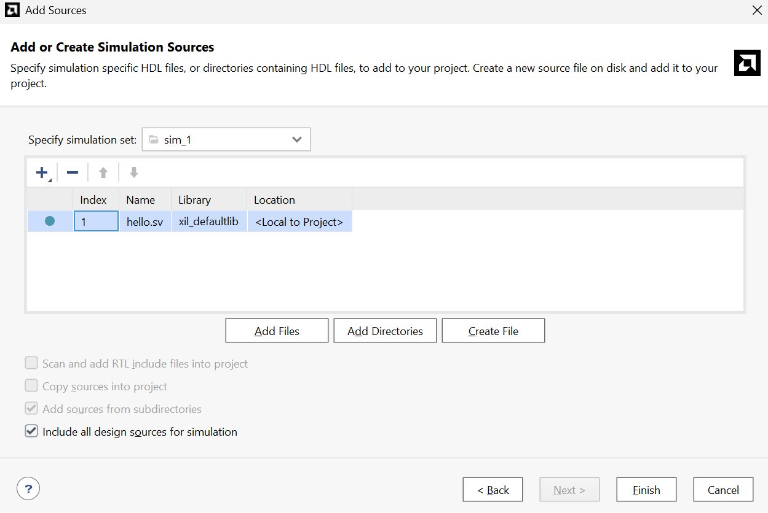
5. Double click hello.sv in Sources  
   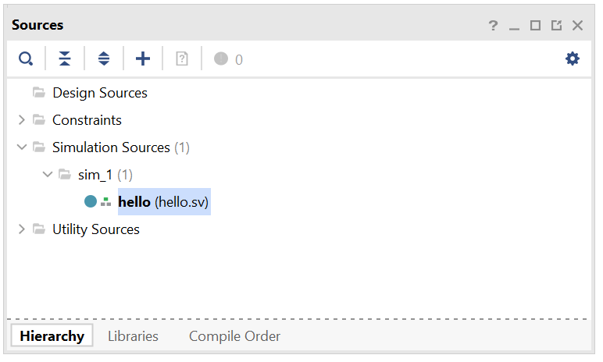
6. This will open the hello.sv file, then paste the following code in:

module hello;

initial begin

$display("Hello, World!");

$finish;

end

endmodule  
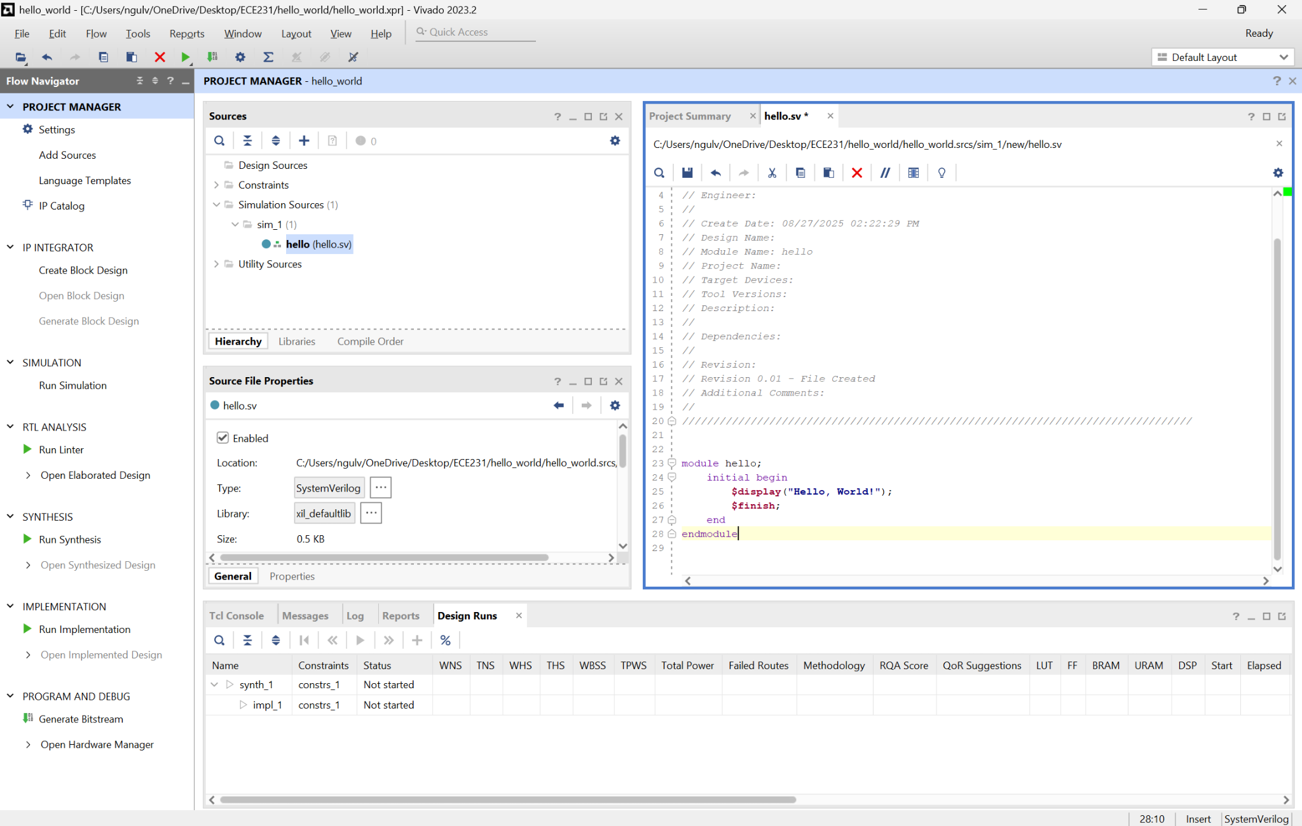

1. In Flow Navigator (left panel), under Simulation, click Run Simulation → Run Behavioral Simulation.  
   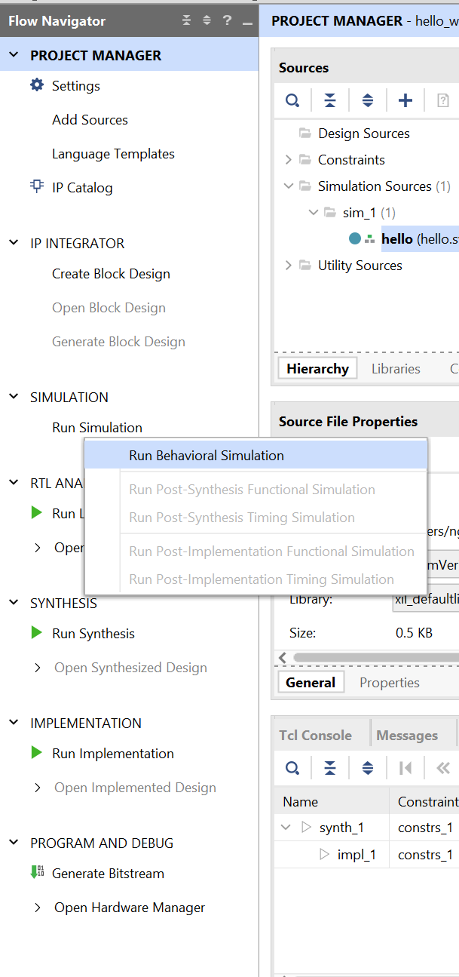
   1. If you get an error message saying “C:/Users/ngulv/OneDrive/Desktop/ECE231/ hello_world/hello_world.cache/wt' already exists, is a directory, but is not writable.” - Create a new folder called ECE231 in another place without OneDrive syncing and follow the instructions again.
2. In the TCL Console, you should see “Hello, World!”

