**Manual for ANIMATIVITY**

**Brief Introduction:**

***ANIMATIVITY*** stands for ANIsotropic MATlab ReflectIVITY, which reveals the function of this software package as computation of the synthetic seismograms after seismic wave propagation through horizontally multi-layered anisotropic medium in different parameterizations.

1) input: This software package requires three different input .txt files which can separate the users from the inside of the package. Users are supposed to modify or generate the contents of the input files with fixed file names and required formats.

* setup.txt: This .txt file contains the environment setup information. Users are expected to provide the following three pieces of information in one line. From left to right are:

Full path of the target file, site name, model input format (either ‘txt’ or ‘mat’)

An example is shown below:

~/Desktop/QM76 QM76 txt

* info.txt: This .txt file serve as the metadata file, in this file, each line specifies a record of metadata. Each column stands for one parameter, from left to right, separated using tab as delimiter, they are:

Site name, depth of the source/event in km, distance of the event in degree, back azimuth of the event in degree, sampling rate in seconds, duration of the record, type of the source function (1-sin2; 2-sincos), wave length of the source function in seconds, type of the incoming wave/polarization (P, SV, SH), duration of the synthetic records that users would like to plot in seconds (by default, plotting starts from 0 s when the incident wave impinges to the top of the half space, ends at the time specified by the user).

An example is shown below:

QM76 10 90 45 0.05 200 1 1 P 50

QM76 20 60 90 0.05 200 1 1 P 50

In the first line, it means that users are generating synthetics at site ‘QM76’, the event is 10-km deep, 90° away and has a back azimuth of 45°. In the synthetics, the time interval is 0.05 s and the duration of the record is 200 s. In this simulation, the input is a P wave, the source function is 1 s long, and it is sin2. After the simulation, records between 0 – 50 s will be displayed.

* Model-*.txt: This txt file serves as the model file where users can choose a parameterization and describe their models accordingly.

The first line is a description of choice of parameterization, users are supposed to select one of the four following options with exactly the same spelling.

-BackusNotation

-36-componentTensor

-81-componentTensor

-ThomsenNotation

Users are supposed to list the parameters from top to bottom. The depth at the top has to be 0 which stands for the free surface and the depth at the bottom has to be the top of the half space. For each line, users have to provide the numbers of the parameters to describe the corresponding layer in different parameterizations. At the beginning of each line, the depth is specified as the top of the anisotropic layer and the depth of the bottom of the anisotropic layer will be at the beginning of next line. For the half space, users need to fill the anisotropic parameters to be zero.

-Backus Notation

the depth of the interface (m), isotropic P wave velocity (m/s), isotropic S wave velocity (m/s), density (kg/m3), tilt angle of the symmetry axis (°), strike angle of the symmetry axis (°), B and E;

BackusNotation

0 6000 3450 2650 80 90 0.02 0.02

40000 6600 3650 2900 80 90 0.02 0.02

140000 8300 4500 3200 90 0 0 0

-36-componentTensor

the depth of the interface (m), isotropic P wave velocity (m/s), isotropic S wave velocity (m/s), density (kg/m3), three Euler angles (°), 6 by 6 elastic tensor (Gpa).

36-componentTensor

0 8300 4600 2700 20 30 40

$$\begin{matrix}\begin{matrix}320.5 & 68.2 & 71.6 \\ 68.2 & 196.5 & 76.8 \\ 71.6 & 76.8 & 233.5\end{matrix} & \begin{matrix}0 & 0 & 0 \\ 0 & 0 & 0 \\ 0 & 0 & 0\end{matrix} \\ \begin{matrix}0 & 0 & 0 \\ 0 & 0 & 0 \\ 0 & 0 & 0\end{matrix} & \begin{matrix}64 & 0 & 0 \\ 0 & 77 & 0 \\ 0 & 0 & 78.7\end{matrix}\end{matrix}$$

20000 8300 4600 2700 40 50 60

$$\begin{matrix}\begin{matrix}320.5 & 68.2 & 71.6 \\ 68.2 & 196.5 & 76.8 \\ 71.6 & 76.8 & 233.5\end{matrix} & \begin{matrix}0 & 0 & 0 \\ 0 & 0 & 0 \\ 0 & 0 & 0\end{matrix} \\ \begin{matrix}0 & 0 & 0 \\ 0 & 0 & 0 \\ 0 & 0 & 0\end{matrix} & \begin{matrix}64 & 0 & 0 \\ 0 & 77 & 0 \\ 0 & 0 & 78.7\end{matrix}\end{matrix}$$

40000 8300 4600 3300 0 0 0

-81-componentTensor

the depth of the interface (m), isotropic P wave velocity (m/s), isotropic S wave velocity (m/s), density (kg/m3), three Euler angles (°), 9 by 9 elastic tensor (Gpa).

0 6000 4600 2700 20 30 40

put the 81-component tensor using a 9 by 9 matrix in the following format

C11 C12 C13 C14 C15 C16 C17 C18 C19

C21 C22 C23 C24 C25 C26 C27 C28 C29

C31 C32 C33 C34 C35 C36 C37 C38 C39

C41 C42 C43 C44 C45 C46 C47 C48 C49

C51 C52 C53 C54 C55 C56 C57 C58 C59

C61 C62 C63 C64 C65 C66 C67 C68 C69

C71 C72 C73 C74 C75 C76 C77 C78 C79

C81 C82 C83 C84 C85 C86 C87 C88 C89

C91 C92 C93 C94 C95 C96 C97 C98 C99

20000 6000 4600 2700 40 50 60

put the 81-component tensor using a 9 by 9 matrix in the following format

C11 C12 C13 C14 C15 C16 C17 C18 C19

C21 C22 C23 C24 C25 C26 C27 C28 C29

C31 C32 C33 C34 C35 C36 C37 C38 C39

C41 C42 C43 C44 C45 C46 C47 C48 C49

C51 C52 C53 C54 C55 C56 C57 C58 C59

C61 C62 C63 C64 C65 C66 C67 C68 C69

C71 C72 C73 C74 C75 C76 C77 C78 C79

C81 C82 C83 C84 C85 C86 C87 C88 C89

C91 C92 C93 C94 C95 C96 C97 C98 C99

40000 8300 4600 3300 0 0 0

Orders of the 81-component tensor have to be as below (each number stands for a permutation of i, j, k, l)

1111 2111 3111 1211 2211 3211 1311 2311 3311

1121 2121 3121 1221 2221 3221 1321 2321 3321

1131 2131 3131 1231 2231 3231 1331 2331 3331

1112 2112 3112 1212 2212 3212 1312 2312 3312

1122 2122 3122 1222 2222 3222 1322 2322 3322

1132 2132 3132 1232 2232 3232 1332 2332 3332

1113 2113 3113 1213 2213 3213 1313 2313 3313

1123 2123 3123 1223 2223 3223 1323 2323 3323

1133 2133 3133 1233 2233 3233 1333 2333 3333

-Thomsen Parameters

the depth of the interface (m), isotropic P wave velocity (m/s), isotropic S wave velocity (m/s), density (kg/m3), epsilon (dimensionless), gamma (dimensionless), delta (dimensionless).

ThomsenNotation

0 6000 4600 2700 – 0.005 0.005 0.015

20000 6000 4600 2700 – 0.005 0.005 0.015

40000 8300 6000 3300 0 0 0

Notice that for the convenience of the users, they can generate multiple models by specifying a parameter called Nmodel to be the model they want and prepare the model-*.txt file correspondingly. ‘*’ here stands for a number.

2) output: This software will generate three types of output files (.pdf and .mat are by default whereas .txt is optional).

* .pdf: For each 3-component record, corresponding figures will be generated and automatically saved as .pdf files with the back azimuth included in the name. For instance, ’QM76-0-45.pdf’ stands for the records from a back azimuth of 45° using the model stored in file ‘model-0.txt’ at site QM76.

An example of figure is displayed as below:

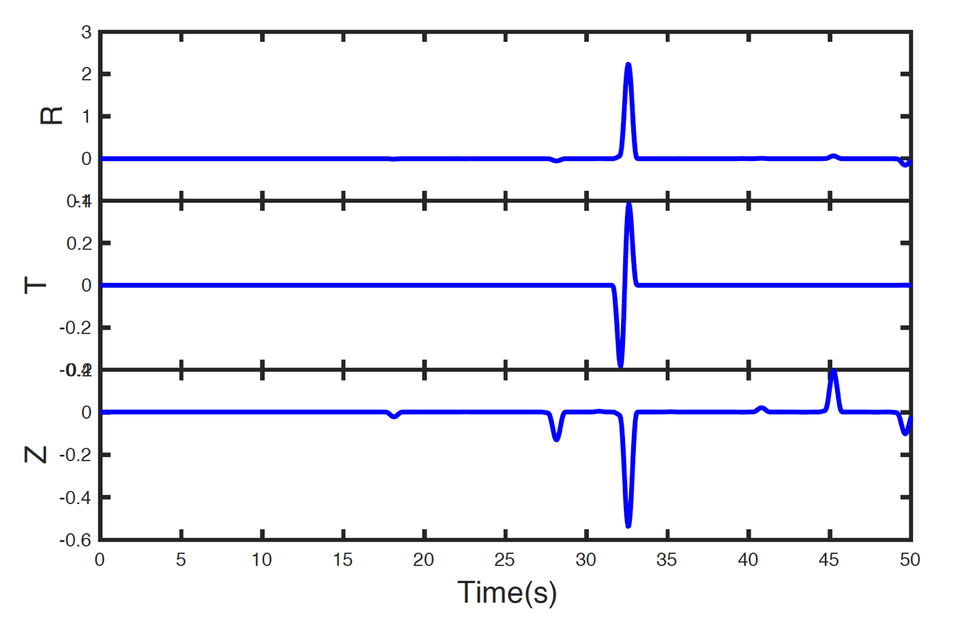

* .mat: the waveform.mat file contains all the information of the records and it is automatically saved in a .mat object. When click on it, each field stands for one parameter:





From left to right are: Site name, depth of the source/event in km, distance of the event in degree, back azimuth of the event in degree, sampling rate in seconds, duration of the record, type of the source function (1-sin2; 2-sincos), wave length of the source function in seconds, type of the incoming wave/polarization (1-P; 2-SV; 3-SH), duration of the synthetic records that users would like to plot in seconds (by default, plotting starts from 0 s when the incident wave impinges to the top of the half space, ends at the time specified by the user), time series with the corresponding sampling rate, model parameters, data of R component, data of T component, data of Z component, R component naming convention (‘site name-depth-phase velocity-back azimuth-component.txt’), T component naming convention (‘site name-depth-phase velocity-back azimuth-component.txt’), Z component naming convention (‘site name-depth-phase velocity-back azimuth-component.txt’).

Another .mat file called rawmodel.mat will be automatically generated along with the waveform.mat file. This file saves the model that is used in computation. Users can use this .mat files directly as input next time without the txt file. An example is provided below (Backus Notation is adopted in this example):

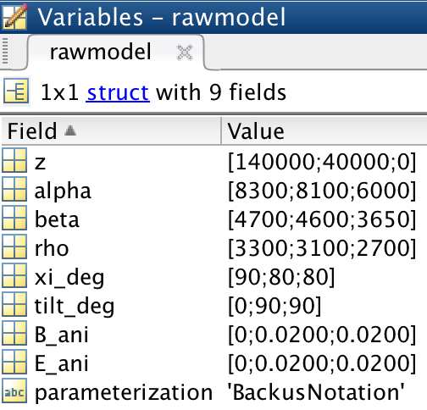

* .txt (Optional): Users can choose to save the corresponding components with the corresponding naming conventions (‘site name’-‘depth’-‘phase velocity’-‘back azimuth’-‘component’.txt’). For instance, the following command line will save the time and R component of the first record in a .txt file.

load waveform.mat

dlmwrite(sprintf('%s', wvfm(1).Rname),wvfm(1).time, wvfm(1).R);

Correspondingly, users can output other components, for instance T and Z components of other records by using the following commands.

dlmwrite(sprintf('%s', wvfm(3).Tname),wvfm(3).time, wvfm(3).T);

dlmwrite(sprintf('%s', wvfm(4).Zname),wvfm(4).time, wvfm(4).Z);

**Procedure:**

**I. Add ANIMATIVITY to path:**

1. Open your Matlab platform, choose the ‘Home’ tab and select ‘Set path’ marked in the red rectangle.

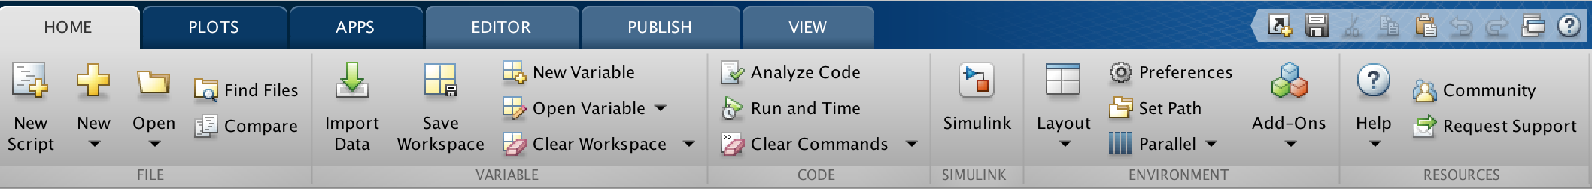

When the following window pop out, click ‘Add folder’

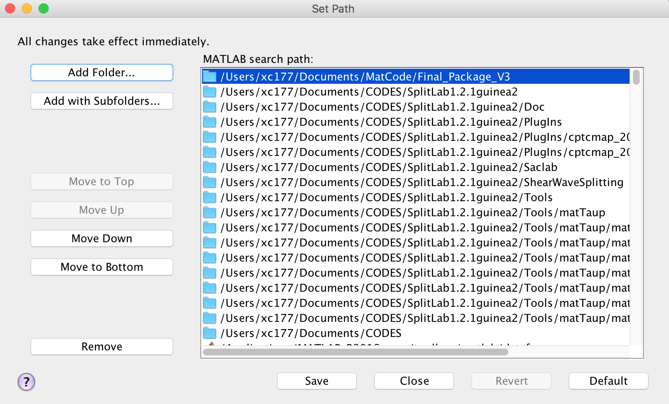

Choose the ANIMATIVITY folder and click ‘Save’. Then ANIMATIVITY is added to path.

1. If users cannot add ANIMATIVITY folder to path following the instructions above, another way of adding path is provided as below.

Make a file called startup.m in a folder on Matlab path. Open startup.m and add the following command:

addpath(genpath('~/Documents/ANIMATIVITY'));

Put the full path of the ANIMATIVITY folder in the quote.

Restart Matlab and you will find ANIMATIVITY in path.

**II. Set up the environment and make models**

1. In your target directory (for instance: ~/Desktop), make a folder (for instance: QM76) where you would like to save all your inputs and outputs and take down its full path (For instance: ~/Desktop/QM76). Then make a subfolder called ‘Input’ in the corresponding directory (Notice that users cannot change the name of the subfolder here, for instance: ~/Desktop/QM76/Input). Go into ‘Input’ and copy the three input txt files (setup.txt, info.txt, model-*.txt) into that folder. Open ‘setup.txt’ and copy the full path you just take down (~/Desktop/QM76) to the first column. Then you can modify the models and metadata based on your needs.

2. Open your Matlab platform and go to your directory where you saved the ‘setup.txt’ file (in this case, ~/Desktop/QM76/Input). In the prompt window, type in ‘TimeSeries’, then the computation will start.

If you do not want to use the Matlab GUI, you can also try to run the code from the terminal. Open your terminal and type in the following command lines:

‘cd (put the full path where you saved the ‘setup.txt file, in this case it is ~/Desktop/QM76/Input)’

matlab -nodisplay -nodesktop -r "TimeSeries; exit;"

**III. Check the output**

1. Wait till the code finishes running, notice that figures may pop up when the code is running. Once it is done, check your target folder (~/Desktop/QM76), a new folder called ‘Output’ will appear and it contains all your outputs. Below is an example of output, .txt and .pdf files may vary upon users’ customizations.

