AFC LEARNING PATHWAYS
Structured AI Training, Certification and Progression Framework
Purpose. This document presents a practical learning pathway for AFC staff and leadership, showing how participants can progress from short, role-based AI courses into examinable national qualifications, sector-focused professional competence certificates and advanced AI degree progression.
AFC value proposition. The pathway is designed to support immediate productivity gains while creating a longer-term skills pipeline for AI adoption, governance, automation, analytics and responsible innovation across AFC functions.

1. Proposed AFC Learning Pathway
Level | Programme / Award | AFC Application | Credential
Entry / Awareness | 3-Day UZ Courses | Mastering AI for Professionals, Executives and Directors | Certificate of Completion
Foundation | NFC in Artificial Intelligence | Baseline AI literacy, responsible use, productivity tools and introductory problem solving | HEXCO Qualification
Core Practitioner | NC in Artificial Intelligence | Applied AI, data use, workflow automation and organisational implementation | HEXCO Qualification
Advanced Practitioner | ND in Artificial Intelligence | Advanced AI applications, implementation projects and technical leadership | HEXCO Qualification
Specialisation | Professional Competence Certificates (PCCs) | Sector-specific AI competence for areas such as procurement, finance, cybersecurity, HR, law, marketing, agriculture, mining and operations | HEXCO Professional Competence Certificate
Technical Skills | Technical Certification | Skills-based technical validation for practical AI implementation roles | HEXCO Qualification / PCC

2. Learning Pathway Diagram
The diagram below converts the AFC pathway into a progression model, showing the relationship between short courses, national qualifications, sector PCCs, technical certification and advanced AI degree progression.
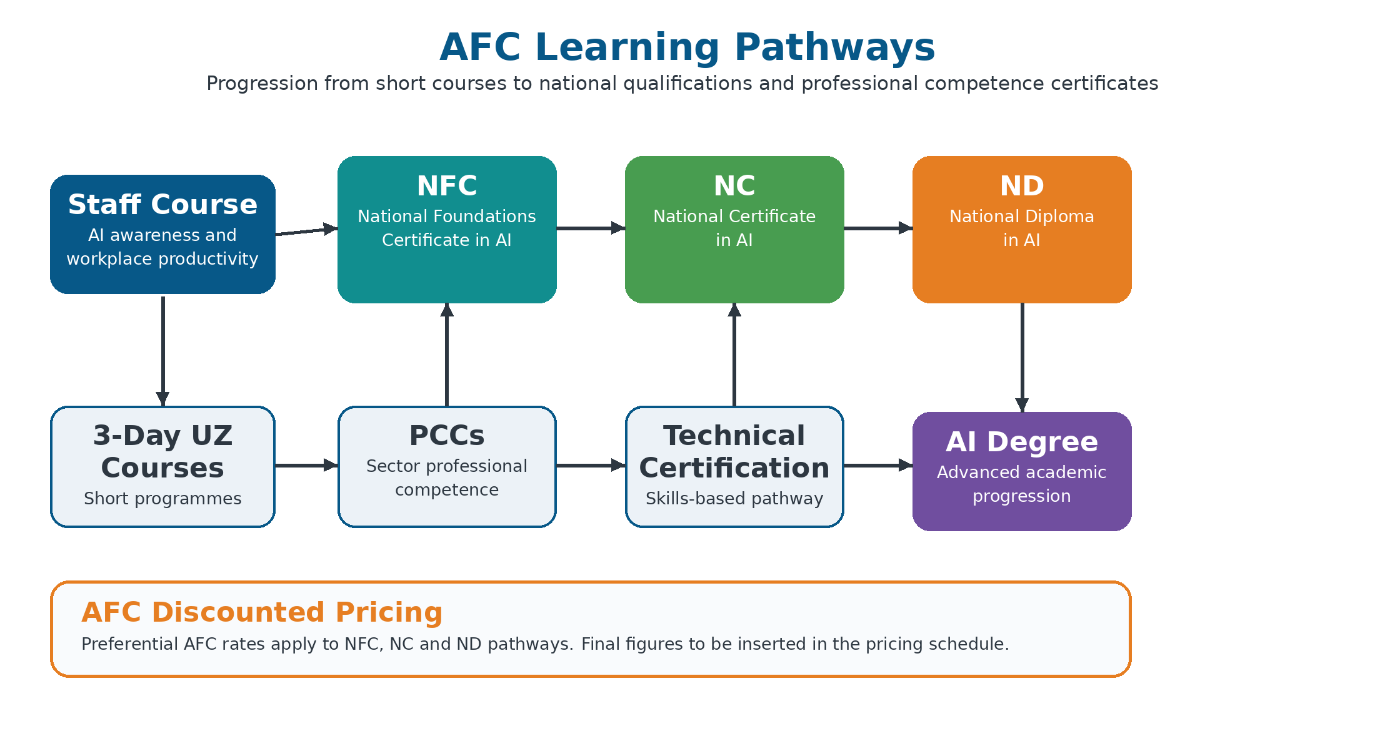

3. AFC Discounted Pricing Structure
Discounted price for AFC. AI Institute Africa will extend preferential AFC pricing for the core progression route, especially NFC, NC and ND. The exact discounted figures should be inserted in the commercial pricing schedule once cohort size, delivery mode and payment terms are confirmed.
Programme | Standard Price | AFC Discount | Discounted AFC Price | Notes
NFC in Artificial Intelligence | To be inserted | Preferential AFC rate | To be inserted | Discount applies to AFC nominated participants
NC in Artificial Intelligence | To be inserted | Preferential AFC rate | To be inserted | Progression option after NFC
ND in Artificial Intelligence | To be inserted | Preferential AFC rate | To be inserted | Advanced practitioner pathway
PCCs / Technical Certification | To be inserted | Preferential AFC rate where applicable | To be inserted | Final price depends on selected specialization
3-Day UZ Courses | To be inserted | AFC cohort rate | To be inserted | For executives, professionals and directors

4. Suggested Implementation Approach
Phase 1: Needs Mapping and Cohort Placement: Map AFC staff groups to suitable learning levels, identify priority departments, and confirm who should start with short courses, NFC, NC, ND, PCCs or technical certification.
Phase 2: Classroom / Instructor-Led Training: Deliver facilitator-led learning to establish AI concepts, productivity use cases, governance principles and practical applications relevant to AFC.
Phase 3: Online Lessons and Guided Practice: Provide structured online learning support, assignments and guided exercises so participants can continue progressing without disrupting core business operations.
Phase 4: Practical Assessment and Certification: Complete practical exercises, assessments, project work or examination requirements leading to the relevant certificate, professional competence certificate or qualification.
Phase 5: Post-Implementation Support: Provide advisory support, learning reports and recommendations for ongoing adoption, skills development and future cohorts.

5. Credential Coverage Referenced from Accreditation Certificates
The full accreditation certificate schedule is contained in the separate accreditation document. For ease of review, the AFC pathway is aligned to the following credential categories.
No. | Category | Certificate / Qualification | Accreditation Body | Certificate Issued
1 | 3-day course | Mastering AI for Professionals | UZ | Certificate of Completion
2 | 3-day course | Mastering AI for Executives | UZ | Certificate of Completion
3 | 3-day course | Mastering AI for Directors | UZ | Certificate of Completion
4 | Examinable | National Foundations Certificate in Artificial Intelligence | HEXCO | Qualification
5 | Examinable | National Certificate in Artificial Intelligence | HEXCO | Qualification
6 | Examinable | National Diploma in Artificial Intelligence | HEXCO | Qualification
7 | Examinable | Technical Certification | HEXCO | Qualification
8 | Examinable | Tourism and Hospitality PCC | HEXCO | Professional Competence Certificate
9 | Examinable | Procurement PCC | HEXCO | Professional Competence Certificate
10 | Examinable | Agriculture PCC | HEXCO | Professional Competence Certificate
11 | Examinable | Banking & Insurance PCC | HEXCO | Professional Competence Certificate
12 | Examinable | Cybersecurity PCC | HEXCO | Professional Competence Certificate
13 | Examinable | Education PCC | HEXCO | Professional Competence Certificate
14 | Examinable | Financial Accounting PCC | HEXCO | Professional Competence Certificate
15 | Examinable | Human Resources PCC | HEXCO | Professional Competence Certificate
16 | Examinable | Law PCC | HEXCO | Professional Competence Certificate
17 | Examinable | Marketing PCC | HEXCO | Professional Competence Certificate
18 | Examinable | Policy, Defence, and Security Operations PCC | HEXCO | Professional Competence Certificate
19 | Examinable | Technical Certification | HEXCO | Professional Competence Certificate
20 | Examinable | Mining PCC | HEXCO | Professional Competence Certificate
Note: Pricing fields are intentionally left editable because the AFC discounted price depends on final cohort numbers, selected pathway mix and delivery terms.

