PROPOSED METHODOLOGY FOR AFC
AI Training, Digital Transformation Enablement, Practical Implementation and Post-Implementation Support
Enhanced methodology focus
This methodology integrates AFC inputs on digital transformation, process improvement alignment, differentiated training streams, hands-on labs, pilot projects, LMS support, change management, AI governance and sustainability documentation.

1. Approach Overview
AI Institute Africa, in partnership with Rubiem Intelligence and the University of Zimbabwe, will adopt a practical, executive-focused and impact-driven methodology designed for AFC's operating environment. The programme is aligned to AFC's digital transformation journey, process improvement work, corporate strategy and AI strategy. It is designed to move participants from awareness and classroom learning into applied practice, pilot implementation and sustained adoption.
The methodology remains structured around four connected phases, now strengthened with banking-relevant capability building, technical environment readiness, change management and measurable implementation outputs:
- Phase 1: Classroom training, training readiness assessment and AFC needs alignment.
- Phase 2: Online lessons, guided assignments, LMS-enabled tracking and knowledge checks.
- Phase 3: Practical exercises, applied workshops and pilot project design using AFC-relevant banking scenarios.
- Phase 4: Post-implementation support, coaching, change management, reporting and sustainability documentation.
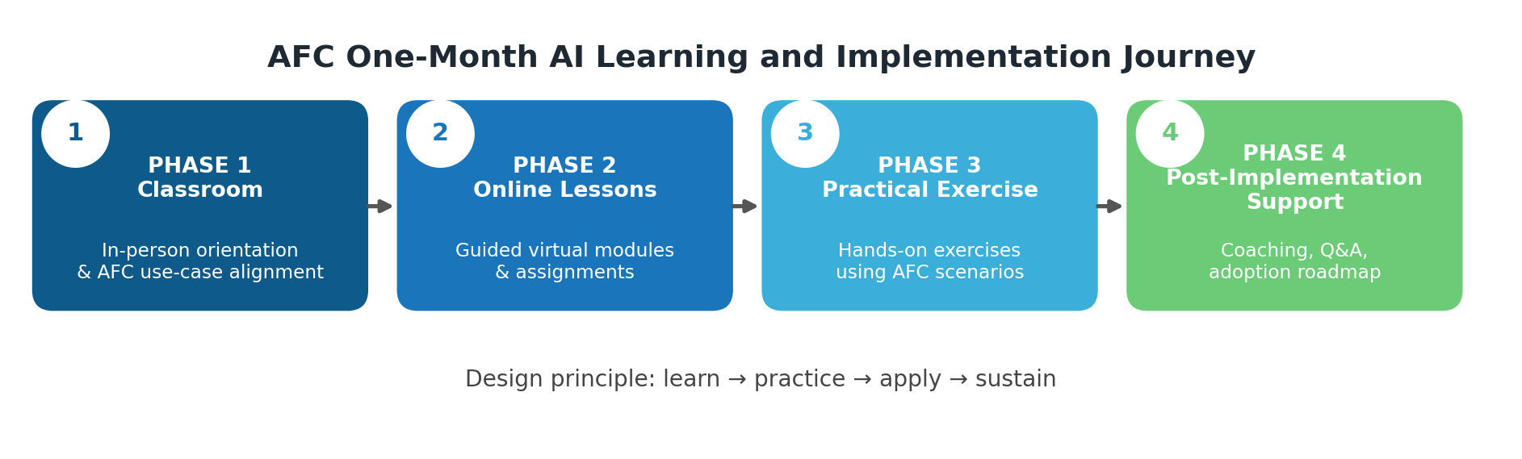

2. AFC Digital Transformation Context
AFC is implementing a structured digital transformation journey aimed at modernizing banking operations, improving efficiency, strengthening governance and enhancing customer experience. The AI training programme will therefore be positioned as the next practical phase of transformation, building on completed process improvement work and converting optimized processes into AI-enabled workflows, automation opportunities and decision-support capabilities.
- The training will dovetail with corporate strategy, digital transformation priorities and the emerging AI strategy.
- Training examples will be grounded in banking operations, governance, customer service, risk, audit, branch operations and support functions.
- Participants will be guided to translate banking business processes into practical AI-driven automation and decision-support use cases.
- The programme will support the identification, design and implementation of three to five AI pilot projects that demonstrate measurable business value.

3. Objectives of the Engagement
- Build sustainable AI and digital transformation skills across Directors, Executive Management and Professional Staff.
- Enable personnel to independently plan, design, implement, deploy and operate AI-enabled solutions integrated with AFC digital transformation priorities.
- Translate banking business processes into practical AI-driven automation, analytics and decision-support systems.
- Deliver measurable business value through a minimum of three to five AI pilot projects.
- Provide structured change management support to ensure adoption, institutionalization and continuity of AI capabilities.

4. Scope of Work
- Design and deliver a structured AI and Digital Transformation Training Programme aligned with AFC strategic direction and operational requirements.
- Deliver training primarily onsite at AFC Head Office and designated branches, supported by online learning where appropriate.
- Provide differentiated learning streams for Directors, Executive Management and Professional Staff.
- Facilitate hands-on labs and applied workshops using banking-relevant scenarios, datasets, case studies and document workflows.
- Support identification, design, development and implementation planning for AFC AI pilot projects.
- Provide mentorship, coaching and onsite advisory support throughout the engagement.
- Provide a structured change management plan, stakeholder engagement approach and communication support.
- Provide, configure and manage a dedicated training platform and required AI technical environment.
- Monitor performance and provide structured reporting, evaluation and progress tracking.
- Deliver final evaluation reports, participant certifications and sustainability documentation.

5. One-Month Core Delivery Timeframe
The core training cycle is delivered over one month, with pilot implementation support and sustainability activities integrated into the programme and extendable where AFC requires branch coverage or deeper pilot support. This provides an accelerated pathway from readiness and training into applied implementation.
Week | Phase | Delivery Mode | Primary Outputs
Week 1 | Phase 1: Classroom and Readiness | Onsite, facilitator-led | Training readiness assessment, aligned agenda, AI foundations, AFC use-case priorities
Week 2 | Phase 2: Online Lessons | LMS, virtual lessons and digital resources | Guided assignments, knowledge checks, LMS tracking and progress analytics
Week 3 | Phase 3: Practical Exercise and Pilot Design | Hands-on labs and applied workshops | AI prompts, workflow prototypes, pilot concepts, practical demonstrations
Week 4 | Phase 4: Support, Change Management and Close-Out | Coaching, advisory support and reporting | Implementation Q&A, change management documentation, post-training report and adoption roadmap
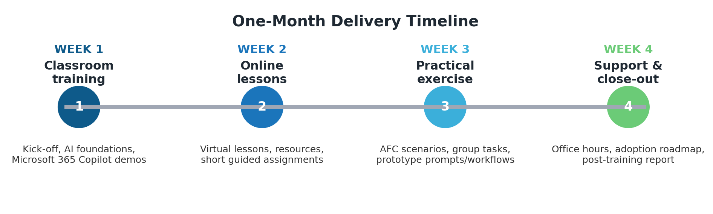

6. Differentiated Training Streams
The programme will be structured to reflect the decision-making responsibilities and technical depth required by different AFC participant groups. This ensures relevance for strategic leaders, operational managers and implementation teams.
Participant Stream | Training Focus | Applied Outcomes
Directors | AI governance, risk, strategy oversight, ethics, regulatory implications and board-level decision support | Board-level AI literacy, governance questions, risk oversight and policy direction
Executive Management | AI strategy, enterprise architecture alignment, digital transformation priorities, use-case prioritization and change leadership | Prioritized AI roadmap, governance approach, investment cases and adoption leadership
Professional Staff | Practical AI productivity, process automation, data use, analytics, prompt engineering, labs and pilot participation | Practical workflows, automation opportunities, pilot contributions and reusable templates
Technical / IT Teams | AI reference architecture, data architecture, application integration, infrastructure, security, MLOps and Agentic AI tools | Technical environment readiness, architecture inputs, model risk controls and implementation capability

7. Phase 1: Classroom Training, Readiness and AFC Needs Alignment
During Phase 1, we will conduct a training readiness assessment and deliver onsite classroom sessions that establish a shared understanding of AI, digital transformation and AFC-specific opportunities. This phase will also identify priority business processes, quick wins and candidate pilot projects.
- Align training content with AFC corporate strategy, process improvement outputs, digital transformation priorities and AI strategy.
- Identify priority workflows across banking operations, branch operations, risk, audit, HR, finance, procurement, customer service and executive reporting.
- Introduce AI, machine learning, deep learning, generative AI, Agentic AI and responsible AI governance.
- Demonstrate Microsoft 365 Copilot and AI productivity applications for Word, Excel, PowerPoint, Outlook and Teams.
- Define training cohorts, expected learning outcomes, readiness gaps and baseline assessment measures.
Outputs: training readiness assessment, tailored AFC training agenda, baseline knowledge assessment, priority AI use-case list and AFC-specific case studies.

8. Phase 2: Online Lessons, LMS and Guided Reinforcement
Phase 2 provides guided online reinforcement through a dedicated training platform with learning management functionality. This reduces disruption to operations while ensuring structured learning, progress tracking and participant accountability.
- Provide a dedicated LMS environment for content hosting, learning paths, assessments, progress analytics and certification tracking.
- Deliver short virtual lessons covering AI productivity, prompt design, data governance, digital transformation and banking AI applications.
- Assign practical exercises that allow participants to apply lessons to real AFC work products and use cases.
- Track completion, assessment scores and engagement data to support reporting and targeted coaching.
- Specify LMS architecture, hosting, security and licensing model as part of mobilisation.
Outputs: LMS setup, online lesson completion records, participant assignment submissions, knowledge checks, progress analytics and refined prompts/templates.

9. Phase 3: Practical Exercises, Applied Workshops and Pilot Projects
Phase 3 moves the programme from theory to practical implementation. Participants will complete applied workshops using AFC-relevant scenarios and will be guided to define three to five AI pilot projects that can demonstrate measurable value.
- Facilitate hands-on labs using banking-relevant scenarios, datasets, case studies, reports, branch workflows and operational processes.
- Apply AI tools to summarization, analysis, drafting, presentation generation, customer communication, meeting preparation and decision support.
- Support the design of three to five AI pilot projects, including problem statements, data needs, risks, success measures and implementation steps.
- Introduce AI and ML development frameworks, Agentic AI tools and MLOps concepts where relevant to technical and professional participants.
- Validate outputs for accuracy, confidentiality, ethics, explainability, data protection and model risk management.
Outputs: completed practical exercises, reusable AI workflow examples, pilot project concepts, prototype prompts/workflows and participant feedback on feasibility.

10. Phase 4: Post-Implementation Support, Change Management and Sustainability
Phase 4 supports adoption beyond classroom delivery. It combines coaching, office hours, change management support, reporting and sustainability documentation so that AI capability is institutionalized and aligned to AFC governance structures.
- Provide mentorship, coaching and advisory support beyond classroom sessions.
- Submit a structured change management plan covering stakeholder engagement, communication, adoption risks and leadership sponsorship.
- Conduct executive alignment workshops and adoption check-ins as required.
- Provide guidance on AI governance frameworks, AI policies, data governance, regulatory compliance and model risk management.
- Prepare monthly or close-out progress reports depending on the final engagement schedule.
- Deliver final evaluation report, participant certifications and sustainability documentation for continuity post-engagement.
Outputs: change management documentation, adoption roadmap, post-training report, final evaluation report, participant certification records and sustainability documentation.

11. Banking, Strategy and Architecture Capability
The delivery team will bring banking operations, business process, digital transformation and AI strategy capability to ensure that training is not generic, but directly connected to AFC implementation requirements.
- Experience in banking operations, banking business processes and digital transformation programmes.
- Capability to formulate AI strategies, AI governance frameworks and AI policies in regulated banking environments.
- Ability to translate corporate strategy into an AI strategy, roadmap and prioritized implementation plan.
- Ability to align enterprise architecture to AI-enabled architecture, covering data, applications, infrastructure/cloud, security and integration.
- Capability to propose an AI reference architecture suitable for banking.
- Understanding of regulatory compliance, data protection, AI security and model risk management in AI deployments.

12. Curriculum Coverage
Curriculum Area | Coverage
Digital Transformation | Strategy alignment, process improvement integration, operating model implications and value realization
AI Strategy and Governance | AI roadmap, governance frameworks, AI policy, ethics, responsible use and regulatory considerations
Data Governance and Analytics | Data quality, data use, analytics foundations, reporting and decision-support applications
Machine Learning and Deep Learning | Core concepts, business applications, limitations, explainability and model risk
Generative AI and Agentic AI | Prompt engineering, workflow automation, autonomous agents, productivity use cases and controls
MLOps and AI Technical Environment | Development frameworks, deployment lifecycle, monitoring, versioning, security and operational management
Banking AI Applications | Credit, risk, audit, customer service, branch operations, fraud, compliance, HR, finance and procurement use cases
Hands-on Labs and Pilots | Practical exercises, prototype workflows, pilot project design and implementation readiness

13. Training Tools and Technical Environment
AFC participants will be supported with a fit-for-purpose training environment that enables demonstrations, labs, assessments and controlled experimentation. The final configuration will be agreed with AFC in line with security and data protection requirements.
- AI productivity tools including Microsoft 365 Copilot where available, supported by prompt templates and workflow checklists.
- AI and machine learning development frameworks appropriate for lab demonstrations and technical participants.
- Agentic AI tools for controlled demonstrations of AI-enabled workflows and task automation.
- MLOps concepts and tool demonstrations for deployment, monitoring, documentation and lifecycle governance.
- Secure LMS configuration for training content, assessments, progress tracking, analytics and certification records.

14. Monitoring, Evaluation and Reporting
Performance will be monitored throughout the engagement using structured reporting and evaluation methods. This ensures the programme remains accountable to AFC objectives and produces measurable outcomes.
Monitoring Area | Measurement / Evidence
Readiness | Training readiness assessment, baseline knowledge check and cohort segmentation
Participation | Attendance, LMS progress, completion rates and online assessment records
Learning Effectiveness | Knowledge checks, practical exercise outputs and facilitator observations
Pilot Progress | Pilot project charters, workflow prototypes, implementation risks and success measures
Adoption and Change | Stakeholder feedback, adoption barriers, change management actions and communication outputs
Close-Out | Final evaluation report, participant certifications and sustainability documentation

15. Deliverables
Deliverable | Description
Training curriculum | Structured AI and Digital Transformation curriculum tailored to AFC participant streams
Detailed training schedule | One-month core programme schedule with branch or cohort coverage to be agreed with AFC
Training platform setup | Dedicated LMS environment with content, tracking, analytics, assessments and certification support
Training materials | Slide decks, use-case guides, prompt templates, toolkits and workflow checklists
Practical labs and pilot concepts | Hands-on exercises and three to five AI pilot project concepts or charters
Change management documentation | Stakeholder engagement plan, communication approach, adoption support and executive alignment inputs
Progress reports | Monthly or milestone-based progress reporting depending on AFC final schedule
Final evaluation report | Programme outcomes, assessment results, insights, adoption recommendations and next steps
Participant certifications | Certificates of completion or relevant credential records
Sustainability documentation | AI adoption roadmap, governance recommendations and continuity toolkit

16. Value Addition
- Academic rigor from the University of Zimbabwe.
- Industry expertise from Rubiem Intelligence.
- Specialized AI training capability from AI Institute Africa.
- Banking-aligned AI strategy, governance, architecture and implementation support.
- A practical methodology designed to create measurable adoption, pilot implementation and immediate productivity gains.

17. Proposed Delivery Team and CV Alignment
The methodology will be delivered by a senior multidisciplinary team combining banking transformation, AI strategy, computer science, data analytics, e-learning, applied AI, cybersecurity and implementation experience. The team profile strengthens the proposed approach by ensuring that AFC receives both executive-level advisory support and practical hands-on technical delivery.
Team Member | Proposed Role in AFC Engagement | Relevant Capability Evidence
Dr. Dennis Magaya, PrEng | Strategic Advisor / AI and Banking Digital Transformation Lead | 29 years cross-sector experience; AI strategy and solution implementation; organisational transformation; digital transformation; banking operations; ICT architecture and governance; lead consulting experience for ZB Financial Holdings, POSB, Reserve Bank of Zimbabwe, Standard Chartered Bank, ZSE, Lion Finance and other financial-sector institutions.
Dr. Cross Gombiro | Lead AI, Data Analytics and Technical Training Specialist | PhD in Information Systems; MSc Computer Science; University of Zimbabwe academic and trainer; experience in AI, machine learning, big data, cybersecurity, data analytics using Python, R, SQL, Excel, SPSS and Power BI; research in AI/IoT, fraud detection, financial crime and security.
Taurayi Rupere | Applied AI, LMS, E-Learning and Workshop Facilitation Lead | University of Zimbabwe Computer Science Chairperson / ICT Lecturer / Consultant; research and training in AI, machine learning, big data analytics, e-learning, business intelligence, blockchain and information security; experience leading surveys, training manuals, digital instruments, analysis plans and client reporting for institutions including POSB, POTRAZ, ZETDC and others.
Capability Alignment to AFC Methodology
The CVs support the methodology in the following areas:
Methodology Requirement | Team Capability | How It Supports AFC Delivery
Banking digital transformation and AI strategy | Dr. Magaya has senior banking transformation and AI strategy experience across financial institutions and regulators. | Ensures the training dovetails with AFC corporate strategy, process improvement, digital transformation and AI adoption priorities.
AI, ML, data analytics and technical labs | Dr. Gombiro and Taurayi Rupere bring computer science, AI, machine learning, big data, Python/R/SQL and information systems training expertise. | Supports practical labs, applied workshops, technical demonstrations and participant capability building.
Governance, security and model risk awareness | The team includes ICT governance, cybersecurity, fraud detection, information security and architecture capability. | Supports responsible AI, data protection, compliance, security and model risk management within a regulated banking environment.
Online learning, LMS and assessments | Taurayi Rupere and Dr. Gombiro have e-learning, LMS, academic delivery, assessment, supervision and training material development experience. | Strengthens the online lessons, LMS-enabled tracking, knowledge checks, assessments and certification process.
Pilot project implementation support | The combined team has delivered strategy, research, process improvement, surveys, technology implementation and client advisory assignments. | Supports identification, design and implementation planning for the three to five AFC AI pilot projects.
Integration into the Four-Phase Methodology
Phase | Lead Input | Specialist Support | Expected Contribution
Phase 1: Classroom and Readiness | Dr. Dennis Magaya | Dr. Cross Gombiro; Taurayi Rupere | Executive alignment, readiness assessment, banking use-case prioritisation and training stream calibration.
Phase 2: Online Lessons and LMS | Taurayi Rupere | Dr. Cross Gombiro | LMS content, online reinforcement, progress tracking, knowledge checks and assignment support.
Phase 3: Practical Exercises and Pilots | Dr. Cross Gombiro | Taurayi Rupere; Dr. Dennis Magaya | Hands-on AI labs, applied banking scenarios, pilot project problem statements and workflow prototypes.
Phase 4: Support and Sustainability | Dr. Dennis Magaya | Dr. Cross Gombiro; Taurayi Rupere | Advisory support, governance guidance, change management, reporting, adoption roadmap and sustainability documentation.

18. Personnel Value Addition
- Senior leadership oversight from a registered Professional Engineer and AI/digital transformation strategist with banking-sector advisory experience.
- Academic depth from University of Zimbabwe computer science and information systems specialists experienced in AI, machine learning, cybersecurity, e-learning and data analytics.
- Practical implementation capability covering banking process translation, data-driven analysis, AI pilot project design, training materials, assessments and sustainability documentation.
- A blended delivery team able to engage Directors, Executive Management, Professional Staff and technical participants at the correct level of depth.
Prepared for AFC | Enhanced AI Training Methodology

